Web Service

# WSDL – Web Service Definition Language

## Components of WSDL

### 1.1.2 Definition

This element should be the root of all the WSDL documents, which defines the name of the web service.

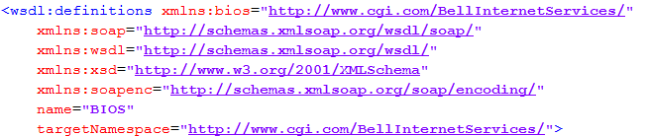

### 1.1.3 Type

This element defines the type (XML schema) for all the elements of the WSDL.

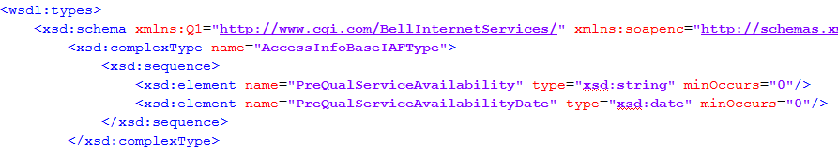

### 1.1.3 Message

It defines the data being exchanged between the web service provider and consumer. Every message has an input, output and a fault. Each message contains zero or more part parameters required for the processing of web service function.



### 1.1.3 Port Type

The <portType> element combines one or more messages that complete a one way or a round trip operation.

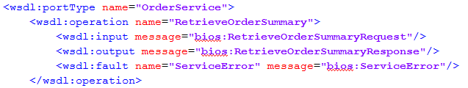

### 1.1.3 Bindings

The <binding> element provides information on the protocol, the location of the service and the style (“Document” or “RPC”).

<binding name = "Hello_Binding" type = "tns:Hello_PortType">

<soap:binding style = "rpc" transport = "http://schemas.xmlsoap.org/soap/http"/>

### 1.1.3 Port

The <port> element defines an individual endpoint by specifying a single address for binding.



### 1.1.3 Service

The service defines the ports supported by the webservice. Any given web service consumers can identify the following information from the definition of “Service”.

1. Where to access the service.
2. Through which port to access the service.
3. How the communication messages are defined.

