## It’s VR Time!

#### Time for some fun! You have **15 minutes** to complete the following two tasks:

#### Enable VR in the Handpainted Forest Scene

1. Try Valve’s Interaction System

# Enable VR in the Park Scene

#### Find the Park scene file at Assets/Scenes/EnableVRScene.unity and double click it to open.

#### In order to test VR is working, make sure to do the following

1. Find the First-Person Controller, remember its **position**, and delete it from the scene.
2. Add the **CameraRig Prefab** to your scene

**Hint**: Try using the search function in the Project Window to find it

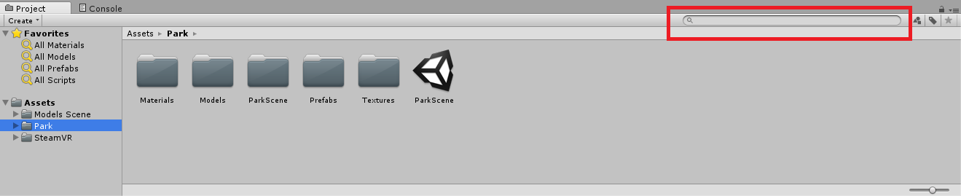

1. Hit the Play Button (). You should now see the Game View camera change based on the orientation of your headset.
2. Test the **Scale** transform parameter on the CameraRig
   1. Good scale values to try are **0.5f** and **3f**. Make sure to keep your X, Y, Z scale settings the same. i.e.

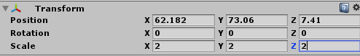

* 1. **WARNING**: If you get simulator sickness (feel free to ask us what this is), **DO NOT** change the position, rotation, or scale of the Camera Rig while you are wearing the headset!!!

# Valve’s Interaction System

When you are done, open up the Interaction System Demo at **SteamVR/InteractionSystem/Samples/Scenes/**

**Interaction_Examples.unity**

**After you do, hit play!**

**We will be using this a lot in the next few hours so now is great time to play around with it and see what it offers.**