ITA0610 - Machine Learning
EXP - 10
Write a Python Program to Implement Expectation & Maximization Algorithm
AIM
To implement the Expectation Maximization (EM) algorithm using Python for clustering data using a Gaussian Mixture Model (GMM).

ALGORITHM
- Import the required libraries.
- Create a sample dataset.
- Train the Gaussian Mixture Model (GMM).
- Apply the Expectation-Maximization (EM) algorithm.
- Predict the cluster labels.
- Display the cluster centers and labels.
- Visualize the clustered data.

PROGRAM:
import numpy as np
import matplotlib.pyplot as plt
from sklearn.mixture import GaussianMixture
X = np.array([
[1,2],[1.5,1.8],[5,8],[8,8],[1,0.6],
[9,11],[8,2],[10,2],[9,3]
])
gmm = GaussianMixture(n_components=2, random_state=42)
gmm.fit(X)
labels = gmm.predict(X)
print("Cluster Labels:")
print(labels)
print("\nCluster Centers:")
print(gmm.means_)
plt.scatter(X[:,0], X[:,1], c=labels, cmap='viridis', s=100)
plt.scatter(gmm.means_[:,0], gmm.means_[:,1], c='red', marker='X', s=200)
plt.title("Expectation Maximization Clustering")
plt.xlabel("Feature 1")
plt.ylabel("Feature 2")
plt.show()
OUTPUT:
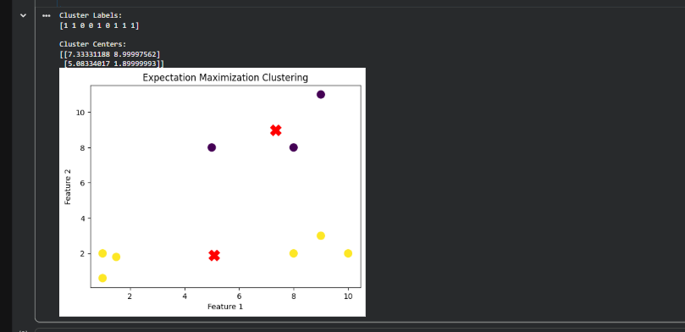
A scatter plot will be displayed showing:
- Different colors representing different clusters.
- Red 'X' markers representing the cluster centers.

RESULT:
Thus, the Expectation Maximization (EM) algorithm was successfully implemented using Python. The algorithm clustered the given dataset into two groups using the Gaussian Mixture Model (GMM), and the clusters along with their centers were visualized successfully.

