ITA0610 - Machine Learning
EXP – 9
Compare Linear and Polynomial Regression using Python
AIM
To compare the performance of Linear Regression and Polynomial Regression using Python.

ALGORITHM
- Import the required libraries.
- Create a sample dataset.
- Train the Linear Regression model.
- Transform the data into polynomial features.
- Train the Polynomial Regression model.
- Predict the output using both models.
- Compare the performance using R² Score.
- Plot the Linear and Polynomial Regression curves.
PROGRAM:
import numpy as np
import matplotlib.pyplot as plt
from sklearn.linear_model import LinearRegression
from sklearn.preprocessing import PolynomialFeatures
from sklearn.metrics import r2_score
X = np.array([[1],[2],[3],[4],[5],[6],[7],[8],[9],[10]])
y = np.array([2,5,10,17,26,37,50,65,82,101])
linear_model = LinearRegression()
linear_model.fit(X, y)
y_linear = linear_model.predict(X)
poly = PolynomialFeatures(degree=2)
X_poly = poly.fit_transform(X)
poly_model = LinearRegression()
poly_model.fit(X_poly, y)
y_poly = poly_model.predict(X_poly)
print("Linear Regression R2 Score:", r2_score(y, y_linear))
print("Polynomial Regression R2 Score:", r2_score(y, y_poly))
plt.scatter(X, y, color='blue')
plt.plot(X, y_linear, color='red', label='Linear Regression')
plt.plot(X, y_poly, color='green', label='Polynomial Regression')
plt.xlabel("X")
plt.ylabel("Y")
plt.title("Linear vs Polynomial Regression")
plt.legend()
plt.show()
OUTPUT:
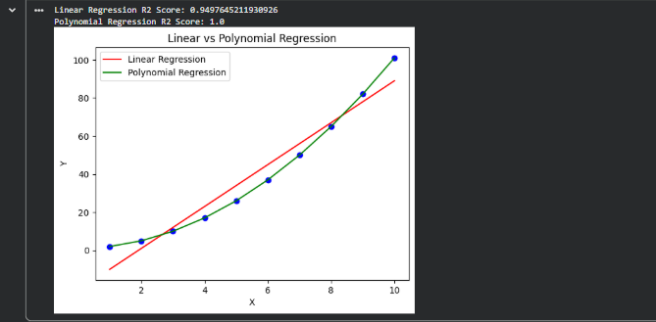
A graph will be displayed showing:
- Red Line → Linear Regression
- Green Curve → Polynomial Regression

RESULT:
The Linear Regression and Polynomial Regression models were successfully implemented and compared. The Polynomial Regression model achieved a higher R² Score and provided a better fit for the nonlinear dataset than the Linear Regression model.

