Traffic simulation of multi lane highways

SI1336 Simulation and modelling

Viggo Moro

1 Introduction

1.1 Background & problem

The aim of this project is to simulate a one, two and three lane highway with overtaking and lane changing when the highway has more than one lane. Furthermore, the cars in the simulation will have different maximum velocities. More specifically, this report will address how the road capacity for highways compare for different number of lanes.

The flow rate is defined as the sum of the velocities of all cars divided by the road length and the car density is defined as the number of cars divided by the road length. The fundamental diagram is the plot of flow rate versus car density. To compare the road capacity for different number of lanes, the fundamental diagram will be plotted for one, two and three lanes. The flow rate will be recorded after the system has reached equilibrium.

1.2 Traffic model

There are many different models for simulating traffic but in this report a cellular automaton traffic model with periodic boundary conditions will be used. If $x_{i}$ and $v_{i}$ represent the position and velocity of the car with index $i$, and the maximum velocity of car $i$ is $v_{max, i}$ the model can be described by the following rules:

* For ${car}_{i}$, $i=1,2,3, …, N$
* If $v_{i}< v_{max, i}$, increase the velocity of car $i$ by one velocity unit. That is $v_{i}→ v_{i}+1$. This change in velocity models the process of acceleration towards the maximum velocity.
* Compute the distance $d$ to the car in front in the current lane of ${car}_{i}$. To prevent crashes, if $v_{i} ≥d$:
  + Try to perform an overtake if the current lane isn’t the maximum lane, the lane furthest to the left. Compute the distance to the car in front and behind in the lane to the left of ${car}_{i}$ at time t. $d_{in front}(t)=$ distance to the car in front in the lane to the left and $d_{behind}\left(t\right)=$ distance to the car behind in the lane to the left. If $v_{i}< d_{in front}(t)$ and $v_{behind}< d_{behind}(t)$, change lane one to the left. This condition ensures that changing lane to the left won’t cause a collision.
  + Otherwise, if an overtake isn’t possible reduce the velocity according to $v_{i}→d-1$. This change in velocity prevents crashes.
* With a given probability $p$, reduce the velocity of car $i$ by one velocity unit: $v_{i}→ v_{i}-1$. This is only done when $v_{i} ≥1$ to avoid negative velocities. This models a random speed reduction which for example could be the consequence of looking down at the phone.
* For ${car}_{i}$, $i=1,2,3, …, N$
* Update the position of car $i$: $x_{i}\left(t+1\right)= x_{i}$ (t) + $v_{i}$
* For ${car}_{i}$, $i=1,2,3, …, N$
  + If the current lane of ${car}_{i}$ isn’t the lane furthest to the right, try to change lane one to the right. Compute the distance to the car in front and behind in the lane one to the right of ${car}_{i}$ at time t. $d_{in front}(t)=$ distance to the car in front in the lane to the right and $d_{behind}(t)=$ distance to the car behind in the lane to the right. If $v_{i}< d_{in front}(t)$ and $v_{behind}< d_{behind}(t)$, change lane to the right.

This model is an extension of the one covered in project two which allows for overtaking and lane changing. Therefore, I will focus on explaining and motivating my choice of rules for overtaking and lane changing.

When a car is too close to the car in front so that a collision may be caused, if $v_{i} ≥d$, I felt that the most realistic and natural course of action would be to first try and change lane and overtake and otherwise reduce the velocity to prevent a crash. Furthermore, I thought that the condition $v_{i}< d_{in front}(t)$ and $v_{behind}< d_{behind}(t)$ was the natural extension of the condition, if $v_{i} ≥d$, since it in the same way prevents crashes between cars when changing lanes. However, this condition for when a car can change lane won’t necessarily ensure that the change is always smooth. It’s possible that ${car}_{i}$ and the car behind ${car}_{i}$ in the new lane will have to reduce their velocities or perform overtakes in the next time step due to the overtake causing them to get too close to their respective cars in front. I thought about adding an additional requirement that the difference in velocity between car $i$ and the car behind and the car in front in the new lane couldn’t be too large. However, since the results are analyzed after equilibrium has been reached, I thought that the occasional lane changes that aren’t smooth wouldn’t influence the results to any great extent. In addition, I wanted to avoid the scenario where overtakes would occur less frequently. Therefore, I decided to stick with the current condition.

The reason why the positions are updated after the velocities have been updated for all cars is to make the condition for when to change lane to the left symmetric with respect to the distance to the car in front and the car behind. If the position of a car would be updated right after the velocity had been updated, cars wanting to overtake would on average have cars closer behind than in front since the cars behind has updated their positions already.

The final rule makes sure that cars strive to drive in a lane as far right as possible and leave the lanes to the left for overtaking as in reality. This step in the traffic model accomplishes that cars that at time t or some earlier time changed lane to the left to overtake change lane back to the right if possible, to complete an overtake. The reason for why I decided to update the position of all cars before trying to change lane to the right is because it thought that it was more realistic that a car in front of a car which begins an overtake changes its velocity independent of whether or not the car behind wants to overtake and certainly before it has completed the overtake. I used the same condition for changing lane to the right as I did for changing lane to the left. However, as opposed to when changing lane to the left, since the positions has been updated a lane change to the right can’t be unsmooth. The condition guarantees that ${car}_{i}$ and the car behind ${car}_{i}$ in the new lane won’t have to reduce their velocities or overtake in the next time step due to getting too close to their respective car in front unless they accelerate and increase the velocity by one velocity unit. This is a bit unrealistic since the effect of this is that lane changes to the right is smoother than lane changes to the right. But I didn’t come up with a condition that closer resembled that for changing lane to the left without updating the positions of the cars directly after the velocities had been updated and thus decided to keep the condition as it is right now. Furthermore, since the results are analyzed at equilibrium, I thought that this wouldn’t have any great effect on the results.

1.3 Approximations & discretization

The traffic model described above is only a simplified model of how traffic looks in reality and thus can be viewed as an approximation itself. The conditions for changing lanes, breaking and accelerating are all simplified and idealized conditions for how people behave in traffic in reality. Moreover, periodic boundary conditions are used for the road length which means that when a car reaches the end of the road, the maximum road length, it’s moved back to the beginning. This approximation is made to replicate a continuous flow of cars at any given point in the highway as in reality. In addition, further approximations have made regarding which rules of traffic in reality to incorporate in the model. Firstly, it’s only possible to overtake to the left of cars in front. In reality, although overtakes are supposed to be performed to the left, they occasionally happen to the right. Moreover, the number of lanes doesn’t depend on where on the highway you are and will always be held constant. In addition, the highway won’t have entrances or exits. In other words, a highly idealized highway structure and set of traffic rules are simulated but it can still provide valuable insight into how traffic behaves in reality.

The traffic model described above treats traffic as something discrete. The road length, maximum velocities, acceleration and positions are all discrete integers as opposed to in reality. The updates of the positions are made according to $x_{i}\left(t+1\right)= x_{i}$ (t) + $v_{i}$ which is equivalent to $x_{i}\left(t+1\right)= x_{i}$ (t) + ${1 ∙v}_{i}$. Thus, the time step can be viewed as being one time unit. It’s worth pointing out that the rules of the traffic model have been adapted to this time step. For example, the probability of braking is set to 0.5 but if the time step were to be reduced to 0.1 time units, it could be considered unreasonable that one would expect cars to brake five times as often in a given time period since the effect of braking is the same, a reduction in velocity by one velocity unit of the cars, regardless of the time step. Furthermore, since the velocities and initial potions are always integers this rule of update will ensure that all future positions will be integers as well. In addition to being adapted to the time step, the rules of the traffic model and the typical velocities of the cars have to some extent been adapted to the road length and specifically to a lower limit of the road length. For example, with a road length of 50 length units, having velocities of ten velocity units or accelerations that changes the velocities by five velocity units would cause the interactions between the cars to break down. Therefore, a road length of 50 length units has been taken into account when discretizing and deciding on velocities and accelerations. One may ask how a discrete model can produce meaningful results of something that is inherently continuous. But it’s important to bear in mind that although each car on a microscopic level behaves in a discrete way, the aggregate behavior of large number of cars can still be effectively continuous which is utilized in the simulations.

2 Method

2.1 Initial condition

The initial position and velocities of the cars are determined randomly. The initial positions will be integers which can vary over the entire road length and the initial velocities will be integers determined randomly between one and three velocity units. The probability of random braking, $p$, will always be held at $0.5$ and the road length will always be 50 length units. Since the flowrate is affected by the maximum velocities of the cars, especially at lower densities, the different maximum velocities of the cars in a simulation will always come in equal proportions and from the same set of possible maximum velocities when comparing the road capacity for different number of lanes. Furthermore, the cars will also be assigned this maximum velocity depending on its initial position. For example, if the allowed maximum velocities are $v_{max}=\{1,2,3\}$ one third of the cars will have a maximum velocity of one velocity unit, one third will have a maximum velocity of two velocity units and one third will have a maximum velocity of three velocity units as long as the number of cars is divisible by three. The cars will also be assigned this maximum velocity depending on its initial position so that initially every third car has the same velocity. Otherwise, when the number of cars isn’t divisible by three, there will be one additional car with a maximum velocity of one velocity unit or alternatively two additional cars where one has a maximum velocity of one velocity unit and the other has a maximum velocity of two velocity units.

2.2 Measurements

The aim of this report is to analyze the road capacity of highways when the number of lanes vary. This will be done by comparing the fundamental diagram for one, two and three lanes. This will be done for tree different sets of maximum velocities, $v_{max}=\{1,2,3,4\}$, $v_{max}=\{1,2,3\}$ and $v_{max}=\{2,3$. To highlight different aspects of the results, figures where the road length for multiple lanes is the same as the road length for one lane will be presented as well as figures where the road length for multiple lanes is that of one lane multiplied by the number of lanes. All of the figures will include error bars that show the standard error estimate of the flow rate.

3 Results & analysis

3.1 Comparison of road capacity for different number of lanes

3.1.1 Road length independent of the number of lanes

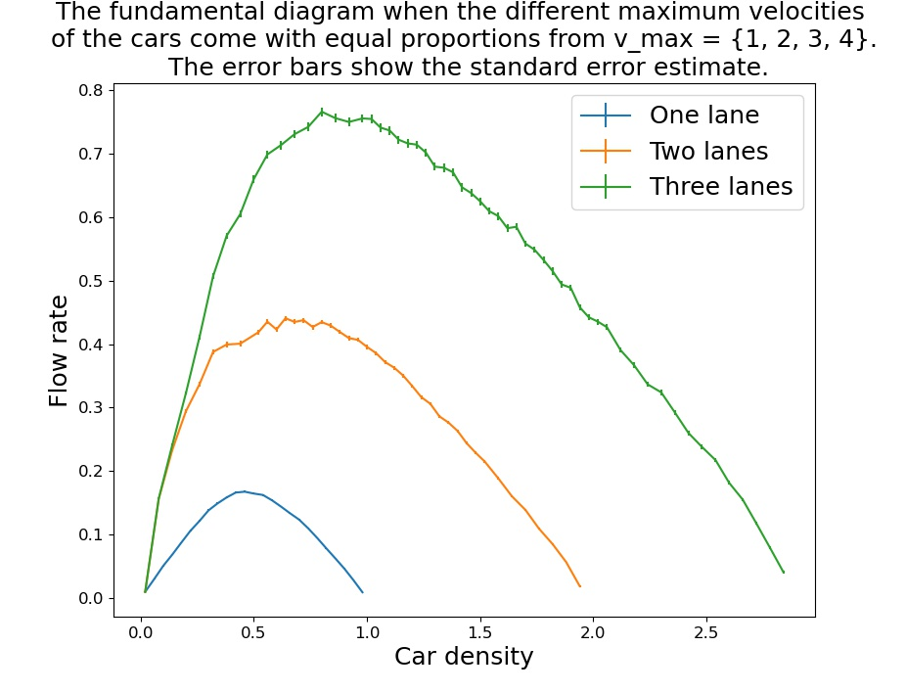

Figure 1. The fundamental diagram for multiple lanes when the distribution of maximum velocities is $v_{max}=\{1,2,3,4\}$.

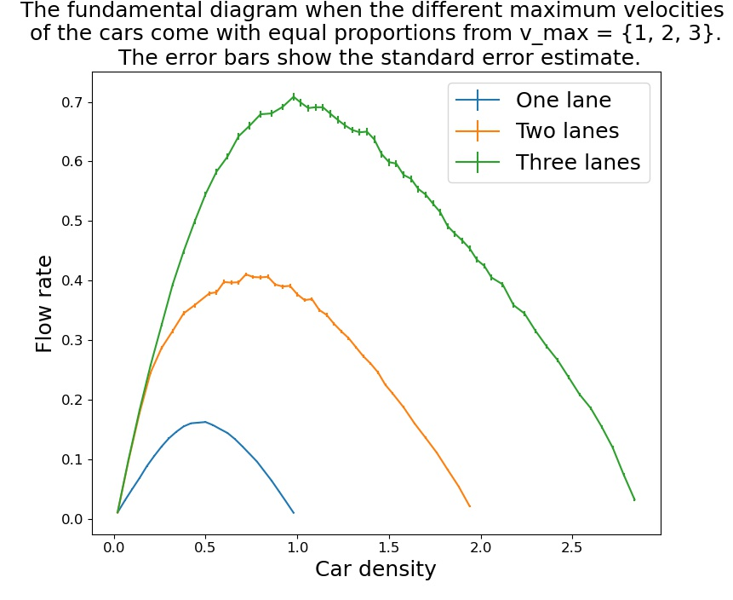

Figure 2. The fundamental diagram for multiple lanes when the distribution of maximum velocities is $v_{max}=\{1,2,3\}$.

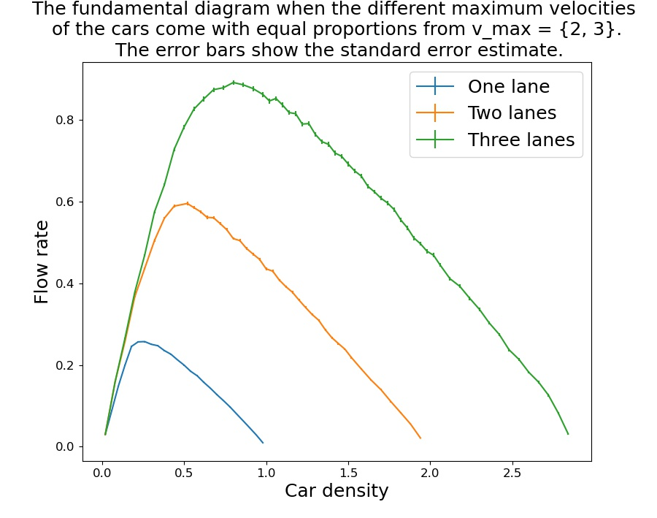

Figure 3. The fundamental diagram for multiple lanes when the distribution of maximum velocities is $v_{max}=\{2,3\}$.

In the above figures, the fundamental diagram is shown for one two and three lanes where every figure has a different distribution of maximum velocities for the cars and the road length is defined as being equal for one lane and for multiple lanes. It’s thus independent of the number of lanes. Since the flow rate is defined as the sum of the velocities of the cars divided by road length and the density is defined as the number of cars divided by the road length, the figures show the relationship between the sum of the velocities at equilibrium and the number of cars. Thus, it would be expected that the curves in the figures demonstrate a linear increase in flow rate until densities where traffic jams begin to occur when the curves start to flatten out and finally start to decrease. This is exactly what we can observe in the figures above.

In figure 3 where the distribution of maximum velocities is $v_{max}=\{2,3\}$, it can be seen that for low densities the curves for one, two and three lanes get very close. This indicates that lane two and three aren’t utilized when the car density is low enough. We can observe that the curves first start to really separate when the curve for one lane starts to flatten out, when traffic jams begin to occur. Since the curves with two and three lanes have the possibility to use additional lanes, the cars start to change lane more frequently so that traffic jams won’t occur, and the curve therefore continues to increase linearly. From this we can conclude that the additional lanes begin to be used more frequently when traffic jams start to occur in the rightmost lane due to the car density being too large. The same thing can be observed again when the curves for two and three lanes start to diverge from one another which is due to the same reason but now with the second lane becoming too crowded leading to traffic jams.

However, the curves for one, two and three lanes getting very close for low densities isn’t equally clear in figure 1 and 2 which have different distributions of maximum velocities. This is due to the relative difference between the maximum velocities in each set, the variance of the set of maximum velocities, being significantly greater. This causes overtakes and lane changing to occur much more frequently when there is more than one lane compared to when $v_{max}=\{2,3\}$. However, when there is only one lane, the larger difference in relative maximum velocity causes faster cars being stuck behind slower cars to a much greater extent. This leads to a significant difference between the flow rate for one and for multiple lanes which causes the curves for different number of lanes to be substantially more separated when the distribution of maximum velocities isn’t $v_{max}=\{2,3\}$.

3.1.1 Road length equal to the number of lanes multiplied by the road length for one lane

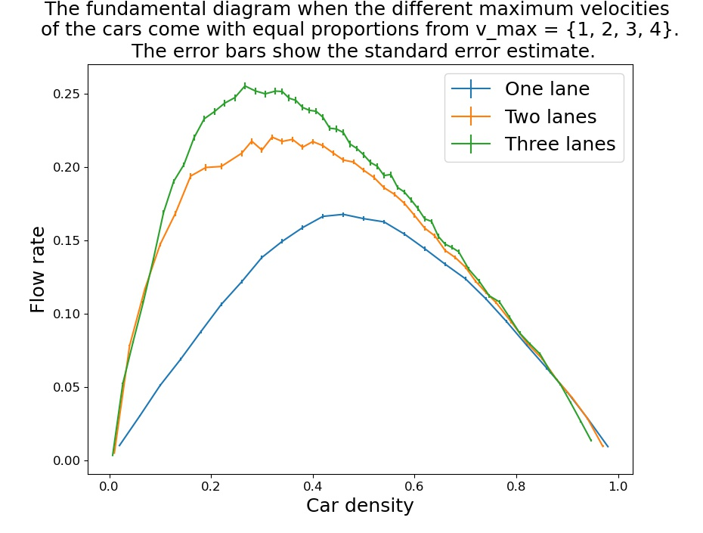

Figure 4. The fundamental diagram for multiple lanes when the distribution of maximum velocities is $v_{max}=\{1,2,3,4\}$.

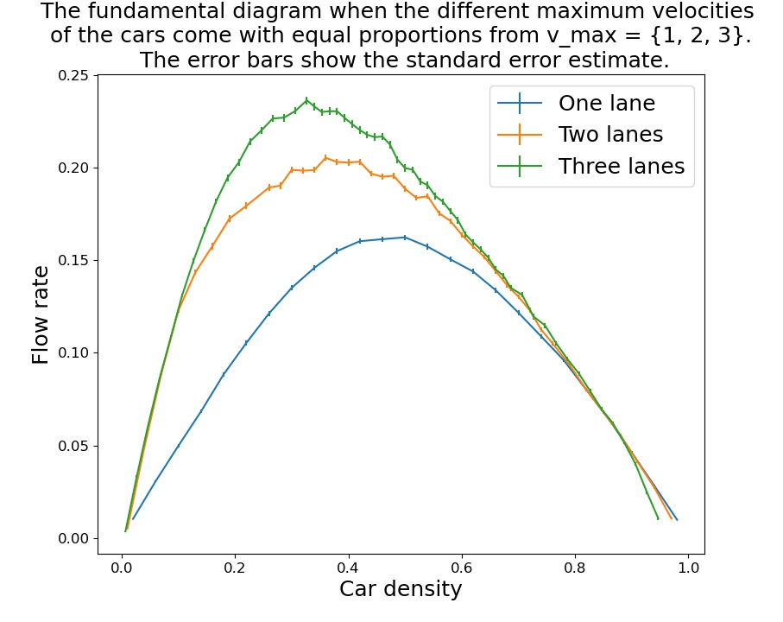

Figure 5. The fundamental diagram for multiple lanes when the distribution of maximum velocities is $v_{max}=\{1,2,3\}$.

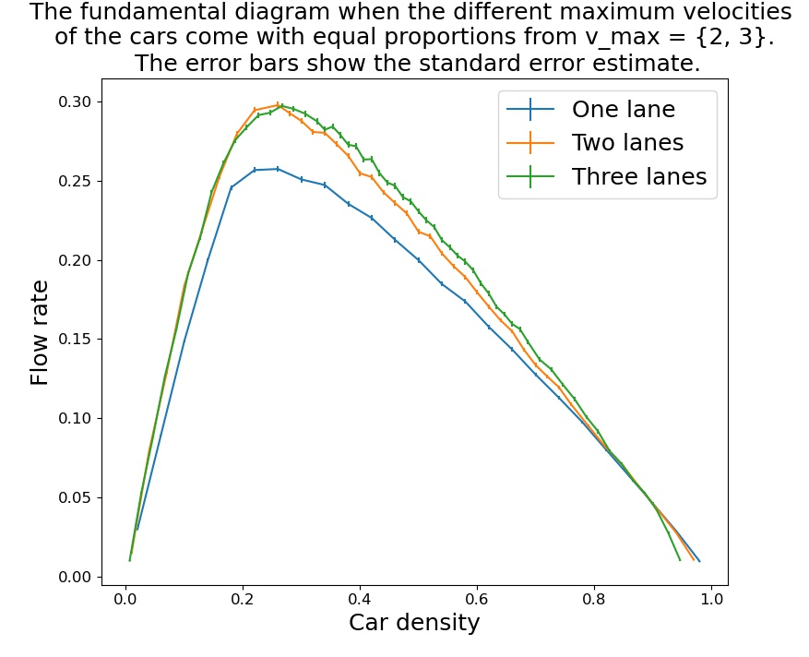

Figure 6. The fundamental diagram for multiple lanes when the distribution of maximum velocities is $v_{max}=\{2,3\}$.

When the road length is instead defined as the number of lanes multiplied by the road length for one lane, the above figures are produced. As described in the first paragraph of this section, traffic jams are the reason for why the curves flatten out and eventually start decreasing. However, in light of the figures above, there might be an additional reason for why the curves with multiple lanes flatten out and eventually start decreasing. It can be seen that the density where the maximum flow rate occurs for two and three lanes is lower than that for one lane. However, the maximum flow rate is greater the more lanes there are. Moreover, the flow rate is also higher when there are multiple lanes for the density that maximizes flow rate for one lane even though the curves for multiple lanes have started decreasing. This leads to the conclusion that adding additional lanes to a highway is always positive for the flow rate due to the ability for cars to perform overtakes but that they are most effective when they are kept fairly empty compared to the lane furthest to the right to allow for effective overtakes. Thus, the reason for why the curves for multiple lanes start decreasing at a lower density than the curve for one lane, isn’t because traffic jams start to occur at a lower density when there is more than one lane. Instead, additional lanes significantly increase the flow rate by allowing overtaking, but this works best when the extra lanes are kept fairly empty compared to the lane furthest to the right to allow for effective overtakes. Thus, when the curves for multiple lanes start to decrease, the additional lanes have become more crowded than what’s optimal which leads to a decrease in flow rate, but they aren’t crowded enough to cause the types of traffic jams that occur for one lane. The type of traffic jams occurring in highways with one lane when the curve start decreasing first start to occur in highways with multiple lanes for higher densities, approximately when the curves for multiple lanes have decreased to the maximum flow rate for one lane. At this density, the curves for one lane and for multiple lanes have gotten very close which indicates that the highways with one and multiple lanes behave in the same way.

However, the exact effect on adding an additional highway depends on the distribution of maximum velocities among the cars. The figure that stands out among the ones above is figure 6 where the distribution of maximum velocities is $v_{max}=\{2,3\}$. I that figure, the curves for two and three lanes have their maximum flow rate for a car density that is practically the same as the density where the maximum flow rate occurs for one lane. Furthermore, the difference in the flow rate between different number of lanes is the smallest for a given density. This suggests that the overking possibilities offered when there is more than one lane aren’t so important when $v_{max}=\{2,3\}$. Therefore, the maximum flow rate doesn’t get much higher when there are multiple lanes, and the additional lanes can me filled with more cars without the flow rate starting to decrease moving the densities for the maximum flow rate closer. This seems very reasonable since $v_{max}=\{2,3\}$ produces the fewest overtakes. As discussed previously, this is due to the relative different between the different maximum velocities in this set being the smallest among the four which were simulated.

In contrast, in figure 4 and 5 for the other distribution of maximum velocities than $v_{max}=\{2,3\}$, the maximum flow rate is significantly higher for multiple lanes and the density where the maximum occurs is significantly lower than that for one lane. The reason for this is that the relative difference between the maximum velocities in each set is greater than when $v_{max}=\{2,3\}$ which leads to more overtakes. Thus, the maximum flow rate significantly increases and the density where this maximum flow rate occurs is lower since the lanes for overtaking need to be kept fairly empty for the overtakes to be performed effectively which moves the densities for the maximum flow rate for different number of lanes further apart.