**3.GIT-HOL**

* Explain branching and merging

Ans: **Branching**: Creates a separate line of work without affecting the main code.

git checkout -b feature-branch

**Merging**: Combines changes from a branch into another.

git checkout main

git merge feature-branch

* Explain about creating a branch request in GitLab

Ans: git checkout -b feature-branch

git push origin feature-branch

* Explain about creating a merge request in GitLab

Ans: Go to Merge Requests > New Merge Request.

Select source branch and target branch.

Click “Compare”, fill details, and Create Merge Request.

**Branching:**

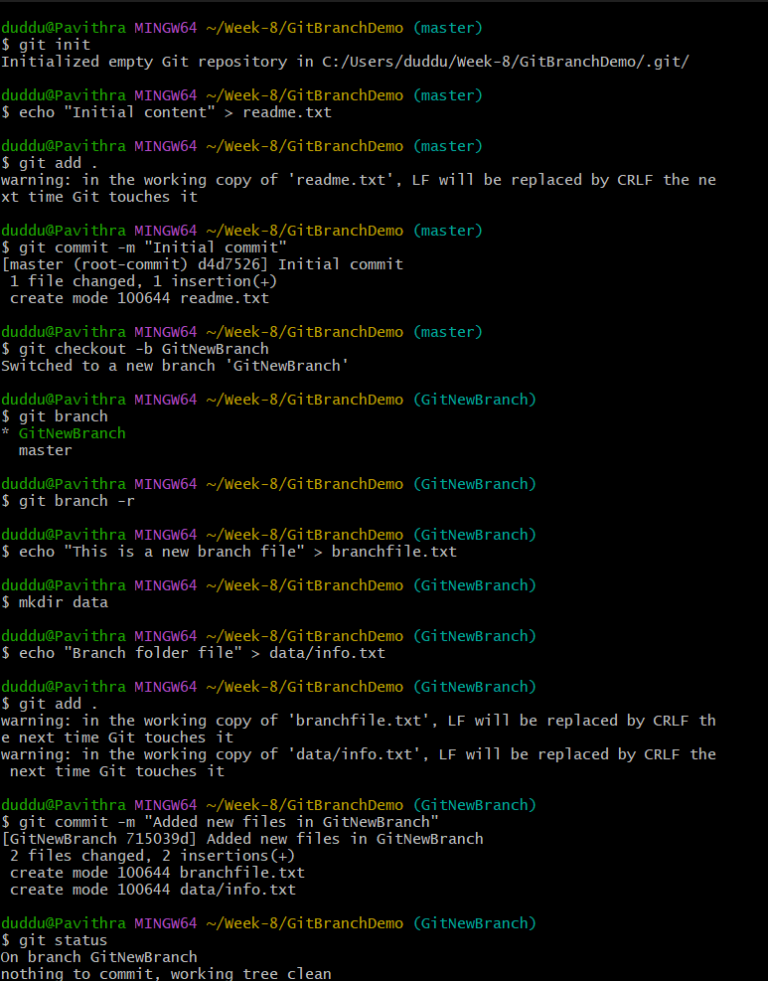

**Merging:**

1. **Switch to the master**

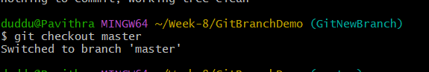

1. **List out all the differences between trunk and branch. These provide the differences in command line interface.**

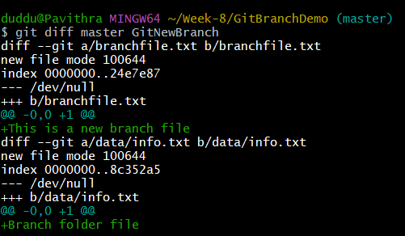

1. **Merge the source branch to the trunk.**

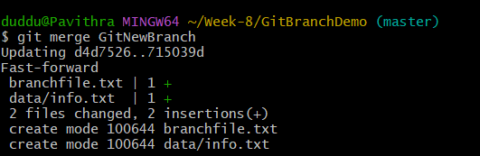

1. **Observe the logging after merging using “git log –oneline –graph –decorate”**

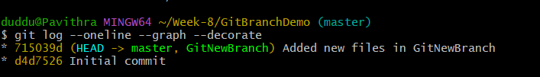

1. **Delete the branch after merging with the trunk and observe the git status.**

