PRDA – 01 Profit Analysis

Task:
- Get data from the database with the given credentials.
- Perform Regression Analysis for the given data to identify how the money spent on Marketing, R&D, and Administration is affecting the company’s Profit. Predict the Profit for the below-given input features.

R&D Spend | Administration | Marketing Spend | Profit
21892.92 | 81910.77 | 164270.7
23940.93 | 96489.63 | 137001.1

- Visualize the data using Tableau /PowerBI and derive insights about all the features provided and give your inputs/suggestions to the company.

About Dataset:
This particular dataset holds data from 50 startups in New York, California, and Florida. The features in this dataset are R&D spending, Administration Spending, Marketing Spending, location features, and Profit.
Link for dataset:
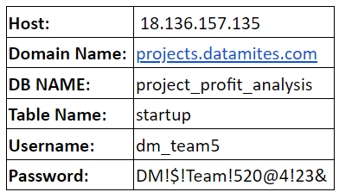

Attribute Information:
- R&D spending: The amount that startups are spending on Research and development.
- Administration spending: The amount that startups are spending on the admin panel.
- Marketing spending: The amount that startups are spending on marketing strategies.
- State: To which state that particular startup belongs.
- Profit: How much profit that particular startup is making.
You can provide your inputs/solution as a PPT presentation and you can explain your project, record it and send it with the PPT file.

