To Compile, from the root folder, on the terminal write,

make

To Run the server,

java Server

To Run the client,

java client

Functionality:

● TCP connection between client and server

Initial state:

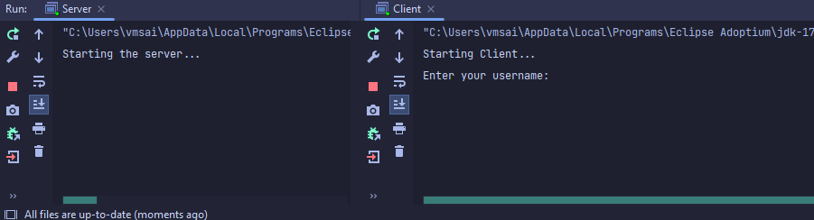

After entering the username, the client gets connected to the server via TCP:



● View list of existing chat rooms

First a room has to be created in order to see the room list. Via -createRoom room_Name

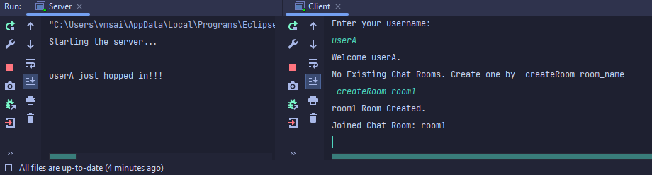



Now list rooms by -rooms

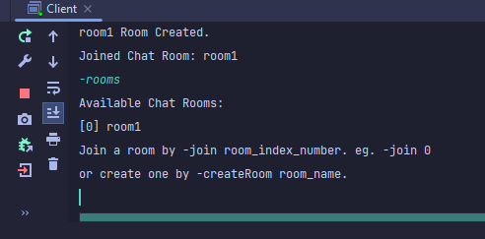

● Join existing chat rooms

Now creating another client, then joining the room by the index number beside the rooms list.



● View the number and list of connected users for each room

From any client, write -rDetails

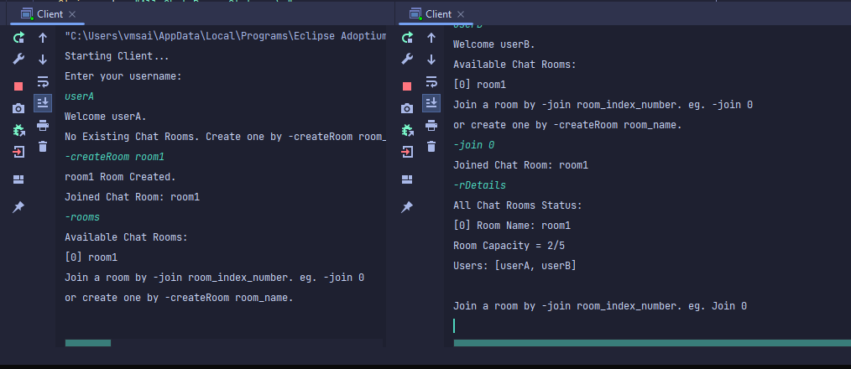

● Check room capacity and restrict access to full capacity rooms

Now creating 6 clients in total, 5 will be joining in one room, the 6th client won’t be able to join on that room



● Create chat rooms

Write -createRoom room_name to create a room

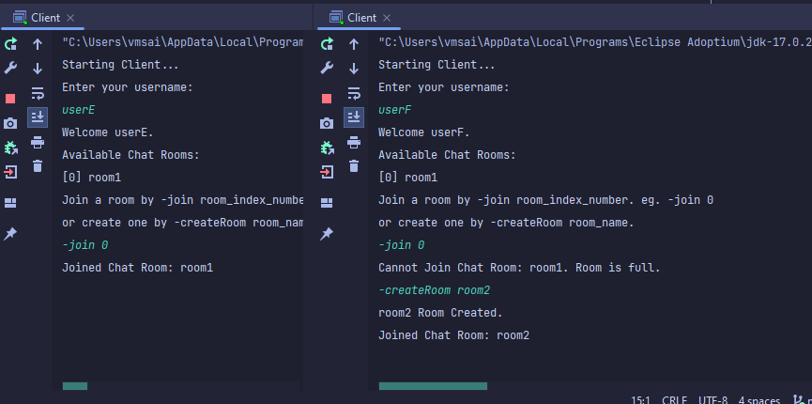

● Leave a chat room

Write -leave to leave the room

● Send messages to chat rooms

