***Target Journal:***Global Change Biology

***Recommended Reviewers:***

* Derek Sikes, [dssikes@alaska.edu](mailto:dssikes@alaska.edu)
* Toke Høye, [tth@ecos.au.dk](mailto:tth@ecos.au.dk)
* Syd Cannings, syd.cannings@ec.gc.ca

**RISING MINIMUM TEMPERATURES CONTRIBUTED TO 50 YEARS OF SHIFTING NORTH AMERICAN ARCTIC AND BOREAL BUTTERFLY COMMUNITIES**

Vaughn Shirey1, Robert Guralnick2, Naresh Neupane1, Leslie Ries1

1 Department of Biology, Georgetown University; Washington, DC; United States of America

2 Florida Museum of Natural History – University of Florida; Gainesville, FL; United States of America

**Abstract:** Global climate change has been identified as a major driver of potential insect declines yet in boreal and Arctic North America, there are critical knowledge gaps for insect responses to climate. We used sparse biodiversity data from natural history collections and community science programs to reconstruct 50 years (1970-2019) of butterfly occupancy trends in response to rising minimum temperatures. Among 90 modeled species, we found that cold-adapted species are far more often in decline (probability of occupancy) compared to their warm-adapted, more southerly distributed counterparts. Further, in a post-hoc analysis using species’ traits, we find that species’ range-wide average annual temperature is a consistent predictor of occupancy decline/increase. Species with warmer ranges are likely to be increasing in occupancy, especially at the northern periphery of their ranges. Our results highlight the importance of using community-wide and subrange analyses to reconstruct historical trends and provide a first look at macroscale butterfly biodiversity shifts in a critically under sampled region of North America.

**Keywords:** arctic, biodiversity, boreal, butterflies, climate change, Lepidoptera

**Authorship Contributions:** VS came up with the study idea and design. NN obtained and processed climate data. VS conducted the analysis and original interpretation. RG, NN, and LR provided feedback on the analysis. VS wrote the original manuscript, and all authors edited the manuscript together.

**Funding:** VS was funded by the Georgetown University Department of Biology, Georgetown Graduate Student Government STEM for the Public Good Award, a National Science Foundation Graduate Research Fellowship (#1937959). Additional funding from a Global Biodiversity Information Facility Young Researchers Award to VS helped pay for computational resources for this work.

**Acknowledgments:** Firstly, we want to thank all of the museum staff, volunteers, and community scientists who aid in the mobilization of biodiversity data used in this study. We would like to thank Laura Melissa Guzman, Rassim Khelifa, Leithen M’Gonigle, Sarah Johnson, Hanna Jackson, and Elijah Reyes for insightful conversations and collaboration on the use of occupancy models with presence-only data. All authors would like to thank Martha Weiss, Gina Wimp, and Greg Breed for their feedback on the original manuscript. Members of the Ries Lab of Butterfly Informatics at Georgetown University also provided helpful feedback and general comments on the manuscript. Finally, model development, testing, and implementation were performed on the Georgetown High-performance Computing Cluster (Woonki Chung), Georgetown Massive Data Institute (Lisa Singh), and the University of Florida HiperGator HPC system (Rob Guralnick).

**1. INTRODUCTION**

Multiple lines of scientific evidence have pointed to the potential for an alarming recent decline in insect biodiversity across the planet (Cardoso et al., 2020; D. Wagner et al., 2021; D. L. Wagner et al., 2021). Major changes in the abundance and composition of insect populations increase the risk of losing vital insect-mediated ecosystem services, including pollination, decomposition, and pest control (Kremen et al., 2007), and the potential for collapse of some ecological networks (Dunne et al., 2002; Grames et al., 2023; Memmott et al., 2004). Although the list of potential agents driving insect decline is multifaceted [(D. L. Wagner et al., 2021)](https://www.zotero.org/google-docs/?8BW3yT) , climate change has been put forth as a major contributor. As ectotherms, insects are especially physiologically sensitive to both local and macroscale climatic conditions (Deutsch et al., 2008). Insects, especially butterflies due to their popularity and amount of available data on their distribution and life history, therefore have also served as indicators of global climate change. Numerous foundational studies in global change biology have used butterflies to better understand how life-history timing, other key traits, and biotic interactions respond to novel climatic conditions [(Breed et al., 2013; Parmesan et al., 1999; Poyry et al., 2009)](https://www.zotero.org/google-docs/?vZFL5N) .

Surface-level temperatures have risen more drastically in high-latitude regions of the planet than anywhere else (Holland & Bitz, 2003), a trend that is expected to continue under nearly all climate change forecasts. Under current, “business-as-usual” carbon-dioxide emission scenarios, climate change is projected to increase surface temperatures in the Arctic by an average of 10° Celsius through 2100, roughly four times the predicted global average increase (You et al., 2021). Further, models point to a shift from snowier to a substantially rainier climate across the region(Bintanja & Andry, 2017; McCrystall et al., 2021). For butterflies in high-latitude regions to persist under such drastically shifting climatic conditions, they must be able to either move to where conditions are favorable, adapt to novel climates *in situ* (Corlett & Westcott, 2013; Kellermann & van Heerwaarden, 2019) or face significant risk of population declines. The rapid climatic changes in this region and the potential for significant barriers to movement contribute to a high degree of “climate debt” for butterflies (J. M. M. Lewthwaite et al., 2018) or an increase in the disparity between current species ranges and the range shifts required to track climatic niche space under future climate change scenarios.

Despite the magnitude of change happening in high-latitude regions and the accrual of climate debt for butterflies, North American boreal and Arctic regions remain critically under sampled for butterflies [(Shirey et al., 2021)](https://www.zotero.org/google-docs/?9tXWmg). These sampling gaps are major impediments to conservation, especially for invertebrates [(Cardoso et al., 2011)](https://www.zotero.org/google-docs/?CUS0Ah) . Data that do exist in this region come largely from natural history museum collections and community science platforms (such as records from online and mobile platforms like iNaturalist) and are almost all “presence-only” or “opportunistic” (henceforth referred to by the former). Presence-only data reflect an *ad hoc* and idiosyncratic sampling process which may or may not capture representatives of all species available from broader butterfly community (Kelling et al., 2019). For example, collectors/observers may more often record species of particular interest or those with traits that make them more conspicuous (Adamo et al., 2021; Meyer et al., 2016). In contrast, cryptic or drab species may go under-reported. This complex process leads to scenarios where both sampling intent and effort are unknown and potentially strongly biased. Uncorrected or mishandled biases in downstream analyses can cause problems when attempting to reconstruct ecological trends over large spatial extents and through time [(Guzman et al., 2021; Larsen & Shirey, 2021)](https://www.zotero.org/google-docs/?oabnuy).

Fortunately, new advances in statistical modeling may be able to address this bias, and unlock the potential of these data for broader research use. For example, occupancy-detection models, which attempt to disentangle the process of observation from underlying ecology (Kéry & Royle, 2015; MacKenzie et al., 2002) can be used to accurately reconstruct ecological signals over space and time from presence-only data (Engelhardt et al., 2022; Jackson et al., 2022; Jönsson et al., 2021; Shirey, Khelifa, et al., 2022; van Strien et al., 2013). The use of occupancy-detection models, especially in a region of sparse, presence-only sampling, to extract sensible ecological trends over large spatiotemporal extents may open up the possibility of assessing insect declines across the planet.

Here, we used an occupancy-detection approach to account for a complex detection process and reconstruct patterns of change in northern butterfly communities over a 50-year period (1970-2019). Specifically, we examined the influence of changes in minimum temperature on species-specific occupancy patterns through space and time. Following prior work, we hypothesized that warm-associated species are likely faring, on average, better than their cold-associated counterparts as warmer winters support enhanced population establishment (Crozier, 2003, 2004). In contrast, cold-adapted species may suffer if warm events lead to stress during or early termination of diapause followed by exposure to typical winter lows (Abarca et al., 2019; Klockmann & Fischer, 2019). We split our modeled occupancy trends into three distinct spatial contexts per species: the southernmost locations, core/mid-latitude locations, and northernmost locations to provide additional information about range shifts in each of these regions of species’ ranges. Finally, we also aimed to test how key species’ traits such as affinity for disturbed habitats, wingspan, host plant breadth, overwintering life-stage, along with phylogeny predict overall occupancy shifts in a *post-hoc* analysis.

**2. METHODOLOGY**

The use of presence-only biodiversity data to reconstruct trends in communities presents several methodological challenges including unknown sample effort and intent, and often significant spatiotemporal and taxonomic biases (Bowler et al., 2022; Shirey et al., 2021; Troudet et al., 2017). Recently, much attention has been paid to developing better ways to analyze these data with recognition of their limitations (Belitz et al., 2022; Guzman et al., 2021; Jackson et al., 2022; Larsen et al., 2022; Larsen & Shirey, 2021; Ries et al., 2019; Shirey, Khelifa, et al., 2022). Occupancy-detection models have emerged as one modeling approach that can be used to disentangle the process of observation from the underlying ecology (Kéry & Royle, 2015; MacKenzie et al., 2002; van Strien et al., 2013). Further, multi-species occupancy models can be used to leverage community definitions of parameter values to model multiple species at the same time (Dorazio & Royle, 2005). In a recent simulation study, these models have demonstrated the ability to accurately reconstruct ecological trends from presence-only datasets that meet certain pre-qualifying conditions (Shirey, Khelifa, et al., 2022).

To use occupancy-detection models for this study, we established grids of 100×100 and 200×200-kilometer square cells across our study region. We set our analysis to the 50 years between 1970 and 2019 and divided this period into ten, five-year-long intervals. In each of these periods we estimated the probability that a given species is an occupant of a specific grid cell. These “occupancy intervals” were further broken down into five one-year-long “visit intervals” to provide a basis for separate estimation of detection and occupancy, which requires tracking multiple visits as repeated trials within the larger occupancy interval (MacKenzie et al., 2002). A graphical representation of our workflow as it pertains to the biodiversity data is illustrated in Supplemental Figure 1.

***2.1 Species Occurrence, Range, Trait, and Phylogenetic Data***

We assembled distribution and trait data about high-latitude butterflies in North America. First, species occurrence data were needed to infer detection/non-detection datasets across the 50 years of the study. Second, species range data were needed to constrain the analysis to regions where each species could plausibly occur. Next, we used the range data to extract climatic traits for each species (e.g., average, range-wide temperature/precipitation). Along with this climatic trait data, we aggregated other traits including wingspan, host plant family breadth, and disturbance affinity to test how these traits may predict declines/increases. Finally, to test for a phylogenetic signal in species-specific trends over time, we required the phylogeny of the species in the region.

Species occurrence data were obtained from the Global Biodiversity Information Facility (GBIF)(GBIF.org, 2022), Integrated Digitized Biocollections (iDigBio) (Supplementary Material S___), and the Symbiota Collections of Arthropods Network (SCAN) (Heinrich et al., 2015) based on a list of species known to occur in high latitude regions. Duplicate records were filtered out. We further selected records that occurred on land for all regions north of 45° N from 1970 to 2019. We removed records with exceptionally low coordinate precision (greater than 25 kilometers of a reported uncertainty radius). We reconciled the taxonomic names using the R package “taxize” (Scott Chamberlain & Eduard Szocs, 2013) and, for non-matches, we resolved the taxonomy by hand where tractable (e.g. by matching unresolved synonymies to currently accepted names). We used the Lamas taxonomy as a backbone (Lamas, 2015) and removed species where taxonomic ambiguity would lead to issues with species’ range assessments. We then filtered the occurrence dataset to include only species with at least 500 reported occurrences across the spatiotemporal scope of our study. Finally, we removed all species from the analysis that are known migrants (*i.e.,* are not historically known to overwinter anywhere north of 45° in North America).

Species range map data were derived from published field guides on North American butterfly species, including The Kaufman Field Guide to Butterflies of North America (Brock & Kaufman, 2006) and A Swift Guide to Butterflies of Mexico and Central America (Glassberg, 2018). The range maps were digitized as part of work by Earl et al. (2021) and were re-used here. Range-wide average annual temperature/precipitation traits were extracted from each species’ range using the range polygons and the BioClim dataset (representing average climatic conditions from 1970-2000) [(Fick & Hijmans, 2017)](https://www.zotero.org/google-docs/?o92OvI). We also calculated the total area of the North American range for each species. To obtain information regarding wingspan, host plant breadth, and disturbance affinity, we obtained trait data for each species from LepTraits (Shirey, Larsen, et al., 2022). The traits we obtained included disturbance affinity/avoidance, the number of host plant families the caterpillar can feed on, the average wingspan, and the overwintering life-stage of each species. Thus, the final dataset of butterfly traits consisted of range-wide average annual temperature, range-wide average annual precipitation, geographic range size, disturbance affinity/avoidance, host plant family breadth, average wingspan, and overwintering stage. Finally, we obtained a recently produced phylogeny (Earl et al., 2021) of North American butterfly species as a final data product to be used in our *post hoc* analysis of occupancy trends. We used this phylogeny to test for phylogenetic signal in our modeled occupancy results.

***2.2 Climate Data***

We used minimum temperatures and precipitation climate data to inform the ecological process of our occupancy-detection model. Land use is also a strong contributor to the occupancy of butterflies across our study region, but to our knowledge, no comprehensive dataset of land cover exists for high-latitude regions of North America extending back into the 1970s (and for every 5-year-long period of our analysis). Thus, we opted to inform our models solely with climatic predictors.

Monthly minimum temperatures from 1970 to 2015 were extracted from the National Oceanic and Atmospheric Administration's (NOAA) 20th-century reanalysis, 20CRv3 (Slivinski et al., 2019). These data are available at 0.1-degree spatial and monthly temporal resolution from 1836 to 2015. Since NOAA data were not yet available for 2016 onward, variables for these years were obtained from the Climate Prediction Center (CPC) (Climate Prediction Center, 2022). These data are available at 0.5-degree spatial and monthly temporal resolution. Monthly data were extracted from the Climate Research Unit (CRU) TS4.04 global precipitation dataset (I. Harris et al., 2020; I. C. Harris et al., 2020). The CRU data are available at ___ spatial resolution back to 1900.

Climate raster data reflecting monthly average minimum temperature and monthly precipitation for the years 1970 through 2019 were read into R using the package “raster” (Hijmans et al., 2015). The raster data were then reprojected to the project coordinate reference system (North America Albers Equal Area Conic) also used as the base projection for all other spatial data in this analysis. The raster data were further summarized into our grid cells using the mean value of all raster values within a given occupancy interval weighted by their coverage of the cell. Thus, average minimum temperature and average precipitation reflect the area-weighted mean of a given five-year occupancy interval (e.g., 1970-1974). Finally, exploration of our climate data revealed that average minimum temperature and average precipitation were highly correlated (Pearson’s r = 0.67 for the 100×100-kilometer scale and Pearson’s r = 0.73 for the 200×200-kilometer scale), thus we opted to include a single climate predictor, average minimum temperature, in our main models. We decided on temperature over precipitation as prior research has demonstrated temperature to be especially important for range dynamics in butterflies (Keret et al., 2020). We also ran precipitation-only models and include those results in the Supplementary Material.

***2.3 Inferring Detection from Presence-only Observations***

Occupancy-detection models use detection/non-detection data to reconstruct occupancy trends (Kéry & Royle, 2015; MacKenzie et al., 2002). This poses methodological challenges regarding when it is appropriate to infer non-detections from presence-only data. We assume, for this study, that the detection of at least two distinct species in a given cell/visit interval is enough to impute non-detection data for all other species that could potentially occur at that grid cell (*i.e.,* their range plus a 100-kilometer buffer intersects the cell) (Supplemental Figure S1). Both simulation and empirical studies have relied on this assumption and, in particular, simulation studies show that such an approach generates results that match known trends. Further, these simulations also demonstrate that occupancy-detection models are robust to violations of this assumption (e.g. an inferred non-detection came from a location/time period where not all species were looked for), but generally, at least half of all sampling events should have intended to capture the entire community of species in order to produce accurate inferences (Shirey, Khelifa, et al., 2022).

To proxy this probability of community-focused sampling events (events where all potentially occurring species were looked for) in our dataset, we spatiotemporally aggregated all of our occurrence data at the point level. The occurrence records must have been collected during the same year and must also have been collected/observed within 5 kilometers of one another to be included in an aggregate cluster. We then used the number of species in these spatiotemporal aggregations as a means to classify clusters. “Community clusters” were point aggregate clusters where more than one distinct species was reported; “singleton clusters” were point clusters or single points where only one species was reported. We took the percentage of points that fell within community clusters compared to the entire occurrence dataset as the proxy of community-focused visitation probability. This percentage was 69.64% and since this was above a 50% recommended threshold, we continued with occupancy-detection modeling.

***2.4 Occupancy-detection Modeling***

We specified a general occupancy model that was used across all detection/non-detection datasets described above. For the occupancy subcomponent of our model, we included two environmental predictors of occupancy, average minimum temperature (or average precipitation) across a 5-year-long period (e.g., 1970-1974, as species-specific slopes), and the terrestrial surface area of the grid cell (to account for cells along coastlines or with other large bodies of water). We also included a species-specific intercept in our model to account for differences in baseline occupancy among species. Thus, the occupancy component of our model is:

[](https://www.codecogs.com/eqnedit.php?latex=%5Cmathrm%7B%5CPsi%7D_%7Bk%2Ct%2Cs%7D%5C%20%5Csim%20%5Calpha_1%2B%5Calpha_%7Bs%7D%2B%5Cbeta_2%5Ctimes%7Barea%7D_k%2B%5Cbeta_%7Bs1%7D%5Ctimes%7BTemperature%2FPrecipitation%7D_%7Bk%2Ct%7D%2B(%5Cbeta_%7Bs2%7D%5Ctimes%7BTemperature%7D_%7Bk%2Ct%7D%5E2)#0)

where [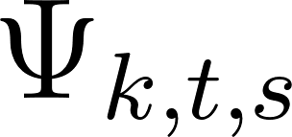](https://www.codecogs.com/eqnedit.php?latex=%7B%5CPsi%7D_%7Bk%2Ct%2Cs%7D#0) is the probability that a given species, [](https://www.codecogs.com/eqnedit.php?latex=s#0), is an occupant of cell [](https://www.codecogs.com/eqnedit.php?latex=k#0) in occupancy interval [](https://www.codecogs.com/eqnedit.php?latex=t#0); [](https://www.codecogs.com/eqnedit.php?latex=%5Calpha_1#0) is the mean occupancy probability for butterflies (on a linear scale); [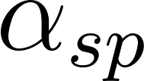](https://www.codecogs.com/eqnedit.php?latex=%5Calpha_%7Bsp%7D#0) is a species-specific intercept; [](https://www.codecogs.com/eqnedit.php?latex=%5Cbeta_2#0) is the effect of terrestrial surface area on occupancy probability; and [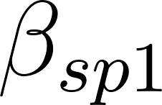](https://www.codecogs.com/eqnedit.php?latex=%5Cbeta_%7Bsp1%7D#0) is the species-specific effect (slope) of minimum temperature/precipitation on occupancy. The parameter [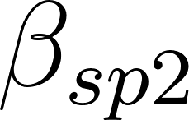](https://www.codecogs.com/eqnedit.php?latex=%5Cbeta_%7Bsp2%7D#0) is only estimated in the temperature model to estimate the potential quadratic effect of minimum temperature on occupancy probability. For all parameters, we assumed the values were to be drawn from normal distributions with a mean of zero and a variance that was estimated at the parameter level.

The detection component of our model was informed by a random-effects structure which included an average intercept value estimated across all grid cell, occupancy interval, and species combinations, a fixed-effect of occupancy interval on detection (to account for potentially increasing detectability due to modern survey methods and digital platforms such as iNaturalist), and two random intercepts that varies by (a) species and (b) cell by occupancy interval. Mathematically, our detection component is defined as:

[](https://www.codecogs.com/eqnedit.php?latex=p_%7Bk%2Ct%2Cs%7D%5C%20%5Csim%20%5Calpha_1%2B%5Calpha_s%5C%20%2B%5C%20%5Calpha_%7Bk%2Ct%7D%2B%5Cbeta_1%5Ctimes%5C%20Occupancy%20Interval#0)

where [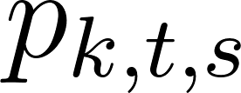](https://www.codecogs.com/eqnedit.php?latex=p_%7Bk%2Ct%2Cs%7D#0) is the detection probability of a given species, [](https://www.codecogs.com/eqnedit.php?latex=s#0), during a given occupancy interval, [](https://www.codecogs.com/eqnedit.php?latex=t#0), at a particular cell, [](https://www.codecogs.com/eqnedit.php?latex=k#0); the parameter [](https://www.codecogs.com/eqnedit.php?latex=%5Calpha_1#0) is the mean detection probability for all butterflies (on a linear scale); [](https://www.codecogs.com/eqnedit.php?latex=%5Calpha_s#0) is a random species-specific intercept; [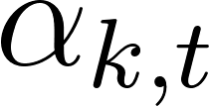](https://www.codecogs.com/eqnedit.php?latex=%5Calpha_%7Bk%2Ct%7D#0) is a cell by occupancy interval random intercept; and [](https://www.codecogs.com/eqnedit.php?latex=%5Cbeta_1#0) is the effect of occupancy interval (OI) on detection probability. For all parameters, we assumed the values were to be drawn from normal distributions with a mean of zero and a variance that was estimated at the parameter level. Finally, the likelihood in our model was defined by the product of the latent occupancy state (either present or absent per a Bernoulli draw of the calculated occupancy probability [](https://www.codecogs.com/eqnedit.php?latex=%7B%5CPsi%7D_%7Bk%2Ct%2Cs%7D#0)) and the probability of detection, [](https://www.codecogs.com/eqnedit.php?latex=p_%7Bk%2Ct%2Cs%7D#0).

We ran our occupancy models using JAGS (Plummer, 2003) on each detection/non-detection dataset for 150,000 iterations, 50,000 of which were discarded as “burn-in,” sampling every 100 iterations across four chains for a total of 4,000 samples from the posterior distribution. We assessed convergence across these chains by examining both Gelman-Rubin diagnostic values (Gelman & Rubin, 1992) (using 1.1 as an upper threshold), and by visually inspecting the trace plots for all parameters (provided in the Supplementary Material). We used the R packages “jagsUI” (Kellner, 2021) and “MCMCvis” (Youngflesh, 2018) to complete the majority of this work. Visualizations of model performance metrics are included in the Supplemental Material.

***2.5 Post-hoc Trait Analysis***

Species’ traits have been demonstrated to be associated with changes in species’ ranges over time and in the relative risk of extinction (). We thus conducted two trait-based analyses on our occupancy model output. We examined if average annual range-wide temperature and other traits such as wingspan, host plant family breadth, overwintering life-stage, and disturbance affinity predicted mean occupancy shifts from the 1970s to 2010s. Our trait data provided enough information to successfully model 75 of the 90 total species in our occupancy analysis. We specified eight models for each geographic region of the modeled range for our species (core/mid-latitude third, southern third, and northern third): (a) an intercept-only, “null” model, (b) a model including only a phylogenetic intercept term, (c) a model including only species’ range-wide average annual temperature, (d) a model including species’ range-wide average annual temperature and phylogenetic intercept term, (e) a model including species’ range-wide temperature, overwintering stage, and the interaction of those two traits, (f) a model including the aforementioned covariates and a phylogenetic intercept term, (g) a model including species’ range-wide average annual temperature, range size, host plant family breadth, wingspan, overwintering stage, and disturbance affinity as predictors, and finally, (h) a model including all aforementioned traits and a phylogenetic intercept term. Detailed mathematical representations of each model can be found in the Supplementary Material. We then compared the models using leave-one-out (LOO) cross-validation in order to select the top candidate model (Vehtari et al., 2017). Phylogenetic signal among occupancy estimates was measured using Pagel’s [](https://www.codecogs.com/eqnedit.php?latex=%5Clambda#0) where values close to zero indicate no phylogenetic signal in the response and values close to one indicate strong correlation with phylogeny (Freckleton et al., 2002; Pagel, 1999). This work was performed using the R package “brms” which interfaces with Stan (Bürkner, 2017). We ran all of our models for 200,000 iterations, discarding 100,000 as “burn-in” and thinning by 50 across four chains for a total of 4,000 samples from the posterior. We assessed convergence by using the Gelman-Rubin diagnostic values and by inspecting trace plots (provided in the Supplementary Material).

**3. RESULTS**

We modeled the response of 90 species of butterfly to changes in temperature from 1970-2019. Generally, cold-adapted species exhibit negative responses to increasing minimum temperatures across their ranges while warm-adapted species generally fare better (Figure 2). Notably, several cold-adapted species exhibit average occupancy declines across their modeled ranges including *Boloria freija* (BOLFRE, -7.5% in mid-latitude sites), *B. chariclea* (BOLCHA, -6.8% in mid-latitude sites), *Boloria eunomia* (BOLEUN, -5.9% in mid-latitude sites), and *Agriades glandon* (AGRGLA, -3.1% in mid-latitude sites). In contrast, warm-adapted/southern species have, in general, exhibited occupancy mean stability or increases alongside rising minimum temperatures (Figure 3). For example, the species, *Pieris rapae* (PIERAP), *Pterourus rutulus* (PTERUT) and *Cercyonis pegala* (CERPEG) have all exhibited average occupancy increases of roughly 4% or greater across all geographic components of their modeled range. Several species for which occupancy trends appear to marginally increase/decrease or that have remained relatively stable compared to the 1970s include *Coenonympha tullia* (COETUL) and *Glaucopsyche lygdamus* (GLALYG).

In sum, we find trends at the northern third of each species’ model range are generally more positive than trends at the southern third (average northern occupancy shifts are greater than southern shifts for 60 species compared to 29 species where average southern occupancy shifts are greater than those in the northern subcomponent of their range). Due to the very small number of sites modeled for *P. glaucus*, a comparison could not be made between northern and southern sites. A full account of average occupancy shifts as well as maps reproducing the shifts from the 1970s for each species are included in the supplementary material for all models.

Our top candidate model for the relationship between phylogeny, species’ traits and occupancy trend was the model that used species’ range-wide temperature as a predictor (Model C/D). In many cases, according to LOOIC, Model C and Model D (a model that included species’ range-wide temperature and a phylogenetic intercept term) were equivalent (Supplemental Table S2-4). Our analysis of LOOIC scores in the southernmost context of species’ ranges revealed that Model C was equivalent to Model A (“null” intercept only model), Model B (intercept only model with an additional phylogenetic intercept), Model D, and, to a lesser extent, Model F (a model with additional species traits and a phylogenetic intercept term) (Supplemental Material S4). The estimated effect of range-wide temperature on 50-year occupancy trend across geographic subranges becomes stronger with increasing latitude. In other word, species with warmer North American ranges are likely to exhibit more positive occupancy shifts in the northernmost part of their range followed by core/mid-latitude sites and finally by southern sites (Figure 4). Overall, there is a positive association between warmer range and increasing occupancy probability across all geographic contexts.

**4. DISCUSSION**

Our models demonstrate that minimum temperature (and in corollary, precipitation) predicts the overall 50-year occupancy trajectory of butterfly species in our study region. On average, minimum temperatures have increased by an average of 0.86 degrees Celsius between the 1970s and 2010s (Figure 1). Such increases may be related to occupancy via two distinct effects on butterflies. First, elevated minimum temperatures may be detrimental to cold-adapted species as lack of snow cover and/or false phenological cues of winter termination may increase the risk of exposure of diapausing butterflies to harsh winter temperatures and early spring frosts (). Second, elevated minimum temperatures are likely beneficial to more southern-distributed species as previously harsh winters become milder, allowing for northward range expansion (). Indeed, poleward shifts are a commonly noted phenomenon among species elsewhere as they aim to track their thermal optima with a changing climate (). The estimated effect of minimum temperature on species-specific occupancy from our model supports this trend (Figure 2), and as evidenced by cold-associated species generally declining in occupancy as minimum temperatures rise (Figure 3). In contrast, many of the warm-associated species in our study benefit from the same increasing minimum temperatures (Figure 2). Spatially, our results confirm that stronger positive shifts in species occupancy are occurring for a majority of species (n = 60 or roughly 66%) in the northern geographic context of their modeled range.

Our post-hoc analysis of species traits revealed that a species’ range-wide temperature is the best predictor of 50-year occupancy shift across our study region (Model C/D, Figure 4). Additionally, the estimated effect of range-wide temperature in predicting occupancy trend becomes stronger along and south-to-north gradient within a given species’ range. Specifically, species’ that could be considered “warm-adapted” (*i.e.,* have warmer North American ranges) exhibit stronger increases in occupancy in the northernmost geographic component of their modeled range. In contrast to the increasing occupancy of warm-adapted species, cold-adapted butterflies are faring worse and often across all geographic components of their ranges (Figure 3). This result makes sense ecologically and parallels prior studies conducted in Europe where structured monitoring data are more common in boreal and Arctic region (Parmesan et al., 1999; Poyry et al., 2009). The natural conclusion of the present work as well as past inference suggests that the composition of butterfly communities in high-latitude North America may turnover to reflect more warm-adapted, southern-distributed species in the future.

We expected that other traits would also serve as predictors of occupancy trend in our analysis; however, the top two candidate models (with the exception of the southern geographic model) consistently indicated that a model including range-wide temperature alone was the best model for predicting average occupancy shift. This result may be unsurprising since we modeled occupancy trends based on temperature and that species’ thermal niches are nearly ubiquitous predictors of range shifts across taxa (Braschler et al., 2020; McMahon & Hays, 2006; Scridel et al., 2017). Secondly, a recent review suggests that the ability of traits to predict range shifts may be limited by a multitude of factors including potentially complex, interactive, and potentially non-linear dynamics (Beissinger & Riddell, 2021). Thus, at the scale of our analysis, species’ traits may not be good predictors of occupancy outcomes. Further analysis at finer spatiotemporal resolution may reveal more nuanced evidence for the important of species’ traits and life-history in predicting population trends. Experimental designs that aim to test for potentially complex relationships governing species’ responses to increasing temperature, for example, the interplay between hostplant quality and thermal stress, are likely the best way to elucidate these dynamics (Abarca, 2019; Abarca et al., 2019; Litchman & Thomas, 2023).

A full examination of our post-hoc model suite revealed that Model D (a model that included range-wide temperature and phylogenetic intercepts) was equivalent to Model C (discussed above) in the northern and southern geographic contexts (Supplemental Material S2-4). Despite this model scoring on par with Model C, our estimates of Pagel’s from Model D revealed no strong phylogenetic signal in our occupancy trends regardless of geographic context (South = 0.01 [0, 0.05 95% CRI]; Core = 0 [0, 0.01 95% CRI]; North = 0 [0, 0.01 95% CRI]). Despite this, some notable groups do exhibit declines across our study region including members of the genus *Boloria*, *Erebia,* and *Oeneis* (Figure 3, Supplemental Table S1).

While we examined the impacts of climate on species-specific occupancy trends, the importance of changing land-cover/use on boreal and Arctic butterflies cannot be ignored. Butterflies are especially sensitive to habitat type and disturbance as well as the availability of corridors to navigate to new, suitable habitats. In boreal Canada, butterfly abundance and species richness increases along human-made cutlines (Riva et al., 2018a). Additionally, increasing frequency and intensity of forest fire in the region may also contribute to both opportunities and challenges for high-latitude butterflies (Girardin & Mudelsee, 2008; Hanes et al., 2019). Forest fire (of varying severity) may contribute to initial negative butterfly abundance patterns, but over time, butterflies may benefit from the presence of early successional and open canopy habitats (Johansson et al., 2020; Mason Jr et al., 2021; Ulyshen et al., 2022). Further, open canopy areas (including roadsides, smaller cutlines, and trails) may act as corridors for butterfly movement (Haddad, 1999; Haddad & Tewksbury, 2005; Riva et al., 2018b). Low connectivity of habitat/mobility of species can make it more challenging for more southern distributed butterflies to navigate and colonize new habitats as they track their thermal tolerances (Hodgson et al., 2012). Limited ability to colonize newly available habitat in this region is the leading hypothesis surrounding why so much climate debt has accrued for butterflies (J. M. Lewthwaite et al., 2017; J. M. M. Lewthwaite et al., 2018).

**5. CONCLUSION**

Global climate change is impacting high-latitude butterfly communities across North America, However, it is important to recognize that not all species are being impacted equally. Our research, in tandem with recent occupancy analyses of other groups demonstrates the importance of understanding how climatic shifts will impact insects on a species-specific level. Further, we show that occupancy-detection models can be used with sparse, presence-only data to extract clear ecological signals over large spatiotemporal scales. As such, occupancy-detection models will be an important tool for ecologists and conservation biologists, especially for hyperdiverse groups like insects, where structured monitoring data are often unavailable. While an overall perspective shows that rising minimum temperatures may benefit butterflies; cold-adapted species typically do not benefit and are likely being forced to the northern periphery of their ranges. Species’ range-wide average annual temperature is the strongest predictor of modeled occupancy trend while other traits did not strongly predict the same trends. Further research on the interplay of traits including the role of intraspecific variation in thermal tolerance, phenological and morphological adaptation, and genetic variation/effective population size are needed to contextualize these broad scale patterns further.

**Conflict of Interests**

The authors declare no conflict of interest in completing this work.

**Data Availability Statement**

The code utilized in this analysis are freely available via GitHub at xxx and via Zenodo at the following DOI: xxx. Model inference can be found on GitHub and also at DataDryad via the following DOI: xxx. Range maps used in this analysis can be made available upon request.

**REFERENCES**

Abarca, M. (2019). Herbivore seasonality responds to conflicting cues: Untangling the effects of host, temperature, and photoperiod. *PLoS One*, *14*(9), e0222227.

Abarca, M., Larsen, E. A., & Ries, L. (2019). Heatwaves and novel host consumption increase overwinter mortality of an imperiled wetland butterfly. *Frontiers in Ecology and Evolution*, *7*, 193.

Adamo, M., Chialva, M., Calevo, J., Bertoni, F., Dixon, K., & Mammola, S. (2021). Plant scientists’ research attention is skewed towards colourful, conspicuous and broadly distributed flowers. *Nature Plants*, *7*(5), 574–578.

Ayres, M. P., & Scriber, J. M. (1994). Local adaptation to regional climates in Papilio canadensis (Lepidoptera: Papilionidae). *Ecological Monographs*, *64*(4), 465–482.

Beissinger, S. R., & Riddell, E. A. (2021). Why are species’ traits weak predictors of range shifts? *Annual Review of Ecology, Evolution, and Systematics*, *52*, 47–66.

Belitz, M. W., Larsen, E. A., Shirey, V., Li, D., & Guralnick, R. P. (2022). Phenological research based on natural history collections: Practical guidelines and a Lepidopteran case study. *Functional Ecology*, *Early View*. https://doi.org/10.1111/1365-2435.14173

Bintanja, R., & Andry, O. (2017). Towards a rain-dominated Arctic. *Nature Climate Change*, *7*(4), 263–267.

Bowler, D. E., Callaghan, C. T., Bhandari, N., Henle, K., Benjamin Barth, M., Koppitz, C., Klenke, R., Winter, M., Jansen, F., Bruelheide, H., & others. (2022). Temporal trends in the spatial bias of species occurrence records. *Ecography*, e06219.

Braschler, B., Duffy, G. A., Nortje, E., Kritzinger-Klopper, S., du Plessis, D., Karenyi, N., Leihy, R. I., & Chown, S. L. (2020). Realised rather than fundamental thermal niches predict site occupancy: Implications for climate change forecasting. *Journal of Animal Ecology*, *89*(12), 2863–2875.

Breed, G., Stichter, S., & Crone, E. (2013). Climate-driven changes in northeastern US butterfly communities. *Nature Climate Change*, *3*(2), 142–145. https://doi.org/10.1038/NCLIMATE1663

Brock, J. P., & Kaufman, K. (2006). *Kaufman field guide to butterflies of North America*. Houghton Mifflin Harcourt.

Bürkner, P.-C. (2017). brms: An R package for Bayesian multilevel models using Stan. *Journal of Statistical Software*, *80*, 1–28.

Cardoso, P., Barton, P., Birkhofer, K., Chichorro, F., Deacon, C., Fartmann, T., Fukushima, C., Gaigher, R., Habel, J., Hallmann, C., Hill, M., Hochkirch, A., Kwak, M., Mammola, S., Noriega, J., Orfinger, A., Pedraza, F., Pryke, J., Roque, F., … Samways, M. (2020). Scientists’ warning to humanity on insect extinctions. *Biological Conservation*, *242*. https://doi.org/10.1016/j.biocon.2020.108426

Cardoso, P., Erwin, T. L., & Borges, P. A. V. (2011). The seven impediments in invertebrate conservation and how to overcome them. *Biological Conservation*, *144*(11), 2647–2655. https://doi.org/10.1016/j.biocon.2011.07.024

Climate Prediction Center. (2022). *Global Temperature data provided by the NOAA/OAR/ESRL PSL*. NOAA/OAR/ESRL PSL. www.psl.noaa.gov

Corlett, R. T., & Westcott, D. A. (2013). Will plant movements keep up with climate change? *Trends in Ecology & Evolution*, *28*(8), 482–488.

Crozier, L. (2003). Winter warming facilitates range expansion: Cold tolerance of the butterfly Atalopedes campestris. *Oecologia*, *135*(4), 648–656. https://doi.org/10.1007/s00442-003-1219-2

Crozier, L. (2004). Warmer winters drive butterfly range expansion by increasing survivorship. *Ecology*, *85*(1), 231–241. https://doi.org/10.1890/02-0607

Deutsch, C. A., Tewksbury, J. J., Huey, R. B., Sheldon, K. S., Ghalambor, C. K., Haak, D. C., & Martin, P. R. (2008). Impacts of climate warming on terrestrial ectotherms across latitude. *Proceedings of the National Academy of Sciences*, *105*(18), 6668–6672.

Dorazio, R. M., & Royle, J. A. (2005). Estimating size and composition of biological communities by modeling the occurrence of species. *Journal of the American Statistical Association*, *100*(470), 389–398.

Dunne, J. A., Williams, R. J., & Martinez, N. D. (2002). Network structure and biodiversity loss in food webs: Robustness increases with connectance. *Ecology Letters*, *5*(4), 558–567.

Earl, C., Belitz, M. W., Laffan, S. W., Barve, V., Barve, N., Soltis, D. E., Allen, J. M., Soltis, P. S., Mishler, B. D., Kawahara, A. Y., & Guralnick, R. (2021). Spatial phylogenetics of butterflies in relation to environmental drivers and angiosperm diversity across North America. *IScience*, *24*(4), 102239. https://doi.org/10.1016/j.isci.2021.102239

Engelhardt, E. K., Biber, M. F., Dolek, M., Fartmann, T., Hochkirch, A., Leidinger, J., Löffler, F., Pinkert, S., Poniatowski, D., Voith, J., Winterholler, M., Zeuss, D., Bowler, D. E., & Hof, C. (2022). Consistent signals of a warming climate in occupancy changes of three insect taxa over 40 years in central Europe. *Global Change Biology*, *28*(13), 3998–4012. https://doi.org/10.1111/gcb.16200

Freckleton, R. P., Harvey, P. H., & Pagel, M. (2002). Phylogenetic analysis and comparative data: A test and review of evidence. *The American Naturalist*, *160*(6).

GBIF.org. (2022). *Occurrence Download for High Latitude, North American Butterflies*. The Global Biodiversity Information Facility. https://doi.org/10.15468/DL.PYK5BD

Gelman, A., & Rubin, D. B. (1992). Inference from iterative simulation using multiple sequences. *Statistical Science*, 457–472.

Girardin, M. P., & Mudelsee, M. (2008). Past and future changes in Canadian boreal wildfire activity. *Ecological Applications*, *18*(2), 391–406.

Glassberg, J. (2018). *A swift guide to butterflies of Mexico and Central America*. Princeton University Press.

Grames, E. M., Montgomery, G. A., Youngflesh, C., Tingley, M. W., & Elphick, C. S. (2023). The effect of insect food availability on songbird reproductive success and chick body condition: Evidence from a systematic review and meta-analysis. *Ecology Letters*.

Guzman, L. M., Johnson, S. A., Mooers, A. O., & M’Gonigle, L. K. (2021). Using historical data to estimate bumble bee occurrence: Variable trends across species provide little support for community-level declines. *Biological Conservation*, *257*, 109141.

Haddad, N. M. (1999). Corridor and distance effects on interpatch movements: A landscape experiment with butterflies. *Ecological Applications*, *9*(2), 612–622.

Haddad, N. M., & Tewksbury, J. J. (2005). Low-quality habitat corridors as movement conduits for two butterfly species. *Ecological Applications*, *15*(1), 250–257.

Hanes, C. C., Wang, X., Jain, P., Parisien, M.-A., Little, J. M., & Flannigan, M. D. (2019). Fire-regime changes in Canada over the last half century. *Canadian Journal of Forest Research*, *49*(3), 256–269.

Harris, I. C., Jones, P. D., & Osborn, T. (2020). *CRU TS4.04: Climatic Research Unit (CRU) Time-Series (TS) version 4.04 of high-resolution gridded data of month-by-month variation in climate (January 1901 – December 2019)*. Centre for Environmental Data Analysis | University of East Anglia Climatic Research Unit. https://catalogue.ceda.ac.uk/uuid/89e1e34ec3554dc98594a5732622bce9

Harris, I., Osborn, T. J., Jones, P., & Lister, D. (2020). Version 4 of the CRU TS monthly high-resolution gridded multivariate climate dataset. *Scientific Data*, *7*(1), 1–18.

Heinrich, P. L., Gilbert, E., Cobb, N. S., & Franz, N. (2015). *Symbiota collections of arthropods network (SCAN): A data portal built to visualize, manipulate, and export species occurrences*.

Hijmans, R. J., Van Etten, J., Cheng, J., Mattiuzzi, M., Sumner, M., Greenberg, J. A., Lamigueiro, O. P., Bevan, A., Racine, E. B., Shortridge, A., & others. (2015). Package ‘raster.’ *R Package*, *734*, 473.

Hodgson, J. A., Thomas, C. D., Dytham, C., Travis, J. M., & Cornell, S. J. (2012). *The speed of range shifts in fragmented landscapes*.

Holland, M. M., & Bitz, C. M. (2003). Polar amplification of climate change in coupled models. *Climate Dynamics*, *21*(3–4), 221–232.

Jackson, H. M., Johnson, S. A., Morandin, L. A., Richardson, L. L., Guzman, L. M., & M’Gonigle, L. K. (2022). Climate change winners and losers among North American bumblebees. *Biology Letters*, *18*(6), 20210551.

Johansson, V., Gustafsson, L., Andersson, P., & Hylander, K. (2020). Fewer butterflies and a different composition of bees, wasps and hoverflies on recently burned compared to unburned clear-cuts, regardless of burn severity. *Forest Ecology and Management*, *463*, 118033.

Jönsson, G. M., Broad, G. R., Sumner, S., & Isaac, N. J. (2021). A century of social wasp occupancy trends from natural history collections: Spatiotemporal resolutions have little effect on model performance. *Insect Conservation and Diversity*, *14*(5), 543–555.

Kellermann, V., & van Heerwaarden, B. (2019). Terrestrial insects and climate change: Adaptive responses in key traits. *Physiological Entomology*, *44*(2), 99–115.

Kelling, S., Johnston, A., Bonn, A., Fink, D., Ruiz-Gutierrez, V., Bonney, R., Fernandez, M., Hochachka, W. M., Julliard, R., Kraemer, R., & others. (2019). Using semistructured surveys to improve citizen science data for monitoring biodiversity. *BioScience*, *69*(3), 170–179.

Kellner, K. (2021). *JagsUI: A Wrapper Around “rjags” to Streamline “JAGS” Analyses*. https://CRAN.R-project.org/package=jagsUI

Keret, N., Mutanen, M., Orell, M., Itamies, J., & Valimaki, P. (2020). Climate change-driven elevational changes among boreal nocturnal moths. *Oecologia*, *192*(4), 1085–1098. https://doi.org/10.1007/s00442-020-04632-w

Kéry, M., & Royle, J. A. (2015). *Applied Hierarchical Modeling in Ecology: Analysis of Distribution, Abundance and Species Richness in R and BUGS*.

Klockmann, M., & Fischer, K. (2019). Strong reduction in diapause survival under warm and humid overwintering conditions in a temperate-zone butterfly. *Population Ecology*, *61*(2), 150–159. https://doi.org/10.1002/1438-390X.1016

Kremen, C., Chaplin-Kramer, R., & others. (2007). Insects as providers of ecosystem services: Crop pollination and pest control. *Insect Conservation Biology: Proceedings of the Royal Entomological Society’s 23rd Symposium*, 349–382.

Lamas, G. (2015). *Catalog of the butterflies (Papilionoidea)*. Available from author.

Larsen, E. A., Belitz, M. W., Guralnick, R. P., & Ries, L. (2022). Consistent trait-temperature interactions drive butterfly phenology in both incidental and survey data. *Scientific Reports*, *12*(1), 1–10.

Larsen, E. A., & Shirey, V. (2021). Method matters: Pitfalls in analysing phenology from occurrence records. *Ecology Letters*, *24*(6), 1287–1289.

Lewthwaite, J. M., Debinski, D. M., & Kerr, J. T. (2017). High community turnover and dispersal limitation relative to rapid climate change. *Global Ecology and Biogeography*, *26*(4), 459–471.

Lewthwaite, J. M. M., Angert, A. L., Kembel, S. W., Goring, S. J., Davies, T. J., Mooers, A. Ø., Sperling, F. A. H., Vamosi, S. M., & Vamosi, J. C. (2018). Canadian butterfly climate debt is significant and correlated with range size. *Ecography*, *41*(12), 2005–2015.

Litchman, E., & Thomas, M. K. (2023). Are we underestimating the ecological and evolutionary effects of warming? Interactions with other environmental drivers may increase species vulnerability to high temperatures. *Oikos*, *2023*(2), e09155.

MacKenzie, D. I., Nichols, J. D., Lachman, G. B., Droege, S., Andrew Royle, J., & Langtimm, C. A. (2002). Estimating site occupancy rates when detection probabilities are less than one. *Ecology*, *83*(8), 2248–2255.

Mason Jr, S. C., Shirey, V., Ponisio, L. C., & Gelhaus, J. K. (2021). Responses from bees, butterflies, and ground beetles to different fire and site characteristics: A global meta-analysis. *Biological Conservation*, *261*, 109265.

McCrystall, M. R., Stroeve, J., Serreze, M., Forbes, B. C., & Screen, J. A. (2021). New climate models reveal faster and larger increases in Arctic precipitation than previously projected. *Nature Communications*, *12*(1), 1–12.

McMahon, C. R., & Hays, G. C. (2006). Thermal niche, large-scale movements and implications of climate change for a critically endangered marine vertebrate. *Global Change Biology*, *12*(7), 1330–1338.

Memmott, J., Waser, N. M., & Price, M. V. (2004). Tolerance of pollination networks to species extinctions. *Proceedings of the Royal Society of London. Series B: Biological Sciences*, *271*(1557), 2605–2611.

Meyer, C., Jetz, W., Guralnick, R. P., Fritz, S. A., & Kreft, H. (2016). Range geometry and socio-economics dominate species-level biases in occurrence information. *Global Ecology and Biogeography*, *25*(10), 1181–1193.

Pagel, M. (1999). Inferring the historical patterns of biological evolution. *Nature*, *401*, 877–884.

Parmesan, C., Ryrholm, N., Stefanescu, C., Hill, J., Thomas, C., Descimon, H., Huntley, B., Kaila, L., Kullberg, J., Tammaru, T., Tennent, W., Thomas, J., & Warren, M. (1999). Poleward shifts in geographical ranges of butterfly species associated with regional warming. *Nature*, *399*(6736), 579–583. https://doi.org/10.1038/21181

Plummer, M. (2003). JAGS: A program for analysis of Bayesian graphical models using Gibbs sampling. *Proceedings of the 3rd International Workshop on Distributed Statistical Computing*, *124*(125.10), 1–10.

Poyry, J., Luoto, M., Heikkinen, R., Kuussaari, M., & Saarinen, K. (2009). Species traits explain recent range shifts of Finnish butterflies. *Global Change Biology*, *15*(3), 732–743. https://doi.org/10.1111/j.1365-2486.2008.01789.x

Ries, L., Zipkin, E. F., & Guralnick, R. P. (2019). Tracking trends in monarch abundance over the 20th century is currently impossible using museum records. *Proceedings of the National Academy of Sciences*, *116*(28), 13745–13748.

Riva, F., Acorn, J. H., & Nielsen, S. E. (2018a). Localized disturbances from oil sands developments increase butterfly diversity and abundance in Alberta’s boreal forests. *Biological Conservation*, *217*, 173–180.

Riva, F., Acorn, J. H., & Nielsen, S. E. (2018b). Narrow anthropogenic corridors direct the movement of a generalist boreal butterfly. *Biology Letters*, *14*(2), 20170770.

Scott Chamberlain & Eduard Szocs. (2013). taxize—Taxonomic search and retrieval in R. *F1000Research*. https://f1000research.com/articles/2-191/v2

Scridel, D., Bogliani, G., Pedrini, P., Iemma, A., von Hardenberg, A., & Brambilla, M. (2017). Thermal niche predicts recent changes in range size for bird species. *Climate Research*, *73*(3), 207–216.

Shirey, V., Belitz, M. W., Barve, V., & Guralnick, R. (2021). A complete inventory of North American butterfly occurrence data: Narrowing data gaps, but increasing bias. *Ecography*, *44*(4).

Shirey, V., Khelifa, R., M’Gonigle, L. K., & Guzman, L. M. (2022). Occupancy-detection models for natural history museum data: Promise and pitfalls. *Methods in Ecology and Evolution*, *Early View*.

Shirey, V., Larsen, E., Doherty, A., Kim, C. A., Al-Sulaiman, F. T., Hinolan, J. D., Itliong, M. G. A., Naive, M. A. K., Ku, M., Belitz, M., & others. (2022). LepTraits 1.0 A globally comprehensive dataset of butterfly traits. *Scientific Data*, *9*(1), 1–7.

Slivinski, L. C., Compo, G. P., Whitaker, J. S., Sardeshmukh, P. D., Giese, B. S., McColl, C., Allan, R., Yin, X., Vose, R., Titchner, H., & others. (2019). Towards a more reliable historical reanalysis: Improvements for version 3 of the Twentieth Century Reanalysis system. *Quarterly Journal of the Royal Meteorological Society*, *145*(724), 2876–2908.

Troudet, J., Grandcolas, P., Blin, A., Vignes-Lebbe, R., & Legendre, F. (2017). Taxonomic bias in biodiversity data and societal preferences. *Scientific Reports*, *7*, 9132. https://doi.org/10.1038/s41598-017-09084-6

Ulyshen, M. D., Hiers, J. K., Pokswinksi, S. M., & Fair, C. (2022). Pyrodiversity promotes pollinator diversity in a fire-adapted landscape. *Frontiers in Ecology and the Environment*, *20*(2), 78–83.

van Strien, A. J., van Swaay, C. A. M., & Termaat, T. (2013). Opportunistic citizen science data of animal species produce reliable estimates of distribution trends if analysed with occupancy models. *Journal of Applied Ecology*, *50*(6), 1450–1458.

Vehtari, A., Gelman, A., & Gabry, J. (2017). Practical Bayesian model evaluation using leave-one-out cross-validation and WAIC. *Statistics and Computing*, *27*, 1413–1432.

Wagner, D., Fox, R., Salcido, D., & Dyer, L. (2021). A window to the world of global insect declines: Moth biodiversity trends are complex and heterogeneous. *Proceedings of the National Academy of Sciences of the United States of America*, *118*(2). https://doi.org/10.1073/pnas.2002549117

Wagner, D. L., Grames, E. M., Forister, M. L., Berenbaum, M. R., & Stopak, D. (2021). Insect decline in the Anthropocene: Death by a thousand cuts. *Proceedings of the National Academy of Sciences*, *118*(2), e2023989118.

Wilson, J. K., Casajus, N., Hutchinson, R. A., McFarland, K. P., Kerr, J. T., Berteaux, D., Larrivée, M., & Prudic, K. L. (2021). Climate change and local host availability drive the northern range boundary in the rapid expansion of a specialist insect herbivore, Papilio cresphontes. *Frontiers in Ecology and Evolution*, *9*, 579230.

You, Q., Cai, Z., Pepin, N., Chen, D., Ahrens, B., Jiang, Z., Wu, F., Kang, S., Zhang, R., Wu, T., & others. (2021). Warming amplification over the Arctic Pole and Third Pole: Trends, mechanisms and consequences. *Earth-Science Reviews*, *217*, 103625.

Youngflesh, C. (2018). MCMCvis: Tools to visualize, manipulate, and summarize MCMC output. *Journal of Open Source Software*, *3*(24), 640. https://doi.org/10.21105/joss.00640

**FIGURES**

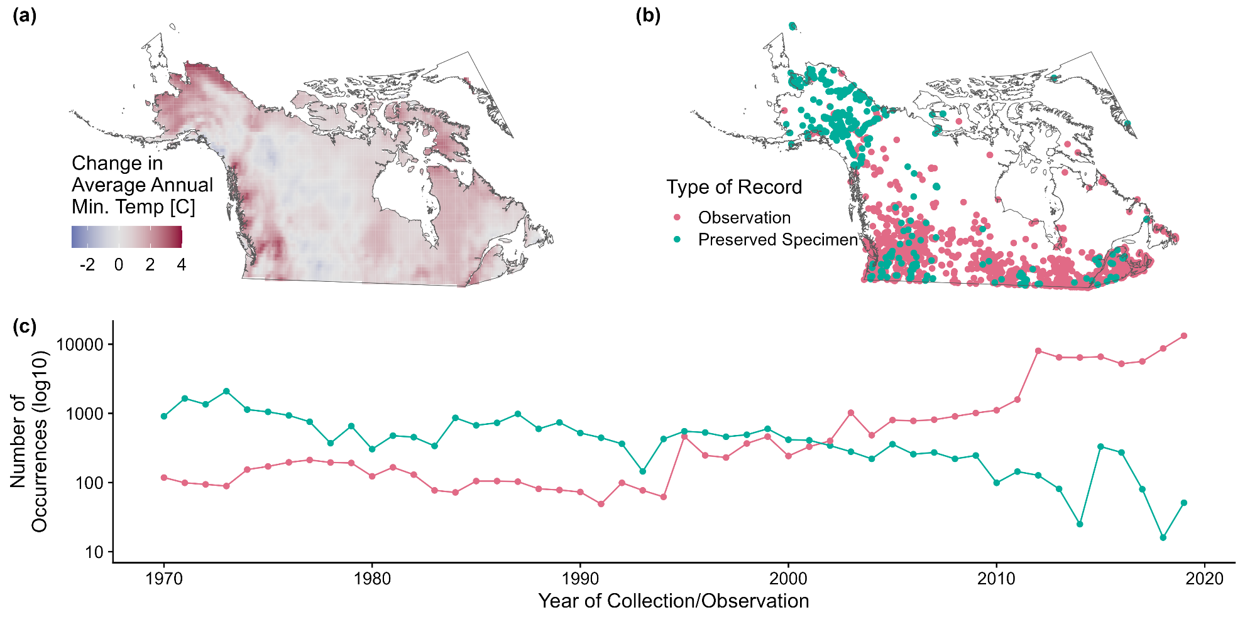

**Figure 1.** An overview of the study region encompassed by our analysis including (a) the change in average annual minimum temperature from the 1970s to 2010s, (b) the spatial distribution of occurrence records from natural history collections and community science platforms, and (c) the number of occurrence records from natural history museum collections and community science platforms by year over the same 50-year timeframe. Note that only 5,000 randomly occurrence records are shown on the map to avoid overplotting.

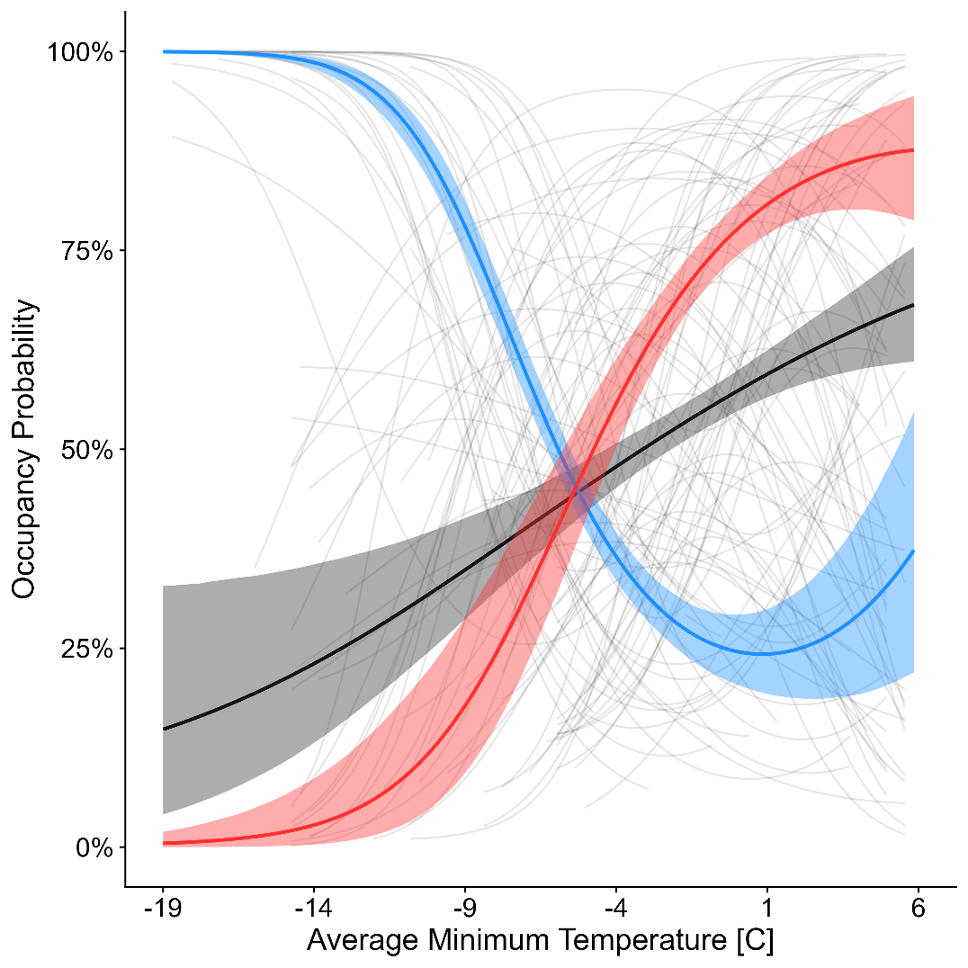

**Figure 2.** Species-specific responses to average minimum temperature (faded, grey lines) as well as the response of the butterflies with the coldest quarter of North American ranges (blue), warmest quarter of North American ranges (red), and butterflies overall (grey). Species-specific responses are shown only for the range of temperatures that species has experienced within its range between 1970-2019. All lines are derived from model estimated responses (linear and quadratic) of species to the average minimum temperature covariate.

**Figure 3.** Species-specific occupancy shifts from the 1970s to 2010s where points indicate the mean occupancy shift and lines indicate one standard deviation of the variation in occupancy shift among (a) the northernmost third of sites within that species’ range in the study region, (b) the core third of sites within that species’ range, (c) the southernmost third of sites within that species’ range, and (d) the all of sites within that species’ range (all ranges truncated at 45°N). Species are colored by the average annual temperature across their entire North American range as derived from BioClim.

**Figure 4.** Parameter estimates for the top model intercept(s) (Model C) and covariate (range-wide temperature) when predicting mean occupancy shift from the 1970s across the three geographic components of each species’ modeled range: lower/purple are parameter estimates for the southernmost part of the species’ range, middle/grey is the core/mid-latitude third of the species’ range, and upper/purple is the northernmost part of the species range.

**SUPPLEMENTAL MATERIAL**

***Table of Contents***

**Mathematical Definition of Post-hoc Trait Models**

**Supplemental Table S1.** Average occupancy trend estimates across all models/species

**Supplemental Table S2.** Model selection for core/mid-latitude 100-km temperature analysis

**Supplemental Table S3.** Model selection for northern 100-km temperature analysis

**Supplemental Table S4.** Model selection for southern 100-km temperature analysis

**Supplemental Table S5.** Model selection for core/mid-latitude 200-km temperature analysis

**Supplemental Table S6.** Model selection for northern 200-km temperature analysis

**Supplemental Table S7.** Model selection for southern 200-km temperature analysis

**Supplemental Table S8.** Model selection for core/mid-latitude 100-km precipitation analysis

**Supplemental Table S9.** Model selection for northern 100-km precipitation analysis

**Supplemental Table S10.** Model selection for southern 100-km precipitation analysis

**Supplemental Table S11.** Model selection for core/mid-latitude 200-km precipitation analysis

**Supplemental Table S12.** Model selection for northern 200-km precipitation analysis

**Supplemental Table S13.** Model selection for southern 200-km precipitation analysis

**Supplemental Figure S1.** Graphical illustration of the approach used in this study

**Supplemental Figure S2.** Occupancy trends from the 200km temperature model

**Supplemental Figure S3.** Occupancy trends from the 100km precipitation model

**Supplemental Figure S4.** Occupancy trends from the 200km precipitation model

**Supplemental Figure S5.** Parameter estimates for the 200km temperature post-hoc Model C.

**Supplemental Figure S6.** Parameter estimates for the 200km temperature post-hoc Model H.

**Supplemental Figure S7.** Parameter estimates for the 100km precipitation post-hoc Model C.

**Supplemental Figure S8.** Parameter estimates for the 200km precipitation post-hoc Model C.

**ADDITIONAL SUPPLEMENTARY MATERIAL FILES**

**Supplemental File S1:** Trace plots and other model assessment metrics for our 100-kilometer temperature occupancy-detection model.

**Supplemental File S2:** Trace plots and other model assessment metrics for our 200-kilometer temperature occupancy-detection model.

**Supplemental File S3:** Trace plots and other model assessment metrics for our 100-kilometer precipitation occupancy-detection model.

**Supplemental File S4:** Trace plots and other model assessment metrics for our 200-kilometer precipitation occupancy-detection model.

**Supplementary File S5.** Mean occupancy shift maps for species modeled using across all models (denoted by specific .pdf files names for each, default is the 100-kilometer temperature model).

***Mathematical Definitions of Post-hoc Trait and Phylogeny Models***

We specified eight potential models to examine the predictive relationship between species traits, phylogeny and mean occupancy trend in each of the geographic contexts of our study (south, core/mid-latitude, and north). The models were as follows: (a) and intercept-only, “null” model, (b) a model including only a phylogenetic intercept term, (c) a model including only species’ range wide temperature as a predictor, (d) a model including species’ range wide temperature and a phylogenetic intercept term, (e) a model containing range wide temperature, overwintering stage, and their interaction as predictors, (f) a model similar to (e) but with an additional phylogenetic intercept term, (g) a model including all potential traits, and finally (h) a model containing all potential traits and a phylogenetic intercept term. The equations below illustrate the specific models in more detail (*RangePrecip* substituted *RangeTemp* for the precipitation analysis):

**Model A**

[****](https://www.codecogs.com/eqnedit.php?latex=Mean%20Occupancy_%7Bg%7D%5Csim%20%5Calpha#0)

**Model B**

[****](https://www.codecogs.com/eqnedit.php?latex=Mean%20Occupancy_%7Bg%7D%20%5Csim%20%5Calpha%20%2B%20%5Calpha_%7Bphylo%7D#0)

**Model C**

[](https://www.codecogs.com/eqnedit.php?latex=MeanOccupancy_%7Bg%7D%20~%20%5Calpha%20%2B%20%5Cbeta_%7B1%7D%5Ctimes%20RangeTemp#0)

**Model D**

[****](https://www.codecogs.com/eqnedit.php?latex=MeanOccupancy_%7Bg%7D%20~%20%5Calpha%20%2B%20%5Calpha_%7Bphylo%7D%20%2B%20%5Cbeta_%7B1%7D%5Ctimes%20RangeTemp#0)

**Model E**

[****](https://www.codecogs.com/eqnedit.php?latex=MeanOccupancy_%7Bg%7D%20%5Csim%20%5Calpha%20%2B%20%5Cbeta_%7B1%7D%5Ctimes%20RangeTemp%20%2B%20%5Cbeta_%7B2%7D%5Ctimes%20OverwinterStage%20%2B%20%5Cbeta_%7B3%7D%5Ctimes%20(RangeTemp%20%5Ctimes%20OverwinterStage)#0)

**Model F**

[****](https://www.codecogs.com/eqnedit.php?latex=MeanOccupancy_%7Bg%7D%20%5Csim%20%5Calpha%20%2B%20%5Calpha_%7Bphylo%7D%20%2B%20%5Cbeta_%7B1%7D%5Ctimes%20RangeTemp%20%2B%20%5Cbeta_%7B2%7D%5Ctimes%20OverwinterStage%20%2B%20%5Cbeta_%7B3%7D%5Ctimes%20(RangeTemp%20%5Ctimes%20OverwinterStage)#0)

**Model G**

[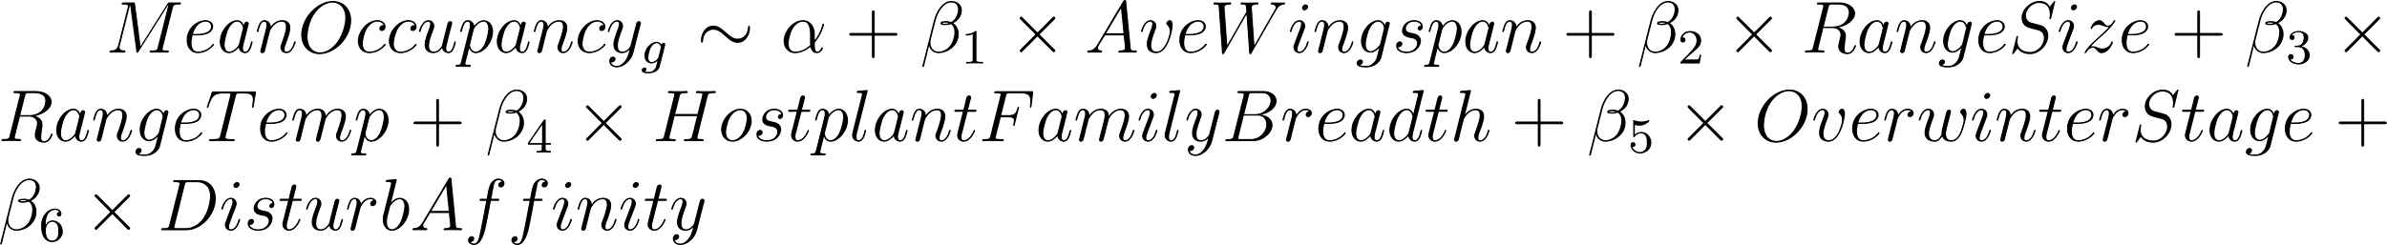](https://www.codecogs.com/eqnedit.php?latex=Mean%20Occupancy_%7Bg%7D%20%5Csim%20%5Calpha%20%2B%20%5Cbeta_%7B1%7D%5Ctimes%20AveWingspan%20%2B%20%5Cbeta_%7B2%7D%5Ctimes%20RangeSize%20%2B%20%5Cbeta_%7B3%7D%5Ctimes%20RangeTemp%20%2B%20%5Cbeta_%7B4%7D%5Ctimes%20HostplantFamilyBreadth%20%2B%20%5Cbeta_%7B5%7D%5Ctimes%20OverwinterStage%20%2B%20%5Cbeta_%7B6%7D%5Ctimes%20DisturbAffinity#0)

**Model H**

[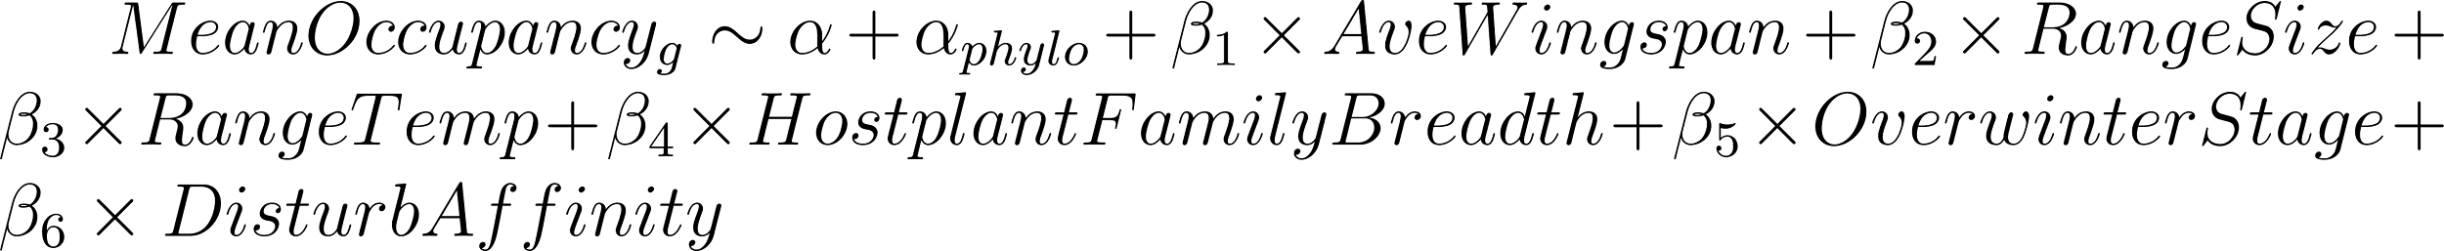](https://www.codecogs.com/eqnedit.php?latex=Mean%20Occupancy_%7Bg%7D%20%5Csim%20%5Calpha%20%2B%20%5Calpha_%7Bphylo%7D%20%2B%20%5Cbeta_%7B1%7D%5Ctimes%20AveWingspan%20%2B%20%5Cbeta_%7B2%7D%5Ctimes%20RangeSize%20%2B%20%5Cbeta_%7B3%7D%5Ctimes%20RangeTemp%20%2B%20%5Cbeta_%7B4%7D%5Ctimes%20HostplantFamilyBreadth%20%2B%20%5Cbeta_%7B5%7D%5Ctimes%20OverwinterStage%20%2B%20%5Cbeta_%7B6%7D%5Ctimes%20DisturbAffinity#0)

In each model, the mean occupancy trend in geographic context, [](https://www.codecogs.com/eqnedit.php?latex=g#0), is modeled considering the standard error of the mean by a global intercept term, [](https://www.codecogs.com/eqnedit.php?latex=%5Calpha#0). In trait-based models, an effect of each estimated trait is considered and given by the indexed [](https://www.codecogs.com/eqnedit.php?latex=%5Cbeta#0) parameters. In models including phylogenetic intercepts, a phylogenetic intercept term is denoted by [](https://www.codecogs.com/eqnedit.php?latex=%5Calpha_%7Bphylo%7D#0) where the estimates for this parameter were expected to follow a covariance structure dictated by a phylogeny of the modeled species. We tested this by computing Pagel’s [](https://www.codecogs.com/eqnedit.php?latex=%5Clambda#0) a measure of phylogenetic signal in the response variable, [](https://www.codecogs.com/eqnedit.php?latex=MeanOccupancy_%7Bg%7D#0). A Pagel’s [](https://www.codecogs.com/eqnedit.php?latex=%5Clambda#0) value of zero indicates no phylogenetic signal in mean occupancy trend while as estimate closer to one would indicate strong signal in mean occupancy trend across the phylogeny.

**Supplemental Table S1.** Mean occupancy trend for modeled butterfly species across all occupancy-detection models in this analysis. Occupancy trends reflect the overall average trend at each site +/- one standard deviation of the variance across all sites modeled for that species. Inferences from each model type are denoted by column headers (100T = 100km temperature, 200T = 200km temperature, 100P = 100km precipitation, and 200P = 200km precipitation. Cells are conditionally formatted by the direction and magnitude of decline/increase.

|  |  |  |  |  |  |
| --- | --- | --- | --- | --- | --- |
| **CODE** | **SCIENTIFIC NAME** | **100T MODEL** | **200T MODEL** | **100P MODEL** | **200P MODEL** |
| AGLMIL | *Aglais milberti* | 2.4% (+/-5.4%) | 2.8% (+/-5.8%) | 0.0% (+/-0.1%) | 0.1% (+/-0.3%) |
| AGRGLA | *Agriades glandon* | -2.5% (+/-2.7%) | -2.2% (+/-2.3%) | -0.2% (+/-0.6%) | -0.1% (+/-0.4%) |
| AMBVIA | *Amblyscirtes vialis* | -2.2% (+/-2.1%) | -0.7% (+/-0.8%) | -0.7% (+/-1.6%) | -0.2% (+/-0.7%) |
| ANCNUM | *Ancyloxypha numitor* | 8.1% (+/-9.5%) | 6.3% (+/-7.7%) | 0.9% (+/-0.8%) | 0.9% (+/-0.9%) |
| ARGATL | *Argynnis atlantis* | 1.5% (+/-5.2%) | 1.8% (+/-6.0%) | -0.1% (+/-0.3%) | 0.1% (+/-0.3%) |
| ARGCYB | *Argynnis cybele* | 0.2% (+/-5.4%) | 0.5% (+/-4.6%) | -0.4% (+/-0.9%) | -0.2% (+/-0.8%) |
| ARGHYD | *Argynnis hydaspe* | 4.9% (+/-4.7%) | 4.2% (+/-4.6%) | 2.3% (+/-1.8%) | 2.5% (+/-2.1%) |
| ARGMOR | *Argynnis mormonia* | -0.7% (+/-4.3%) | 0.0% (+/-3.7%) | -0.6% (+/-0.7%) | -0.4% (+/-0.5%) |
| BORBEL | *Boloria bellona* | -1.9% (+/-3.7%) | -1.2% (+/-3.0%) | -0.9% (+/-3.5%) | -0.3% (+/-2.3%) |
| BOLCHA | *Boloria chariclea* | -5.1% (+/-7.1%) | -3.6% (+/-6.1%) | -0.9% (+/-2.4%) | -0.5% (+/-1.9%) |
| BOLEUN | *Boloria eunomia* | -3.9% (+/-6.1%) | -3.2% (+/-4.8%) | -0.7% (+/-1.9%) | -0.2% (+/-1.3%) |
| BOLFRE | *Boloria freija* | -5.2% (+/-7.1%) | -4.4% (+/-6.3%) | -1.7% (+/-3.7%) | -1.1% (+/-3.4%) |
| BOLFRI | *Boloria frigga* | -0.7% (+/-7.6%) | -1.4% (+/-7.6%) | -1.4% (+/-2.9%) | -0.9% (+/-3.3%) |
| BOLIMP | *Boloria improba* | 1.6% (+/-3.1%) | -1.8% (+/-3.7%) | -2.2% (+/-2.3%) | -1.9% (+/-2.7%) |
| BOLPOL | *Boloria polaris* | -2.1% (+/-3.8%) | -4.4% (+/-5.8%) | -3.0% (+/-3.5%) | -2.0% (+/-4.8%) |
| BOLSEL | *Boloria selene* | 0.4% (+/-6.0%) | 2.1% (+/-6.6%) | 1.1% (+/-2.2%) | 0.5% (+/-1.4%) |
| CALAUG | *Callophrys augustinus* | -0.4% (+/-4.7%) | 0.1% (+/-4.1%) | 0.6% (+/-1.3%) | 0.6% (+/-1.6%) |
| CALERY | *Callophrys eryphon* | 1.1% (+/-4.9%) | 1.3% (+/-4.4%) | 0.3% (+/-0.4%) | 0.2% (+/-0.6%) |
| CALNIP | *Callophrys niphon* | 0.3% (+/-4.0%) | 1.8% (+/-4.0%) | 0.3% (+/-0.3%) | 0.8% (+/-1.2%) |
| CALPOL | *Callophrys polios* | 0.3% (+/-3.4%) | 0.9% (+/-3.9%) | -0.2% (+/-0.5%) | 0.0% (+/-0.2%) |
| CARPAL | *Carterocephalus palaemon* | 1.0% (+/-4.8%) | 1.7% (+/-4.9%) | 0.9% (+/-2.0%) | 0.7% (+/-1.5%) |
| CERPEG | *Cercyonis pegala* | 6.7% (+/-8.6%) | 5.7% (+/-7.2%) | -0.1% (+/-0.3%) | 0.0% (+/-0.2%) |
| CHLHAR | *Chlosyne harrisii* | 4.9% (+/-6.2%) | 4.5% (+/-5.3%) | 2.5% (+/-2.2%) | 2.3% (+/-2.2%) |
| COETUL | *Coenonympha tullia* | 0.2% (+/-1.8%) | 0.9% (+/-3.4%) | 0.0% (+/-0.2%) | 0.0% (+/-0.1%) |
| COLEUR | *Colias eurytheme* | 3.7% (+/-4.8%) | 3.4% (+/-5.1%) | -0.3% (+/-0.9%) | -0.1% (+/-0.8%) |
| COLHEC | *Colias hecla* | 2.1% (+/-4.0%) | -2.2% (+/-5.8%) | -2.8% (+/-3.0%) | -2.4% (+/-3.9%) |
| COLINT | *Colias interior* | -2.3% (+/-2.7%) | -0.8% (+/-4.2%) | -0.5% (+/-1.8%) | -0.1% (+/-0.9%) |
| COLPAL | *Colias palaeno* | 1.3% (+/-8.4%) | 0.0% (+/-6.6%) | -3.0% (+/-5.1%) | -1.2% (+/-3.8%) |
| COLPHI | *Colias philodice* | 0.2% (+/-6.2%) | 1.1% (+/-8.6%) | -0.1% (+/-1.0%) | 0.0% (+/-0.9%) |
| CUPAMY | *Cupido amyntula* | -1.7% (+/-4.0%) | -0.4% (+/-3.5%) | -0.3% (+/-1.1%) | -0.1% (+/-0.5%) |
| CUPCOM | *Cupido comyntas* | 4.9% (+/-6.2%) | 6.3% (+/-8.0%) | 1.5% (+/-1.3%) | 1.0% (+/-0.9%) |
| EPACLA | *Epargyreus clarus* | 2.6% (+/-4.4%) | 1.4% (+/-2.5%) | 0.0% (+/-0.0%) | -0.4% (+/-0.4%) |
| EREDIS | *Erebia discoidalis* | -3.7% (+/-3.8%) | -3.2% (+/-2.9%) | -1.4% (+/-2.5%) | -0.7% (+/-2.0%) |
| EREEPI | *Erebia epipsodea* | -2.9% (+/-6.3%) | -1.8% (+/-6.0%) | -0.6% (+/-1.0%) | -0.3% (+/-0.6%) |
| EREFAS | *Erebia fasciata* | 1.6% (+/-2.7%) | -2.1% (+/-4.8%) | -2.4% (+/-2.5%) | -2.9% (+/-3.2%) |
| EREROS | *Erebia rossii* | 0.6% (+/-2.4%) | 0.1% (+/-4.7%) | -2.6% (+/-2.9%) | -2.5% (+/-3.1%) |
| EREYOU | *Erebia youngi* | 1.5% (+/-2.1%) | -0.1% (+/-2.4%) | -2.4% (+/-2.1%) | -2.5% (+/-2.3%) |
| ERYICE | *Erynnis icelus* | -1.1% (+/-5.4%) | -0.1% (+/-6.0%) | -0.1% (+/-1.6%) | 0.0% (+/-0.6%) |
| ERYJUV | *Erynnis juvenalis* | -0.4% (+/-3.8%) | 0.5% (+/-3.1%) | 0.8% (+/-0.6%) | 0.7% (+/-0.6%) |
| ERYPER | *Erynnis persius* | -1.1% (+/-0.9%) | -0.2% (+/-0.4%) | -0.2% (+/-0.5%) | 0.1% (+/-0.3%) |
| EUCAUS | *Euchloe ausonides* | -3.1% (+/-3.9%) | -2.2% (+/-4.4%) | -1.0% (+/-2.5%) | -0.3% (+/-1.9%) |
| EUPANI | *Euphydryas anicia* | -1.3% (+/-3.7%) | 0.1% (+/-2.8%) | -0.3% (+/-0.2%) | 0.2% (+/-0.2%) |
| EUPPHA | *Euphydryas phaeton* | 1.2% (+/-3.6%) | 2.8% (+/-4.5%) | 2.8% (+/-2.1%) | 3.2% (+/-2.7%) |
| EUPVES | *Euphyes vestris* | 1.4% (+/-3.5%) | 0.4% (+/-2.0%) | 2.5% (+/-3.2%) | 2.4% (+/-3.2%) |
| GLALYG | *Glaucopsyche lygdamus* | 0.6% (+/-2.7%) | 1.2% (+/-3.6%) | 0.1% (+/-0.1%) | 0.1% (+/-0.3%) |
| HESCOM | *Hesperia comma* | -0.9% (+/-0.9%) | -0.1% (+/-0.3%) | 0.1% (+/-0.2%) | 0.2% (+/-1.0%) |
| ICAICA | *Icaricia icarioides* | 3.2% (+/-5.5%) | 2.8% (+/-3.3%) | -0.6% (+/-0.4%) | 0.2% (+/-0.2%) |
| ICASAE | *Icaricia saepiolus* | -2.4% (+/-6.7%) | -1.2% (+/-5.6%) | -0.8% (+/-2.1%) | -0.3% (+/-1.1%) |
| LETEUR | *Lethe eurydice* | 7.3% (+/-8.3%) | 6.7% (+/-7.5%) | 1.6% (+/-1.5%) | 1.4% (+/-1.7%) |
| LIMARC | *Limenitis archippus* | 5.1% (+/-6.6%) | 5.0% (+/-6.3%) | 1.2% (+/-2.2%) | 0.8% (+/-1.9%) |
| LIMART | *Limenitis arthemis* | 1.7% (+/-5.2%) | 2.3% (+/-5.0%) | 0.7% (+/-1.9%) | 0.4% (+/-1.7%) |
| LIMLOR | *Limenitis lorquini* | 7.2% (+/-8.9%) | 7.1% (+/-8.8%) | 3.8% (+/-3.3%) | 3.6% (+/-3.3%) |
| LYCDOR | *Lycaena dorcas* | -1.0% (+/-1.7%) | -0.8% (+/-2.4%) | -0.2% (+/-0.5%) | 0.0% (+/-0.1%) |
| LYCPHL | *Lycaena phlaeas* | 5.1% (+/-6.2%) | 4.2% (+/-5.5%) | 0.9% (+/-1.7%) | 0.6% (+/-2.0%) |
| NEOMEN | *Neophasia menapia* | 7.5% (+/-7.8%) | 6.6% (+/-8.5%) | 3.7% (+/-3.1%) | 3.3% (+/-3.0%) |
| NYMANT | *Nymphalis antiopa* | 2.7% (+/-5.1%) | 2.5% (+/-4.5%) | 1.1% (+/-2.4%) | 0.7% (+/-2.4%) |
| NYMCAL | *Nymphalis californica* | 6.3% (+/-5.7%) | 6.4% (+/-5.6%) | 0.8% (+/-0.5%) | 1.1% (+/-0.8%) |
| NYML-A | *Nymphalis l-album* | -2.7% (+/-6.5%) | -2.5% (+/-6.8%) | -1.0% (+/-2.6%) | -0.4% (+/-1.9%) |
| OCHSYL | *Ochlodes sylvanoides* | 7.7% (+/-8.4%) | 6.4% (+/-7.7%) | 2.5% (+/-2.2%) | 2.6% (+/-2.3%) |
| OENBOR | *Oeneis bore* | -2.3% (+/-4.9%) | -6.4% (+/-7.1%) | -2.7% (+/-3.7%) | -1.2% (+/-4.0%) |
| OENCHR | *Oeneis chryxus* | -1.8% (+/-2.5%) | -0.5% (+/-2.8%) | -0.4% (+/-1.2%) | 0.0% (+/-0.1%) |
| OENJUT | *Oeneis jutta* | -2.7% (+/-5.5%) | -1.9% (+/-3.8%) | -0.5% (+/-1.7%) | -0.1% (+/-0.6%) |
| OENMEL | *Oeneis melissa* | -3.4% (+/-3.7%) | -4.0% (+/-4.3%) | -1.3% (+/-2.1%) | -0.6% (+/-2.1%) |
| OENPOL | *Oeneis polixenes* | 0.3% (+/-5.6%) | -2.8% (+/-5.2%) | -1.3% (+/-2.2%) | -0.5% (+/-1.9%) |
| PAPMAC | *Papilio machaon* | -4.0% (+/-5.1%) | -3.6% (+/-4.1%) | -1.4% (+/-2.9%) | -0.8% (+/-2.9%) |
| PAPZEL | *Papilio zelicaon* | 4.3% (+/-4.3%) | 4.3% (+/-4.1%) | 1.7% (+/-1.6%) | 1.5% (+/-1.3%) |
| PARCLO | *Parnassius clodius* | 5.3% (+/-5.0%) | 6.4% (+/-6.1%) | 2.6% (+/-1.8%) | 1.7% (+/-1.4%) |
| PHYTHA | *Phyciodes tharos* | 0.9% (+/-1.4%) | 0.7% (+/-1.2%) | 0.1% (+/-0.1%) | 0.0% (+/-0.2%) |
| PIEOLE | *Pieris oleracea* | 2.8% (+/-2.6%) | 1.8% (+/-2.0%) | 1.1% (+/-2.2%) | 0.5% (+/-2.0%) |
| PIERAP | *Pieris rapae* | 8.2% (+/-9.7%) | 8.2% (+/-9.1%) | 0.6% (+/-1.2%) | 0.8% (+/-1.9%) |
| PLEIDA | *Plebejus idas* | -2.9% (+/-4.2%) | -1.5% (+/-3.9%) | -0.7% (+/-1.6%) | -0.2% (+/-0.9%) |
| PLEMEL | *Plebejus melissa* | -0.3% (+/-4.7%) | -2.0% (+/-3.4%) | -3.0% (+/-3.1%) | -2.5% (+/-2.4%) |
| POAHOB | *Poanes hobomok* | 3.6% (+/-3.8%) | 3.9% (+/-4.3%) | 2.6% (+/-2.8%) | 2.0% (+/-2.8%) |
| POLMYS | *Polites mystic* | 3.3% (+/-3.7%) | 2.1% (+/-2.8%) | 1.1% (+/-1.8%) | 0.9% (+/-1.8%) |
| POLTHE | *Polites themistocles* | 2.3% (+/-5.7%) | 1.6% (+/-3.8%) | 0.0% (+/-0.3%) | 0.2% (+/-0.3%) |
| POLFAU | *Polygonia faunus* | -0.3% (+/-5.4%) | 0.6% (+/-5.9%) | 0.2% (+/-0.6%) | 0.2% (+/-0.7%) |
| POLGRA | *Polygonia gracilis* | -0.5% (+/-1.7%) | -0.2% (+/-2.2%) | 0.0% (+/-0.1%) | 0.1% (+/-0.3%) |
| POLINT | *Polygonia interrogationis* | 5.2% (+/-6.2%) | 3.4% (+/-4.5%) | 3.1% (+/-3.3%) | 2.4% (+/-2.7%) |
| POLPRO | *Polygonia progne* | 3.6% (+/-4.2%) | 4.2% (+/-5.3%) | 0.4% (+/-0.7%) | 0.3% (+/-0.9%) |
| POLSAT | *Polygonia satyrus* | 0.5% (+/-2.2%) | 1.3% (+/-2.2%) | 0.0% (+/-0.1%) | 0.1% (+/-0.6%) |
| PONOCC | *Pontia occidentalis* | -1.7% (+/-2.8%) | -1.1% (+/-2.5%) | -0.6% (+/-1.7%) | -0.2% (+/-1.2%) |
| PTECAN | *Pterourus canadensis* | 0.1% (+/-7.0%) | 0.8% (+/-7.4%) | 0.5% (+/-1.2%) | 0.2% (+/-0.8%) |
| PTEEUR | *Pterourus eurymedon* | 8.4% (+/-9.6%) | 6.9% (+/-8.5%) | 3.1% (+/-2.5%) | 3.0% (+/-2.6%) |
| PTEGLA | *Pterourus glaucus* | -0.6% (+/-0.6%) | 0.1% (+/-1.2%) | -3.6% (+/-0.8%) | -0.2% (+/-0.4%) |
| PTERUT | *Pterourus rutulus* | 9.7% (+/-9.2%) | 8.3% (+/-9.4%) | 3.4% (+/-3.2%) | 2.8% (+/-2.9%) |
| SATLIP | *Satyrium liparops* | -0.7% (+/-3.2%) | -0.6% (+/-2.8%) | 1.6% (+/-1.5%) | 1.8% (+/-2.0%) |
| STRMEL | *Strymon melinus* | 3.4% (+/-5.1%) | 5.9% (+/-6.1%) | 0.1% (+/-0.1%) | 0.2% (+/-0.3%) |
| THOPYL | *Thorybes pylades* | -1.9% (+/-5.5%) | -2.0% (+/-5.3%) | -0.6% (+/-1.4%) | -0.3% (+/-1.6%) |
| THYLIN | *Thymelicus lineola* | 2.5% (+/-4.3%) | 3.7% (+/-6.5%) | 0.9% (+/-1.0%) | 0.6% (+/-0.9%) |
| VANVIR | *Vanessa virginiensis* | 4.8% (+/-6.4%) | 2.8% (+/-3.9%) | 3.0% (+/-3.3%) | 2.7% (+/-3.2%) |

**Supplemental Table S2.** Model comparison metrics for models predicting average core/mid-latitude occupancy shift since the 1970s. Results are shown for the 100km scale, temperature analysis. Top candidate model is italic and bold. We considered models equivalent if the difference in ELPD was less than four.

|  |  |  |  |  |
| --- | --- | --- | --- | --- |
| **MODEL** | **LOOIC** | **DELTA ELPD** | **SE DELTA ELPD** | **NOTES** |
| A | -275.5 | -5.9 | 2.6 | *The top two models are models that includes range-wide temperature with/without a phylogenetic intercept term.* |
| B | -280.4 | -3.5 | 3.4 |
| ***C*** | ***-287.4*** | ***0.0*** | ***0.0*** |
| ***D*** | ***-286.8*** | ***-0.3*** | ***1.4*** |
| E | -276.7 | -5.3 | 2.4 |
| F | -278.0 | -4.7 | 2.5 |
| G | -278.2 | -4.6 | 4.2 |
| H | -277.2 | -5.1 | 4.2 |

**Supplemental Table S3.** Model comparison metrics for models predicting average northern occupancy shift since the 1970s. Results are shown for the 100km scale, temperature analysis. Top candidate model is italic and bold. We considered models equivalent if the difference in ELPD was less than four.

|  |  |  |  |  |
| --- | --- | --- | --- | --- |
| **MODEL** | **LOOIC** | **DELTA ELPD** | **SE DELTA ELPD** | **NOTES** |
| A | -278.9 | -14.4 | 4.9 | *The top two models are models that includes range-wide temperature with/without a phylogenetic intercept term.* |
| B | -286.1 | -10.8 | 3.9 |
| ***C*** | ***-301.6*** | ***-3.1*** | ***2.5*** |
| ***D*** | ***-307.7*** | ***0.0*** | ***0.0*** |
| E | -286.9 | -10.4 | 4.7 |
| F | -296.9 | -5.4 | 2.0 |
| G | -294.8 | -6.4 | 2.8 |
| H | -295.6 | -6.0 | 2.3 |

**Supplemental Table S4.** Model comparison metrics for models predicting average southern occupancy shift since the 1970s. Results are shown for the 100km scale, temperature analysis. Top candidate model is italic and bold. We considered models equivalent if the difference in ELPD was less than four.

|  |  |  |  |  |
| --- | --- | --- | --- | --- |
| **MODEL** | **LOOIC** | **DELTA ELPD** | **SE DELTA ELPD** | **NOTES** |
| ***A*** | ***-270.9*** | ***-0.4*** | ***1.5*** | *Many models tested can predict occupancy trends at the southern geographic context of each species’ range in this analysis.* |
| ***B*** | ***-269.5*** | ***-1.1*** | ***2.6*** |
| ***C*** | ***-271.7*** | ***0.0*** | ***0.0*** |
| ***D*** | ***-269.7*** | ***-1.0*** | ***1.8*** |
| E | -260.8 | -5.5 | 2.5 |
| F | -260.7 | -5.5 | 3.0 |
| G | -266.8 | -2.5 | 5.0 |
| ***H*** | ***-264.5*** | ***-3.6*** | ***5.1*** |

**Supplemental Table S5.** Model comparison metrics for models predicting average core/mid-latitude occupancy shift since the 1970s. Results are shown for the 200km scale, temperature analysis. Top candidate model is italic and bold. We considered models equivalent if the difference in ELPD was less than four.

|  |  |  |  |  |
| --- | --- | --- | --- | --- |
| **MODEL** | **LOOIC** | **DELTA ELPD** | **SE DELTA ELPD** | **NOTES** |
| A | -238.1 | -11.9 | 5.2 |  |
| B | -252.2 | -4.8 | 3.2 |
| C | -252.9 | -4.5 | 4.7 |
| D | ***-261.0*** | ***0.0*** | ***0.0*** |
| E | -239.3 | -11.3 | 5.2 |
| F | -249.8 | -5.9 | 2.7 |
| G | ***-255.4*** | ***-3.2*** | ***4.8*** |
| H | ***-254.3*** | ***-3.8*** | ***4.5*** |

**Supplemental Table S6.** Model comparison metrics for models predicting average northern occupancy shift since the 1970s. Results are shown for the 200km scale, temperature analysis. Top candidate model is italic and bold. We considered models equivalent if the difference in ELPD was less than four.

|  |  |  |  |  |
| --- | --- | --- | --- | --- |
| **MODEL** | **LOOIC** | **DELTA ELPD** | **SE DELTA ELPD** | **NOTES** |
| A | -286.3 | -19.5 | 5.4 |  |
| B | -300.6 | -12.3 | 4.3 |
| C | -313.6 | -5.8 | 2.6 |
| ***D*** | ***-325.5*** | ***0.0*** | ***0.0*** |
| E | -300.9 | -12.1 | 4.2 |
| F | -311.7 | -6.6 | 3.4 |
| G | -300.1 | -12.5 | 3.0 |
| ***H*** | ***-320.3*** | ***-2.0*** | ***2.1*** |

**Supplemental Table S7.** Model comparison metrics for models predicting average southern occupancy shift since the 1970s. Results are shown for the 200km scale, temperature analysis. Top candidate model is italic and bold. We considered models equivalent if the difference in ELPD was less than four.

|  |  |  |  |  |
| --- | --- | --- | --- | --- |
| **MODEL** | **LOOIC** | **DELTA ELPD** | **SE DELTA ELPD** | **NOTES** |
| ***A*** | ***-300.2*** | ***-2.3*** | ***2.4*** |  |
| ***B*** | ***-299.4*** | ***-2.7*** | ***2.8*** |
| ***C*** | ***-304.8*** | ***0.0*** | ***0.0*** |
| ***D*** | ***-302.7*** | ***-1.0*** | ***1.0*** |
| E | -293.1 | -5.8 | 2.0 |
| F | -292.0 | -6.4 | 2.1 |
| G | -295.9 | -4.4 | 3.6 |
| H | -293.4 | -5.7 | 3.7 |

**Supplemental Table S8.** Model comparison metrics for models predicting average core/mid-latitude occupancy shift since the 1970s. Results are shown for the 100km scale, precipitation analysis. Top candidate model is italic and bold. We considered models equivalent if the difference in ELPD was less than four.

|  |  |  |  |  |
| --- | --- | --- | --- | --- |
| **MODEL** | **LOOIC** | **DELTA ELPD** | **SE DELTA ELPD** | **NOTES** |
| A | -422.7 | -4.7 | 3.5 |  |
| B | -420.8 | -5.7 | 2.6 |
| ***C*** | ***-432.1*** | ***0.0*** | ***0.0*** |
| ***D*** | ***-429.5*** | ***-1.3*** | ***1.6*** |
| ***E*** | ***-424.0*** | ***-4.0*** | ***3.1*** |
| F | -422.0 | -5.0 | 3.0 |
| G | -422.2 | -4.9 | 4.4 |
| H | -420.8 | -5.6 | 4.2 |

**Supplemental Table S9.** Model comparison metrics for models predicting average northern occupancy shift since the 1970s. Results are shown for the 100km scale, precipitation analysis. Top candidate model is italic and bold. We considered models equivalent if the difference in ELPD was less than four.

|  |  |  |  |  |
| --- | --- | --- | --- | --- |
| **MODEL** | **LOOIC** | **DELTA ELPD** | **SE DELTA ELPD** | **NOTES** |
| A | -461.8 | -6.1 | 4.6 |  |
| B | -463.0 | -5.5 | 4.8 |
| ***C*** | ***-471.4*** | ***-1.3*** | ***3.7*** |
| ***D*** | ***-472.2*** | ***-0.9*** | ***3.6*** |
| ***E*** | ***-468.0*** | ***-3.0*** | ***3.9*** |
| ***F*** | ***-468.4*** | ***-2.8*** | ***3.6*** |
| ***G*** | ***-474.0*** | ***0.0*** | ***0.0*** |
| ***H*** | ***-471.8*** | ***-1.1*** | ***4.6*** |

**Supplemental Table S10.** Model comparison metrics for models predicting average southern occupancy shift since the 1970s. Results are shown for the 100km scale, precipitation analysis. Top candidate model is italic and bold. We considered models equivalent if the difference in ELPD was less than four.

|  |  |  |  |  |
| --- | --- | --- | --- | --- |
| **MODEL** | **LOOIC** | **DELTA ELPD** | **SE DELTA ELPD** | **NOTES** |
| A | -354.6 | -14.6 | 5.3 |  |
| B | -369.8 | -7.0 | 4.5 |
| C | -373.8 | -5.0 | 3.3 |
| ***D*** | ***-383.8*** | ***0.0*** | ***0.0*** |
| E | -365.1 | -9.3 | 2.8 |
| F | -370.7 | -6.6 | 2.1 |
| G | -370.6 | -6.6 | 3.0 |
| H | -370.8 | -6.5 | 2.9 |

**Supplemental Table S11.** Model comparison metrics for models predicting average core/mid-latitude occupancy shift since the 1970s. Results are shown for the 200km scale, precipitation analysis. Top candidate model is italic and bold. We considered models equivalent if the difference in ELPD was less than four.

|  |  |  |  |  |
| --- | --- | --- | --- | --- |
| **MODEL** | **LOOIC** | **DELTA ELPD** | **SE DELTA ELPD** | **NOTES** |
| ***A*** | ***-491.8*** | ***-3.0*** | ***2.7*** |  |
| ***B*** | ***-491.1*** | ***-3.3*** | ***2.6*** |
| ***C*** | ***-497.8*** | ***0.0*** | ***0.0*** |
| ***D*** | ***-497.2*** | ***-0.3*** | ***1.0*** |
| ***E*** | ***-490.6*** | ***-3.6*** | ***2.4*** |
| ***F*** | ***-491.6*** | ***-3.1*** | ***3.2*** |
| ***G*** | ***-494.7*** | ***-1.6*** | ***3.0*** |
| ***H*** | ***-492.6*** | ***-2.6*** | ***3.0*** |

**Supplemental Table S12.** Model comparison metrics for models predicting average northern occupancy shift since the 1970s. Results are shown for the 200km scale, precipitation analysis. Top candidate model is italic and bold. We considered models equivalent if the difference in ELPD was less than four.

|  |  |  |  |  |
| --- | --- | --- | --- | --- |
| **MODEL** | **LOOIC** | **DELTA ELPD** | **SE DELTA ELPD** | **NOTES** |
| ***A*** | ***-460.4*** | ***-3.8*** | ***5.2*** |  |
| B | -459.3 | -4.3 | 5.1 |
| ***C*** | ***-462.0*** | ***-3.0*** | ***4.4*** |
| ***D*** | ***-461.2*** | ***-3.4*** | ***4.3*** |
| E | -455.9 | -6.0 | 4.5 |
| F | -454.6 | -6.7 | 4.3 |
| ***G*** | ***-468.0*** | ***0.0*** | ***0.0*** |
| ***H*** | ***-465.6*** | ***-1.2*** | ***0.3*** |

**Supplemental Table S13.** Model comparison metrics for models predicting average southern occupancy shift since the 1970s. Results are shown for the 200km scale, precipitation analysis. Top candidate model is italic and bold. We considered models equivalent if the difference in ELPD was less than four.

|  |  |  |  |  |
| --- | --- | --- | --- | --- |
| **MODEL** | **LOOIC** | **DELTA ELPD** | **SE DELTA ELPD** | **NOTES** |
| A | -373.7 | -12.9 | 4.6 |  |
| B | -388.6 | -5.4 | 4.1 |
| ***C*** | ***-393.8*** | ***-2.9*** | ***2.7*** |
| ***D*** | ***-399.5*** | ***0.0*** | ***0.0*** |
| E | -384.9 | -7.3 | 2.6 |
| F | -387.0 | -6.3 | 2.0 |
| G | -389.6 | -5.0 | 3.2 |
| H | -389.5 | -5.0 | 3.1 |

**Supplemental Figure S1.** A summary of the methodological workflow used in this study from data compilation to non-detection imputation and occupancy-detection modeling. The post-hoc analysis using species traits and phylogeny is also visualized.

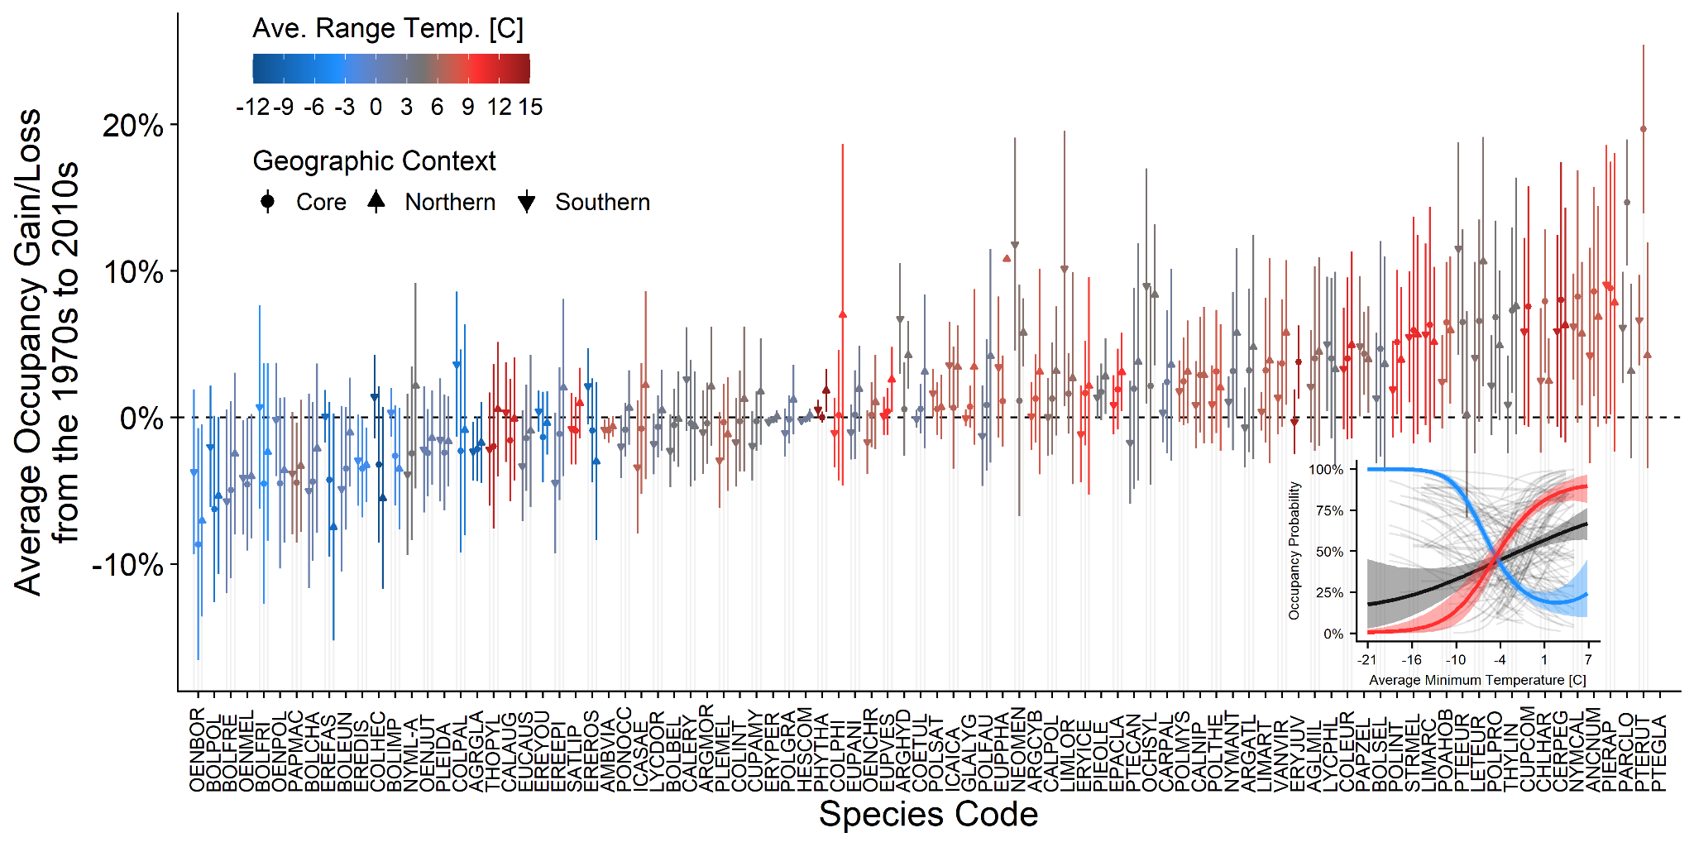

**Supplemental Figure S2.** Species-specific occupancy shifts from the 1970s where points indicate the average occupancy shift for a given geographic context (core/mid-latitude, southern, and northern grid cells) and lines indicate one standard deviation of variation among relevant sites. The inset panel illustrates the relationship between minimum temperature and occupancy probability for each species (thin, grey lines), all butterflies on average (black line), the species with the coldest quarter of ranges (blue line), and the species with the warmest quarter of ranges (red line). Only temperatures that each species has experienced in its range are shown by the species-specific lines. Results shown here are from the 200 kilometer temperature model. Note that there were too few sites to model *Pterourus glaucus* at this scale*.*

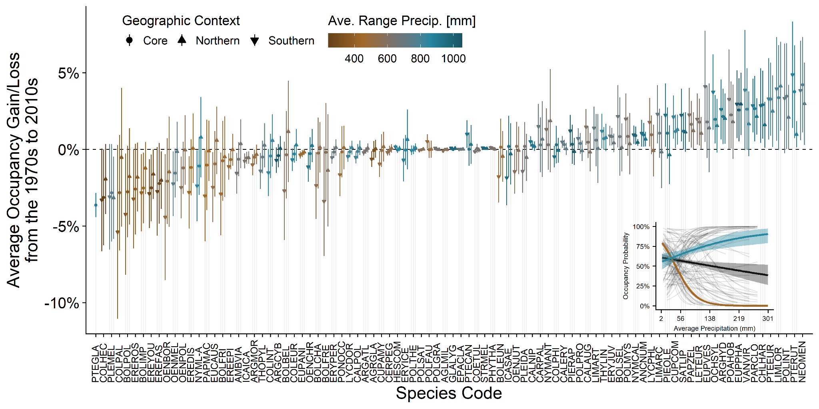

**Supplemental Figure S3.** Species-specific occupancy shifts from the 1970s where points indicate the average occupancy shift for a given geographic context (core/mid-latitude, southern, and northern grid cells) and lines indicate one standard deviation of variation among relevant sites. The inset panel illustrates the relationship between precipitation and occupancy probability for each species (thin, grey lines), all butterflies on average (black line), the species with the wettest quarter of ranges (blue line), and the species with the driest quarter of ranges (brown line). Only precipitation that each species has experienced in its range are shown by the species-specific lines. Results shown here are from the 100 kilometer precipitation model.

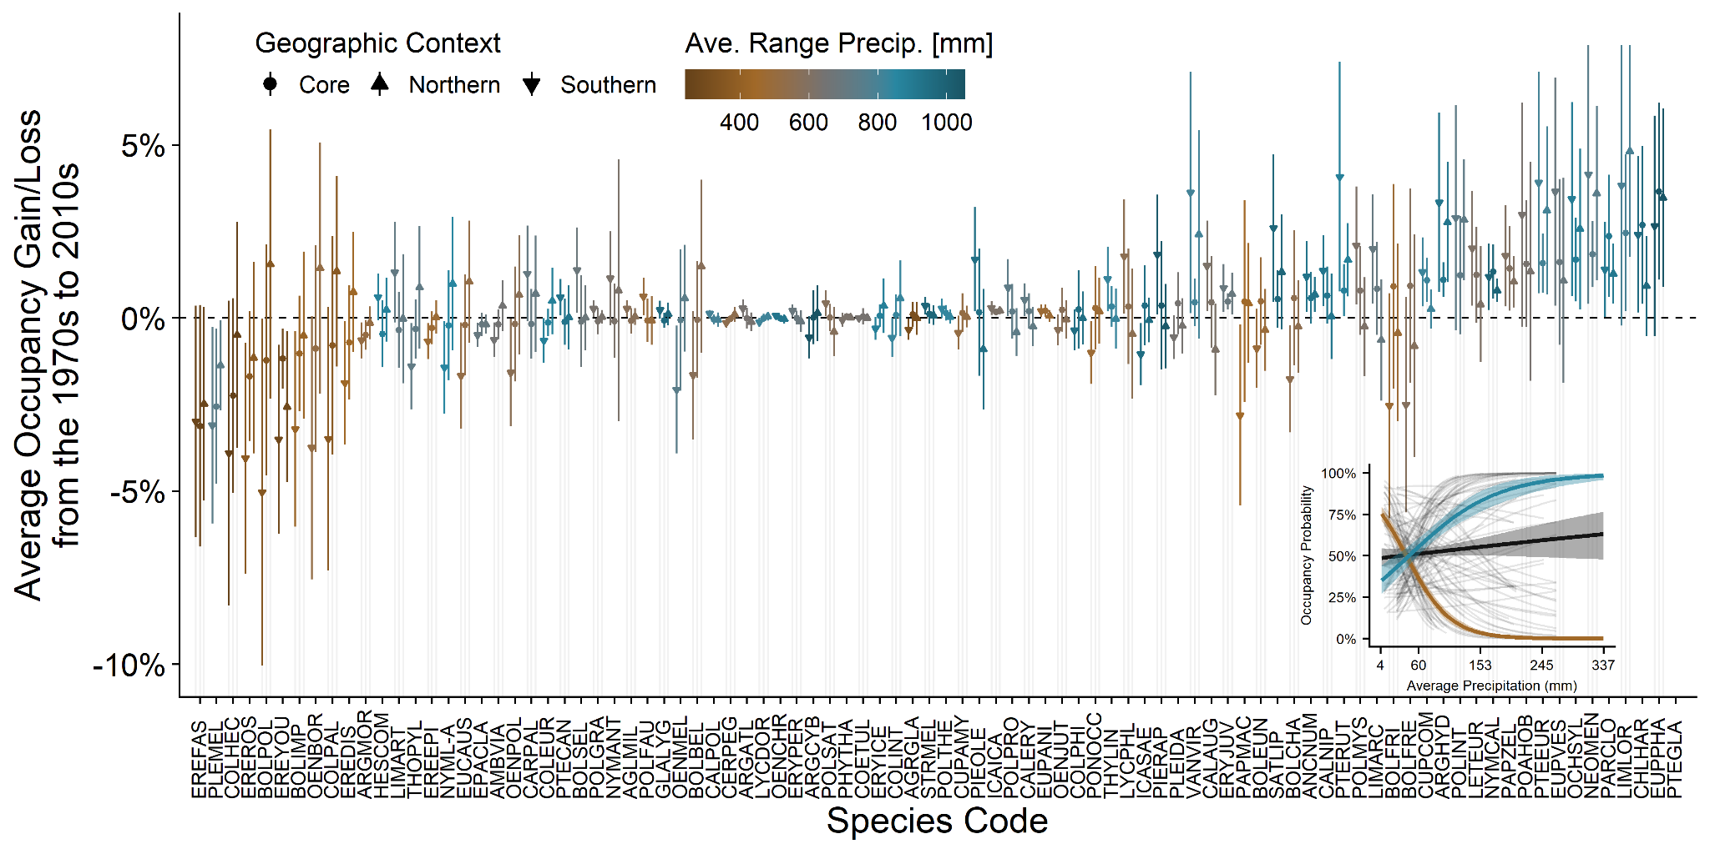

**Supplemental Figure S4.** Species-specific occupancy shifts from the 1970s where points indicate the average occupancy shift for a given geographic context (core/mid-latitude, southern, and northern grid cells) and lines indicate one standard deviation of variation among relevant sites. The inset panel illustrates the relationship between precipitation and occupancy probability for each species (thin, grey lines), all butterflies on average (black line), the species with the wettest quarter of ranges (blue line), and the species with the driest quarter of ranges (red line). Only precipitation that each species has experienced in its range are shown by the species-specific lines. Results shown here are from the 200 kilometer precipitation model.

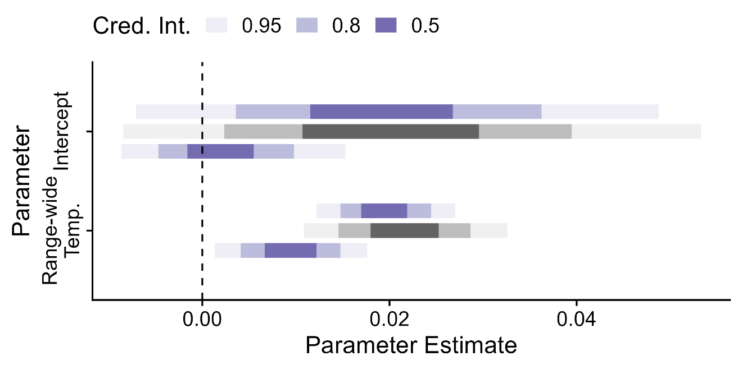

**Supplemental Figure 5.** Parameter estimates for model intercept (Model D) and covariate (range-wide temperature) when predicting mean occupancy shift from the 1970s across the three geographic components of each species’ modeled range: lower/purple are parameter estimates for the southernmost part of the species’ range, middle/grey is the core/mid-latitude third of the species’ range, and upper/purple is the northernmost part of the species range. Results are shown here for the 200-kilometer temperature analysis. Pagel’s mean estimates were 0.0 (0.0 – 0.01 95% CRI, South); 0.01 (0.0 – 0.03 95% CRI, Core); and 0.03 (0.0 – 0.13 95% CRI, North).

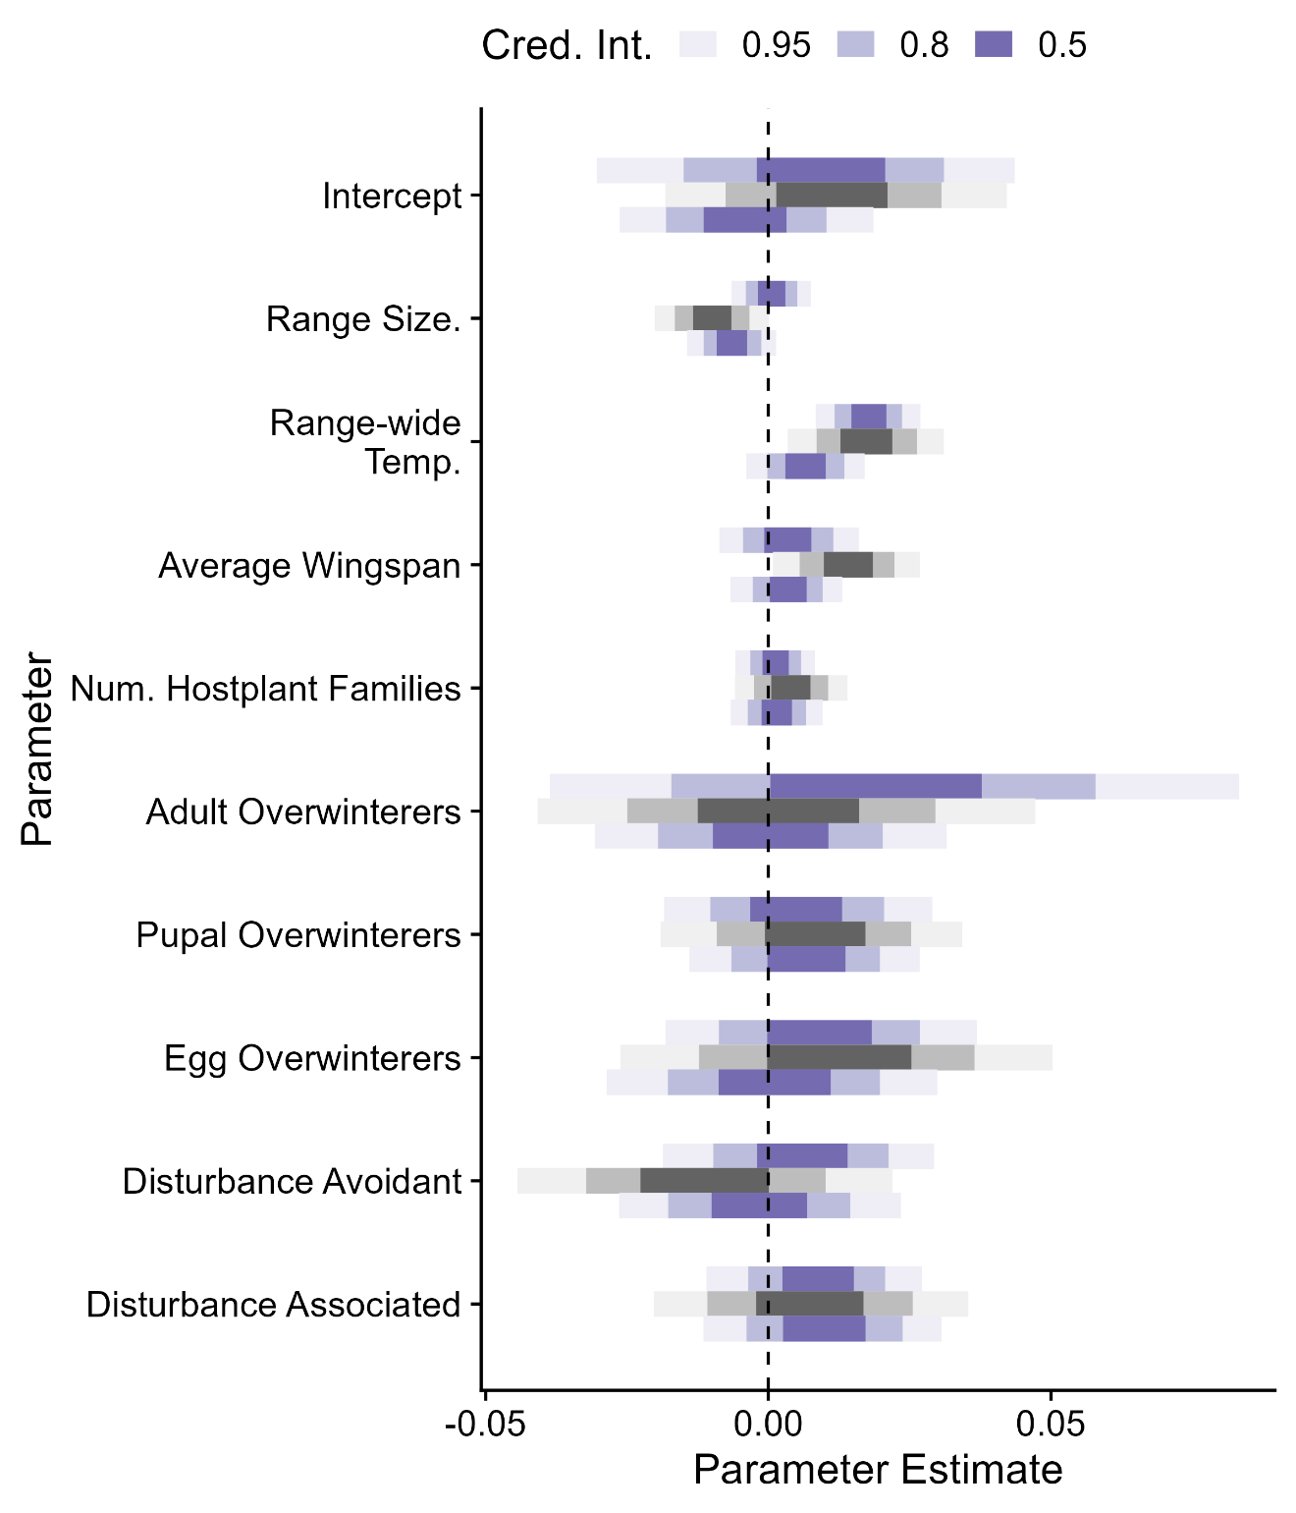

**Supplemental Figure S6.** Parameter estimates for model intercept (Model H) and covariate (range-wide temperature) when predicting mean occupancy shift from the 1970s across the three geographic components of each species’ modeled range: lower/purple are parameter estimates for the southernmost part of the species’ range, middle/grey is the core/mid-latitude third of the species’ range, and upper/purple is the northernmost part of the species range. Results are shown here for the 200-kilometer temperature analysis. Pagel’s mean estimates were 0.0 (0.0 – 0.01 95% CRI, South); 0.00 (0.0 – 0.01 95% CRI, Core); and 0.05 (0.0 – 0.22 95% CRI, North).

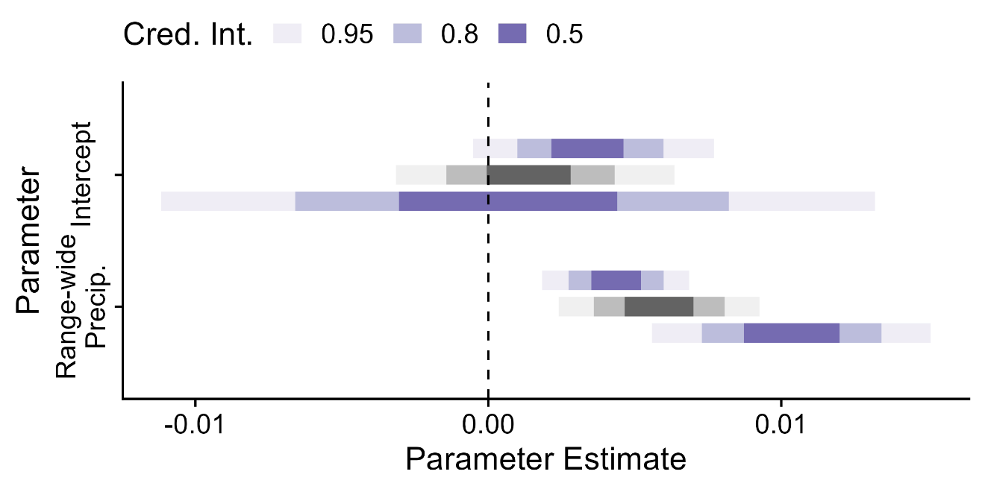

**Supplemental Figure S7.** Parameter estimates for model intercept (Model D) and covariate (range-wide temperature) when predicting mean occupancy shift from the 1970s across the three geographic components of each species’ modeled range: lower/purple are parameter estimates for the southernmost part of the species’ range, middle/grey is the core/mid-latitude third of the species’ range, and upper/purple is the northernmost part of the species range. Results are shown here for the 100-kilometer precipitation analysis. Pagel’s mean estimates were 0.01 (0.0 – 0.02 95% CRI, South); 0.0 (0.0 – 0.0 95% CRI, Core); and 0.0 (0.0 – 0.01 95% CRI, North).

**Supplemental Figure S8.** Parameter estimates for model intercept (Model D) and covariate (range-wide temperature) when predicting mean occupancy shift from the 1970s across the three geographic components of each species’ modeled range: lower/purple are parameter estimates for the southernmost part of the species’ range, middle/grey is the core/mid-latitude third of the species’ range, and upper/purple is the northernmost part of the species range. Results are shown here for the 200-kilometer precipitation analysis. Pagel’s mean estimates were 0.01 (0.0 – 0.02 95% CRI, South); 0.0 (0.0 – 0.01 95% CRI, Core); and 0.0 (0.0 – 0.0 95% CRI, North).