GREAT QUALITY

**Made by robots**

We are India's first and the only brand to use robotic technique that delivers glasses which are accurate to 3 decimal places. These machines imported from Germany, ensure perfection on all front: an automated system that allows to inspect lenses, determine the geometric center, and load the lenses for edging without the need of a finishing block.

**Mind of machine**

Our people have zero tolerance to error and our call center aims to delight every customer, solve their problems and work on their feedbacks.

VARIETY

* **We let the numbers talk.**

We have over 5000 styles of eyewear, which is 5 times more than that any retailer in India. From big brands like RayBan and Oakley to the best in house brands.

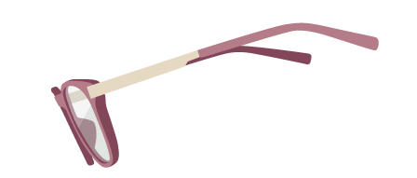

* **An eye for an eye**

From sunglasses to reading glasses to contact lenses, we make everything that can help you see this beautiful world with more clarity.

**We got the whole world**

Yes it is true make eyewear for men, women, kids, for all humans of the world.

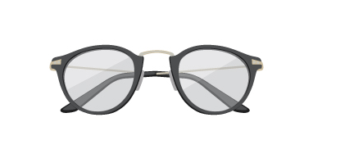

* **All covered**

We have it all. everyday basics. Everyday fashion. Evening wear. Not just that, we update our styles every year to keep up with fashion trends around the globe, taking inspiration from fashion capitals and the best designers of the world.

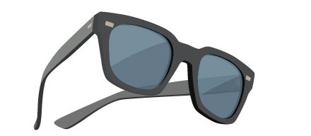

VALUE FOR MONEY

* **Not all good things in the world are expensive**

Our prices are lower than any of your local optician. Our customers can find the most attractive packages on contact lenses

* **No middle man.No extra cost.**

No middleman simply means no middle ground. Our products come straight from the manufacturer, hence getting rid of all extra costs and burden.

* **One for everyone**

We have a wide variety of prices to suit all th customers. Prices range from Rs.345 to Rs. 30,000. never forget that the first frame you buy is absolutely free.

* **Your friendly neighborhood Lenskart**

We bring to you the Lenskart experience alive via brick and marter stores. With over 80 retail stores across the country, we have just started this journey.

**At your doorstep**

When we say we are never too far, we mean it. Give us a call or register online, we will be at your doorstep for home eye check-up. International quality, computerized equipment, certified ruefractionists, we have it all to give you the best home eye check-up experience. No obligations to buy.

