Installation & Overview

What Is CMS.NET?
Simply put, it is a content management system written from scratch in ASP.NET, ADO.NET, and C#, and it uses Microsoft SQL Server (future releases will not be restricted to SQL Server) to store its content.
It was designed from the ground up to support remote Internet maintainability. It uses the power of Microsoft’s .NET to handle most of its dirty work.
CMS.NET is a complete content management system, but lacks many of the bells and whistles of some of the more established (read expensive) CMS available today. Thus, as it currently stands, is currently just the starting point.
Installing CMS.NET
Installing CMS.NET Application Code
Now (insert drum roll), here is how you install all the code of CMS.NET:
Copy the entire CMSNET directory structure from the downloaded zip file to the directory C:\Inetpub\wwwroot.
Yep, that’s it! No registering DLLs and no copying code to special locations. Heck, you don’t even have to copy the code to the directory stated here. You can copy it almost anywhere because next you will be creating a virtual directory to it in Internet Information Services (IIS).
Configuring IIS
When you have the CMS.NET code where you want it, the next step is to let IIS know where it is. To do this, use the Internet Information Services program found in the Administrative Tools folder.
1. Start up the Internet Information Services program.
2. Navigate to and then right-click on the Default Web Site folder.
3. Select Virtual Directory from New menu item (see Figure 1).
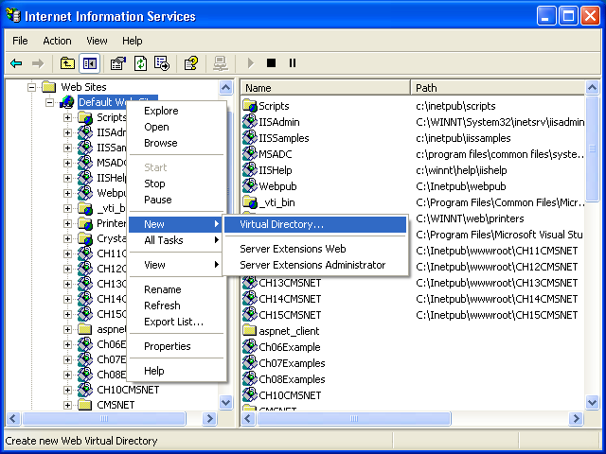
Figure 1 The Internet Information Services program.
4. Click on the Next button on the Virtual Directory Creation Wizard welcome screen (see Figure 2).
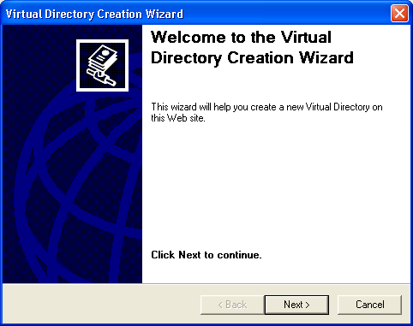
Figure 2 The Virtual Directory Creation Wizard.
5. Enter “CMSNET” in the Alias edit field.
6. Click on the Next button (see Figure 3).
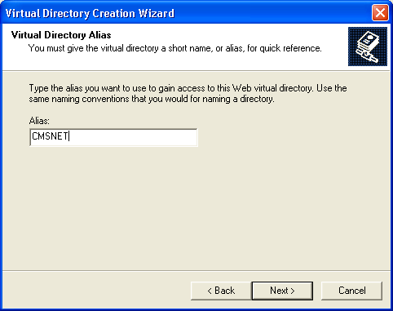
Figure 3 Setting the virtual directory alias.
7. Use the Browse button and navigate to the location where you copied the CMSNET directory earlier. Or, if you used the defaults during IIS installation, enter “C:\Inetpub\wwwroot\CMSNET” in the Directory edit field.
8. Click on the Next button (see Figure 4).
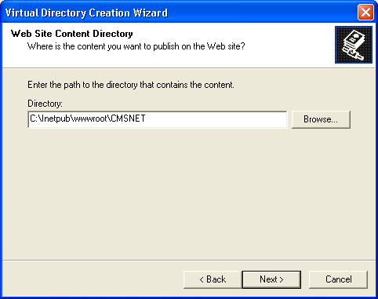
Figure 4 Setting the virtual directory.
9. Use the default checkboxes.
10. Click on the Next button (see Figure 5).
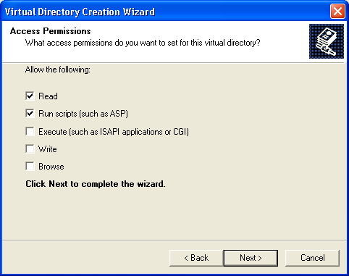
Figure 5 Setting the virtual directory access permissions.
11. Click on the Finish button.
12. Exit the IIS program.
CMS.NET is now ready to run (without a database, of course). If you want, you can type “http://localhost/CMSNET” in the Address edit field on your browser and get your first CMS.NET Web page (see Figure 6).
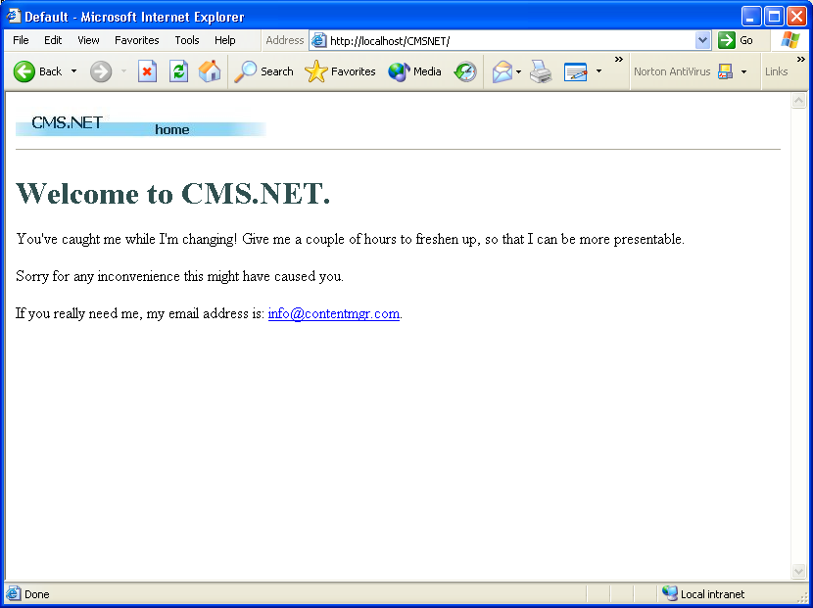
Figure 6 The “I’m changing” Web page.
Creating and Loading the CMSNET Database
You can create and load the CMSNET database in numerous ways. You could, of course, do it the long way and enter everything by hand. But because I’ve already done that, let’s do it three easier ways.
Using Visual Studio.NET
I am aware that not everyone has Microsoft SQL Server 2000 available, so first I will show you how to install CMSNET into the Microsoft SQL Server Desktop Engine (MSDE), which happens to come free with Visual Studio.NET. I happened to come upon this method by luck. There probably is a correct way of doing it, but the following method works and it is very easy:
1. Copy only the CMSNET.mdf file from the Final/MS SQL Database directory on the CD-ROM to the C:\Program Files\Microsoft SQL Server\MSSQL\Data directory. This file makes up an empty copy of the CMS.NET database.
2. Load Visual Studio.NET.
3. Using the Server Explorer, right-click on the Data Connections folder.
4. Select the Add Connection… menu item (see Figure 7).
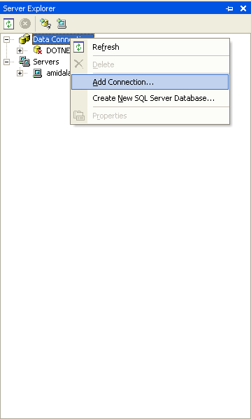
Figure 7 Using Server Explorer to add a database connection.
5. In the Data Link Properties dialog box, select the Connection tab.
6. Enter your server name or enter “local” into the Select or Enter a Server Name edit field.
7. Select the Use a Specific User Name and Password radio button.
8. Enter “sa” into the User Name edit field.
9. Select the Blank Password checkbox.
10. Select the Attach a Database File as a Database Name radio button.
11. Enter “CMSNET” in the edit field below the radio button.
12. Using the button with the ellipses, navigate to where you placed the CMSNET.mdf file.
13. Click on the Open button.
14. Click on the OK button. (see Figure 8).
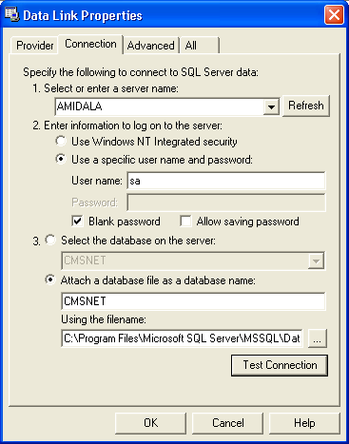
Figure 8 The Data Link Properties dialog box.
Now, believe it or not, delete the newly created data connection. Yes, you read that right! You do this because you now have two copies of the connection: the one you just deleted and the one in the SQL Servers section, where it is supposed to be (see Figure 9).
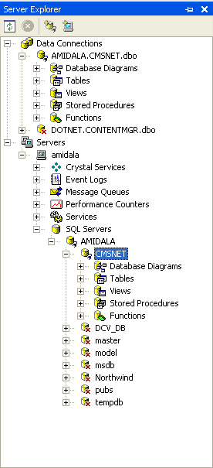
Figure 9 Duplicate connections.
Exit Visual Studio.NET. Now you are all set to play with CMS.NET.
Using Microsoft SQL Server Enterprise Manager
For those of you who are lucky enough to have Microsoft SQL Server available to you, I will now show you how to do virtually the same thing you did with Visual Studio.NET but this time with Enterprise Manager.
1. Copy the CMSNET.mdf and CMSNET_Log.ldf files from the Final\MS SQL Database directory on the CD-ROM to the C:\Program Files\Microsoft SQL Server\MSSQL\Data directory.
2. Load Enterprise Manager.
3. Navigate down to your Server Group and right-click on the Databases folder.
4. Select the Attach Database… submenu item from the All Tasks menu item (see Figure 10).
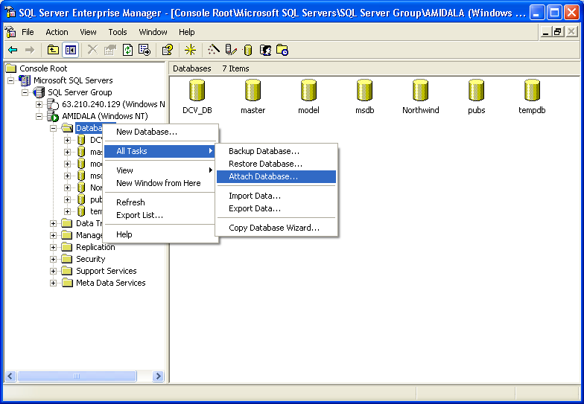
Figure 10 Using Enterprise Manager to attach a database.
5. Using button with the ellipses, navigate to where you placed the CMSNET.mdf file.
6. Click on the OK button to close the Navigation dialog box.
7. Enter “CMSNET” in the Attach As edit field.
8. Enter “sa” in the Specific Database Owner edit field.
9. Click on the OK button (see Figure 11).
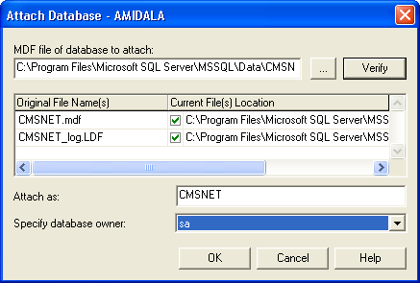
Figure 11 The Attach Database dialog box.
Exit Enterprise Manager. Now you are all set to play with CMS.NET.
Using Microsoft Query Analyzer
Just for grins and giggles, I will show you a third way to create and load the CMSNET database. This time, you will execute a SQL script that defines the database. You will find the SQL script, CMSNET.sql, in the same directory on the CD-ROM as the .mdf and .ldf database files--Final/MS SQL Database.
This procedure is a lot easier to execute than the previous two. (It was also a lot harder to build the SQL script, but that is a story for another time.) First, make sure you connect to the SQL Server using SQL Server Authentication and use the login name sa without a password. Then, simply load the Query Analyzer, open the CMSNET.sql file in the script editor, and execute the script. It couldn’t be any easier (see Figure 12).
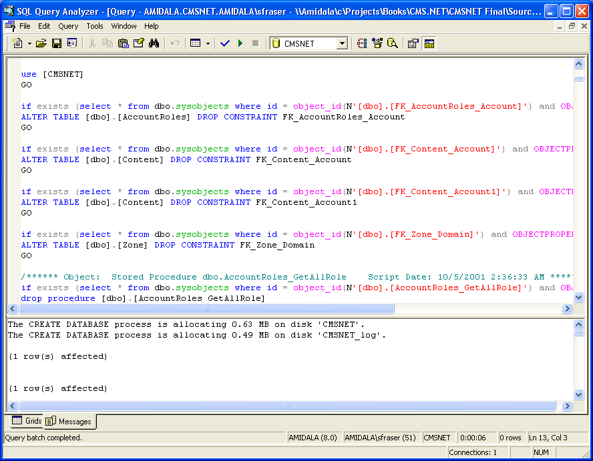
Figure 12 Running CMSNET.sql in the Query Analyzer.
Exit the Query Analyzer. Now you are all set to play with CMS.NET.
Running CMS.NET Setup
The first thing you need to do to get CMS.NET up and running is to let CMS.NET know where its database is. After that is established, CMS.NET needs to know who its administrator is. Let’s pretend you are just an administrator.
You don’t have to do anything special to run the setup procedure--just access CMS.NET’s administration Web site. You can do this in one of two ways. If CMS.NET is on your own machine, enter “http://localhost/CMSNET/admin.aspx” in the address edit field on your browser. If, on the other hand, you are accessing CMS.NET remotely, enter the host address instead of “localhost.” In my case, I entered “www.contentmgr.com/CMSNET/admin.aspx.”
The first time the administration Web site is run, CMS.NET intercepts the request and runs the setup routine. The first Web page you will see is the “Welcome to the CMS.NET Setup” Web page (see Figure 13). Read it and then click on the Continue button.
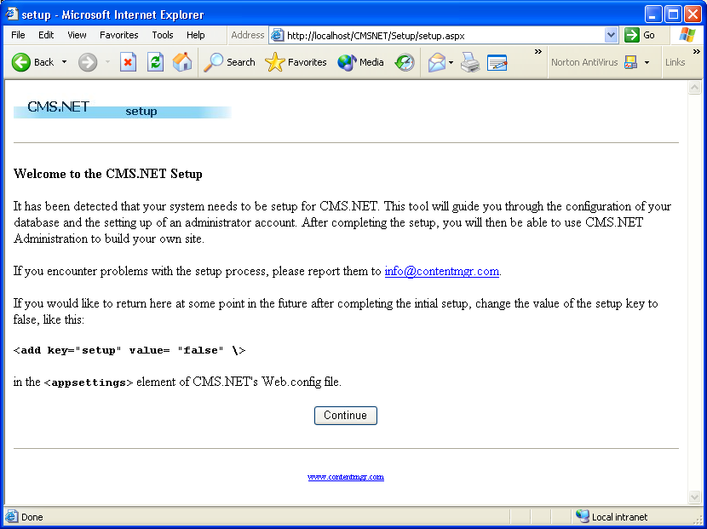
Figure 13 The “Welcome to the CMS.NET Setup” Web page.
The next setup Web page requests where to find its database (see Figure 14). On this Web form, you will enter the following:
* Database--The name you gave the database. It defaults to CMSNET.
* Data Source--The server where the database is housed. If it is on your local machine, just enter “localhost.” On the other hand, if it is remote, enter the server name or the IP address of the database server.
* User ID--The user ID needed to connect to the database. I used the default “sa,” but your database administrator could use just about anything.
* Password--The password needed to connect to the database. I left this blank, but again, you might want to consult with your database administrator because she might have assigned a password.
* Connection Timeout--The length of time in seconds that the system will wait before timing out due to connection problems.
* SMTP Server--The name of the SMTP server to be used to send email alerts. If this filed is left blank no email alerts will be sent.
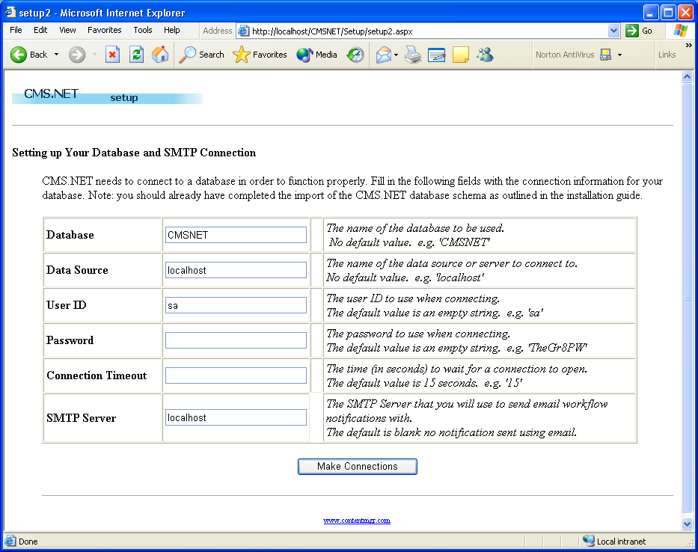
Figure 14 The configure database Web page.
After you have entered the appropriate data, click on the Make Connection button. If CMS.NET can connect to the database you provided, you will be presented with the next Web page. If not, you will be presented with an error message, which should point you in the right direction to fix the problem.
If you get the error:
Access to the path "C:\Inetpub\wwwroot\CMSNET\web.config.001" is denied.
Then you have to provide write privileges to the CMSNET directory for the user group {Machine}\ASPNET. To do this, you do the following:
1. Using Windows explorer, right click on the C:\Inetpub\wwwroot\CMSNET directory.
2. Select properties. This will bring up the dialog box shown in Figure 15.
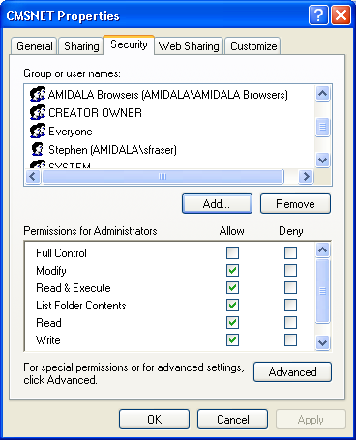
Figure 15 CMSNET Properties dialog box.
3. Select the Security tab.
4. Click on the Add button.
5. Enter {Machine}\ASPNET in the presented dialog box. For my computer I entered AMIDALA\ASPNET.
6. Click on the OK button.
7. Click on the Modify or Write check box.
8. Click on the OK button.
With the database connection out of the way, the setup process next needs to find out who is the primary administrator (see Figure 16). There is really nothing difficult with this Web page; just enter the appropriate information. You have probably entered this same information a hundred times or more elsewhere.
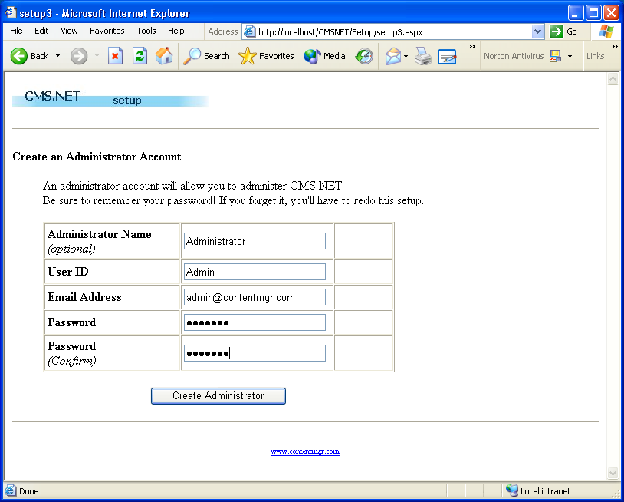
Figure 16 Setting up the administrator account.
That’s all there is to setting up CMS.NET. Your CMS might need more configuration, but this is all that CMS.NET needs to work. The setup procedure presents one more Web page that tells you of your success (see Figure 17), and then it offers you a button to start administrating the Web site.
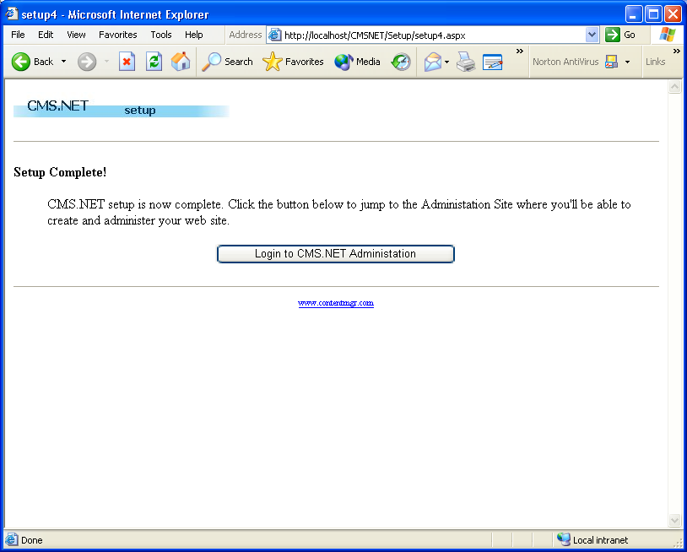
Figure 17 Successful completion of the setup procedure.
Press Login to CMS.NET Administration, and I will meet you in the next section.
A Brief Tutorial
Before I get to coding CMS.NET, let’s take a quick trip through the features of the CMS.NET administration system. If you are like me, seeing things in action before getting into the details provides a frame of reference and makes it easier to understand. This book will not be providing a tutorial of the Internet Web site because that should be self-explanatory or the site is not going to be successful.
Login
Obviously, the first thing you are going to do before you enter the administration Web site is enter your username and password (see Figure 18). If you are the primary administrator, you need to enter the username and password you created during the setup procedure. If you don’t want to have to reenter your password every time you enter the system, you can click on the Remember Login checkbox.
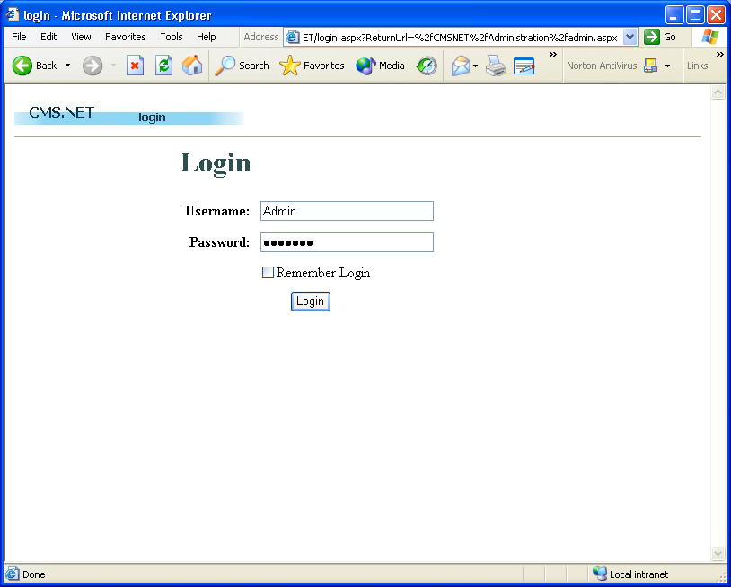
Figure 18 The CMS.NET administration login Web page.
Adding Users
Most likely, you will be developing the Web site with the help of others, and each of these people will have a different role to play. CMS.NET provides a role-based approach to developing content. For now, let’s just create a user that does everything on the system. By the way, you already have someone who has that capability. He is called the administrator, but let’s create another one. As time progresses, your users will start to have smaller or more specific roles, but for now let him have the world.
1. Select Account Maint from the NavBar.
2. Select Create Account. This will display a Web form to create a new user (see Figure 19).
3. Enter the data that is requested in the top half of the form.
4. In the bottom half, Ctrl+click all the roles.
5. Click on the Create Account button.
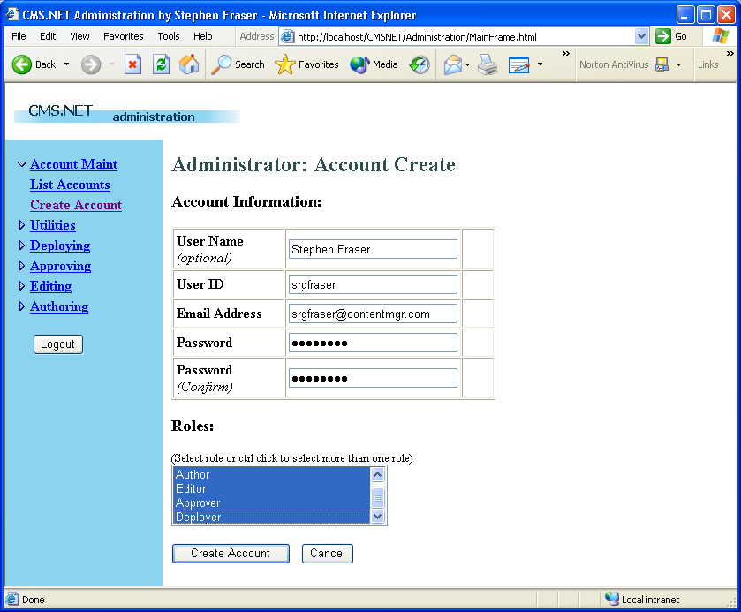
Figure 19 Creating a power user.
You now have a user that can do anything on the system--a very dangerous person, indeed. Log out and then log back in as this new power user.
Creating a Story
Without content, there is no purpose for the CMS, so let’s create our first story and walk it through to deployment. The process of entering the story is very simple.
1. Select Authoring from the NavBar.
2. Select the Create Content menu item. This will display a Web form to create a story (see Figure 20).
3. Enter the data that is requested.
4. Click on the Create Content button.
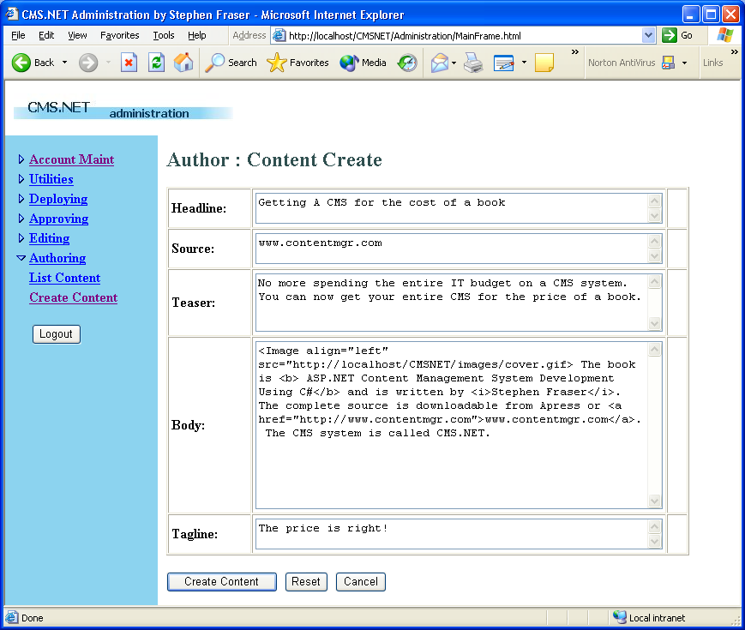
Figure 20 Creating content.
You now have your first story in CMS.NET. I’m sure you want to see if you typed in all that HTML right.
Viewing a Story
Let’s take a look at what you entered. When you finished creating your story, you then jumped to the Content List Web page. This Web page gives an author a snapshot of everything he is currently working on. From here, the author can view, create a note, update, submit, and delete the content (see Figure 21).
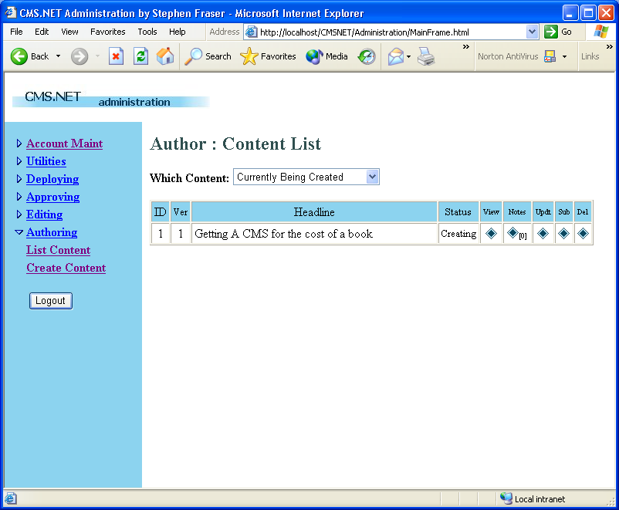
Figure 21 Listing the author’s content.
Okay, let's view the story you entered. Click on the button that looks like a diamond under the View heading for the story you want to view. You will be presented with an author’s view of the story. This is nothing like the view that will be presented to the Internet users. It shows all the content components as separate entities on the Internet site; these components will be merged seamlessly.
Figure 22 shows what you wrote. Not what you were expecting! This shows the danger of giving an author the capability to enter HTML code; if HTML is used incorrectly, complete garbage can be the result, as you can see.
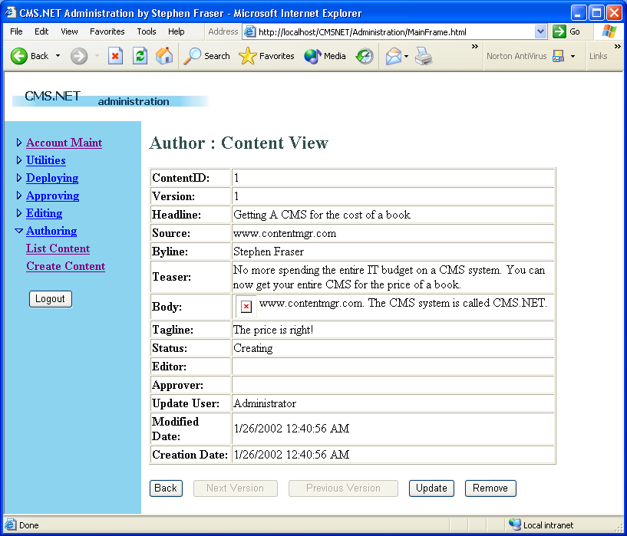
Figure 22 Viewing a content mistake.
Updating a Story
The Web page for updating is very similar to the Web page for creating. The big difference is that it shows more information about the content, such as who was the original author and when she wrote this story.
To update content, simply click on the diamond button under the Update column for the story you want to update. This will open the Update content Web form.
The problem with the page is actually a simple and very common mistake in HTML. I forgot a quote after the address of the image. After fixing this, all is well with the story.
Take a look at the options at the bottom of the Update Web page (see Figure 23). CMS.NET provides simple content versioning. It is possible to create a new version of the content with each update or to fix the current version. It is up to the author whether she wants to use versioning or not. Let’s make the change and create a new version.
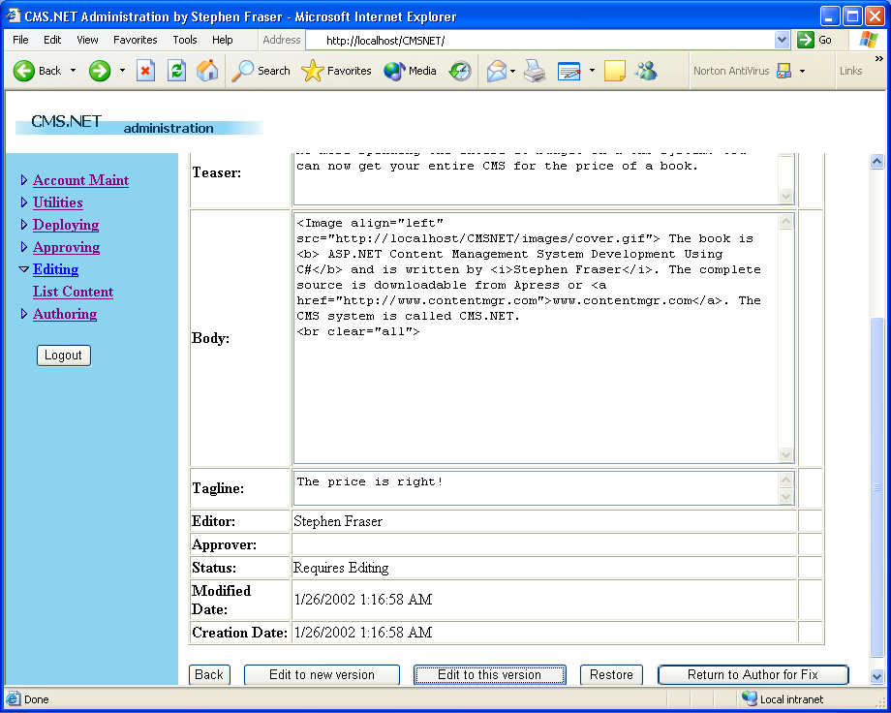
Figure 23 CMS.NET’s version control.
When you view the content now, you notice that it says it’s version 2, just as expected (see Figure 24). You might also notice that at the bottom of the View Web page, you can view previous versions of the content.
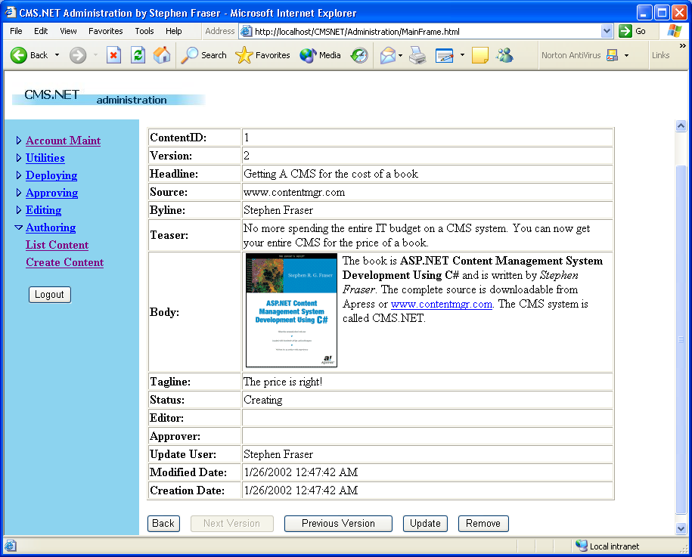
Figure 24 Viewing the corrected content.
Creating a Note
Even though the note facility is very simple in CMS.NET, it provides a lot of functionality if used correctly. It can be used as a means of passing information between roles as the content progresses through its life cycle. It also can be a simple notepad to jot down ideas about a story. Because it is a free format of almost unlimited size, you can put nearly anything you want in it.
Creating a note is simple. Click on the diamond Note button, click on the Create A Note button, and then type your heart out. Finally, just click on the Create Note button (see Figure 25) to save the note and have it associated with a specific piece of content.
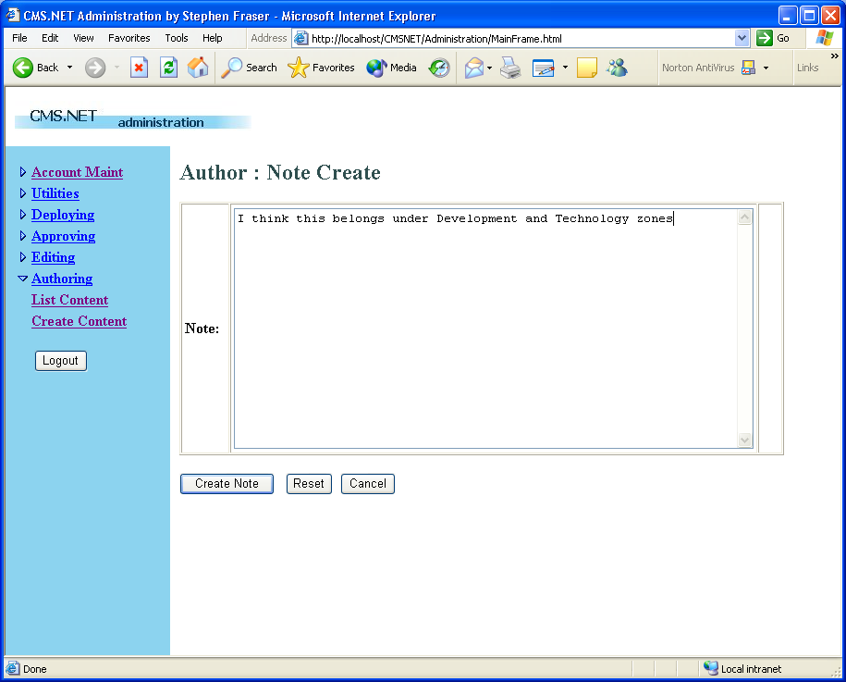
Figure 25 The Note Web page.
Submitting Content to Editors
You’ve finished your masterpiece, and you’re ready for the editors to rip it to shreds. It’s time to submit the content back into the workflow. The process barely needs explanation. Just click on the diamond Submit button and then click on the Submit Content button (see Figure 26). At this point, the story is no longer under your control. In fact, you now only have read access to the story. You still have the capability to create notes for the story, and using this method, you can request it back for any changes you think you need to make.
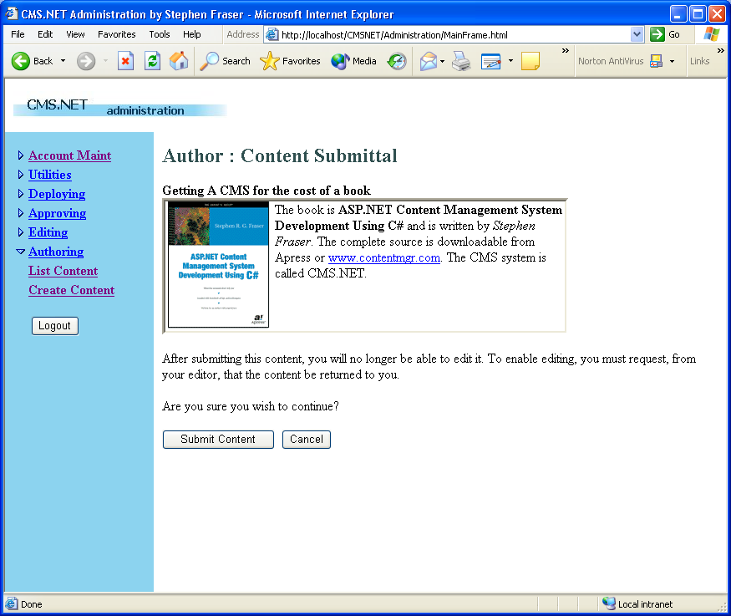
Figure 26 Submitting content.
That’s it from the author’s point of view. There are a few other features, and I recommend that you play around with the content development Web pages. But it is now time to move on to the editor’s role.
Editing Content
The editing process is very similar to the authoring process. The big difference is that a piece of content does not originate with an editor. Thus, there is no menu item to create content. An editor has the capability to view, create notes, edit, withdraw, submit, and return content back to the author (see Figure 27). I have already covered viewing, creating notes, and submitting when covering the author’s functionality.
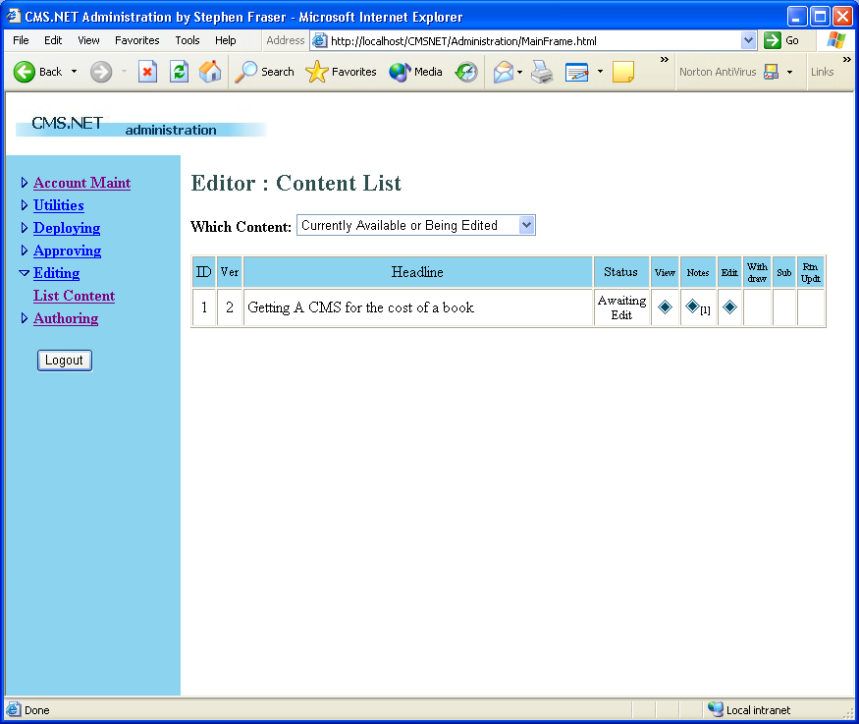
Figure 27 Listing the editor’s content.
In fact, I have already covered editing as well because it is nearly identical to the author’s updating process. The only difference is that when an editor first selects a piece of content to edit, it gets assigned to him and no one else can edit it. Before this time, the content was available to all editors for editing.
Withdrawing
Because the editor has exclusive rights to the content, CMS.NET needed to add a way for the editor to give up his lock on the content so that another editor could work on it. Why do you need to be able to do this? Editors get sick and go on vacations, so if the content is important enough, withdrawing and allowing another editor to finish the work might enable the content to get through the system in a timelier manner.
The withdrawing process is nearly the same as the submitting process. Click on the diamond Withdraw button and then click on the Withdraw As Editor button (see Figure 28). By the way, there is nothing stopping an editor from reselecting a piece of content at a later date.
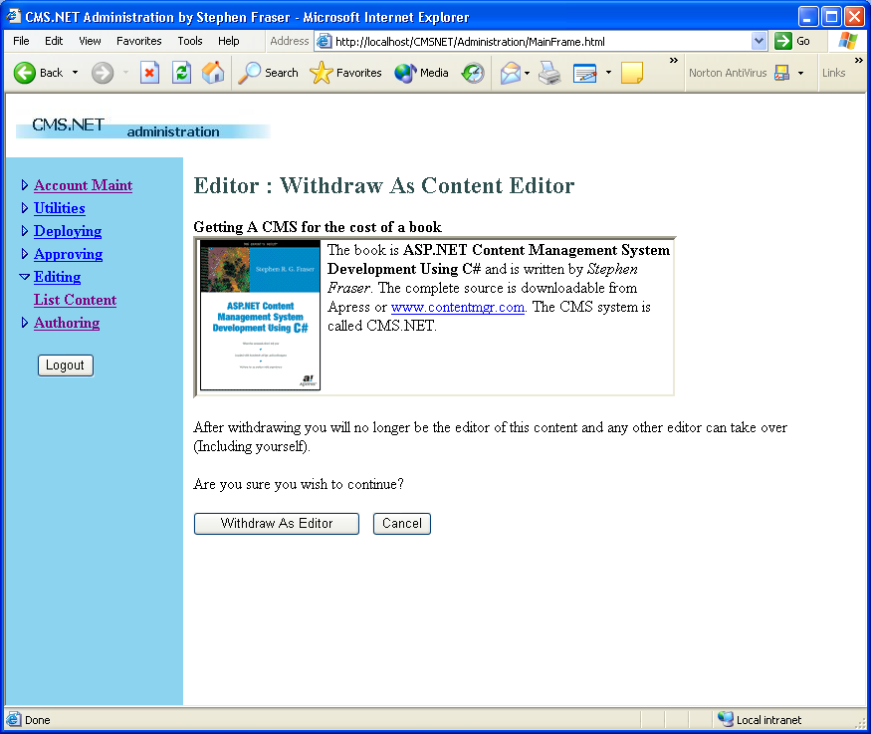
Figure 28 Withdrawing as the editor.
Returning Content to the Author
If the editor feels that the author needs to do more work on the content, he can return it. When the author finishes with her updates to the story and resubmits it, this time the story is routed directly to the editor who returned it to the author. This author-to-editor cycle can be repeated as many times as necessary to complete an acceptable story for the Web site.
The returning process is the same as all role-transition processes. Click on the diamond Return button and then click on the Return Content button (see Figure 29).
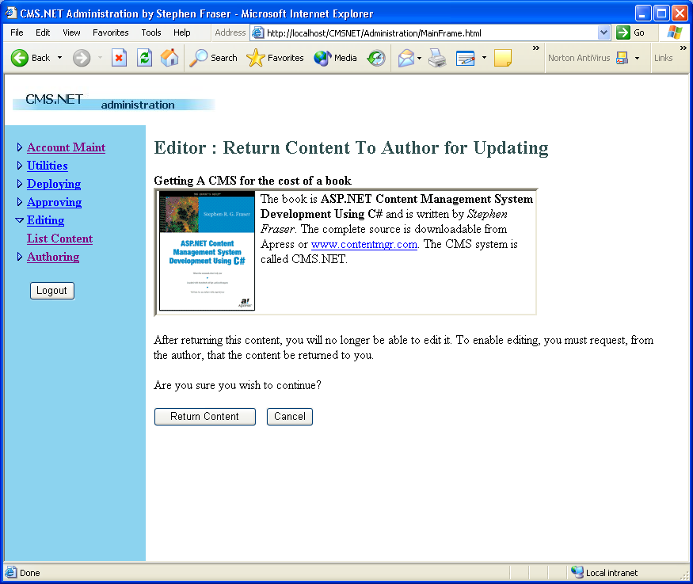
Figure 29 Returning content to the author.
That’s it for the new functionality provided to the editor. Now let's move on to the approver, who has the ultimate say on whether the story is acceptable for the Web site.
Approving Content
CMS.NET requires only one person with approval status to approve content. After an approver approves content, it will be eligible to be placed on the Web site. Approvers cannot change the content they are approving in any way. If changes need to be made, the content must be returned to the editor, usually accompanied by a note discussing what needs to be fixed.
The role of the approver is very simple. He can view, create notes, approve, return, or cancel content (see Figure 30). I have covered almost every one of these functions in the previous roles. The only one that needs some clarification is canceling content.
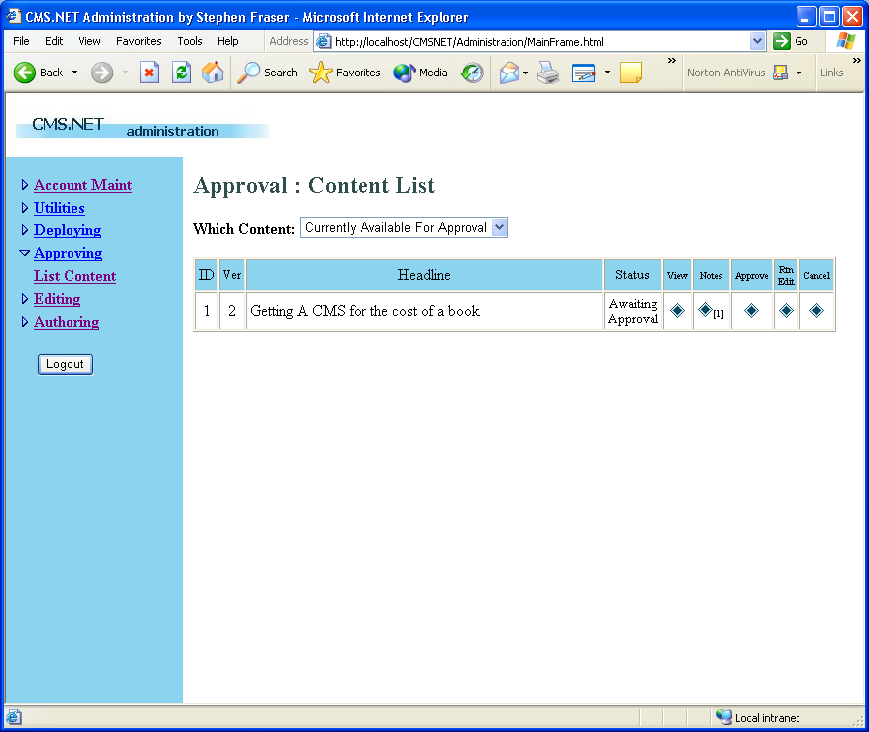
Figure 30 Listing the approver’s content.
Canceling Content
The workflow of CMS.NET uses simple static workflow and the approver has the capability to stop midstream the development of a piece of content. This obviously means that if the approval staff is not kept in the loop as to what is in the content pipeline, it is possible that time could be wasted by authoring and editing an unwanted piece of content.
The process of canceling is very similar to any of the other role-transition processes. The big difference is that the author and editor of the content are emailed and told the reason why the content was cancelled (see Figure 31).
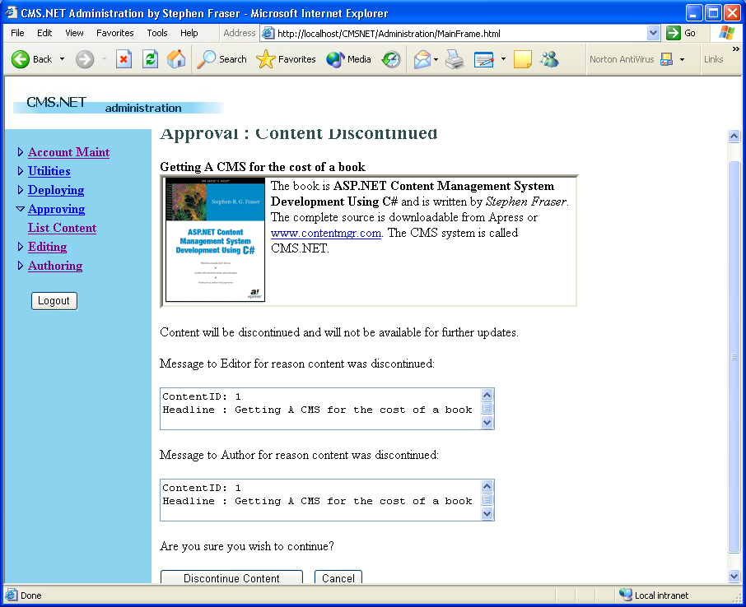
Figure 31 Canceling content.
All that is left after approval is deploying the content to the Web site. Once deployed, it will be visible to the Internet world (if, of course, the Web site is visible to the Web).
Deploying Content
The role of a deployer is very simple and is broken into two parts: routing and prioritizing. Routing is the process of placing the content into the appropriate zone or zones. Prioritizing is the process of ranking content to determine in what order the content is displayed.
The deployment process starts by receiving content in the Deploy List (see Figure 32). All content that is approved is routed to this list. From here, the deployer views the content and determines which zone to place it in. If notes have been used, the job of the deployer may be simplified because the author, editor, and approver might also provide suggestions as to where to deploy the content.
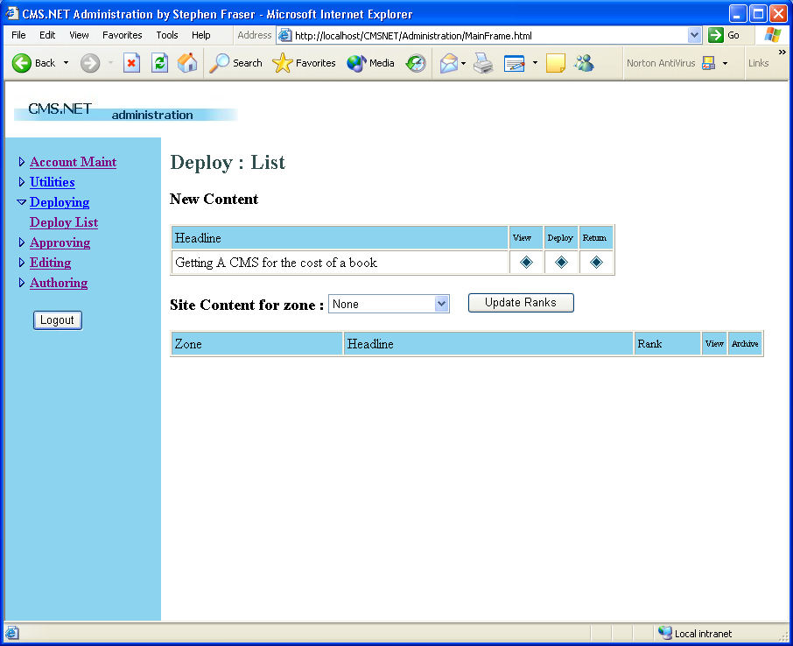
Figure 32 The deployer’s content list.
After the deployer decides where the content is to be placed, he then clicks on the diamond Deploy button. This will bring up the Content Deployment Web page (see Figure 33). This page simply displays the content and asks the deployer to Ctrl+click on any zones in which the content should be deployed. After all the zones have been selected, click on the Deploy Content button.
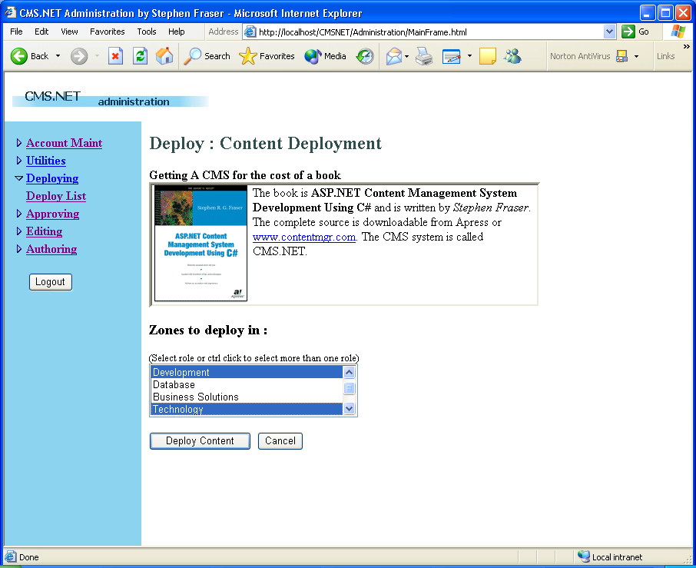
Figure 33 Deploying the content.
Prioritizing Content
The final step before the content is displayed is prioritizing the content. Each piece of content can have a different priority in each zone in which it appears. There are four priorities in CMS.NET:
* Low--This content will be displayed last, sorted by date last modified.
* Average--This content will be displayed before the Low setting but after the High setting. It is also sorted by last modified date.
* High--This content will be displayed first, sorted by date last modified. The exception is if there is a lead.
* Lead--This is the top story, and there is only one per zone. It will always be displayed first.
All content is deployed with a default value of Average. To change the default, select the zone in which the content resides from the Site Content For Zone drop-down box. Then, after all the content is displayed for that zone (see Figure 34), update the ranking in the drop-down box for the content. Finally, click on the Update Ranks button. (If you forget to do this, no ranking changes will be saved.)
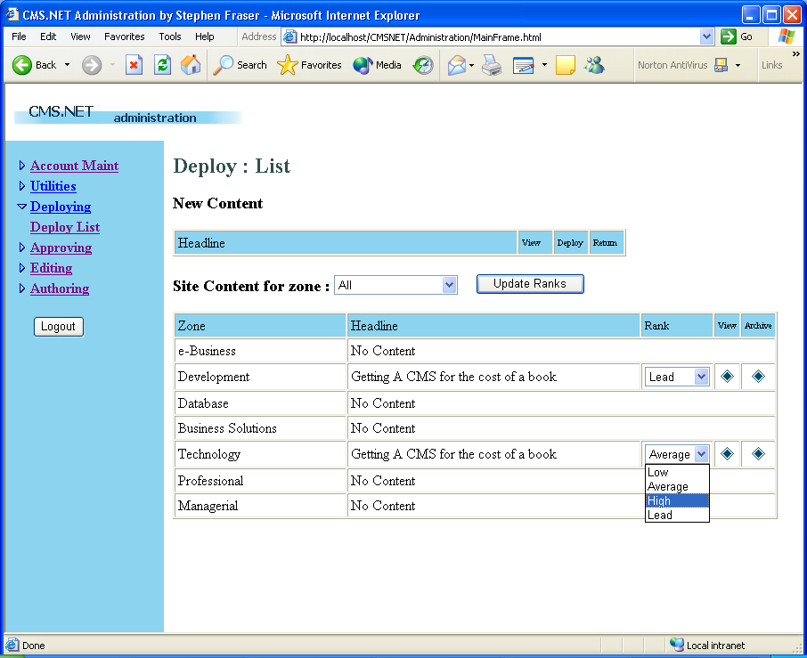
Figure 34 Updating priorities.
You now have a piece of content that you can view from your Web site--congratulations! Okay, log on to the Web site and take a peek.
Oops, the “I’m changing” Web page is still there. Not a big deal. Let’s fix that.
Starting and Stopping the Web Site
First, click the Utilities and Site Start/Stop menu items on the NavBar and then simply click on the Bring Site Up? button (see Figure 35). The button will then change to Bring Site Down?, which you click on to shut the Web site down. Pretty easy, don’t you think?
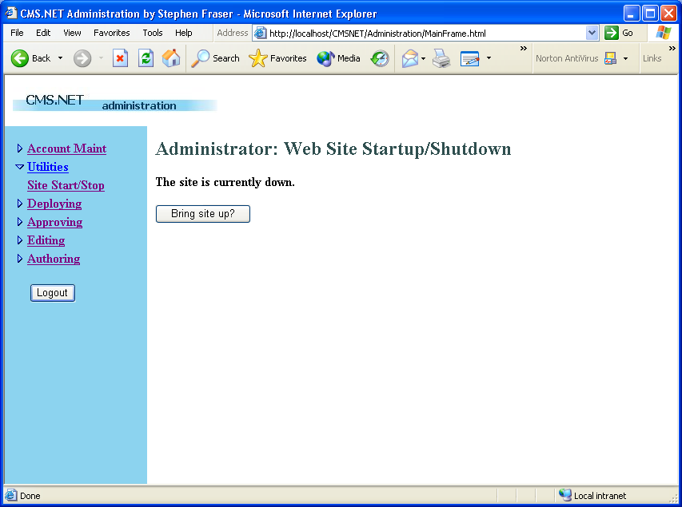
Figure 35 Starting and stopping the Web site.
Okay, now log in and see your story. You will find it in the zone into which you deployed it. Here it is in Figure 36. Not too bad, if you ask me.
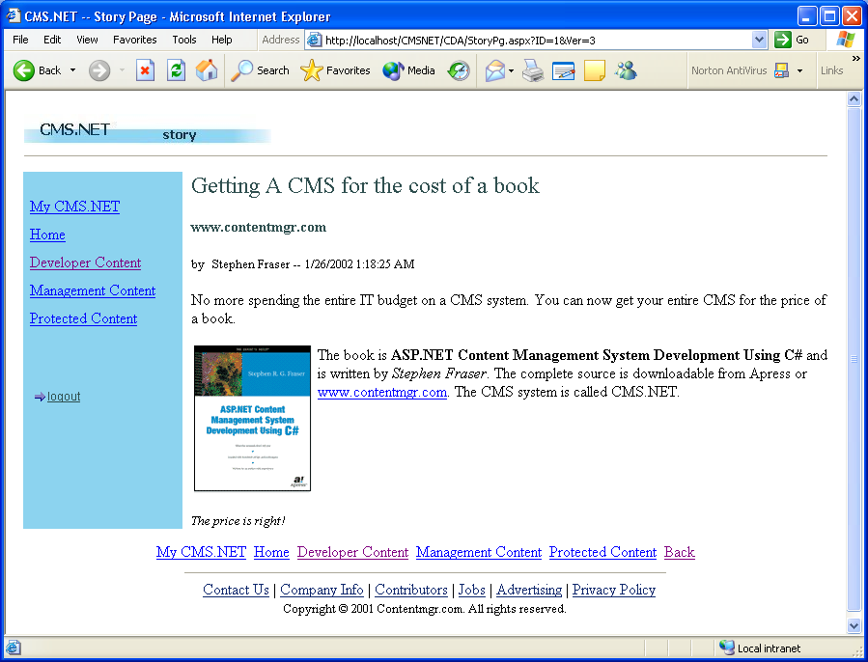
Figure 36 Your first CMS.NET story.

