**Step 1: Install Python (if not already installed)**

Before proceeding with the installation of any packages, ensure that Python is installed on your system. You can check if it's already installed by running:

python –version

If Python is not installed, you can download it from [python.org](https://www.python.org/downloads/).

Make sure to click ‘Use admin privileges when installing py.exe’ and ‘Add python.exe to PATH’

If you close, and re-open the terminal you should now see python installed  
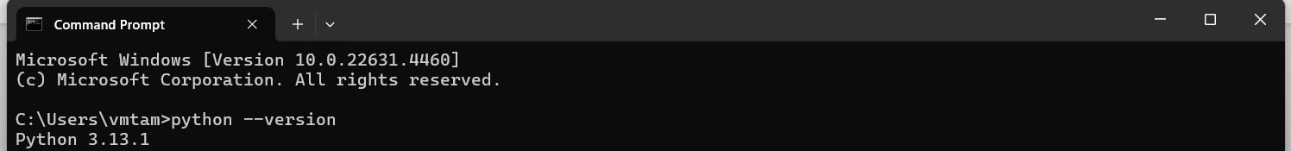

**Step 2: Install Jupyter Notebook**

If you don't already have Jupyter Notebook installed, you can install it using pip (Python's package installer). Open your terminal and run:

pip install notebook

**Step 3: Install scikit-learn**

Now, to install the scikit-learn package (which is likely the correct name you're referring to), run the following command in your terminal:

pip install scikit-learn

**Step 4: Launch Jupyter Notebook**

Once Jupyter Notebook and scikit-learn are installed, you can launch Jupyter by running:

jupyter notebook

This will open Jupyter in your web browser. Create a folder directory on your PC for this course.

**Step 5: Import scikit-learn in a Notebook**

After opening Jupyter Notebook, create a new Python notebook and try importing scikit-learn to make sure it's installed correctly. In a notebook cell, enter:

import sklearn

print(sklearn.__version__)

Click ctrl + enter to run this cell. If no errors appear, scikit-learn is successfully installed and ready to use.

*Note: You will need to be comfortable installing certain packages. Attempt to install the following common packages using the below command  
  
pip install pandas  
*

*Repeat for  
numpy, matplotlib, imageio, mglearn*