Dublin Ohio Office Move Analysis

**Applied Data Science Capstone Project Presentation**

Vincent Tkac

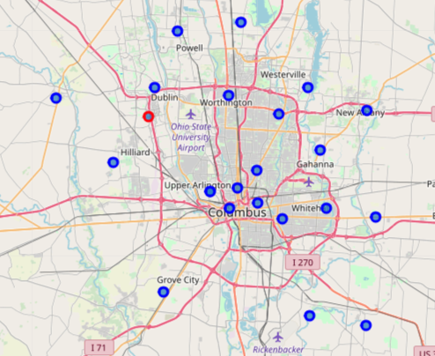

# **Introduction Learn about potential new office locations**

To get started right away, just tap any placeholder text (such as this) and start typing.

* View and edit this document in Word on your computer, tablet, or phone.
* You can edit text; easily insert content such as pictures, shapes, and tables; and seamlessly save the document to the cloud from Word on your Windows, Mac, Android, or iOS device.

## **Data**

My data will came from a number of sources, including wikipedia, google/bing, foursquare and the USPS.

* The following data sources were used:
  + wikipedia and other sites about Columbus Ohio to gather zip code and neighborhood info.
  + foursquare to collect info on locations and venues
  + google/bing to determine drive time to each location from my home.
* The data zip code and neighborhood data will be of the format:

Zip, neighborhood, longitude, latitude

* The venue data will be of the format:

Neighborhood, top venues 1-10

* The travel data will be of the format:

Neighborhood, travel distance to loation, travel time to location

## **Discussion**

* Several of the locations close to my home also have good venue options but I do worry about Delaware given the lack of restaurants and cafes shown in the results.

## **Methodology**

* The exploratory data analysis is explained in detailed in the Jupyter notebook. See the notebook for futher details.
* Collect a list of areas around Columbus.
* Use Foursquare REST APIs to determine the zipcode and longitude and latitude data for those areas.
* Use Foursquare REST APIs to determine the most common venue types for each target area.
* Use Bing REST APIs to determine drive time and drive distance between my home and each target area.

## **Results**

* As you can see in the following data, the top locations for me are Powell, Lewis Center, Dublin (where the office is now) and Westerville.
* I do worry about Delaware given the lack of restaurants and cafes shown in the results.

Determine the drive distance and drive time from my home to the potential new office locations.

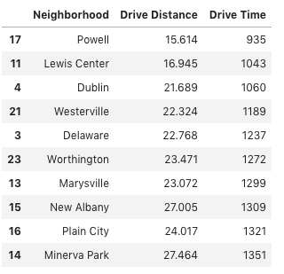

Determine the most prevalent venue types in each area.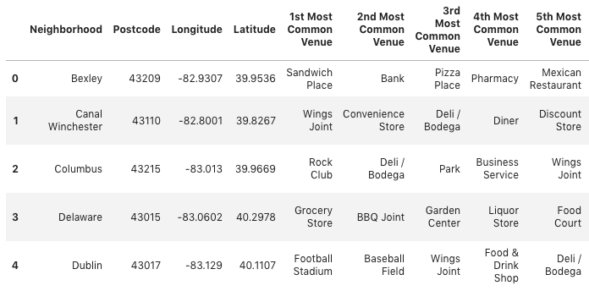

Bring the driving distance and venue data back together and sort based on driving distance.

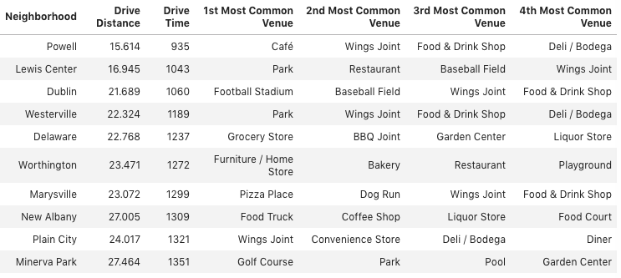



## **Conclusion**

* There are several good locations for the new office that would be reasonable driving distance and offer an acceptable level of venues for lunch and shopping.
* An analysis of more detailed longitude and latitude locations with tighter radius should be done.