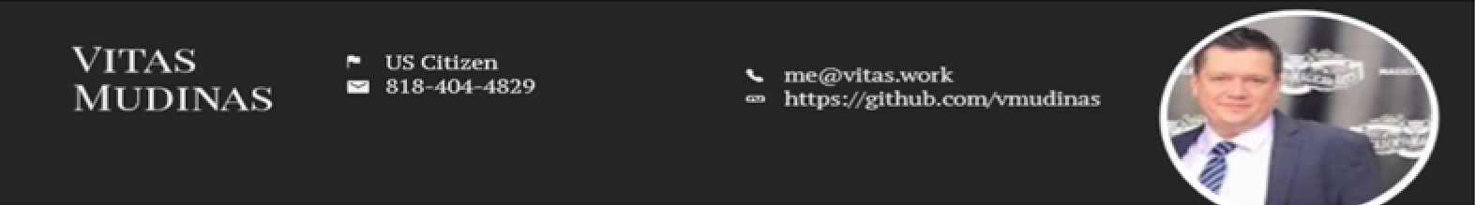

Over 20 years’ experience in complex enterprise level windows and web front-end (React, Angular, jQuery, [ASP.NET](http://asp.net/), MVC, WinForms, WPF, etc.) as well as back- end implementations (Sockets, REST, WCF, Web API, Node), experience working as DevOps engineer on various size projects. Strong understanding of software architecture, design patterns, test-driven development and various other software development methodologies and practices.

# WORK EXPERIENCE

**Senior Software Engineer** 01/2020 – 06/2022 Universal Music Group, Los Angeles, United States

Implementation of UMG video publishing system.

**Stack**: .*net core 6, react Js, Kubernetes, Microservices, AWS, SQS, CloudWatch, Lambda, PostgreSQL, Octopus Deployment, Terraform*

*Hybrik, SonyCli integration*

**Senior Software Consultant** 08/2019 – 07/2020 Optimity Advisors, Los Angeles, United States

Daylight transport and Monterey Bay project design and implementation.

**Stack**: *.net core, Angular 8, Redux, Webpack, Docker, AWS, SQS, Lambda, Git, Jira*

**Software Architect** 10/2016 – 07/2019 Hygiena/Warburg Pincus, Camarilo, USA

Design, management and implementation of Biotech hardware and cloud solution for it.

Micro-services, azure environment and CI/CD pipeline setup. Kanban implementation. WPF application migration to Angular .net core on Azure. SQL/Cosmos DB database design and implementation. Web API 2 design and implementation for data synchronization. **Stack**: *Angular, ReactJs, Node, js, Asp. net core, Azure, Devexpress, Devextreme, C3 .js, D3 .js, moment .js*

**Senior Software Engineer** 01/2016 – 12/2016 Union Bank/Mitsubishi UFJ, Los Angeles, USA

Asset Liability Management, Liquidity Management, short and long-term cash flow and stress testing regulatory system.

**Stack**: *WCF, ASP .net MVC, MVVM, AngularJS, SQL, SSIS ETL, Autosys, MS SQL, Oracle, TFS, Kendo UI, Telerik Controls*

**Lead Software Engineer** 09/2012 – 01/2016 Lightspeed Data Solutions, Inc., Beverly Hills, USA

TDMS post-trade settlement systems development and support.

**Stack**: *ASP .net 5, MVC 5/6, MVVM, Kendo UI, Kendo Data Access ORM, Entity Framework, MS SQL, TFS, Git, Bower, react js*

**Software developer** 09/2010 – 08/2012 SmartAction, Los Angeles, USA

SmartAction™ is at the evolutionary forefront of call automation, with our cloud-based, artificial intelligence speech IVR solution

**Stack**: .*net C#, WPF, ASP .net MVC.*

# WORK EXPERIENCE

**IT Consultant** 03/2008 – 09/2010 Cymba Technologies/Octopus Investments, London, United Kingdom

Developed trading engine with C++/CLI (FIX protocol, sockets) for Bloomberg/Fidessa. Supported Octopus Investment hedge fund and HSBC

# DEVELOPMENT

## Programming Languages

C#

JavaScript Batch/Power Shell C/C++/C++ CLI

VB .net

## Programming

ASP .net core/MVC Web API/WCF MEAN Stack HTML 5

CSS, Bootstrap, Flexbox WPF/Windows Forms Signal R

## Frameworks

Angular Js Angular 2-8 React Js Node Js Knockout Js jQuery

## Libraries

Kendo UI/Telerik DevExpress/ DevExtreme Infragistics

## Databases

Azure Cosmo DB MS SQL/T-SQL/ETL

MySQL/Oracle

Mongo DB/ NoSQL Lite/ Casandra/ Redis Cache AWS RDS/ MySQL Aurora PostgreSQL

# CLOUD/OTHER EXPERIENCE

## Cloud

Docker/ Docker Compose Azure CI/CD, Setup Azure Functions

AWS SQS

AWS ECS, EC2, LightSail AWS Lambda

Kubernetes

Terraform

Octopus Deployment TeamCity