EE 5356 4/28/2011
Assignment 11A

Vasudevan Murali
1000723391

11A. Multi - Scale SSIM:

- Program :
%%%%%%%%%%%%%%%%%%% assign11a.m %%%%%%%%%%%%%%%%%%%
clear all;
close all;
clc;
lena = double(imread('Lena.gif'));
subplot(2,4,1);imshow(uint8(lena));title('Test Image');
image1 = double(imread('Lena1.gif'));
subplot(2,4,2);imshow(uint8(image1));title('Image 1 - Salt Pepper noise');
image2 = double(imread('Lena4.gif'));
subplot(2,4,3);imshow(uint8(image2));title('Image 2 - Mean shift');
image3 = double(imread('Lena3.gif'));
subplot(2,4,4);imshow(uint8(image3));title('Image 3 - Speckle');
image4 = double(imread('Lena2.gif'));
subplot(2,4,5);imshow(uint8(image4));title('Image 4 - Gaussian noise');
image5 = double(imread('Lena6.gif'));
subplot(2,4,6);imshow(uint8(image5));title('Image 5 - Blurred Image');
image6 = double(imread('Lena7.gif'));
subplot(2,4,7);imshow(uint8(image6));title('Image 6 - Compressed Image');
image7 = double(imread('Lena5.gif'));
subplot(2,4,8);imshow(uint8(image7));title('Image 7 - Contrast Stretching');

%%%%%%%%%% Weight for Task 1 %%%%%%%%%%%%%
%w = [0.0448 0.2856 0.3001 0.2363 0.1333];

%%%%%%%%%% Weight for Task 2 %%%%%%%%%%%%%
w = [0.0619 0.1337 0.2254 0.3536 0.2254];

for i = 1:5
mssim1(i) = msssim(lena,image1,i,w);
mssim2(i) = msssim(lena,image2,i,w);
mssim3(i) = msssim(lena,image3,i,w);
mssim4(i) = msssim(lena,image4,i,w);
mssim5(i) = msssim(lena,image5,i,w);
mssim6(i) = msssim(lena,image6,i,w);
mssim7(i) = msssim(lena,image7,i,w);
end
real(mssim1)
real(mssim2)
real(mssim3)
real(mssim4)
real(mssim5)
real(mssim6)
real(mssim7)
avg_mssim1 = sum(mssim1)/5
avg_mssim2 = sum(mssim2)/5
avg_mssim3 = sum(mssim3)/5
avg_mssim4 = sum(mssim4)/5
avg_mssim5 = sum(mssim5)/5
avg_mssim6 = sum(mssim6)/5
avg_mssim7 = sum(mssim7)/5

%%%%%%%%%%%%%%%%%%% msssim.m %%%%%%%%%%%%%%%%%%%
function overall_mssim = msssim(img1, img2, level, weight, K, win, method)

% Multi-scale Structural Similarity Index (MS-SSIM)
% Z. Wang, E. P. Simoncelli and A. C. Bovik, "Multi-scale structural similarity
% for image quality assessment," Invited Paper, IEEE Asilomar Conference on
% Signals, Systems and Computers, Nov. 2003

if (nargin < 2 || nargin > 7)
overall_mssim = -Inf;
return;
end

if (~exist('K'))
K = [0.01 0.03];
end

if (~exist('win'))
win = fspecial('gaussian', 11, 1.5);
end

if (~exist('level'))
level = 1;
end

if (~exist('weight'))
weight = [0.0448 0.2856 0.3001 0.2363 0.1333];
end

if (~exist('method'))
method = 'product';
end

if (size(img1) ~= size(img2))
overall_mssim = -Inf;
return;
end

[M N] = size(img1);
if ((M < 11) || (N < 11))
overall_mssim = -Inf;
return;
end

if (length(K) ~= 2)
overall_mssim = -Inf;
return;
end

if (K(1) < 0 || K(2) < 0)
overall_mssim = -Inf;
return;
end

[H W] = size(win);

if ((H*W)<4 || (H>M) || (W>N))
overall_mssim = -Inf;
return;
end

if (level < 1 || level > 5)
overall_mssim = -Inf;
return;
end

min_img_width = min(M, N)/(2^(level-1));
max_win_width = max(H, W);
if (min_img_width < max_win_width)
overall_mssim = -Inf;
return;
end
%{
if (length(weight) ~= level || sum(weight) == 0)
overall_mssim = -Inf;
return;
end
%}
if (method ~= 'wtd_sum' & method ~= 'product')
overall_mssim = -Inf;
return;
end

downsample_filter = ones(2)./4;
im1 = double(img1);
im2 = double(img2);
for l = 1:level
[mssim_array(l) ssim_map_array{l} mcs_array(l) cs_map_array{l}] = my_ssim_index(im1, im2, K, win);
% [M N] = size(im1);
filtered_im1 = imfilter(im1, downsample_filter, 'symmetric', 'same');
filtered_im2 = imfilter(im2, downsample_filter, 'symmetric', 'same');
clear im1, im2;
im1 = filtered_im1(1:2:end, 1:2:end);
im2 = filtered_im2(1:2:end, 1:2:end);
end

if (method == 'product')
% overall_mssim = prod(mssim_array.^weight);
overall_mssim = prod(mcs_array(1:level-1).^weight(1:level-1))*(mssim_array(level).^weight(level));
else
weight = weight./sum(weight);
overall_mssim = sum(mcs_array(1:level-1).*weight(1:level-1)) + mssim_array(level).*weight(level);
end

%%%%%%%%%%%%%%%%%%% my_ssim_index.m %%%%%%%%%%%%%%%%%%%

function [mssim, ssim_map, mcs, cs_map] = my_ssim_index(img1, img2, K, win)

if (nargin < 2 || nargin > 4)
mssim = -Inf;
ssim_map = -Inf;
return;
end

if (size(img1) ~= size(img2))
mssim = -Inf;
ssim_map = -Inf;
return;
end

[M N] = size(img1);

if (nargin == 2)
if ((M < 11) || (N < 11))
mssim = -Inf;
ssim_map = -Inf;
return
end
win = fspecial('gaussian', 11, 1.5); %
K(1) = 0.01; % default settings
K(2) = 0.03; %
end

if (nargin == 3)
if ((M < 11) || (N < 11))
mssim = -Inf;
ssim_map = -Inf;
return
end
win = fspecial('gaussian', 11, 1.5);
if (length(K) == 2)
if (K(1) < 0 || K(2) < 0)
mssim = -Inf;
ssim_map = -Inf;
return;
end
else
mssim = -Inf;
ssim_map = -Inf;
return;
end
end

if (nargin == 4)
[H W] = size(win);
if ((H*W) < 4 || (H > M) || (W > N))
mssim = -Inf;
ssim_map = -Inf;
return
end
if (length(K) == 2)
if (K(1) < 0 || K(2) < 0)
mssim = -Inf;
ssim_map = -Inf;
return;
end
else
mssim = -Inf;
ssim_map = -Inf;
return;
end
end

C1 = (K(1)*255)^2;
C2 = (K(2)*255)^2;
win = win/sum(sum(win));

mu1 = filter2(win, img1, 'valid');
mu2 = filter2(win, img2, 'valid');
mu1_sq = mu1.*mu1;
mu2_sq = mu2.*mu2;
mu1_mu2 = mu1.*mu2;
sigma1_sq = filter2(win, img1.*img1, 'valid') - mu1_sq;
sigma2_sq = filter2(win, img2.*img2, 'valid') - mu2_sq;
sigma12 = filter2(win, img1.*img2, 'valid') - mu1_mu2;

if (C1 > 0 & C2 > 0)
ssim_map = ((2*mu1_mu2 + C1).*(2*sigma12 + C2))./((mu1_sq + mu2_sq + C1).*(sigma1_sq + sigma2_sq + C2));
cs_map = (2*sigma12 + C2)./(sigma1_sq + sigma2_sq + C2);
else
numerator1 = 2*mu1_mu2 + C1;
numerator2 = 2*sigma12 + C2;
denominator1 = mu1_sq + mu2_sq + C1;
denominator2 = sigma1_sq + sigma2_sq + C2;

ssim_map = ones(size(mu1));
index = (denominator1.*denominator2 > 0);
ssim_map(index) = (numerator1(index).*numerator2(index))./(denominator1(index).*denominator2(index));
index = (denominator1 ~= 0) & (denominator2 == 0);
ssim_map(index) = numerator1(index)./denominator1(index);

cs_map = ones(size(mu1));
index = denominator2 > 0;
cs_map(index) = numerator2(index)./denominator2(index);
end

mssim = mean2(ssim_map);
mcs = mean2(cs_map);

return

- Images:

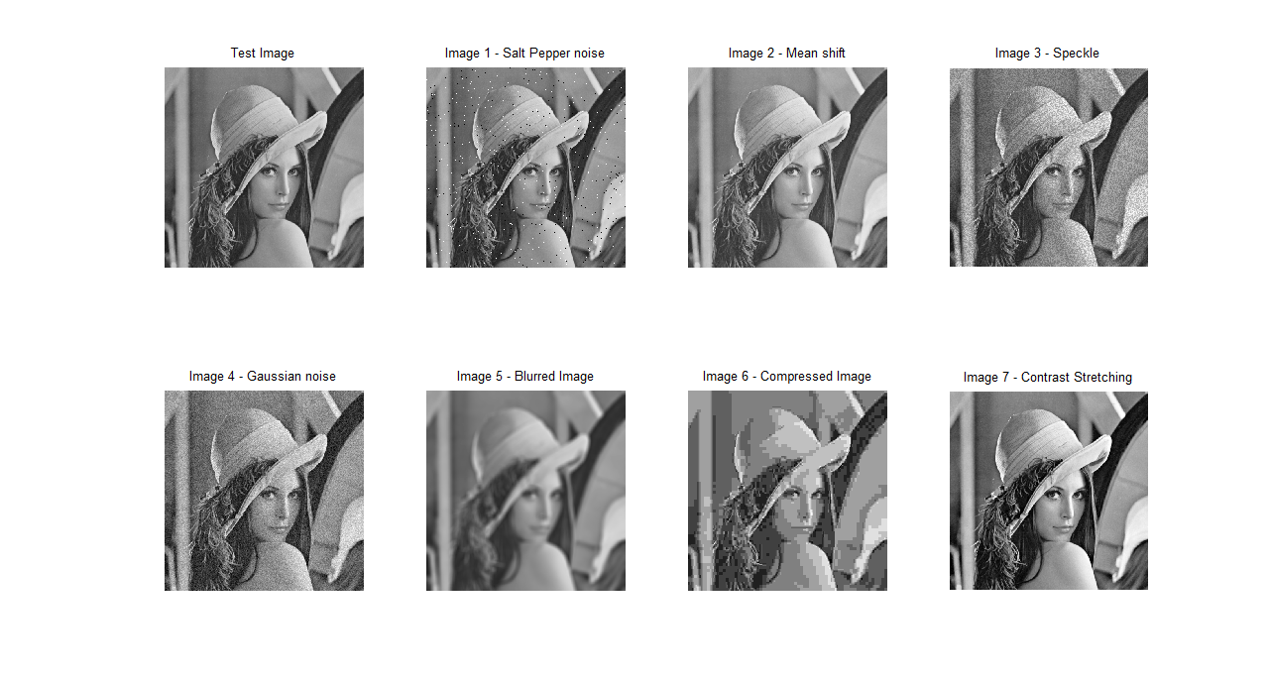

Test Image | Rank
Image 1 | 3
Image 2 | 1
Image 3 | 4
Image 4 | 5
Image 5 | 6
Image 6 | 7
Image 7 | 2

Table 1 MSSSIM values at different levels
Test Image | Level 1 SSIM | Level 2 SSIM | Level 3 SSIM | Level 4 SSIM | Level 5 SSIM | Overall SSIM
Image 1 | 0.98556 | 0.92766 | 0.91400 | 0.91273 | 0.91265 | 0.93052
Image 2 | 0.99951 | 0.99705 | 0.99714 | 0.99794 | 0.99893 | 0.99811
Image 3 | 0.96950 | 0.90196 | 0.88763 | 0.88645 | 0.88640 | 0.90639
Image 4 | 0.96493 | 0.89541 | 0.88185 | 0.88067 | 0.88059 | 0.90069
Image 5 | 0.98339 | 0.90740 | 0.86913 | 0.86160 | 0.86091 | 0.89648
Image 6 | 0.98228 | 0.89573 | 0.84261 | 0.82361 | 0.82114 | 0.87307
Image 7 | 0.99767 | 0.98565 | 0.97877 | 0.97363 | 0.97071 | 0.98129

Table 2 MSSSIM and subjective ranks
Test Image | Level 1 SSIM Rank | Level 2 SSIM Rank | Level 3 SSIM Rank | Level 4 SSIM Rank | Level 5 SSIM Rank | Overall SSIM Rank | Your Subjective Rank
Image 1 | 3 | 3 | 3 | 3 | 3 | 3 | 3
Image 2 | 1 | 1 | 1 | 1 | 1 | 1 | 1
Image 3 | 6 | 5 | 4 | 4 | 4 | 4 | 4
Image 4 | 7 | 7 | 5 | 5 | 5 | 5 | 5
Image 5 | 4 | 4 | 6 | 6 | 6 | 6 | 6
Image 6 | 5 | 6 | 7 | 7 | 7 | 7 | 7
Image 7 | 2 | 2 | 2 | 2 | 2 | 2 | 2

Conclusion:

From the SSIM values we can conclude that the overall SSIM rank of the images is same as that determined by the human eye. The values of 1st and 2nd level are very different from the overall value, so the rank of those respective images varies, even though the SSIM values for other level is high. Also, as the number of levels increase, the SSIM value decreases. These values are calculated with given default weight [0.0448 0.2856 0.3001 0.2363 0.1333]. We can see that the level 3 weight is the highest.
TASK 2:
Now, we assign weights for the level according to the rank that is similar with the subjective rank, normalize the weight such that their sum is equal to 1. In our case, level 3, 4 and 5 ranks matches with the subjective, so I choose almost equal weights for these three levels and it decreases according to the matching rank level.
Weight = [0.0619 0.1337 0.2254 0.3536 0.2254]
Here level 4 has the highest weight followed by 5, 3, 2 and 1.

Table 3 Calculated MSSSIM from the above weights
Test Image | Level 1 SSIM | Level 2 SSIM | Level 3 SSIM | Level 4 SSIM | Level 5 SSIM | Overall SSIM
Image 1 | 0.9800 | 0.9527 | 0.9421 | 0.9401 | 0.9400 | 0.9510
Image 2 | 0.9993 | 0.9986 | 0.9978 | 0.9969 | 0.9981 | 0.9982
Image 3 | 0.9581 | 0.9262 | 0.9151 | 0.9133 | 0.9132 | 0.9252
Image 4 | 0.9518 | 0.9191 | 0.9086 | 0.9068 | 0.9067 | 0.9186
Image 5 | 0.9771 | 0.9411 | 0.9110 | 0.8992 | 0.8980 | 0.9253
Image 6 | 0.9755 | 0.9345 | 0.8924 | 0.8623 | 0.8579 | 0.9046
Image 7 | 0.9967 | 0.9923 | 0.9853 | 0.9739 | 0.9685 | 0.9834

