EE 5356
Assignment 12

Vasudevan Murali
1000723391

12. Universal Image Quality Index (UIQI):

- Program :
%%%%%%%%%%%%%%%%%%% my_uiqi.m %%%%%%%%%%%%%%%%%%%
function [UIQI_metric UIQI_map] = my_uiqi(img1,img2,b_size)

N = b_size.^2;
sum2_filter = ones(b_size);

img1_sq = img1.*img1;
img2_sq = img2.*img2;
img12 = img1.*img2;

img1_sum = filter2(sum2_filter, img1, 'valid');
img2_sum = filter2(sum2_filter, img2, 'valid');
img1_sq_sum = filter2(sum2_filter, img1_sq, 'valid');
img2_sq_sum = filter2(sum2_filter, img2_sq, 'valid');
img12_sum = filter2(sum2_filter, img12, 'valid');

img12_sum_mul = img1_sum.*img2_sum;
img12_sq_sum_mul = img1_sum.*img1_sum + img2_sum.*img2_sum;
numerator = 4*(N*img12_sum - img12_sum_mul).*img12_sum_mul;
denominator1 = N*(img1_sq_sum + img2_sq_sum) - img12_sq_sum_mul;
denominator = denominator1.*img12_sq_sum_mul;

UIQI_map = ones(size(denominator));
index = (denominator1 == 0) & (img12_sq_sum_mul ~= 0);
UIQI_map(index) = 2*img12_sum_mul(index)./img12_sq_sum_mul(index);
index = (denominator ~= 0);
UIQI_map(index) = numerator(index)./denominator(index);

UIQI_metric = mean2(UIQI_map);

return

%%%%%%%%%%%%%%%%%%% my_ssim.m %%%%%%%%%%%%%%%%%%%
function [SSIM_metric SSIM_map] = my_ssim(img1,img2,alph,beta,gamma,C1,C2,C3)

window = fspecial('gaussian', 11, 1.5); %
window = window/sum(sum(window));
image1 = double(img1);
image2 = double(img2);

mu1 = filter2(window, image1, 'valid');
mu2 = filter2(window, image2, 'valid');
mu1_sq = mu1.*mu1;
mu2_sq = mu2.*mu2;
mu1_mu2 = mu1.*mu2;
sigma1_sq = filter2(window, image1.*image1, 'valid') - mu1_sq;
sigma2_sq = filter2(window, image2.*image2, 'valid') - mu2_sq;
sigma12 = filter2(window, image1.*image2, 'valid') - mu1_mu2;

numerator1 = 2.*mu1_mu2 + C1;
numerator2 = 2.*(sqrt(sigma1_sq).*sqrt(sigma2_sq)) + C2;
numerator3 = sigma12 + C3;
denominator1 = mu1_sq + mu2_sq + C1;
denominator2 = sigma1_sq + sigma2_sq + C2;
denominator3 = (sqrt(sigma1_sq) .* sqrt(sigma2_sq)) + C3;
SSIM_map = ones(size(mu1));
index = (denominator1 > 0);
SSIM_map(index) = SSIM_map(index) .* (numerator1(index)./denominator1(index)).^alph;
index = (denominator2 > 0);
SSIM_map(index) = SSIM_map(index) .* (numerator2(index)./denominator2(index)).^beta;
index = (denominator3 > 0);
SSIM_map(index) = SSIM_map(index) .* (numerator3(index)./denominator3(index)).^gamma;

SSIM_metric = mean2(SSIM_map);

return

%%%%%%%%%%%%%%%%%%%%% assign12.m %%%%%%%%%%%%%%%%%%%
% Universal Image Quality Index
clear all;
close all;
clc;

lena = double(imread('Lena.gif'));
subplot(2,4,1);imshow(uint8(lena));title('Original Image');
image1 = double(imread('Lena1.gif'));
subplot(2,4,2);imshow(uint8(image1));title('Image 1 - Salt Pepper noise');
image2 = double(imread('Lena2.gif'));
subplot(2,4,3);imshow(uint8(image2));title('Image 2 - Gaussian noise');
image3 = double(imread('Lena3.gif'));
subplot(2,4,4);imshow(uint8(image3));title('Image 3 - Speckle');
image4 = double(imread('Lena4.gif'));
subplot(2,4,4);imshow(uint8(image4));title('Image 4 - Mean shift');
image5 = double(imread('Lena5.gif'));
subplot(2,4,5);imshow(uint8(image5));title('Image 5 - Contrast Stretching');
image6 = double(imread('Lena6.gif'));
subplot(2,4,6);imshow(uint8(image6));title('Image 6 - Blurred Image');
image7 = double(imread('Lena7.gif'));
subplot(2,4,7);imshow(uint8(image7));title('Image 7 - Compressed Image');

L = 255;
K1 = 0.01;
K2 = 0.03;

C1 = (K1 * L)^2;
C2 = (K2 * L)^2;
C3 = C2/2;

alph = 1;
beta = 1;
gamma = 1;

[SSIM_metric1 SSIM_map1] = my_ssim(lena,image1,alph,beta,gamma,C1,C2,C3);
[SSIM_metric2 SSIM_map2] = my_ssim(lena,image2,alph,beta,gamma,C1,C2,C3);
[SSIM_metric3 SSIM_map3] = my_ssim(lena,image3,alph,beta,gamma,C1,C2,C3);
[SSIM_metric4 SSIM_map4] = my_ssim(lena,image4,alph,beta,gamma,C1,C2,C3);
[SSIM_metric5 SSIM_map5] = my_ssim(lena,image5,alph,beta,gamma,C1,C2,C3);
[SSIM_metric6 SSIM_map6] = my_ssim(lena,image6,alph,beta,gamma,C1,C2,C3);
[SSIM_metric7 SSIM_map7] = my_ssim(lena,image7,alph,beta,gamma,C1,C2,C3);

b_size = 8;
[UIQI_metric1 UIQI_map1] = my_uiqi(lena,image1,b_size);
[UIQI_metric2 UIQI_map2] = my_uiqi(lena,image2,b_size);
[UIQI_metric3 UIQI_map3] = my_uiqi(lena,image3,b_size);
[UIQI_metric4 UIQI_map4] = my_uiqi(lena,image4,b_size);
[UIQI_metric5 UIQI_map5] = my_uiqi(lena,image5,b_size);
[UIQI_metric6 UIQI_map6] = my_uiqi(lena,image6,b_size);
[UIQI_metric7 UIQI_map7] = my_uiqi(lena,image7,b_size);

- UIQI attributes : Block size = 8 ; SSIM attributes : α = β = γ = 1, L = 255, K1 = 0.01 & K3 = 0.03

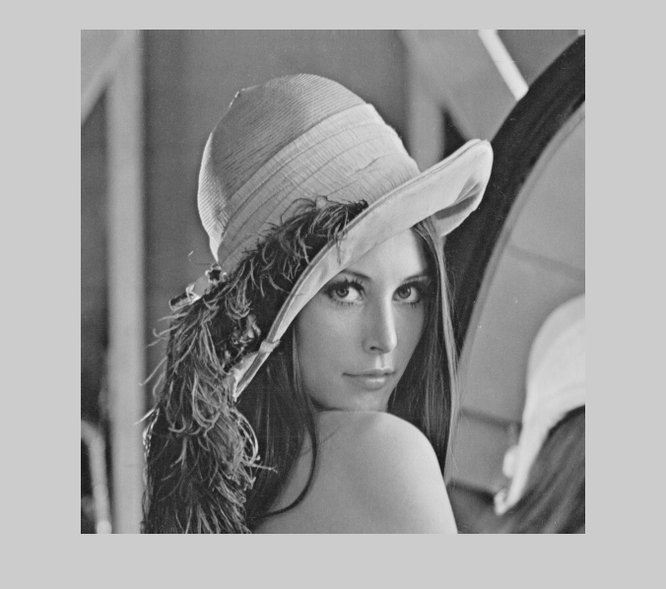
Original Lena UIQI_map
MSE = 0, SSIM = 1, Q = 1

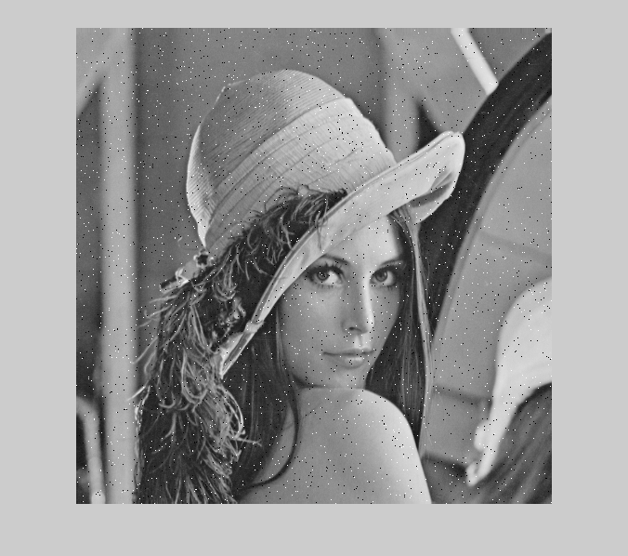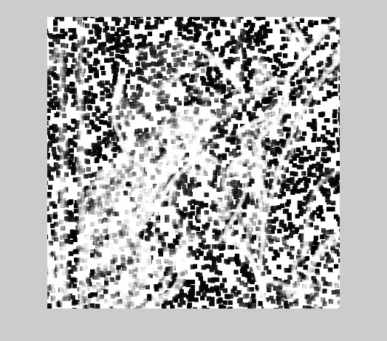
Lena with Impulsive salt pepper noise UIQI_map
MSE = 255, SSIM = 0.7227, Q = 0.6494

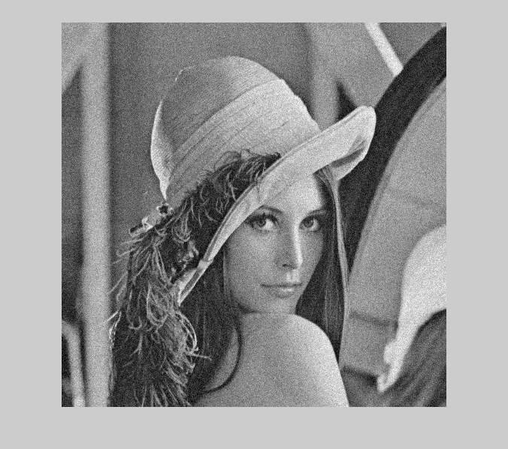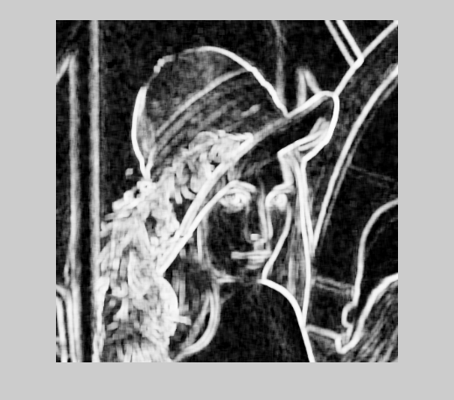
Lena with Additive Gaussian noise UIQI_map
MSE = 255, SSIM = 0.4508, Q = 0.3891

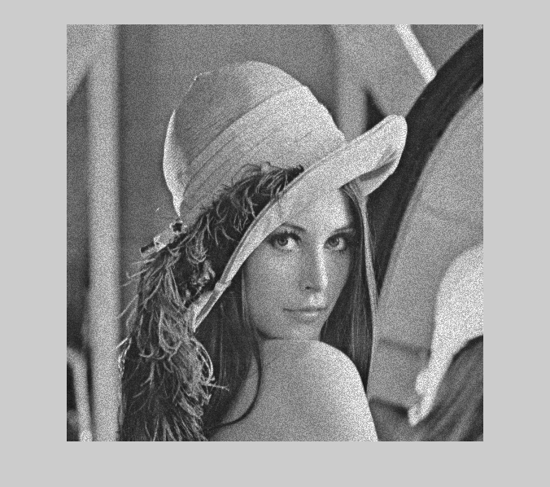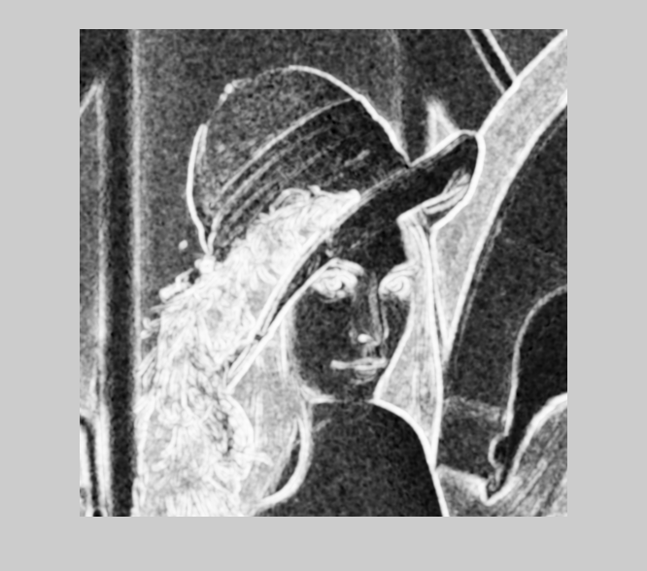
Lena with Multiplicative speckle noise UIQI_map
MSE = 255, SSIM = 0.5009, Q = 0.4408

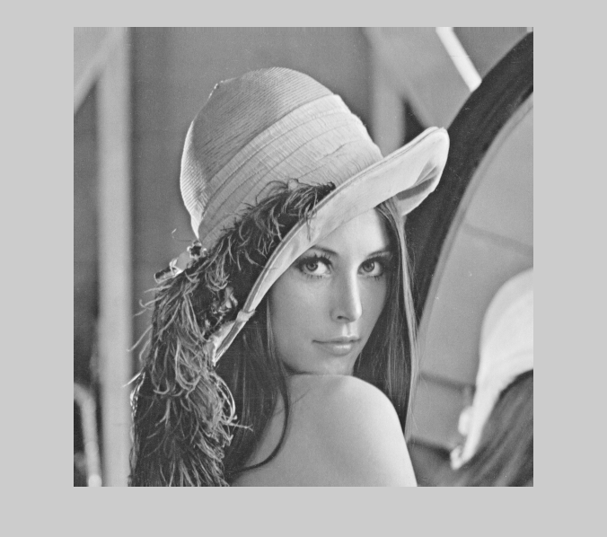
Lena with Mean shift UIQI_map
MSE = 255, SSIM = 0.9890, Q = 0.9894
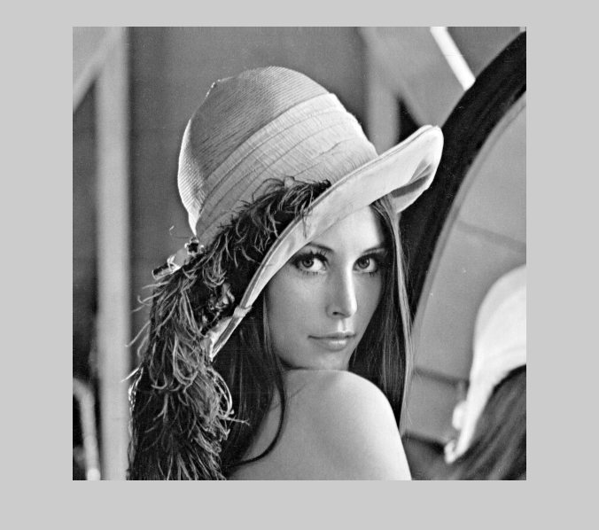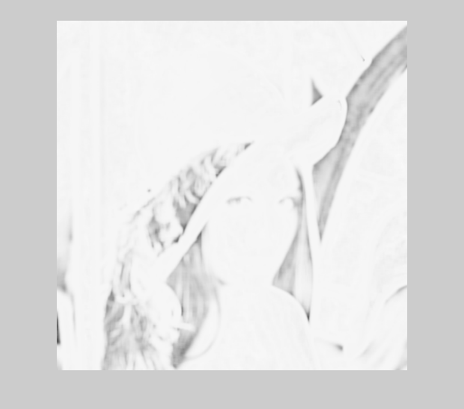
Lena with contrast stretch UIQI_map
MSE = 255, SSIM = 0.9494, Q = 0.9372

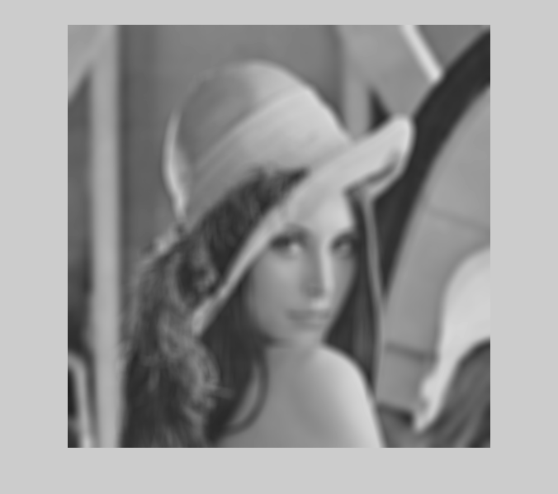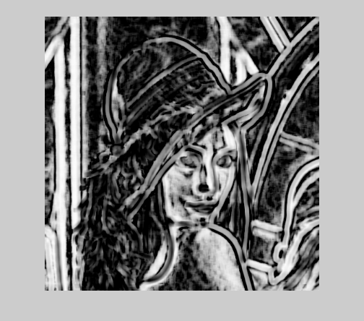
Lena with Blurring UIQI_map
MSE = 255, SSIM = 0.6880, Q = 0.3461

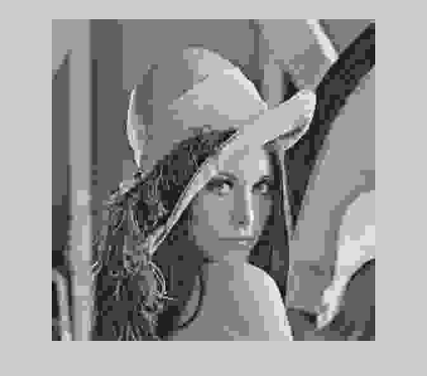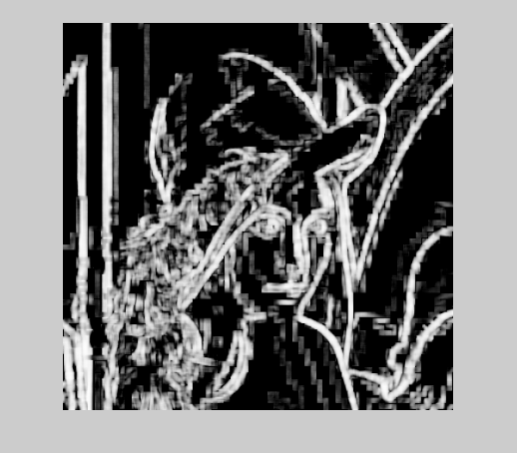
Lena with Compressed Image
MSE = 215, SSIM = 0.6709, Q = 0.2876
Table :

 | MSE | SSIM | UIQI (Q)
Original Lena | 0 | 1 | 1
Lena with salt and pepper noise | 255 | 0.7227 | 0.6494
Lena with additive Gaussian noise | 255 | 0.4508 | 0.3891
Lena with Multiplicative speckle noise | 255 | 0.5009 | 0.4408
Lena with mean shift | 255 | 0.9890 | 0.9894
Lena with contrast stretch | 255 | 0.9494 | 0.9372
Lena with blurring | 255 | 0.6880 | 0.3461
Lena with compression | 255 | 0.6709 | 0.2876

Conclusion:
As we can see that SSIM and UIQI values for do not have any changes in the ranking of the images but values assigned by SSIM and UIQI are very different. The universal image quality index is more similar to perception of the human eye than MSE or SSIM.

