EE 5356 3/31/2011
Assignment 5A

Vasudevan Murali
1000723391

5. Root Filtering:

- Program :
%%%%%%%%%%%%%%%%%%% assign5A.m %%%%%%%%%%%%%%%%%%%
%IGF
clear all;
close all;
clc;

disp(sprintf('menu\n1.Lena\n2.Goldhill\n3.Boat\n4.Girl\n'));
choice = input('enter choice: ');
if(choice == 1)
image = imread('Lena512.bmp');
sigma_sq = 15707;
elseif(choice == 2)
image = imread('goldhill256.bmp');
sigma_sq = 28198;
elseif(choice == 3)
image = imread('boat512.gif');
sigma_sq = 41694;
else
image = imread('Girl512.bmp');
sigma_sq = 34657;
end

fftImage = fft2(image);

[row col] = size(image);

IGF = zeros(row,col);

for i = 1:row
for j = 1:col
if (i <= row/2)
if(j <= col/2)
IGF(i,j) = exp((i^2 + j^2)/(2*sigma_sq));
else
IGF(i,j) = IGF(i,col-j+1);
end
else
if(j <= col/2)
IGF(i,j) = IGF(row-i+1,j+1);
else
IGF(i,j) = IGF(row-i+1,col-j+1);
end
end
end
end

filtImage = IGF.*fftImage;
ifftImage = ifft2(filtImage);

subplot(1,2,1),imshow(image),title('original image');
subplot(1,2,2),imshow(uint8(abs(ifftImage))),title('filtered image');

figure, surf( IGF, 'EdgeColor', 'none');
colormap(hsv);
shading interp;
alpha(0.7);
grid on;
axis tight;
title('IGF');

- Output :
Lena
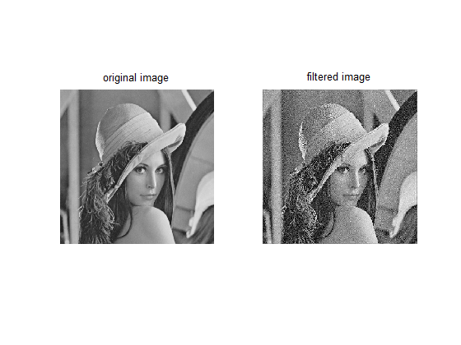
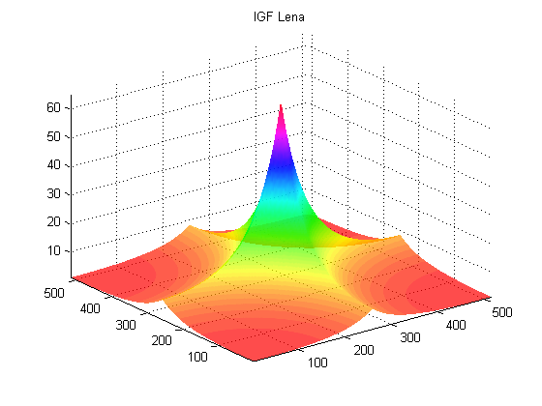

Goldhill
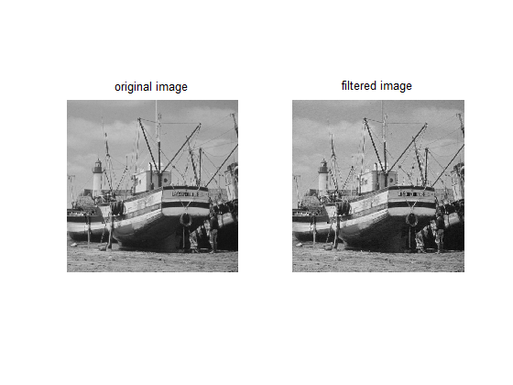
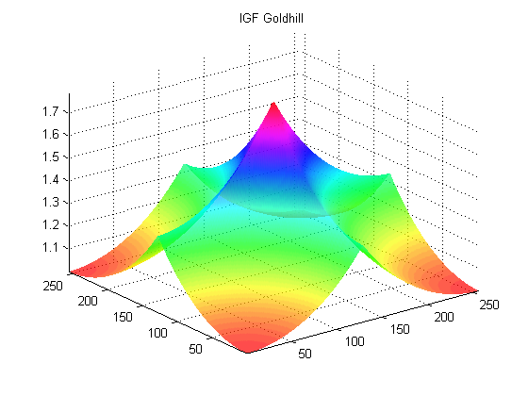
Boat
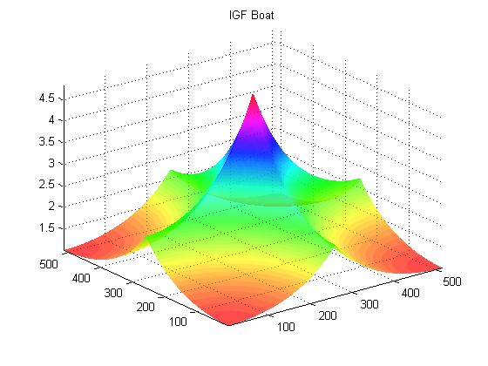
Girl
