EE 5356 4/21/2011
Assignment 8
Vasudevan Murali
1000723391

8. 2-D DPCM:

- Program :
%%%%%%%%%%%%%%%%%%% assign8.m %%%%%%%%%%%%%%%%%%%
% 2D DPCM
clear all;
clc;
close all;

U = imread('goldhill256.bmp');
[row col] = size(U);
Udouble = double(U);
a1 = 0.95;
a2 = 0.95;
a3 = -a1*a2;
a4 = 0;

quantlevels = input('Enter number of quantization levels : ');
q = 256/quantlevels;

Ebar = zeros(size(U));
Uqbar = Ebar;
E = Ebar;
Uq = Ebar;

t = 0:q:q*quantlevels;

r = zeros(1,quantlevels);
for k = 1 : quantlevels
r(k) = t(k) + (q/2);
end

for i = 1:1:row
for j = 1:1:col

E(i,j) = Udouble(i,j) - Uqbar(i,j);

% quantization process
for k = 1:quantlevels
if (E(i,j) >= t(k) && E(i,j) < t(k+1))
Ebar(i,j) = r(k);
end
end

Uq(i,j) = Ebar(i,j) + Uqbar(i,j);

if i > 1
Uqbar(i,j) = Uqbar(i,j) + a1*Uq(i-1,j);
if j > 1
Uqbar(i,j) = Uqbar(i,j) + a3*Uq(i-1,j-1);
end
if j < col
Uqbar(i,j) = Uqbar(i,j) + a4*Uq(i-1,j+1);
end
end
if j > 1
Uqbar(i,j) = Uqbar(i,j) + a2*Uq(i,j-1);
end
end
end

sq_err = 0;
for i = 1:row
for j = 1:col
sq_err = sq_err + (Udouble(i,j)- Uq(i,j))^2;
end
end
mse = sq_err/(row*col); % MSE calculation
variance = var(var(E));
psnr = 10 * log10(variance/mse); % PSNR calculation

% Reconstruction filter

Uq = Ebar + Uqbar;

figure; imshow(U,[]); title('Original Image');
figure; imshow(Uq,[]); title('Reconstructed Image');
disp(psnr);

- Images:

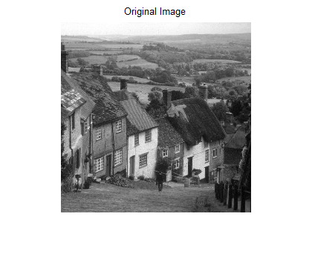

Q = 100
PSNR = 53.1730

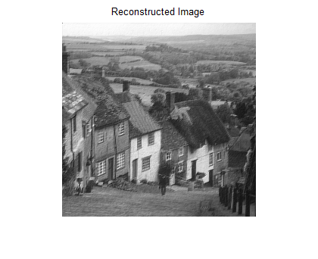

Q = 500
PSNR = 67.1845

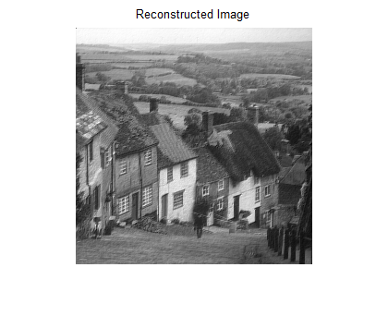

Q = 800
PSNR = 71.1036

