EE 5356 4/21/2011
Assignment 9
Vasudevan Murali
1000723391

9. LOSSLESS PREDICTIVE CODING:

- Program :
%%%%%%%%%%%%%%%%%%% assign9.m %%%%%%%%%%%%%%%%%%%
%lossless predictive coding

clear all;
clc;
close all;

U = double(imread('Lena512.bmp'));
[row col] = size(U);

Ubar = zeros(size(U));
for i = 1:1:row
for j = 1:1:col
if j > 1
Ubar(i,j) = U(i,j-1);
else
Ubar(i,j) = U(i,j);
end
end
end

% prediction error
E = U - Ubar;

Udot = zeros(size(U));
%reconstruction
for i = 1:1:row
for j = 1:1:col
if j > 1
Udot(i,j) = E(i,j) + U(i,j-1);
else
Udot(i,j) = E(i,j) + U(i,j);
end
end
end

figure; imshow(U,[]),title('Lena Original Image');
figure; imshow(Udot,[]),title('Lena Reconstructed Image');
figure; imshow(E,[]),title('Prediction Error Image');

% figure,imhist(uint8(U));
% figure,imhist(uint8(E));

% figure;plot(Uhist),title('Histogram of Original Lena image');
% figure;plot(Ehist),title('Histogram of Prediction Error image');

% Uentropy = entropy(U);
% Eentropy = entropy(E);

[nU,xoutU] = hist(reshape(U,1,512*512),100);
figure(4);
bar(xoutU,nU);title('Image Histogram');
pU = nU/sum(nU);
entropyU=0;

for i=1:length(xoutU)
if ( pU(i)>10e-8 )
entropyU = entropyU - pU(i) * log2(pU(i));
end
end

[nE,xoutE] = hist(reshape(E,1,512*512),100);
figure(5);
bar(xoutE,nE);title('Error Image Histogram');
pE = nE/sum(nE);
entropyE = 0;
for i=1:length(pE)
if (pE(i)>10e-8)
entropyE = entropyE - pE(i) * log2(pE(i));
end
end

fprintf('Entropy of original image = %f',entropyU);
fprintf('Entropy of reconstructed image = %f',entropyE);

- Images:

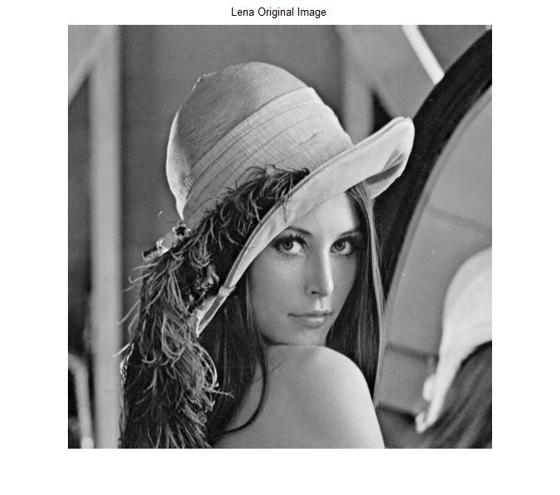
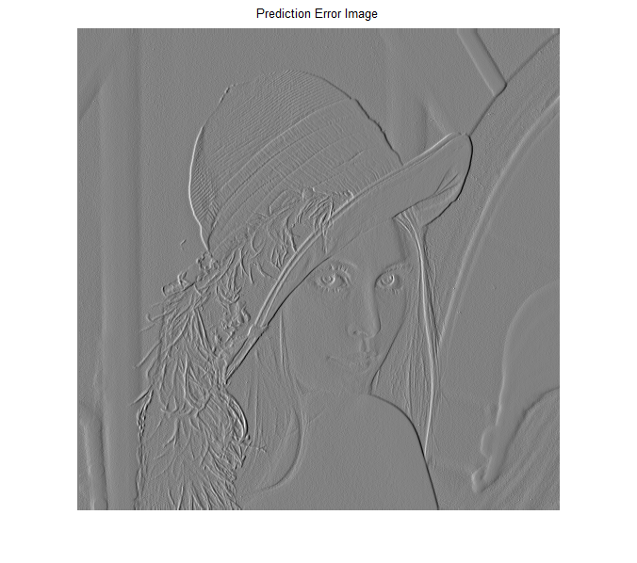
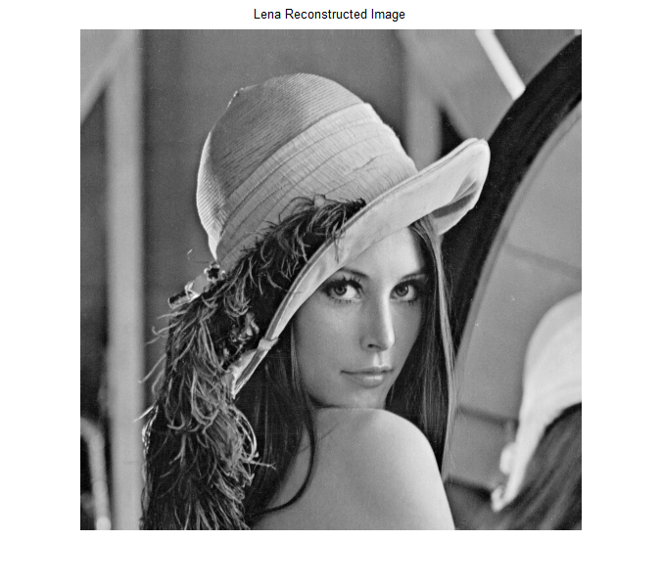

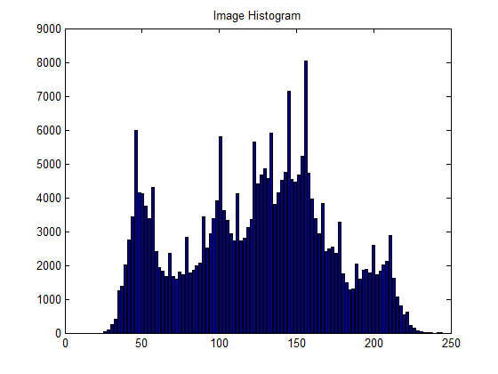
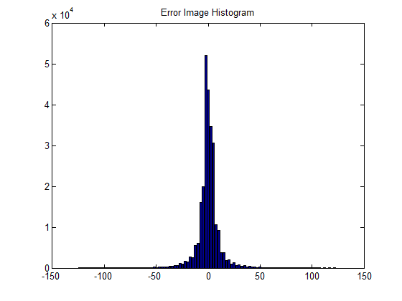

Entropy of original image = 6.287904
Entropy of reconstructed image = 3.767214

Conclusion :

The Prediction Error Sequence can be entropy coded without distortion, which provides us a lossless predictive codec whose minimum achievable rate is equal to the Entropy of the Prediction Error Sequence. Also, we observe that there is the process of compression of data. Entropy of the error image is less than the original image. The quality of the reconstructed image is also good.

