EE5356 LAB Assignment #2
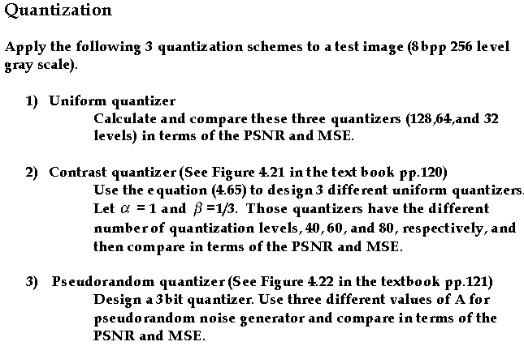
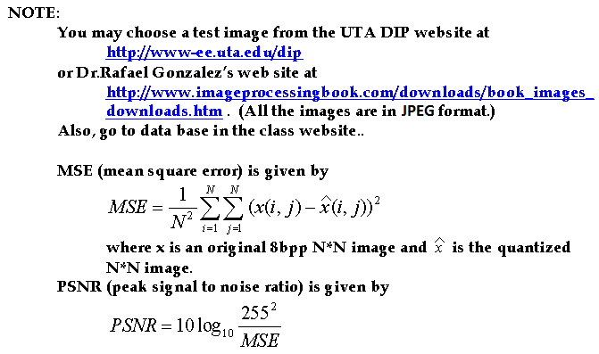
(for an 8 bits per pixel image)

References:
1) Textbook pp.99-123
2) Rafael C. Gonzalez and Richard E.Woods, “Digital Image Processing”, III edition, Prentice Hall 2008
3) Gonzalez, Woods and Eddins, “Digital Image Processing with MATLB”, Prentice Hall

Text references:

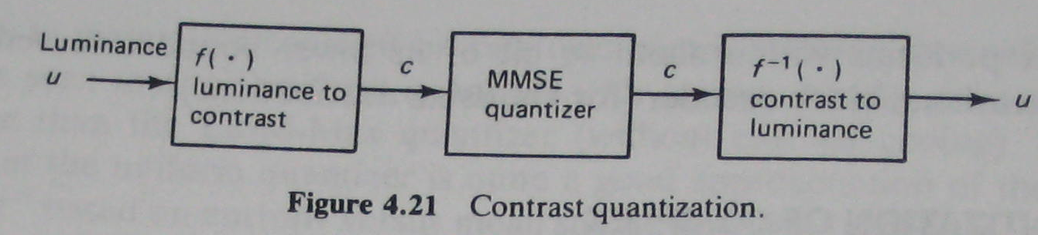

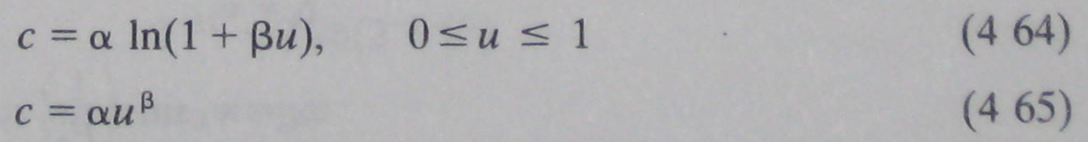

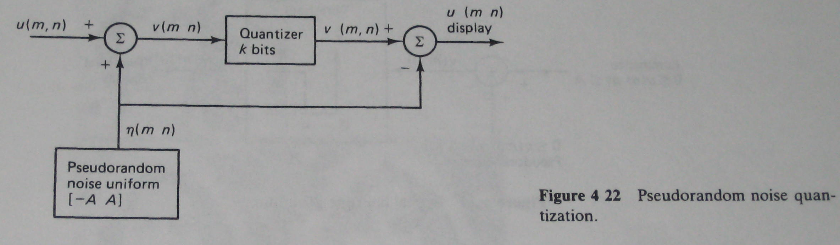

The figures 4.21 and 4.22, and equations 4-64 and 4-65 are taken from:
Anil K. Jain, “Fundamentals of Digital Image Processing”, Upper Saddle River, NJ: PRENTICE HALL, 1989

