EE 5356

LAB Program # 3

By

Vasudevan Murali

1000723391

3. Color Transformation:

a) Procedure : First read the “.raw” format file into a matrix. The matrix will be a 1 X 196608 dimension matrix. In this matrix, each three consecutive numbers starting from the first number represent the Red, Green and Blue value of a pixel. Separate each of the three consecutive numbers into three different matrices of R, G and B. The three new matrices will be of dimensions 1 X 65536. Now convert these matrices into 256 X 256 matrices.

To reconstruct the image, a matrix with dimensions 256 X 256 X3 must be created and the R, G and B matrices should be stored in it consecutively. The matlab function image.m can be used to display the color image.

b) Program:

clear all

clc

%reading .raw file to RGB

fileID = fopen('girl256color.raw');

A = fread(fileID);

status=fclose(fileID);

[row col] = size(A);

compSize = row/3;

R = zeros(compSize,1);

G = zeros(compSize,1);

B = zeros(compSize,1);

x=1;

for y = 1:1:(compSize)

R(y) = A(x);

G(y) = A(x+1);

B(y) = A(x+2);

x=x+3;

end

matSize = sqrt(compSize);

z=1;

for i = 1:1:matSize

for j = 1:1:matSize

R1(i,j) = R(z);

G1(i,j) = G(z);

B1(i,j) = B(z);

z=z+1;

end

end

imshow(uint8(R1));title('R component')

figure,imshow(uint8(G1));title('G component')

figure,imshow(uint8(B1));title('B component')

% reconstruction of image from RGB

fullImage(:,:,1) = R1;

fullImage(:,:,2) = G1;

fullImage(:,:,3) = B1;

figure,image(uint8(fullImage)); title('Reconstructed image')

% RGB to YUtVt

Y=(0.299*R1)+(0.587*G1)+(0.114*B1);

Ut=(-0.147*R1)+(-0.289*G1)+(0.436*B1);

Vt=(0.615*R1)+(-0.515*G1)+(-0.100*B1);

figure,imshow(uint8(Y));title('Y component')

figure,imshow(uint8(Ut));title('Ut component')

figure,imshow(uint8(Vt));title('Bt component')

% RGB to YdCbCr

Yd=(0.257*R1)+(0.504*G1)+(0.098*B1)+16;

Cb=(-0.148*R1)+(-0.291*G1)+(0.439*B1)+128;

Cr=(0.439*R1)+(-0.368*G1)+(-0.071*B1)+128;

figure,imshow(uint8(Yd));title('Yd component')

figure,imshow(uint8(Cr));title('Cb component')

figure,imshow(uint8(Cb));title('Cr component')

c) output:

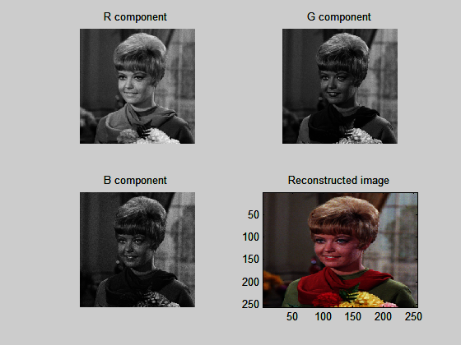

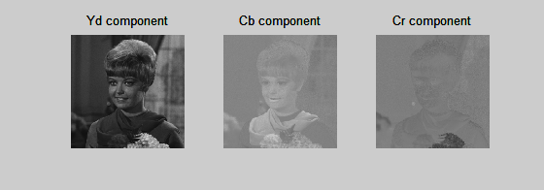

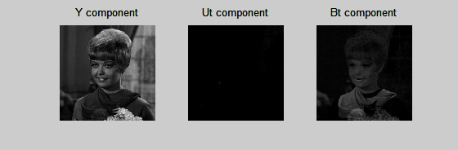

3B. Other color transforms:

1. Program:

clear all

clc

% RGB to YIQ

fileID = fopen('girl256color.raw');

A = fread(fileID);

status=fclose(fileID);

[row col] = size(A);

compSize = row/3;

R = zeros(compSize,1);

G = zeros(compSize,1);

B = zeros(compSize,1);

x=1;

for y = 1:1:(compSize)

R(y) = A(x);

G(y) = A(x+1);

B(y) = A(x+2);

x=x+3;

end

matSize = sqrt(compSize);

z=1;

for i = 1:1:matSize

for j = 1:1:matSize

R1(i,j) = R(z);

G1(i,j) = G(z);

B1(i,j) = B(z);

z=z+1;

end

end

Y = (0.299 * R1) + (0.587 * G1) + (0.114 * B1);

I = (0.596 * R1) - (0.274 * G1) - (0.322 * B1);

Q = (0.211 * R1) - (0.523 * G1) + (0.312 * B1);

subplot(4,3,1),imshow(uint8(Y)),title('Y component');

subplot(4,3,2),imshow(uint8(I)),title('I component');

subplot(4,3,3),imshow(uint8(Q)),title('Q component');

R2 = Y + (0.956 * I) + (0.621 * Q);

G2 = Y - (0.272 * I) - (0.647 * Q);

B2 = Y - (1.106 * I) + (1.703 * Q);

subplot(4,3,4),imshow(uint8(R2)),title('R component');

subplot(4,3,5),imshow(uint8(G2)),title('G component');

subplot(4,3,6),imshow(uint8(B2)),title('B component');

% color space conversion

A = imread('flowers.bmp');

R3 = double(A(:,:,1));

G3 = double(A(:,:,2));

B3 = double(A(:,:,3));

% image(A);

C0 = bitshift((R3 - B3),-1);

t = B3 + C0;

Cg = bitshift((G3 - t),-1);

Ys = bitshift((G3 + t),-1);

subplot(4,3,7),imshow(uint8(Ys)),title('Ys component');

subplot(4,3,8),imshow(uint8(C0)),title('C0 component');

subplot(4,3,9),imshow(uint8(Cg)),title('Cg component');

% inverse color space conversion

G4 = Ys + Cg;

t = Ys - Cg;

B4 = t - C0;

R4 = t + C0;

subplot(4,3,10),imshow(uint8(R4)),title('R component');

subplot(4,3,11),imshow(uint8(G4)),title('G component');

subplot(4,3,12),imshow(uint8(B4)),title('B component');

image1(:,:,1) = R4;

image1(:,:,2) = G4;

image1(:,:,3) = B4;

figure(2),image(uint8(image1));

1. Ouput: 