EE 5356

Assignment 5

Vasudevan Murali

1000723391

5. Root Filtering:

1. Program :

%%%%%%%%%%%%%%%%%%% assign5.m %%%%%%%%%%%%%%%%%%%

clear all;

close all;

clc;

%project 5

image = imread('goldhill256.bmp');

%taking DFT of the image matrix

dftImage = fft2(double(image));

%performing the roots filtering

[row col] = size(dftImage);

% getting alpha from user

alpha = input('enter the value of alpha : ');

rootImage = zeros(row,col);

for k = 1:1:row

for l = 1:1:col

rootImage(k,l) = (abs(dftImage(k,l))^alpha)\*sign(dftImage(k,l));

end

end

%energy of filtered image before zonal filtering

energyDftImage = energyCalc(dftImage);

energyRootImage = energyCalc(rootImage);

% geometric zonal filtering

H = ones(row,col);

% threshold value taken as 91

Th = 91;

H(Th+1:1:row-Th,1:1:col) = 0;

H(1:1:row,Th+1:1:col-Th) = 0;

filteredDftImage = H .\* dftImage;

filteredRootImage = H .\* rootImage;

%energy of filtered image after zonal filtering

egyfilteredDftImage = energyCalc(filteredDftImage);

egyfilteredRootImage = energyCalc(filteredRootImage);

ratio = energyDftImage/egyfilteredDftImage;

ratio1 = energyRootImage/egyfilteredRootImage;

%taking inverse DFT

reconImage = ifft2(filteredDftImage);

reconImage1 = ifft2(filteredRootImage);

% display image

figure(1),imshow(image),title('Original image');

figure(2),imshow(real(dftImage)),title('DFT of image');

figure(3),imshow(real(reconImage),[]),title('reconstructed image of DFT');

figure(4),imshow(real(rootImage)),title(sprintf('image after root filtering (alpha = %0.2f)',alpha));

figure(5),imshow(real(reconImage1),[]),title(sprintf('reconstructed Image (alpha = %0.2f)',alpha));

%display ratios

disp(ratio);

disp(ratio1);

%%%%%%%%%%%%%%%%%%%%% arithmetic.m %%%%%%%%%%%%%%%%%%%

function [sum] = energyCalc(a)

sum = 0;

[row col] = size(a);

for k = 1:1:row

for l = 1:1:col

sum = sum + abs(a(k,l))^2;

end

end

1. Input :

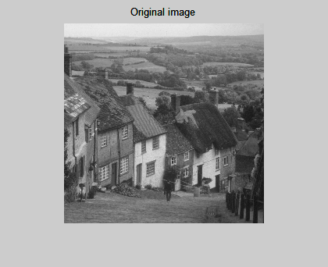

1. Output :

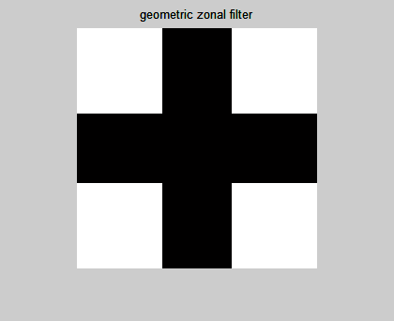

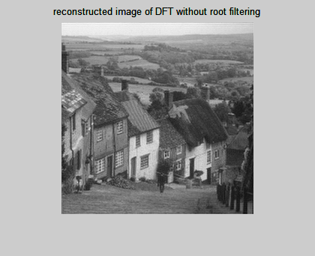

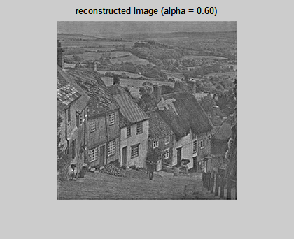

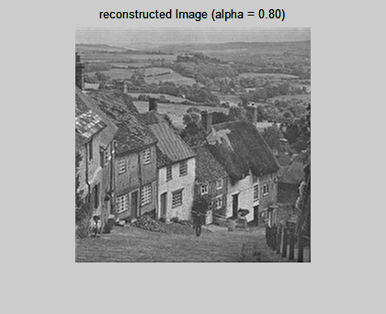

Ratio of energies image before and after geometric zonal filtering:

Case 1: DFT of image without root filtering = 1.0033

Case 2: image with root filtering with alpha of 0.6 = 1.2171

Case 3: image with root filtering with alpha of 0.8 = 1.0427