Introduction 2
LWIO-SRV 2
Function 2
Architecture 3
Driver 4
Shares 4
Transport 5
Protocols 5
Features 6
Scalability 6
Zero-copy 6
Asynchronous processing 6
Throttling 6
Threading Model 6
Configuration 7
References 8

Introduction

The Likewise Input Output system (LWIO) provides network storage support through SMB/CIFS on Linux and UNIX platforms. LWIO is implemented using a plug-in architecture where various driver modules are loaded dynamically, and can communicate among themselves using IRP (I/O request packet) structures.
This document is the technical specification for the “srv” driver module (LWIO-SRV), whose primary responsibility it is to receive and fulfill requests based on the SMB/CIFS protocol in a secure manner.
The LWIO-SRV module is provided as a single dynamically loadable library named libsrv.sys.<library_extension>. For instance, /opt/likewise/lib/libsrv.sys.so

LWIO-SRV

Function

The primary functions of the LWIO-SRV module can be summarized as follows.
- Listens on port 445 for incoming CIFS requests
- Receives messages delivered through the local inter-process communication channels implemented using Linux/UNIX domain sockets. Local system daemons such as lsassd (Authentication daemon) and srvsvcd (Share management RPC Interface) will use the local inter-process communication channel to register their communication pipe.
- Maintains network connections according to the CIFS specification. This will include support for durable handles in the case of SMB2.
- Maintains a persistent set of shares (file system mappings) and provides access to these shares in a secure manner using the GSSAPI (Kerberos, NTLMv1 and NTLMv2).
- Fulfills requests conforming to the SMB-1 and SMB-2 protocols.
- Provides metrics on connections, sessions, trees and open file handles through the local inter-process communication channel as well as the SRVSVC RPC Channel.

Architecture

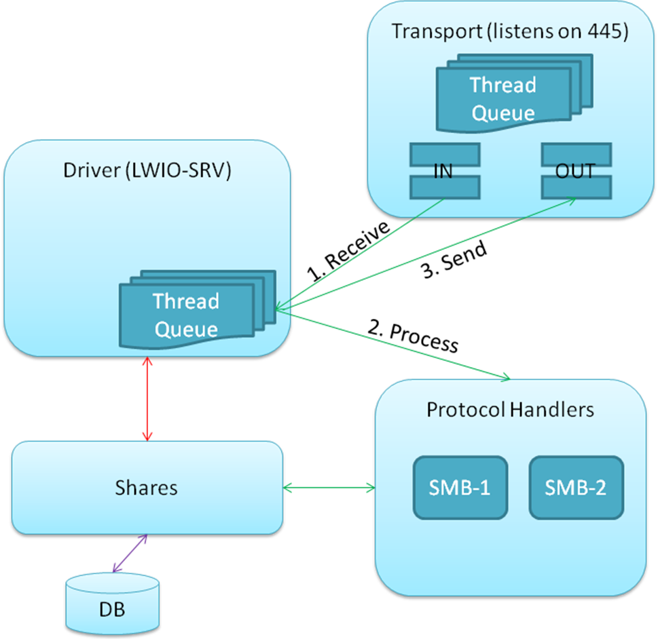
Figure 1: LWIO-SRV Internal layout

The LWIO-SRV driver comprises of the following sub-systems.
- Driver
- Shares
- Transport
- Protocols

Driver

Function
- This module contains the entry point used to load the sub-system into the LWIO service.
- Provides the interface for share management through Device Control (IOCTL) functions.
- Hosts a thread queue which processes SMB/CIFS traffic through the port 445. SMB/CIFS packets are retrieved from the LWIO-SRV/Transport, processed in the LWIO-SRV/Protocols sub-system, and any results are deposited back to the LWIO-SRV/Transport sub-system.

API

Shares

Function
- Provides an in-memory collection of shares, based on a repository. The repository can be a local database, local file or be cluster-aware. The in-memory collection shall be guarded by a readers-writer lock.
- Updates to shares are performed in memory first and then persisted to the repository as a single transaction.
- The implementation of the share repository shall be separated from the share management interface, and these components will be bound at compile time.
- The default share repository provided by Likewise will use the sqlite database.

API

Transport

Function
- Listens on port 445 for incoming CIFS connections
- Uses an appropriate scalable method to handle network traffic, depending on platform capabilities. Likewise will provide implementations supporting epoll for Linux systems, kqueue/kevent for FreeBSD, event ports for Solaris, poll and select.
- This sub-system shall own the socket connection object.
- After an SMB/CIFS packet is received, it will be associated with the connection over which it was received. These parameters will form the SMB SRV Context which will be en-queued to be processed.
- Any SMB response packets generated when processing an SMB request will be submitted back to the Transport layer to be transmitted back through the associated connection.
- Hosts a thread queue which is responsible for network activity (listen/accept/read/write).

API

Protocols

Function
- Process CIFS requests conforming to SMB Version 1
- Process CIFS requests conforming to SMB Version 2
- Access shares from the Shares sub-system as part of SMB processing.
- Assign references to shares to Tree objects
- Owns the SMB Session, Tree and File objects

API

Features

Scalability
- The transport sub-system will use the epoll group of calls to receive network requests. This should increase the number of maximum connections that can be accepted.
- The number of worker threads can be adjusted to a multiple of the number of cores on the system, to increase the rate of processing (of CIFS requests).
- Pre-allocated SMB Packets are maintained in a free list. The size of the free list can be configured.

Zero-copy
Certain requests receive a data payload that must be deposited to the file system. An example of this is the WriteAndX request. In order to reduce memory allocation and copies, the srv driver will read only the SMB Headers; the actual data will be read by the driver.

Throttling
The number of connections, sessions, trees and files can be controlled through configuration.

Threading Model
Thread pools are maintained in the Driver and Transport sub-systems.
In the case of synchronous processing, a Driver thread removes an SMB context from the Transport’s inbound queue, processes the packet and queues the SMB response context back on the Transport’s outbound queue.
In the case of asynchronous processing, a Driver thread removes an SMB context from the Transport’s inbound queue, processes the packet and queues the intermediate (STATUS_PENDING) response context back on the Transport’s outbound queue. When the IOManager module returns with the real asynchronous response, it will be added to the Transport’s outbound queue.
The transport system will have at least (2) threads, one to process inbound requests and the other to process outbound responses.

Configuration
The configuration file for the LWIO daemon is located at /etc/likewise/lwiod.conf. This file is in the “INI” format. The settings for the LWIO-SRV module can be found in the [driver:srv] section.
The following parameters are supported.
Parameter Name | Default Value | Maximum Value | Minimum Value | Description
DriverWorkerCount | 2 | - | 1 | Number of worker threads processing SMB Requests in the Driver sub-system
TransportWorkerCount | 2 | - | 2 | Number of worker threads performing network activity in the transport sub-system

References
- CIFS Technical Reference, Version 1.0 (Release date: 3/1/2002)
- Microsoft Networks SMB FILE SHARING PROTOCOL, Version 6.0p (Release date: 1/1/1996)

- Dan Kegel's website about the C10K Problem
- Jeff Darcy's webpage about implementing high performance servers

