# VMware PKS and vRealize Automation 7.5 Integration

# Guide

Table of Contents

VMware PKS and vRealize Automation 7.5 Integration 1

Guide 1

Introduction 2

Pre-requisites 2

Configuring the vRA appliance 3

Creating Users 3

Configuring Roles 7

Configuring the admin role 7

Configuring the developer role 8

Creating a Business Group 9

Adding PKS Endpoint 11

Create a K8s cluster 15

Adding an existing k8s Cluster 17

# Introduction

PKS integrates with vRealize suite of products to provide extended functionality using the familiar and trusted product suite from VMware. This guide goes through step by step instructions for configuring vRA 7.5 to provide a management UI for managing a PKS deployment.

# Pre-requisites

1. PKS Deployment is already up and running
2. vRA appliance is already deployed. Only the minimal version of vRA is required without an IAAS server. vRA appliance can be downloaded from [VMware vRealize Automation 7.5.0 OVA file](https://my.vmware.com/group/vmware/details?downloadGroup=VRA-750&productId=787)
3. Network connectivity between PKS API VM and K8s master Nodes to vRA Appliance VM

# Configuring the vRA appliance

After deploying the vRA appliance, navigate to the IP address of the appliance to start configuring the appliance.

## Creating Users

1. Navigate to <https://10.40.206.35>. Click on the “vRealize Automation console”

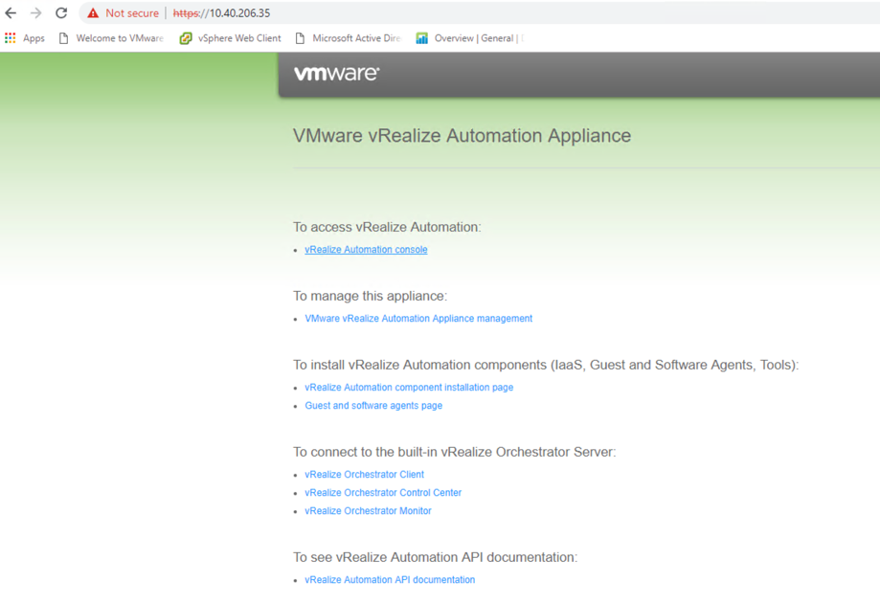

1. Login in the appliance with “administrator" as the username and with the password you chose at the time of appliance deployment

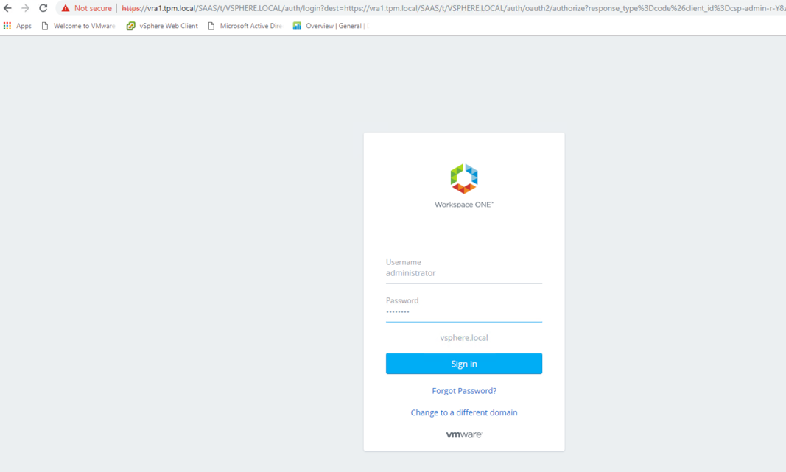

1. Navigate to tenants tab on the left and open the default, "vsphere.local", tenant. In this guide, we will use with the default tenant

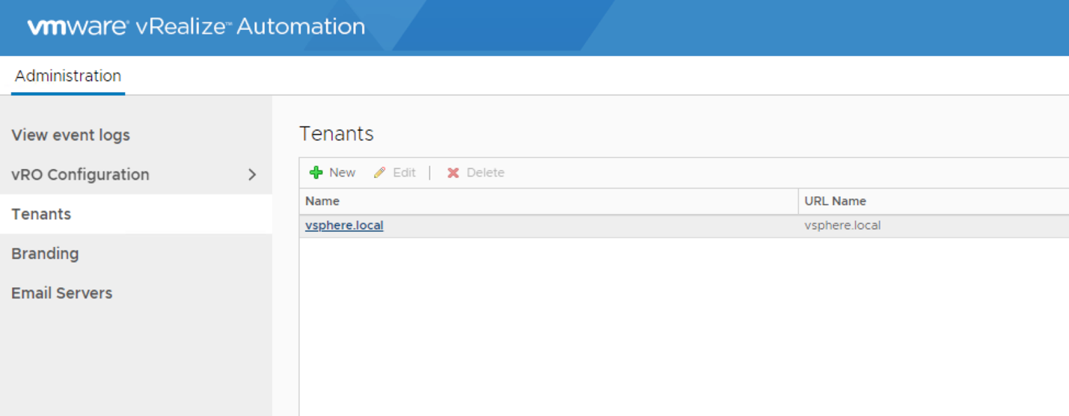

1. Navigate to “local users” tab

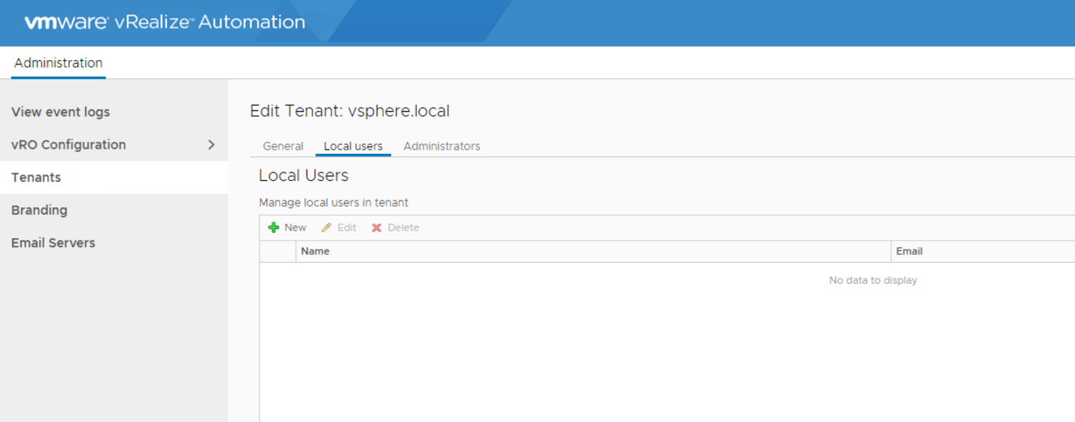

1. We need to create an admin user who will manage the container infrastructure. Fill in the details of this user as shown below. In this guide, the username for this user is “admin  
     
   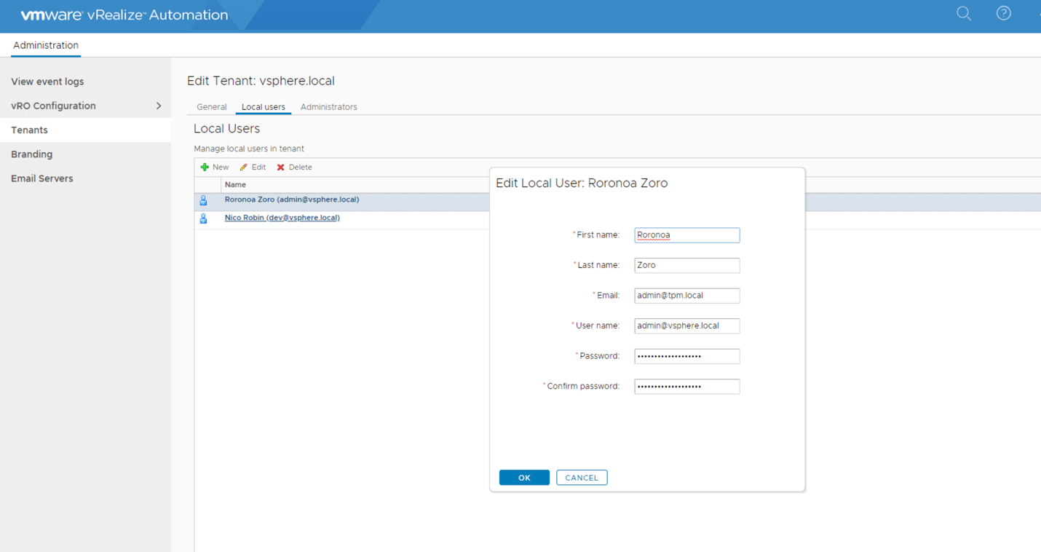
2. Add another user who will depict our developer persona. As shown below, enter the details for this user. Hit “Next” to configure the tenant administrators.

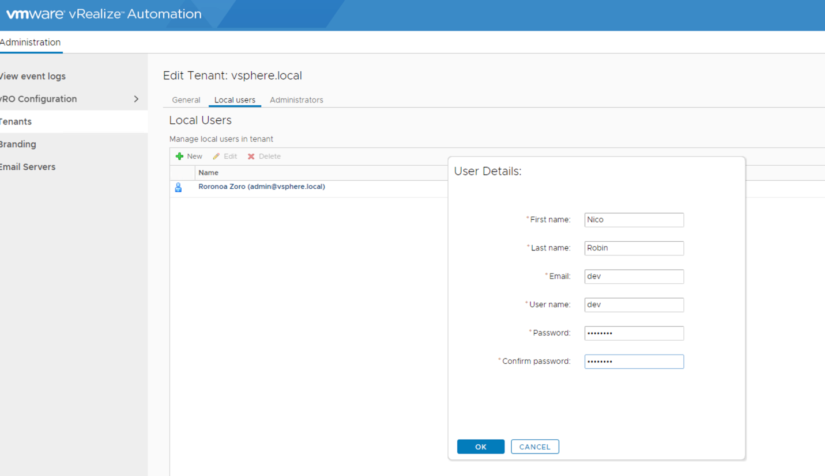

1. Add “admin” to the “Tenant Administrator” role for this tenant. Once you have added the user, press finish to save the configurations

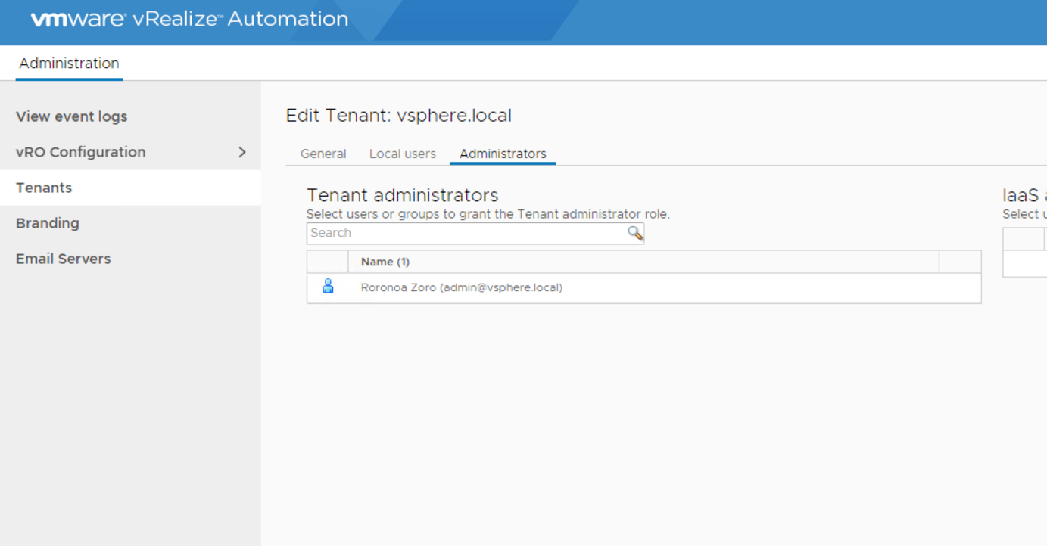

## Configuring Roles

At this point, we have created the admin and dev users and made admin user as the tenant administrator. Now we will log back in using the “admin” user and start configuring additional permissions to enable container roles for these users

Logout of the appliance and log back in using the tenant administrator(admin) user we created earlier

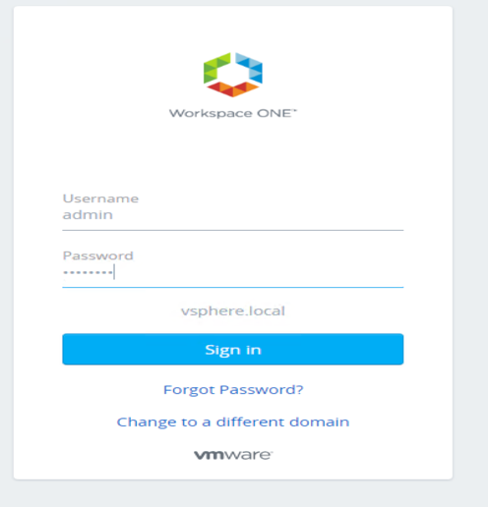

### Configuring the admin role

1. This user(admin) currently does not have container administrator privileges. Navigate to "Users & Groups" > "Directory Users and Groups" and search for admin user. Once found, open that user's preferences

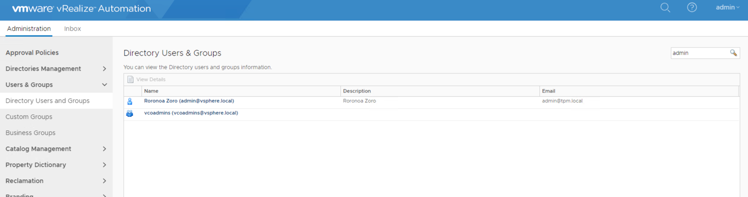

1. Add the “Container Administrator” role to this user. This is the admin role for managing containers. Hit "Finish" to save the setting.

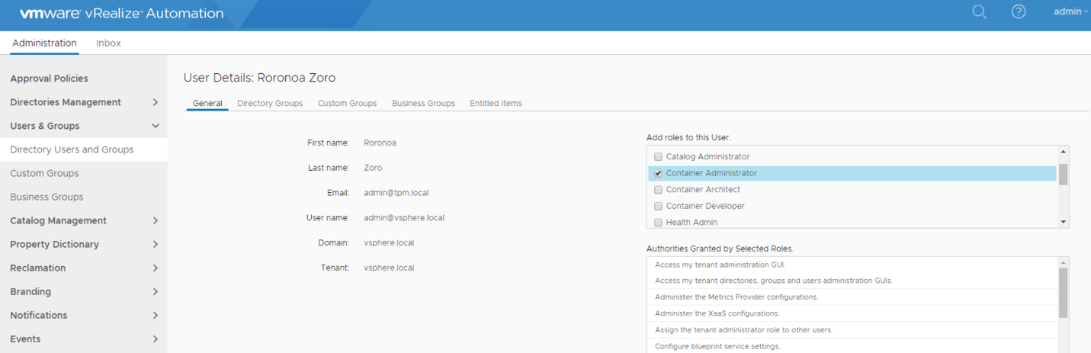

### Configuring the developer role

We will add the developer role for our dev user

1. Under ‘Administration”, navigate to "Users & Groups" => "Directory Users and Groups" and search for dev user. Once found, open dev user's preferences

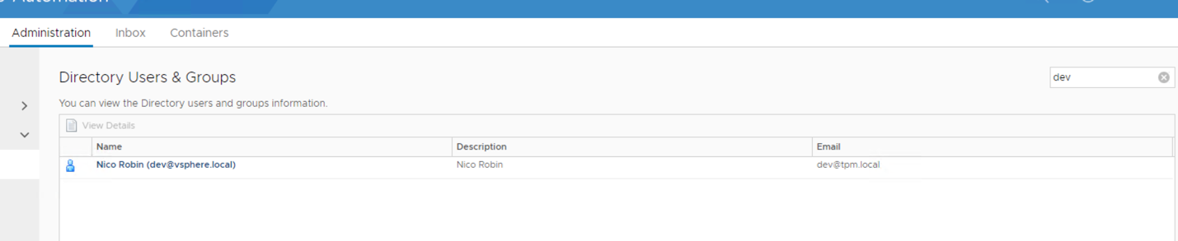

1. Check the “Container Developer” role for the dev user and press finish to save the configuration

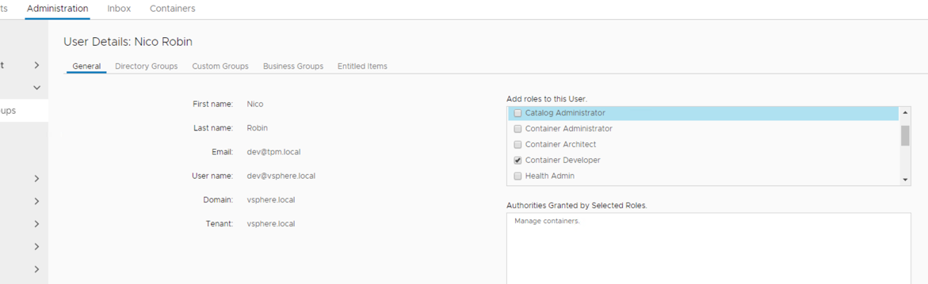

## Creating a Business Group

Business groups are used to associate a set of services and resources to a set of users. These groups often correspond to a line of business, department, or other organizational unit. You create a business group so that you can configure reservations and entitle users to provision service catalog items for the business group members. We need to create at-least 1 business group to associate a PKS endpoint to

1. Under the “Administration” tab, navigate to “User & Groups” => “Business Group”.

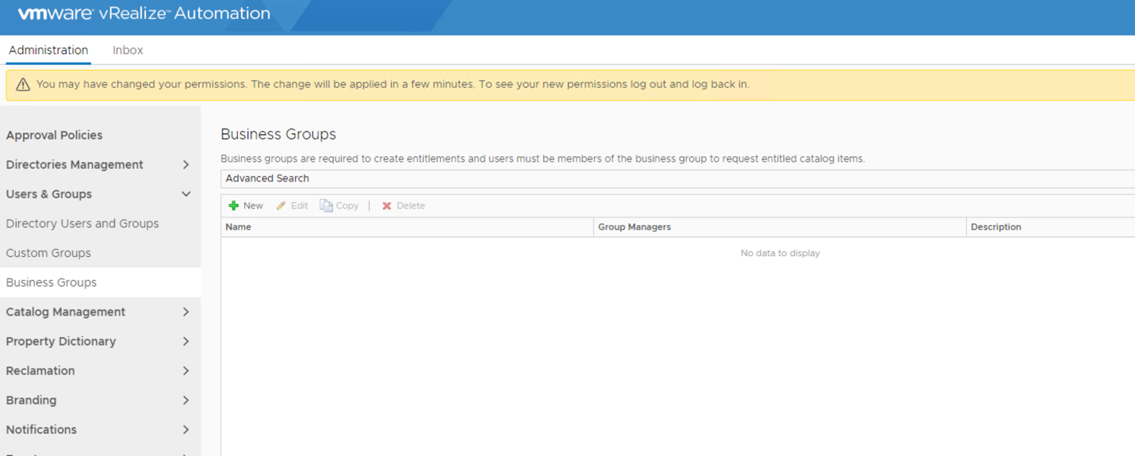

1. Name the “Business Group” and add the email address that will monitor the capacity for this Group and hit “Next”

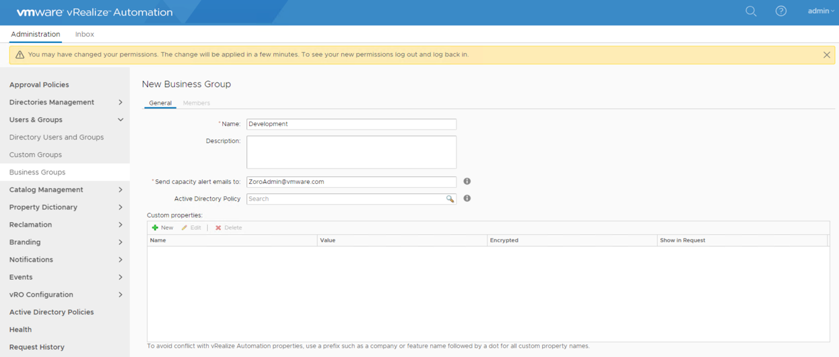

1. In the “Group Manager” role, add the admin user. This will allow the admin user to be able to administer the business group

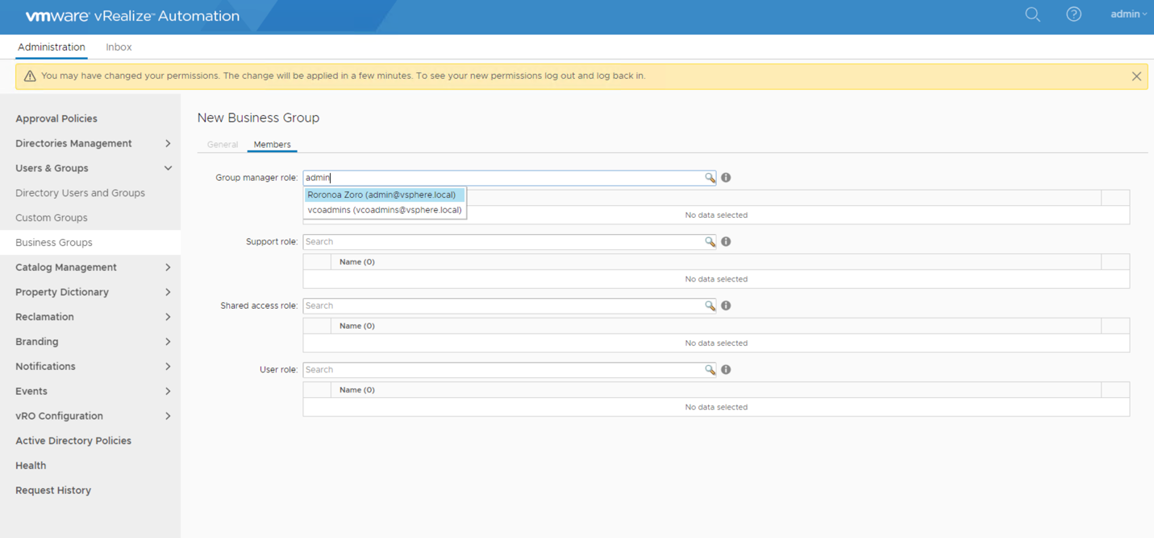

1. Add the dev user to the “User role”. This will allow restricted access to the dev user as to what she can do in this “Business Group”. Hit “Finish” to save your configuration.

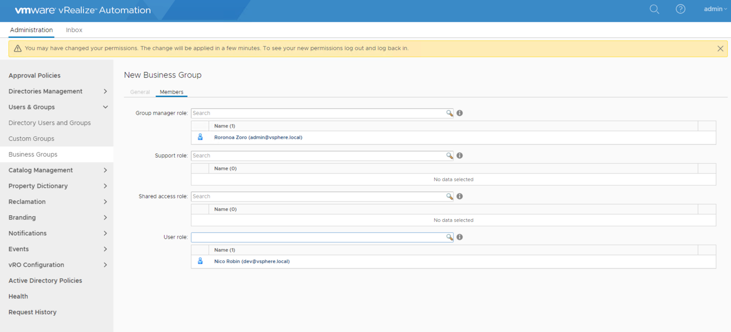

# Adding PKS Endpoint

We have completed all the pre-requisites for attaching a PKS Cluster to vRA. Let’s continue to add our PKS deployment to vRA and start creating/adding clusters.

1. Log out of the appliance and log back in using the admin account so that new permissions, that we have configured in the previous steps, take effect. Note that the “Containers” tab is visible. This is because we added the “Container Administrator” privileges to the admin user. Also note that on the top left, we can see our business group, “Development” in this case. This is a result of adding the “Group Manager” role for admin user to this business group.

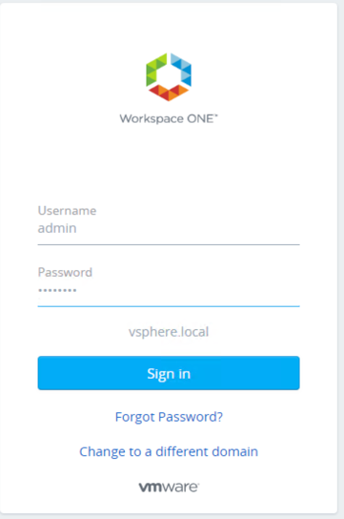

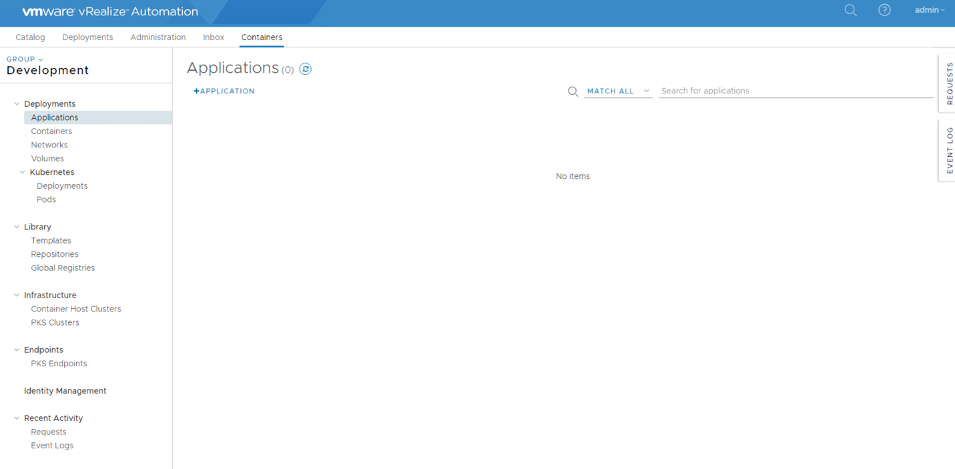

1. First create the credentials that would be used to connect to the PKS API. Navigate to the “Identity Management” tab located at the bottom left of the page, in the Containers tab, and add new credentials. Choose the credentials in username/password format and provide the credentials for a user. This would be a user that can create clusters using the PKS CLI. Press “Save”

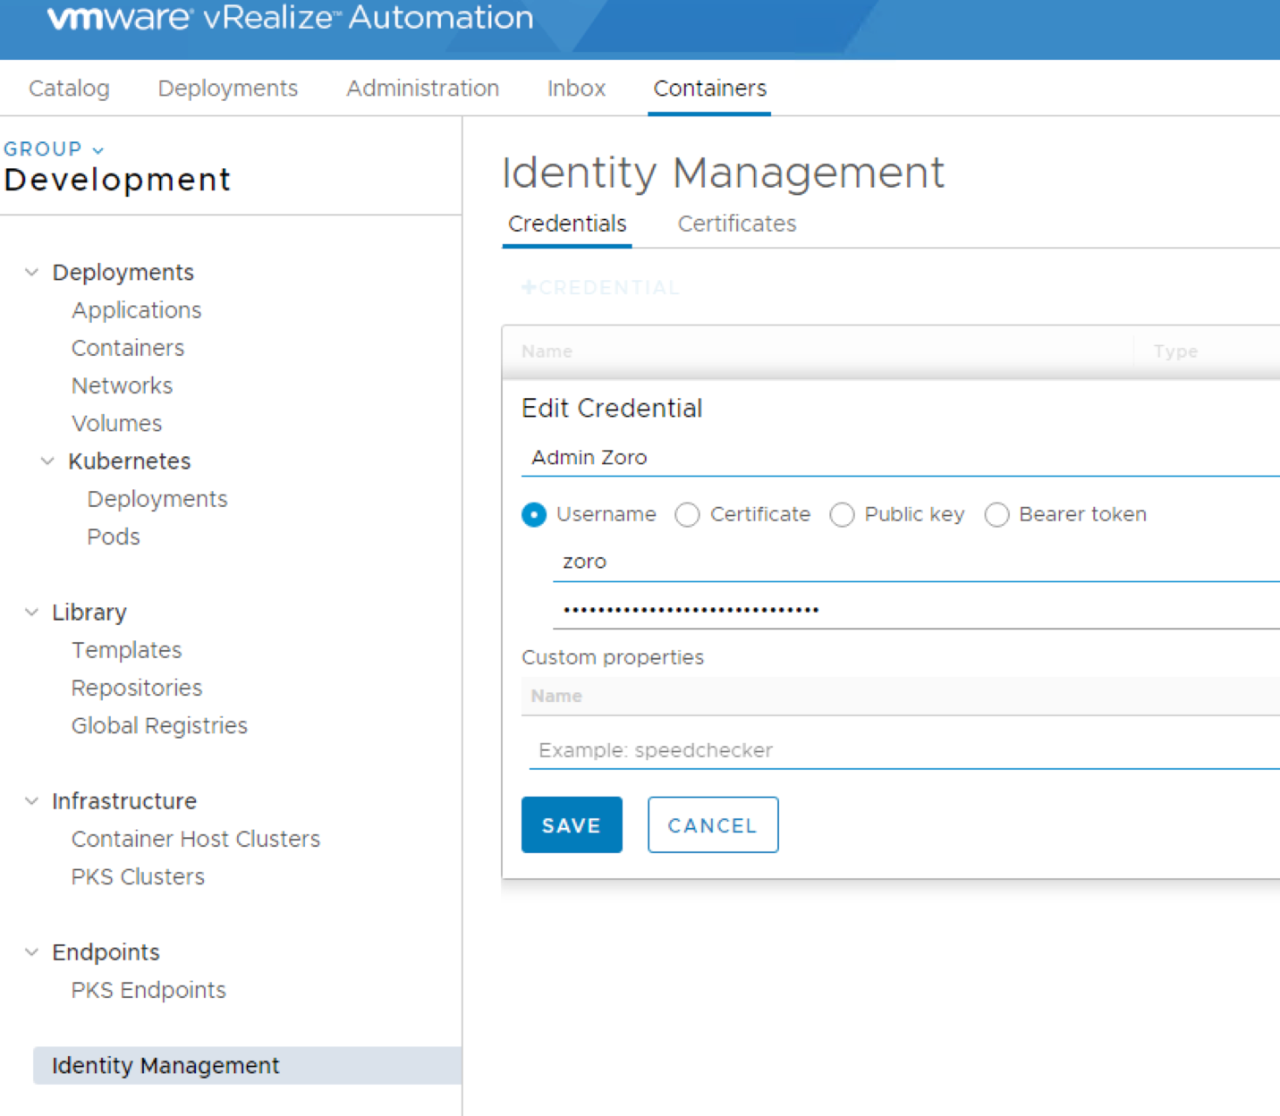

1. Navigate to the PKS Endpoint menu on the bottom left. Add a new endpoint. Note that the port for “UAA Address” is 8443 and for “PKS Address” is 9021.
   1. Name: “PKS”
   2. UAA Address: <https://pks-api.tpm.local:8443>
   3. Credentials: pks
   4. PKS Address: <https://pks-api.tpm.local:9021>

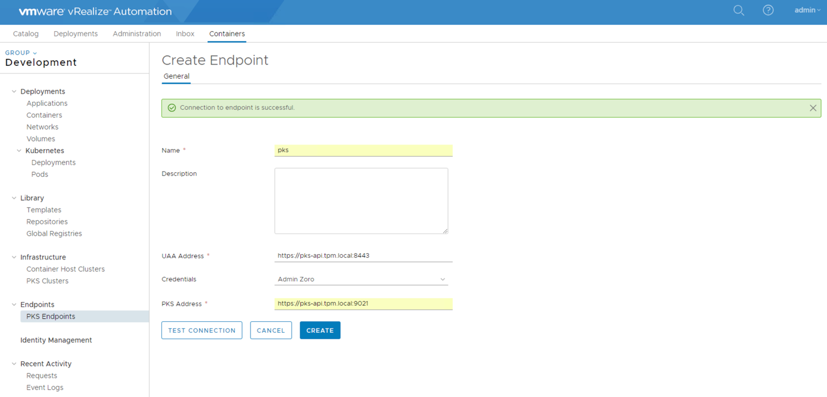

1. Press Test Connection to verify the connection is successful. Verify the connection and press save.

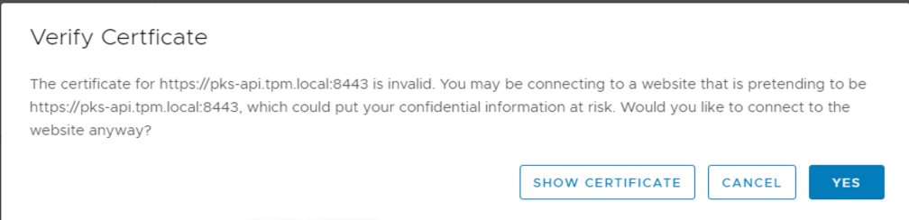

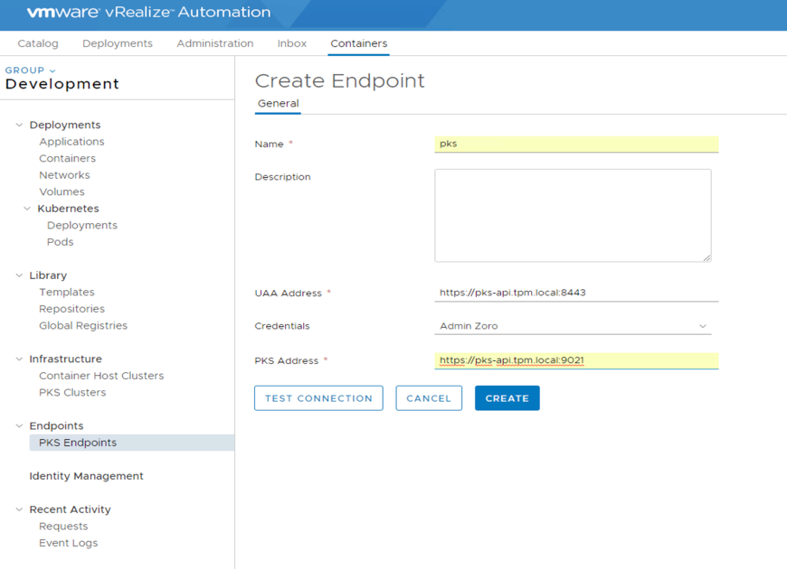

1. Once the PKS Endpoint is setup, associate plans to this PKS endpoint. This way, an admin can restrict the size of PKS clusters that is created by other users.

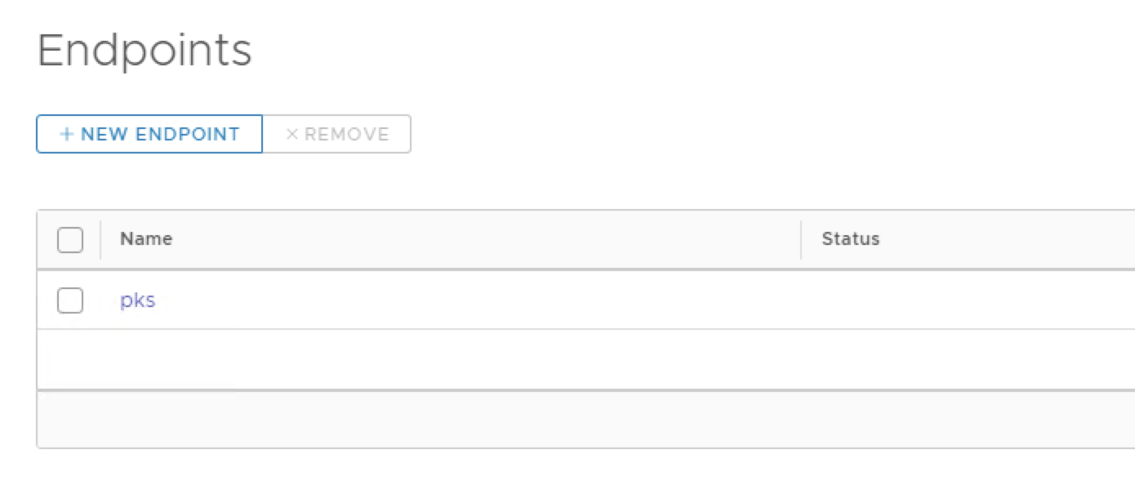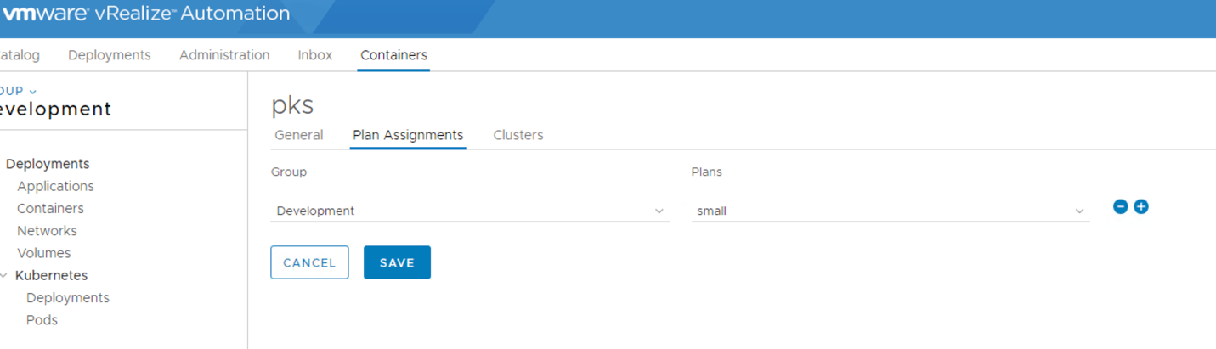

The PKS Endpoint is now setup and is ready to create new k8s clusters or import existing clusters in vRA.

# Create a K8s cluster

1. Navigate to Containers tab, under infrastructure => PKS Clusters, add a New Cluster

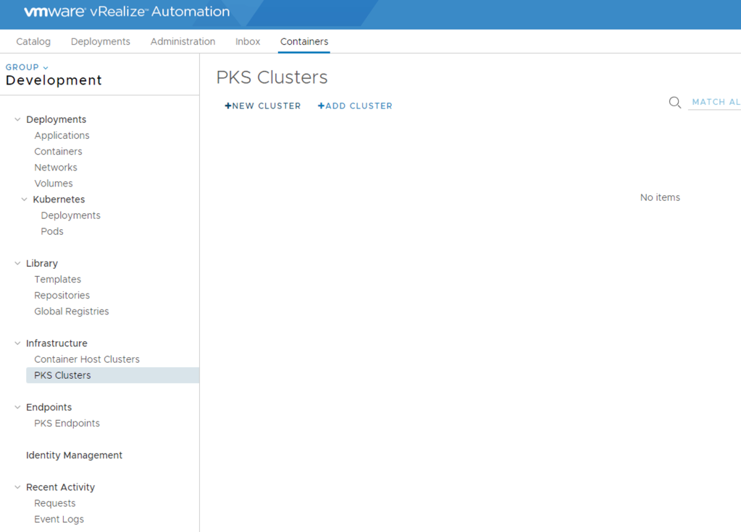

1. Fill in the table with all the field
   1. PKS Endpoint: pks  
      This information is fetched from the PKS Endpoint tab
   2. Cluster name: vRA-demo  
      This can be any arbitrary name to refer to the cluster
   3. Plan: No item  
      If there is only 1 plan added in the PKS Endpoint, no plans will show up here. If there are no plans added to PKS Endpoint, you won’t be able to select a. If there are more than one plans added in PKS Endpoint, then you will have the option to choose between different plans here
   4. Master Host Name: vra-demo  
      This is how vRA will connect to the cluster. If hostnames are not added to DNS server by default, choose the Master Node IP checkbox in the Connect By field
   5. Master Host Port:   
      Default Port will be used when no value is added here
   6. Worker Nodes: 3  
      You can provide custom amount for the number of worker nodes for your k8s cluster
   7. Connect By: Master Node IP  
      This option is used by vRA to connect to your k8s cluster using either hostname or IP of the master. In this case, we are using Master IP to connect to the cluster

Press Create to initiate the creation of the k8s cluster

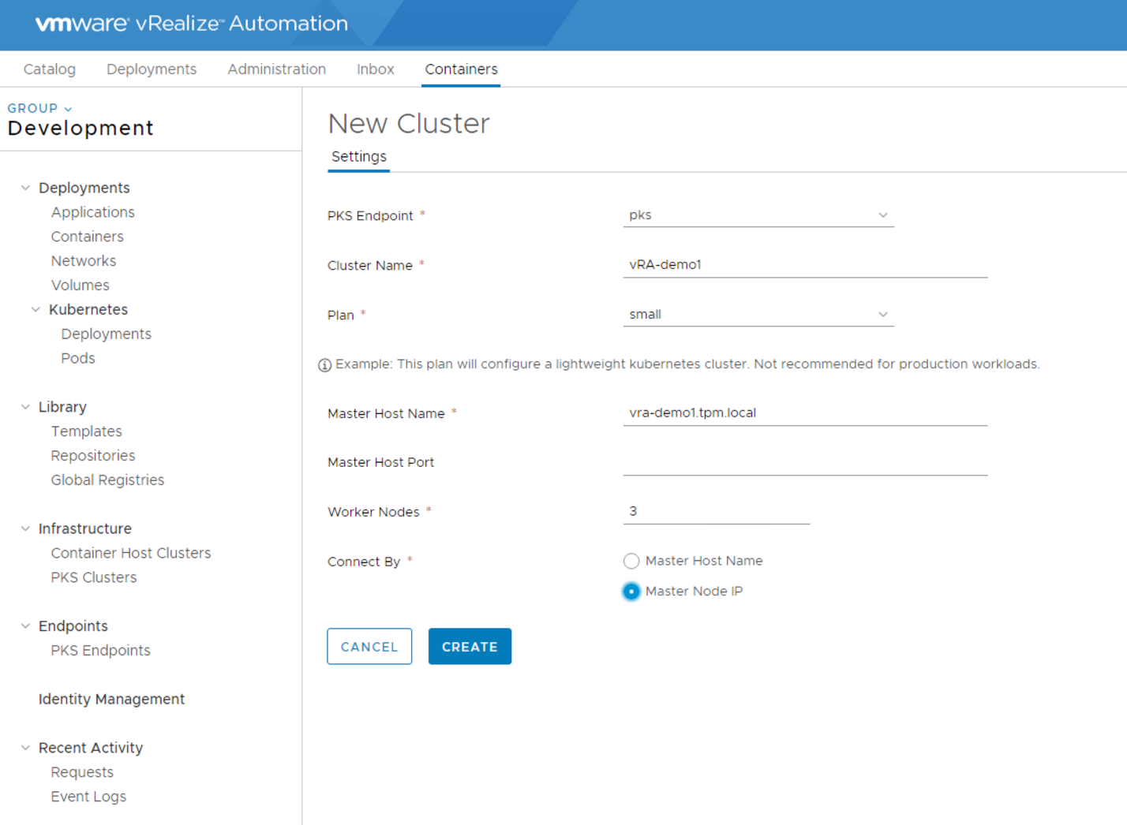

1. After couple of seconds, you can see your k8s cluster in the provisioning state

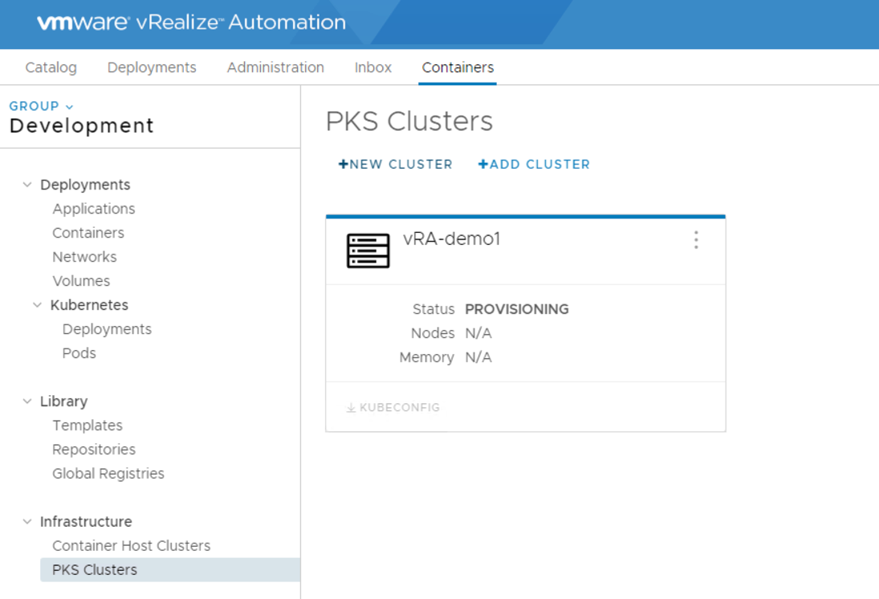

Once the deployment is complete, you can download the KUBECONFIG file and start deploying apps on the k8s clusters. All the deployments and PODs can be seen under the K8s tab

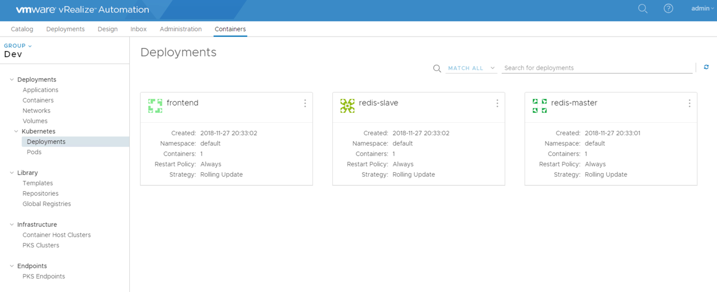

# Adding an existing k8s Cluster

1. Navigate to Containers tab, under infrastructure => PKS Clusters, add a New Cluster



1. Click on Add Cluster. Select the PKS Endpoint from which you want to import a cluster from. Check the cluster and the method you want to connect to the master with, either hostname or IP. Press Add to add this cluster to vRA

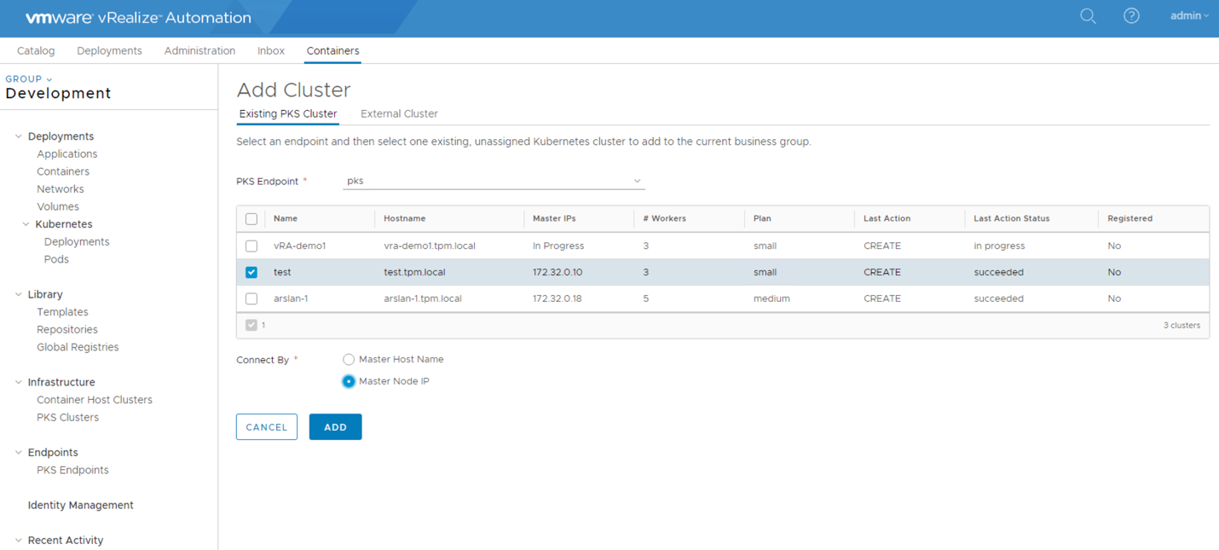

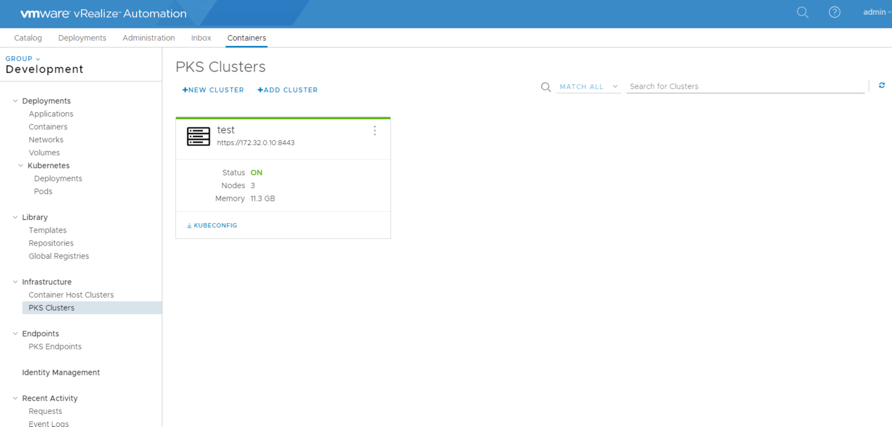

Now you can see all the deployments and PODs in your cluster in the Deployments as shown below



/C:/dcef48c4348c8f74dcc7d32cdc123ce7