**A Homogenization Approach to Multi-Scale Radiative Transfer in Nano-Structures**

Vincent M. Wheeler and Wojciech Lipiński

Research School of Engineering, The Australian National University, Canberra, Australia

E-mail of corresponding author: [wojciech.lipinski@anu.edu.au](mailto:wojciech.lipinski@anu.edu.au)

**ABSTRACT**

We propose a homogenization approach for modelling thermal radiative transfer in nano-structured materials to obtain an effective radiative transport equation (RTE). The approach is based on the concept of moment-linking—the macroscopic moments of an effective RTE are matched to the moments of the underlying electrodynamic solution. Here we present the approach and discuss anticipated results and future directions.

**1. Introduction**

Radiative transfer in complex hetero-structured media has garnered much attention in the recent decade [1]. When the heterogeneous features of such media are sufficiently large, the radiative transfer equation (RTE) can be applied at discrete levels, which drastically simplifies the analysis. Recent developments provide a strong theoretical foundation for the use of the single and multiple RTE continuum approaches in macro-structured media consisting of multiple components with arbitrary-shaped discrete-level geometry and arbitrary radiative properties of the constituents [2]. Studies on predicting thermal characteristics, in particular radiative properties, of nano- and micro-structured media are nearly absent in the literature and pose serious modelling challenges. Of particular interest here are the high-temperature processes considered in the emerging field of solar thermochemistry [3] where hetero-structured, multi-scale materials have already appeared in experimental investigations [4].

The connection between the electrodynamic description of light and the ray description that underlies the RTE in discrete and continuous random media has been explored by numerous authors and was derived explicitly from the underlying electrodynamic equations in limiting cases [5,6,7]. In doing so, these authors have shown that the traditional interpretation of the RTE—in terms of rays traveling through a particulate medium—can be generalized, making its application to diverse physical situation more plausible. Indeed, the RTE has been shown to agree with electrodynamic simulations for two-dimensional slabs of randomly-located cylinders, even for a system with a size comparable to the wavelength [8]. However, the agreement was shown to break down for cases exhibiting strong dependent scattering for high volume fractions of scatterers. Theoretical developments for discrete random media often exclude this effect by employing the far-field approximation, for example [7]. It has been postulated that by changing the coefficients appearing in the RTE to be effective coefficients, a better agreement is possible for highly dense media [8].

In this work we propose a method to obtain such effective properties. As a result, we hope to describe a method where the effective properties of a dependently scattering medium, porous materials in particular, can be determined from an electrodynamic simulation on a representative volume.

**2. Proposed methodology**

We consider the limiting case of the RTE written in terms of a phase-space energy densityfor a non-absorbing, non-emitting medium [5],



Here, *σ* is the scattering rate,*k* is the wave-vector,  is the *i*th component of the phase velocity vector, and Φ is the scattering phase function. The permeability and permittivity of the local medium is given by *ε* and *μ*. Space and time are denoted *x* and *t*. Note that the phase-space energy density has the units of J m-3µm3, i.e. energy density per wave-vector, and the scattering phase function is properly normalized and should ensure that scattering only takes place within a certain wavenumber band. For the reader more comfortable with an RTE written in terms of a specific intensitywe point out that for a medium with a dilute collection of independent scatterers we have where is the speed of light in the background medium. We would like to connect this equation to the fields obtainable by a solution to Maxwell’s equations. To this end, we express the coefficients defining the medium—namely  andin terms of quantities that can be readily calculated using both the RTE and Maxwell’s equations, the macroscopic moments.

The moments of the RTE are calculated by



where and are positive integers. If we assume the RTE to exist in a region of infinite extent and impose the energy density goes to zero at infinite, we can obtain a set of ordinary differential equations in time for the moments by multiplying Eq. (1) by and integrating over all wave-vectors and space:



Defining the moments for the electrodynamic problem requires a more sophisticated approach because the fundamental quantities—namely, the electric and magnetic fields—are not functions of wavenumber. That is, we need to take a physical model that exists in configuration space only (Maxwell’s equations), and project it in a meaningful way into phase space. Ryzhik et al. [5], among others, utilizes the Wigner function for this purpose,

.

The vectoris defined by and the star denotes the complex conjugate. This quantity has been shown to be analogous to the phase-space energy density in that its zeroth and first moments in wave-vector correspond to the internal energy and the energy flux, respectively. It has been theoretically shown to to satisfy a RTE under limiting circumstances; see [7]. The Wigner function is not positive definite, so its interpretation as a phase space energy density is limited to the high-frequency case. Regardless, the proper moments can be obtained by

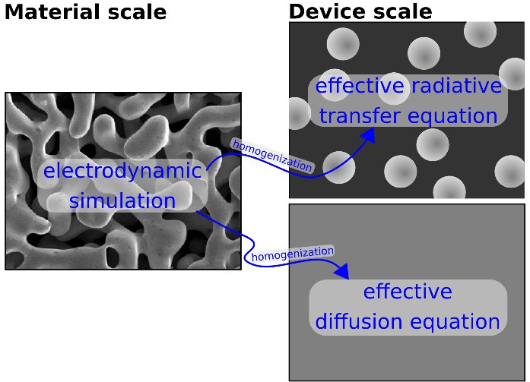

**Figure 1. A concept diagram for the moment-linking homogenization process for a nano-structured material and a macroscopic device. An effective diffusion equation was not discussed here but will be considered by an approach analogous to the RTE case .**



where tr represents the trace operation.

We are now ready to state the approximation underlying the proposed homogenization process. We impose that the ODEs given by (3) fit the time dependent moments calculated by a solution to Maxwell’s equations for the geometry under study. In other words, we impose that



This imposition has been shown to give excellent agreement when approximating radiative transfer by a diffusion equation [9]. Figure 1 is a representation of the proposed scale-linking process. For the case of a medium that strictly satisfies the RTE—that is, dilute independent scatterers—the transport coefficients obtained from the electrodynamic solution should exactly correspond to the proper transport coefficients. When the medium does not satisfy the conditions for a RTE to be valid, we expect the fitting process proposed here to give *effective* transport coefficients. All electrodynamic information that is lost in the RTE description, namely interference effects, will be coarsely contained within them and the *effective* RTE can be solved as a good approximation to the electrodynamic problem on the large scale.

**3. Future work**

With the conceptual connection between scales in place, future work will focus on the validation of the proposed theory. The electrodynamic moments will be computed by solving Maxwell’s equations for cases with increasing complexity to verify the results. First, scattering of a plane, monochromatic wave by a single non-absorbing sphere will be considered because an exact solution is available in that case. Next, averaged realizations of a slab of independently scattering spheres, as considered in [8], will be solved. The RTE has been rigorously derived in this limit using the Wigner function used herein [5]. We will then extend the approach to cases of interest—dependently scattering porous materials. Like the independent scattering case, we will consider a slab of material irradiated by a plane, monochromatic wave with periodic conditions in one or two directions if considering a two- or three-dimensional problem, respectively. To obtain solutions for the slab cases, Maxwell’s equations will be solved using computational electrodynamics. The proposed theory can be verified by comparing the electrodynamic results against RTE results using effective parameters.

**References**

[1] L.A. Dombrovsky and D. Baillis. *Thermal Radiation in Disperse Systems: An Engineering Approach*. Begell House, New York and Redding (CT), 2010.

[2] W. Lipiński, D. Keene, S. Haussener, and J. Petrasch. Continuum radiative heat transfer modeling in media consisting of optically distinct components in the limit of geometrical optics. *Journal of Quantitative Spectroscopy and Radiative Transfer*, 111:2474–2480, 2010.

[3] R. Bader and W. Lipiński. Solar thermochemical processes. In *The World Scientific Handbook of Solar Energy* (ed. Crawley, G. M.) (World Scientific, 2016).

[4] P. Furler et al. Thermochemical CO2 splitting via redox cycling of ceria reticulated foam structures with dual-scale porosities. *Physical Chemistry Chemical Physics*, 16(22):10503–10511, 2014.

[5] L. Ryzhik, G. Papanicolaou, and J.B. Keller. Transport equations for elastic and other waves in random media. *Wave Motion*, 24(4):327–370, 1996.

[6] M.I. Mishchenko, J.M. Dlugach, M.A. Yurkin, L. Bi, B. Cairns, L. Liu, R. Lee Panetta, L.D. Travis, P. Yang, and N.T. Zakharova. First-principles modeling of electromagnetic scattering by discrete and discretely heterogeneous random media. *Physics Reports*, 632:1–75, 2016.

[7] M.I. Mishchenko. Poynting–stokes tensor and radiative transfer in discrete random media: the microphysical paradigm. *Optics express* 18.19 (2010): 19770-19791.

[8] L. Roux, et al. Scattering by a slab containing randomly located cylinders: comparison between radiative transfer and electromagnetic simulation. *JOSA A* 18.2 (2001): 374-384.

[9] K. Razi Naqvi and S. Waldenstrøm. Brownian Motion Description of Heat Conduction by Phonons. *Physical Review Lett*ers, 95(6):065901, 2005.