1. a. UML class diagram for home security system.

Solution: The class diagram consists of SecuritySystemController class with all the basic functionality to control the security system such as SoundWarningAlarm(), TurnLightsOn(), TurnLightsOff() etc. Configuration class is used to configure the security code and contact phone number which is utilized by SecuritySystemController. Sensor class is the base class for SmokeSensor, TemperatureSensor, EntrySensor and FloodSenser.



1. UML sequence diagram

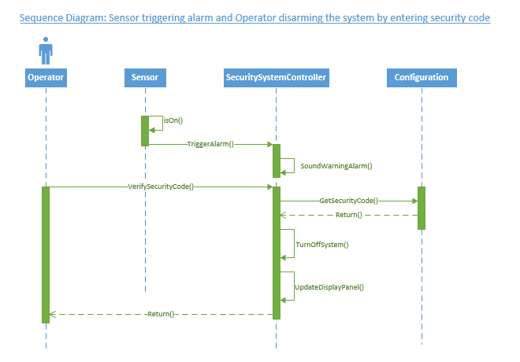

1. Creating a Github account

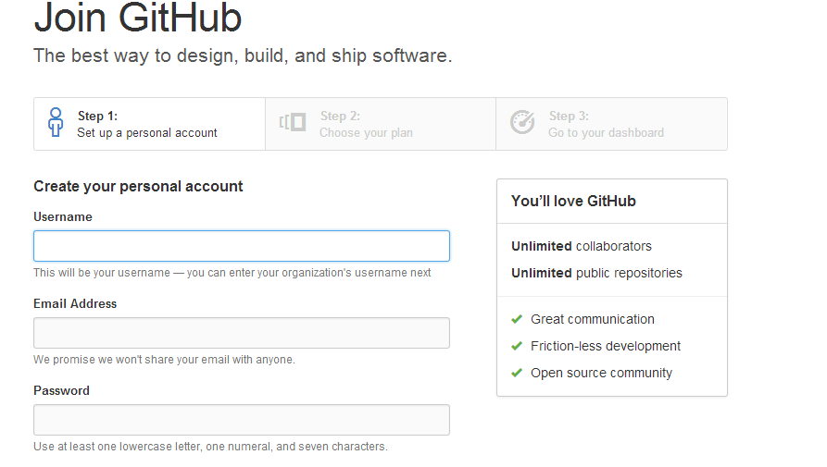

After creating a Github account. Install Github for windows

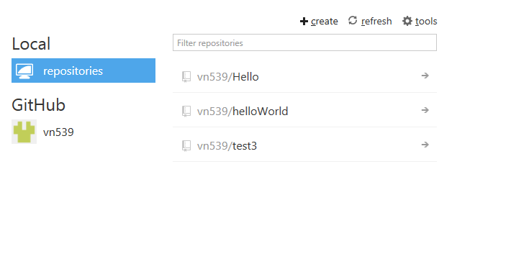

Creating new repository

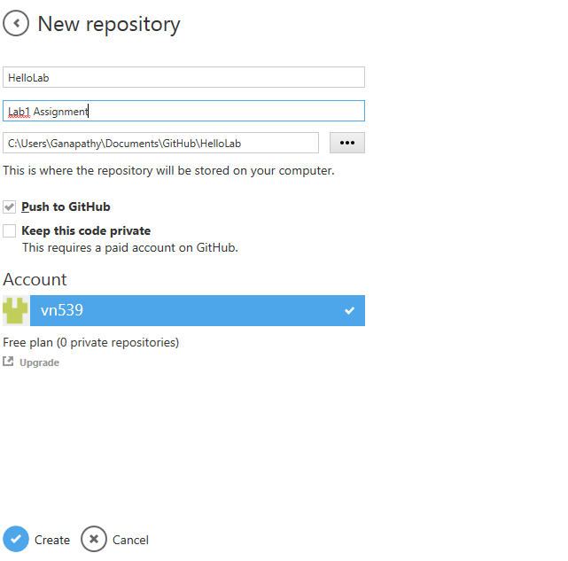

Repository created on the local machine

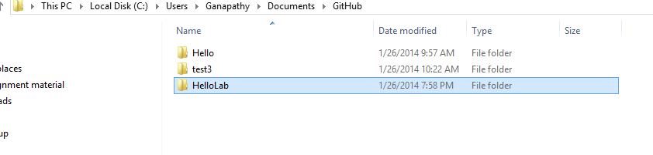

Created a text doc in the HelloLab folder

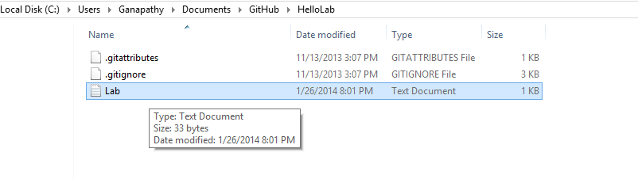

Using publish and synch button the changes on the local repository is pushed to the remote Github server.

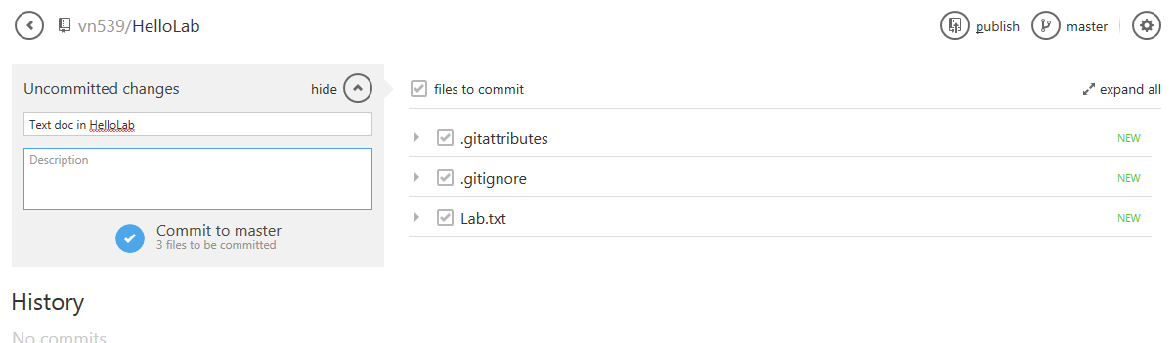

HelloLab folder is created on the remote server.

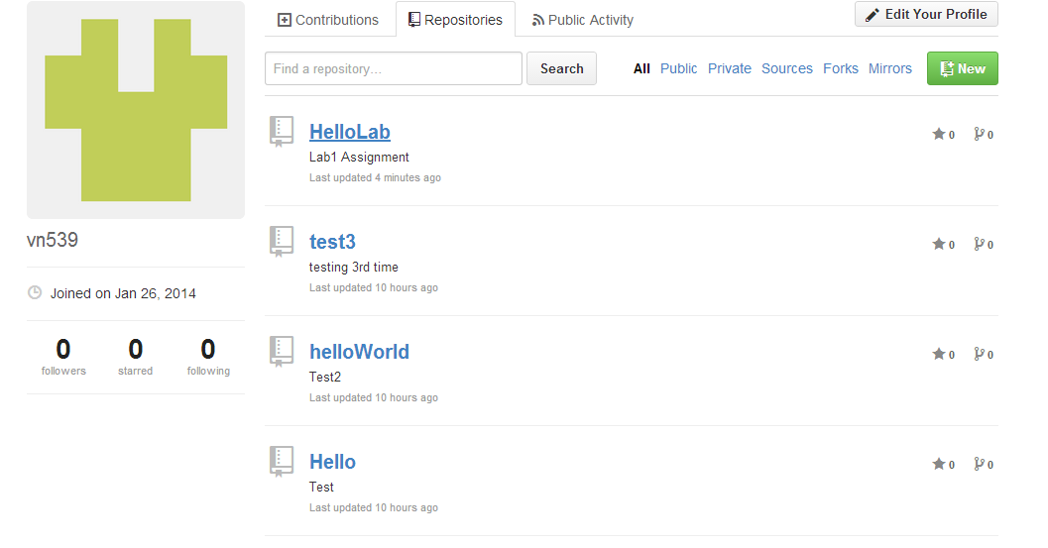

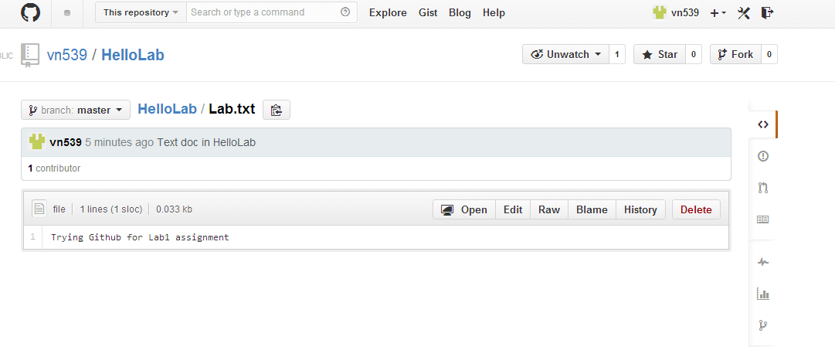

Creating scrumDo account

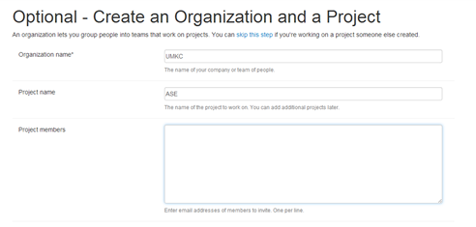

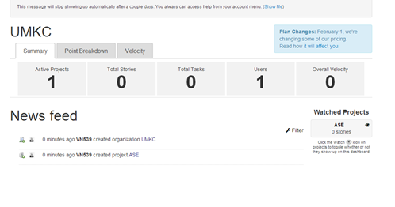

Defining user stories and Planning Iterations and Release for Home Security Systems.

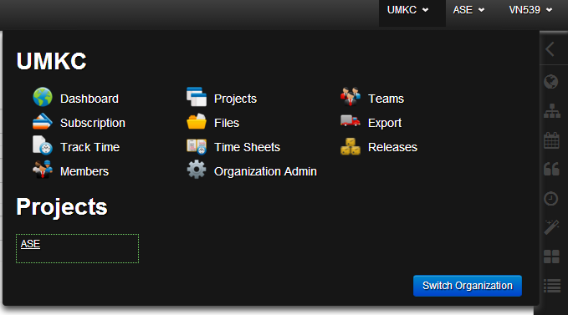

Adding stories and tasks for security alarms systems .

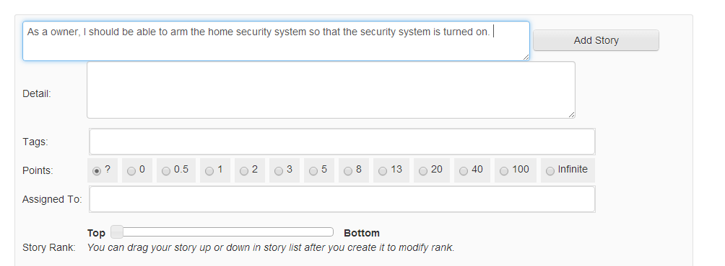

Backlog with all the user stories.

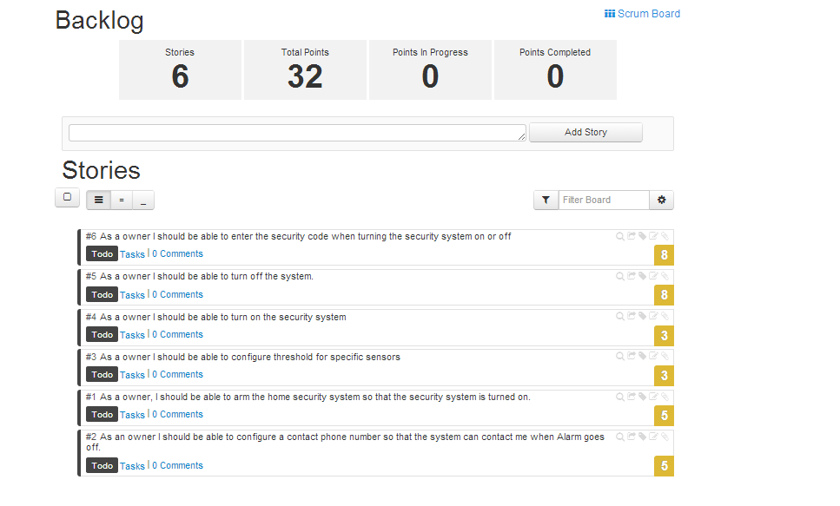Tasks assigned to each user story.

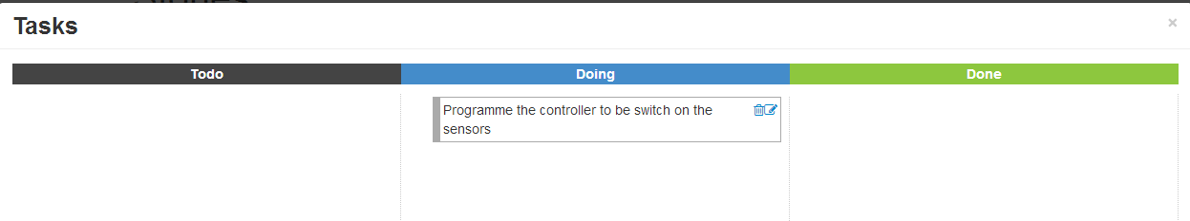

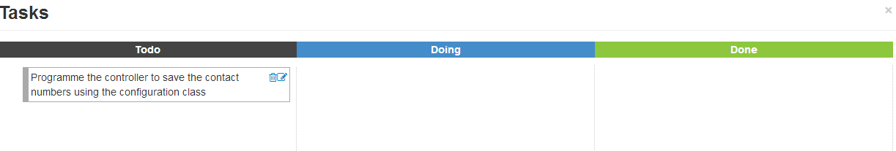

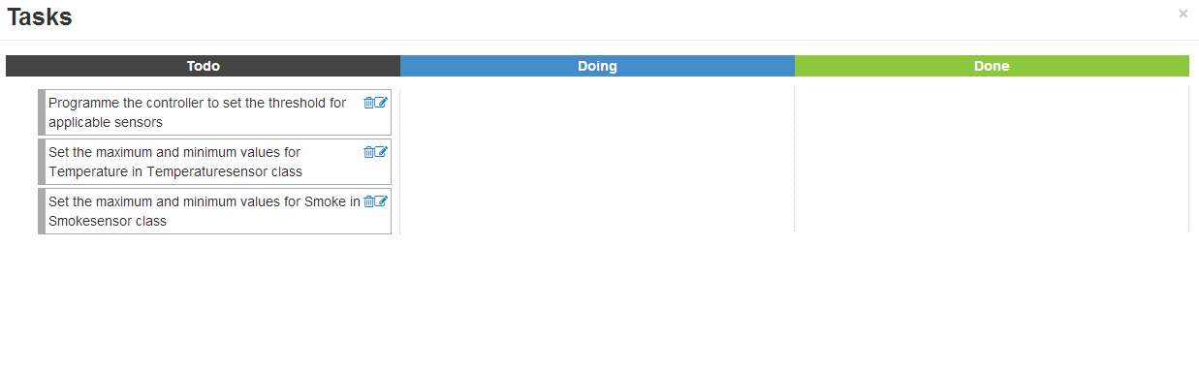Backlog with all user stories.

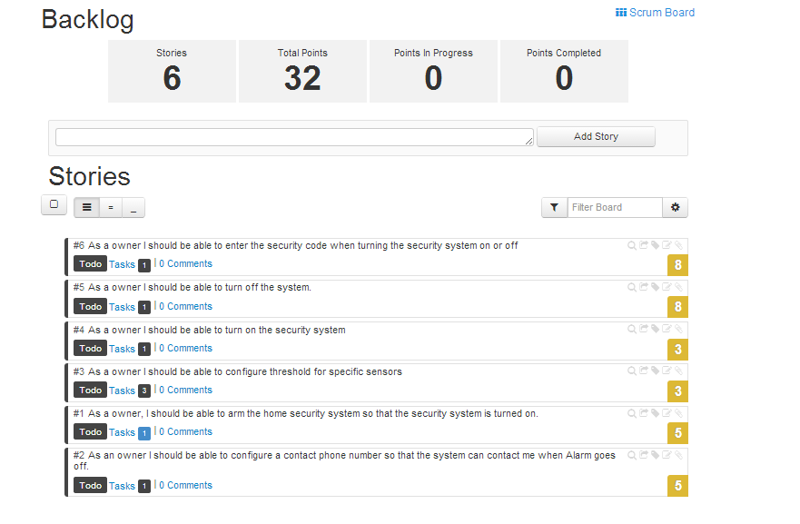

Creating Iterations and adding stories to the Iteration. Iteration is a planned time period within which the stories can be completed.

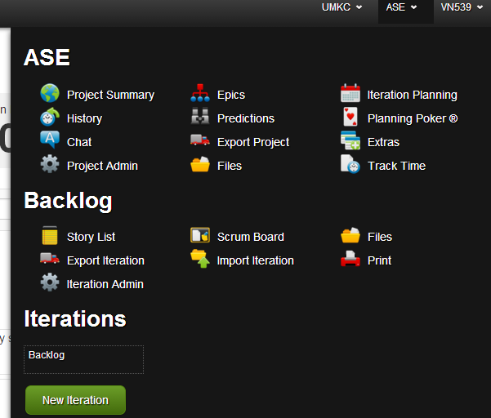

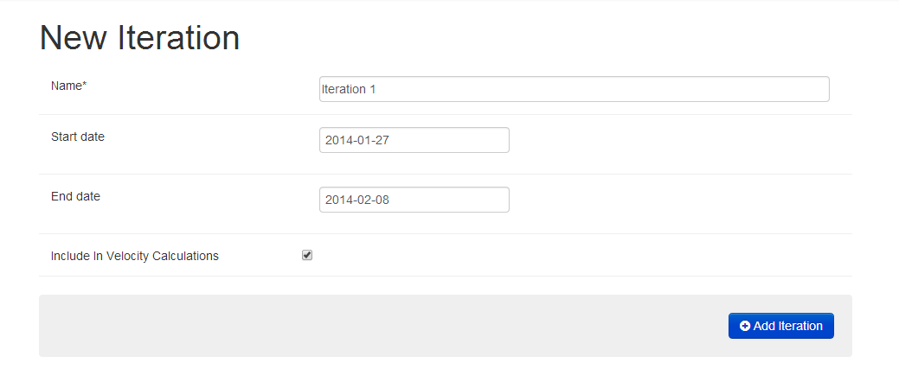

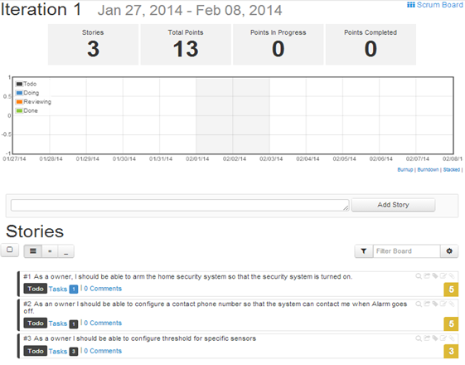

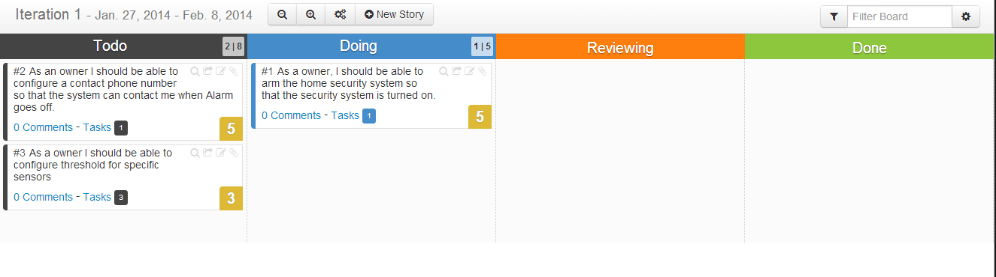

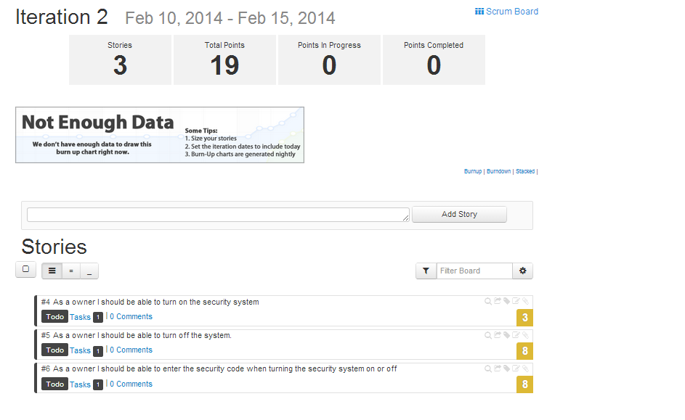

Delivery

Step 1: Release can be used to set a date for delivery of Project which can be found under UMKC Projects.

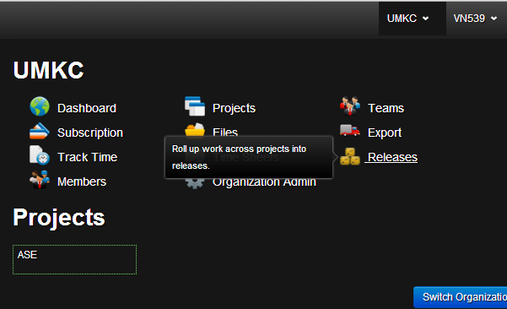

Step 2: Create a release name with the start and delivery dates.

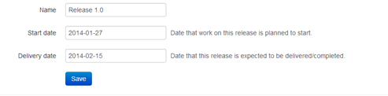

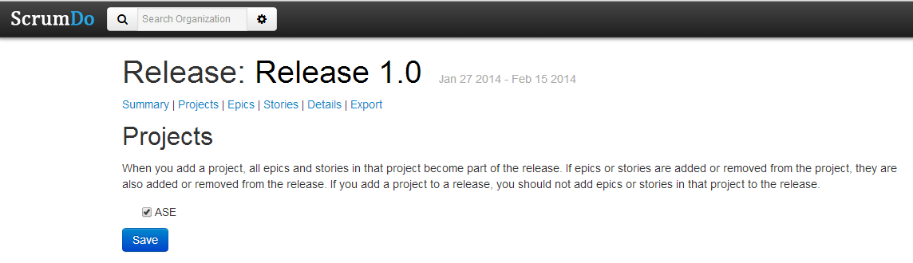

Step 3: All the related information of the project along with the stories can be found under summary.

