Vi Nguyen

Period 5

nQueens

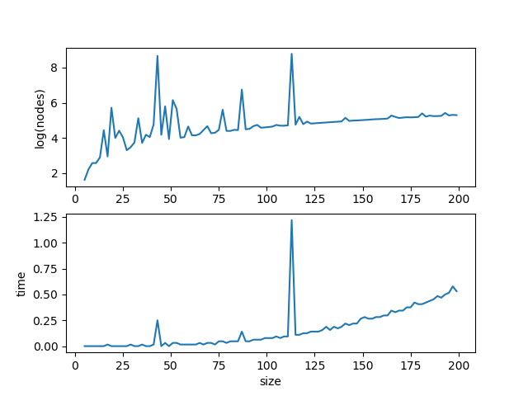

For nQueens, the variable designated a column in which a queen would be placed on the board. To choose the next variable, I used the Minimum Remaining Value heuristic with random tie breaks. The heuristic chose the column which had the least spaces available to place a queen without being attacked by other queens on the board.

The value heuristic returned a sorted list of possible values or rows where a queen could be placed in a particular column. I used an inside out sort with random tiebreaks which prioritized rows closer to the middle of the board.

To store the state of each board, I used a tuple of a list and a dictionary. The list stored the position of each queen on the board such that the indexes were columns and the values were rows. Initially all the rows would be set to -1 to represent no queens. The dictionary stored columns as keys. For each column, the value in the dictionary was a set of all possible rows where a queen could be placed in that column. When a queen was placed in a column, the column would be removed from the dictionary.