# 5/29

## Minting:

1. CRITICAL : Badges still not visible in recipient wallet and also no transactions showing up [FIXED]

2. What is the new signature process added in minting? [APPROVED]

3. Ideally as its the connected wallet minting, there should be tokens send transaction in the wallet and

[FIXED]

## Adding Contributor :

2. Admin menu : Contributor login cannot see the existing DAO User to manage [FIXED]

3. ONERep Board : Can't see the existing records [FIXED]

## Super Admin: Working as expected

4. Please add DAO Name column in all Admin, ONERep Files and ONERep Board. A bit difficult to figure out which DAO they belong to. [FIXED]

## Cosmetic

5. Side Menu visible in registration screen. Attached screenshot [FIXED]

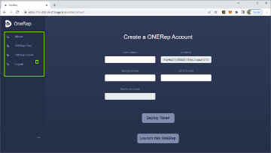

6. Please change the green color of popup to match with the theme colors. [FIXED]

please check and update

# 6/1

## Adding Contributor :

1. Admin menu : Contributor login cannot see the existing DAO User to manage

2. ONERep Board : Can't see the existing records

## DAO User :

1. Admin menu : DAO User login cannot see his own account details in the Admin menu

## Cosmetic :

Please sort the ONERep Board records by ONERep Tokens descending by default in all logins