1)install prettier on visual studio
2)cntr+shift+p type prettier configuration file (in backend folder )
--------install library for prettier ---------
3) npm init
4) npm install prettier
5) to format something cntr shift p format document with prettier h cntr shift I

create server
1)npm init
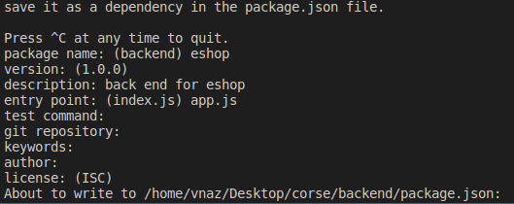

2)npm install nodemon (for monitor changes)
3) we add to pacage.json the next code

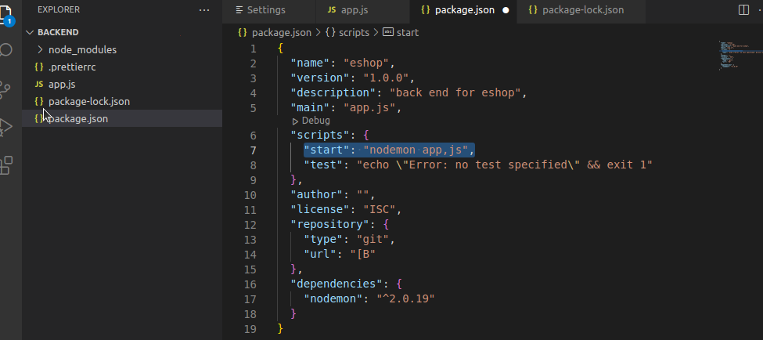
4)for run npm start

----------- for install web server--------------------
5)npm install express

------you can add an .env file for variables with scope in all pages
6) create an .env file
7) npm install dotenv
-- in .env we have a API_URL variables
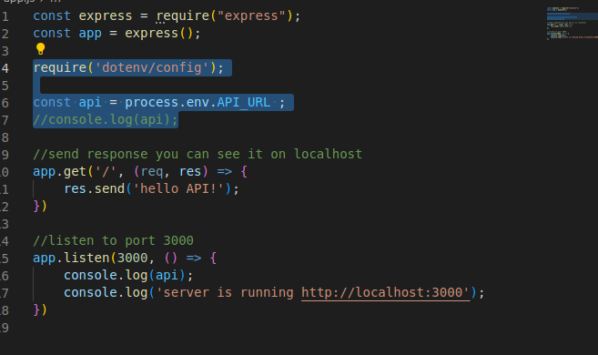

Make json for communication

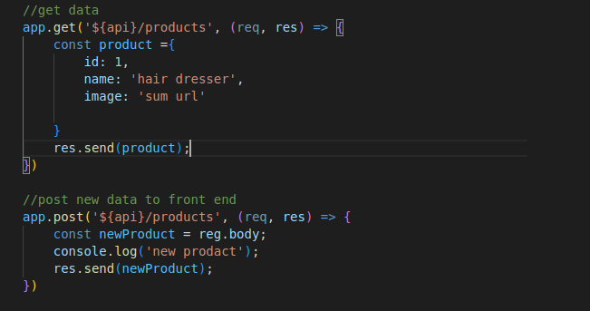
We need middleware because we need to convert json and be understandable from front end
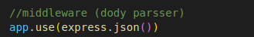

Trace logs

1) npm install morgan
--it is a middlewere library
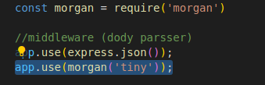
2)

3)

Mongodb atlas

1) install mongoose
2) npm install mongoose
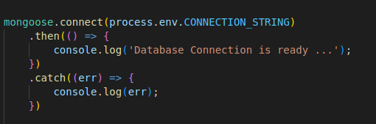
---------------Lockal data for browsing mongo db localy
mongo db compass

3)create a model with mongoose schema

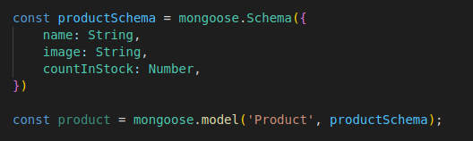

4)check how routers and models wreeten in project
get and post written in routers folder

how to fix back end don’t trust font end (if you do front and back-end together)

1)npm install cors
2)
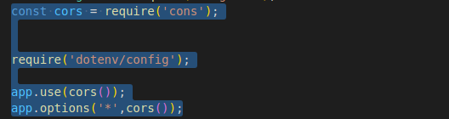

Hashing password for protection
1)npm install bcryptjs
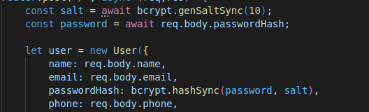

--json with token

1)npm i jsonwebtoken

Protect the api and authenitcation JWT
1)Make a folder helpers with jwt.js
2)npm i express-jwt
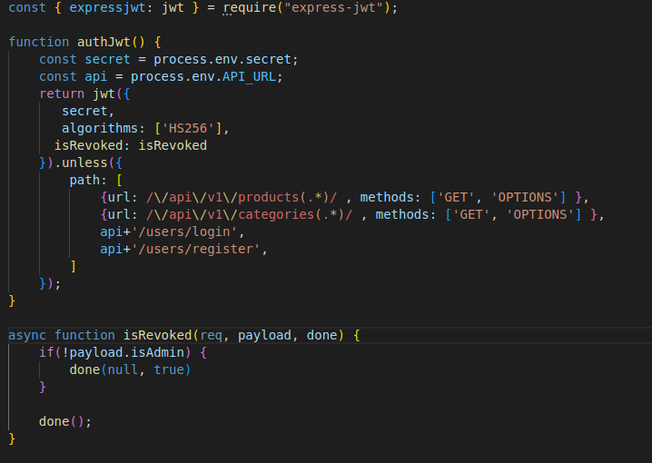
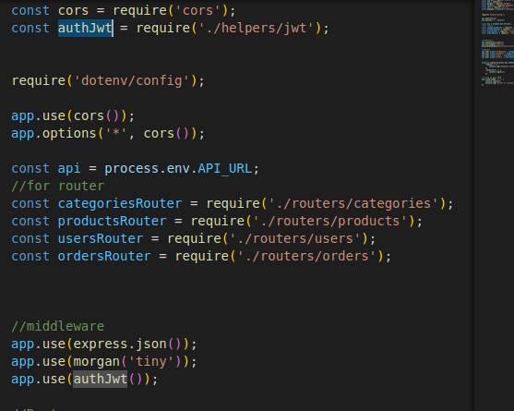

Handle pictures
1) npm i multer

