Language-Guided Weakly Supervised Video Anomaly Detection with Adaptive Instance Selection

Abstract

Weakly Supervised Video Anomaly Detection (WS-VAD) aims to temporally localise anomalous events in untrimmed surveillance videos using only video-level supervision during training. Existing Multiple Instance Learning (MIL)-based approaches primarily rely on visual representations, which often suffer from context bias where visually similar normal and abnormal scenes are confused. This work investigates whether semantic language guidance can improve anomaly localisation under weak supervision. We propose a language-guided cross-attention framework that combines BLIP-2-generated captions, CLIP visual embeddings, and CLIP text embeddings within a shared semantic embedding space. Building upon this foundation, we further investigate Adaptive Instance Selection (AIS) for stabilising weakly supervised optimisation and explore feature magnitude learning inspired by RTFM. Experimental results on the UCF-Crime dataset demonstrate that semantic guidance improves frame-level localisation beyond traditional visual-only MIL baselines, while AIS further stabilises temporal supervision and improves localisation behaviour. Additional extension experiments investigating temporal resolution scaling from T=32 to T=128 show that temporal granularity strongly affects anomaly localisation precision. Overall, the study highlights the importance of semantic reasoning, stable weak supervision, and temporal resolution in modern WS-VAD systems.

1. Introduction
Weakly Supervised Video Anomaly Detection (WS-VAD) aims to temporally localise anomalous events in long untrimmed surveillance videos using only video-level supervision during training. The rapid growth of surveillance systems has increased the need for automated anomaly detection across applications such as public safety monitoring, traffic surveillance, industrial safety, and smart-city infrastructure. However, obtaining frame-level temporal annotations is extremely labour-intensive and expensive, making weak supervision an important research direction.
Most existing WS-VAD approaches formulate the problem using Multiple Instance Learning (MIL), where videos are represented as bags of temporal segments. Although effective, many MIL-based methods rely exclusively on visual representations extracted from CNN or transformer backbones, leading to context bias. Visually similar scenes may correspond to semantically different situations. For example, smoke may represent normal cooking activity in one scene and an explosion in another, while running may indicate athletic activity or violent escape behaviour depending on the semantic context.
To address this limitation, we investigate whether semantic language guidance can improve anomaly localisation under weak supervision. We propose a language-guided cross-attention framework that combines BLIP-2-generated captions, CLIP visual embeddings, and CLIP text embeddings within a shared semantic embedding space. Unlike direct feature concatenation approaches, textual embeddings act as semantic queries while visual embeddings act as keys and values within a cross-attention mechanism.
Building upon this foundational framework, we further investigate Adaptive Instance Selection (AIS) for stabilising weak supervision and explore feature magnitude learning inspired by RTFM. Additional extension experiments investigate temporal resolution scaling and localisation behaviour.

Main Contributions
1. A language-guided cross-attention framework for semantic anomaly localisation.
2. Investigation of Adaptive Instance Selection (AIS) for stabilising weak supervision.
3. Exploration of feature magnitude learning alongside semantic guidance.
4. Extension experiments investigating temporal resolution scaling from T=32 to T=128.

2. Related Work
Sultani et al. introduced foundational MIL-based WS-VAD using visual-only representations. RTFM later explored feature magnitude learning for anomaly separation. Recent multimodal models such as CLIP and BLIP-2 have enabled stronger semantic alignment between visual and textual representations.

2.1 Weakly Supervised Video Anomaly Detection
Sultani et al. [1] introduced one of the foundational MIL-based WS-VAD frameworks using C3D features and ranking-loss optimisation. Their work demonstrated that weak supervision can localise anomalies without requiring frame-level annotations. However, the framework relied entirely on visual representations and often produced coarse temporal localisation.

2.2 Feature Magnitude Learning
Tian et al. [2] proposed Robust Temporal Feature Magnitude Learning (RTFM), based on the observation that anomalous segments often exhibit stronger feature magnitudes than normal segments. Instead of relying solely on anomaly scores, RTFM introduced feature magnitude separation for robust anomaly localisation. Inspired by this idea, our work investigates whether feature magnitude information can complement semantic language guidance within a multimodal WS-VAD framework.

2.3 Multimodal and Language-Guided Methods
Recent multimodal foundation models such as CLIP [3] and BLIP-2 [4] have enabled strong semantic alignment between visual and textual representations. Several recent anomaly detection approaches have explored multimodal fusion and language-guided reasoning. However, many methods rely on direct feature concatenation or prompt engineering. In contrast, our framework uses language-guided cross-attention, where semantic text embeddings actively guide visual feature selection.

2.4 Self-Training and Adaptive Supervision
Feng et al. [5] introduced MIST, a pseudo-label self-training framework that gradually transitions from bag-level to instance-level supervision in WS-VAD. Inspired by adaptive supervision strategies such as MIST, we further investigate Adaptive Instance Selection (AIS) to stabilise noisy Top-K MIL optimisation through confidence-aware segment weighting within a semantic-guided MIL framework.

3. Methodology
The proposed framework consists of offline feature extraction and online weakly supervised training. CLIP visual embeddings and BLIP-2-generated semantic captions are encoded into a shared embedding space and fused using language-guided cross-attention.
3.1 Overall Pipeline
The proposed framework consists of two stages: offline feature extraction and online weakly supervised training.During offline extraction, video frames are processed using the CLIP visual encoder [3] to generate visual embeddings. Simultaneously, BLIP-2 [4] generates semantic captions for sampled frames. These captions are encoded using CLIP’s text encoder to obtain semantic text embeddings within the same embedding space as the visual features.

The extracted multimodal embeddings are subsequently used during online Multiple Instance Learning (MIL)-based training.

Pipeline Overview

Frames → CLIP Visual Encoder → Visual Features
Frames → BLIP-2 Captioning → CLIP Text Encoder → Text Features
Visual + Text Features → Cross-Attention → MIL Scoring → Frame-Level Anomaly Scores

Figure 1 — Overall Language-Guided WS-VAD Pipeline

[INSERT PIPELINE DIAGRAM HERE]

Figure 1 illustrates the complete semantic-guided WS-VAD framework. Visual embeddings extracted using CLIP are combined with semantic text embeddings generated through BLIP-2 captioning and CLIP text encoding. Cross-attention enables semantic guidance during anomaly localisation under weak supervision.

3.2 Feature Extraction
Videos are divided into temporal segments. The foundational experiments use T=32 temporal segmentation, where each video is represented by 32 sampled temporal snippets. CLIP ViT-B/16 [3] is used for visual feature extraction, producing 512-dimensional embeddings. BLIP-2 [4] generates semantic captions for sampled frames, and the captions are encoded into the same 512-dimensional CLIP embedding space.
This shared embedding space is important because it enables direct semantic interaction between textual and visual representations during cross-attention.

3.3 Language-Guided Cross-Attention
The core contribution of the framework is language-guided cross-attention. Instead of concatenating visual and textual embeddings, textual features act as semantic queries while visual features act as keys and values.
Attention(Q,K,V)=softmax(QKTdk)V\mathrm{Attention}(Q,K,V)=\mathrm{softmax}\left(\frac{QK^T}{\sqrt{d_k}}\right)VAttention(Q,K,V)=softmax(dk​​QKT​)V
where:
- QQQ = text embeddings
- KKK = visual embeddings
- VVV = visual embeddings
This mechanism allows semantic descriptions to guide attention towards anomaly-relevant visual patterns. For example, captions describing aggressive interactions can guide the model towards violent motion regions instead of generic movement.

Figure 2 — Language-Guided Cross-Attention Mechanism
[INSERT CROSS-ATTENTION DIAGRAM HERE]
Figure 2 illustrates how semantic text embeddings guide visual attention. Unlike direct feature concatenation approaches, cross-attention enables the model to selectively focus on visual patterns aligned with semantic anomaly descriptions.

3.4 Multiple Instance Learning and Adaptive Instance Selection (AIS)
The model predicts anomaly scores for each temporal segment. Since only video-level labels are available during training, Multiple Instance Learning (MIL) [1] is used.
Traditional MIL frameworks rely on rigid Top-K segment selection. However, early training stages often produce noisy anomaly scores, causing unstable supervision and reinforcement of incorrect temporal regions.
To address this issue, we investigate Adaptive Instance Selection (AIS), where soft probabilistic weighting replaces hard Top-K supervision. Inspired by adaptive supervision strategies such as MIST [5], AIS gradually sharpens supervision during training, behaving similarly to curriculum learning. Early training allows broader segment participation, while later training increasingly focuses on high-confidence anomaly segments.

Figure 3 — Top-K MIL vs AIS Localisation Behaviour

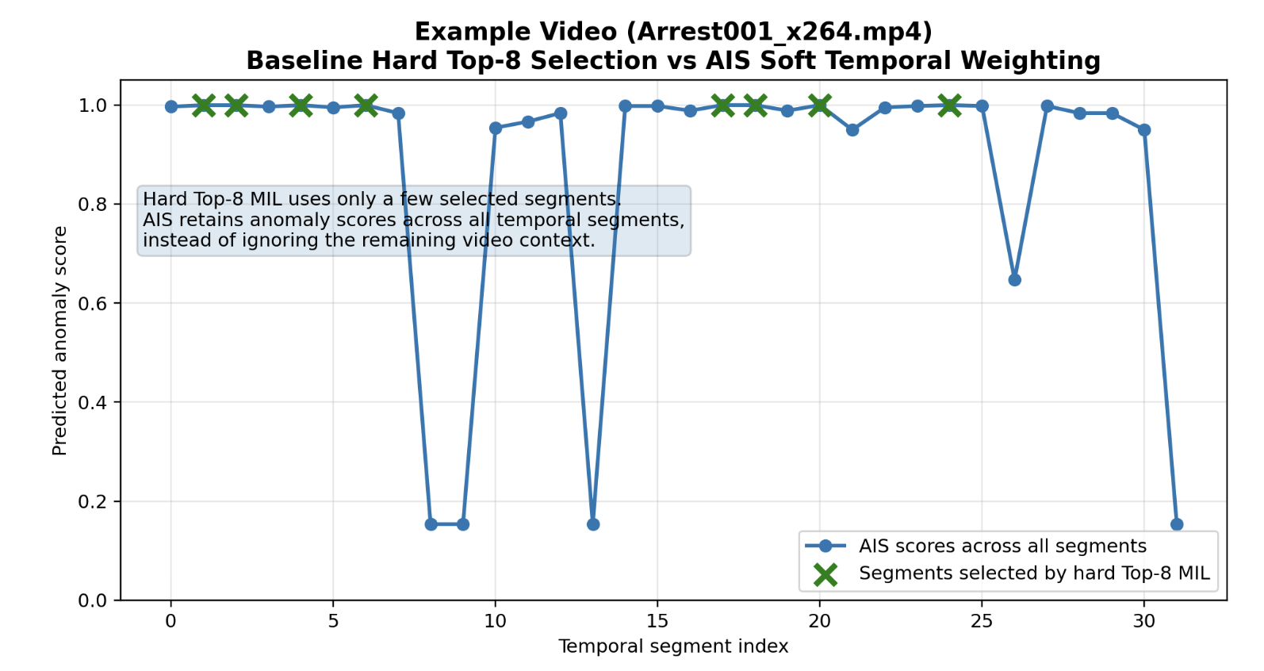
Figure 3 compares anomaly score behaviour between rigid Top-K MIL supervision and AIS-based supervision. The AIS approach produces smoother and more temporally consistent anomaly localisation, reducing unstable spikes observed under rigid Top-K selection.

3.5 Feature Magnitude Exploration
Inspired by RTFM [2], we explored whether feature magnitude information could complement semantic guidance. Visual feature L2 norms were used as an auxiliary anomaly signal and fused additively with semantic anomaly scores.
Although conceptually motivated, experiments suggested that semantic cross-attention and AIS contributed more significantly to localisation performance than raw feature magnitude within the proposed framework.

3.6 Loss Function
The total loss combines:
- MIL ranking objectives
- AIS weighting
- temporal smoothness regularisation
- self-training objectives
Temporal smoothness regularisation encourages neighbouring temporal segments to produce consistent anomaly scores, reducing abrupt prediction noise during localisation.

4. Experiments
Experiments were conducted on the UCF-Crime dataset using the foundational T=32 semantic-guided setup. Additional extension experiments explored temporal resolution scaling.

4.1 Dataset and Experimental Setup
Experiments were conducted on the UCF-Crime dataset [1], which contains 13 anomaly categories alongside normal surveillance videos. The dataset includes 1,610 training videos and 283 testing videos.
Training was performed using PyTorch on an NVIDIA RTX 4060 GPU. The foundational experiments used T=32 temporal segmentation and were trained for 100 epochs.

4.2 Evaluation Metrics
Performance was evaluated using:
- Video-Level AUROC
- Frame-Level AUROC
Frame-level AUROC is particularly important because it measures temporal localisation quality and evaluates whether anomalous temporal regions are accurately identified.

4.3 Main Semantic-Guidance Track
The primary research track focused on semantic guidance, AIS stabilisation, and feature magnitude exploration while preserving the same foundational WS-VAD framework.
Model | Main Idea | Frame-Level AUROC
Sultani et al. [1] | Visual-only MIL baseline | 75.41
V1 Baseline | Language-guided cross-attention | 77.14
V2 | Magnitude branch exploration | Similar / slight change
V2.1 | + AIS stabilisation | 78.98
The V1 baseline demonstrated that semantic language guidance improved localisation beyond the traditional visual-only MIL framework. Subsequent AIS experiments further stabilised weak supervision and improved temporal localisation behaviour.

Figure 4 — Frame-Level AUROC Comparison
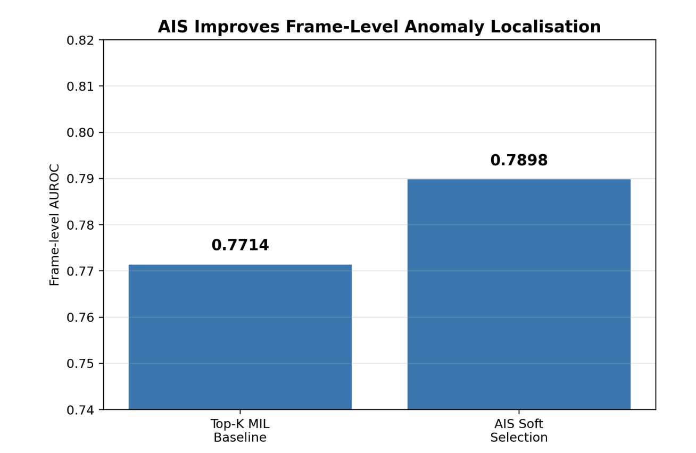
Figure 4 summarises the performance progression across the foundational semantic-guided WS-VAD track. Language-guided cross-attention demonstrated the importance of semantic guidance over traditional visual-only MIL frameworks, while AIS further improved localisation stability by reducing noisy Top-K segment selection behaviour.
Sultani et al. baseline (75.41%) → + Language-Guided Visual Cross-Attention (77.14%) → + Adaptive Instance Selection (AIS) (78.98%).

4.5 Extension Experiments: Temporal Resolution Scaling
T=64 and T=128 experiments demonstrated that temporal granularity strongly affects anomaly localisation precision.

4.4 Error Analysis
Error analysis played a central role throughout the project. Several important failure modes were identified:
- context bias in visually ambiguous scenes
- lazy localisation under weak supervision
- temporal aliasing caused by coarse segmentation
- false positives triggered by strong normal motion patterns
AIS experiments revealed that rigid Top-K supervision amplified noisy early predictions, motivating adaptive soft selection strategies.
Overall, the analysis demonstrated that semantic guidance improved contextual anomaly reasoning, while AIS reduced unstable temporal spikes and improved localisation consistency under weak supervision.

4.5 Extension Experiments: Temporal Resolution Scaling
Building upon the shared semantic-guided foundation, additional extension experiments investigated temporal resolution scaling and localisation precision.
Temporal Resolution | Frame-Level AUROC
T=32 | Baseline
T=64 | Improved
T=128 | 82.06
These experiments revealed that temporal granularity strongly affects localisation precision. Increasing temporal resolution reduced temporal aliasing and enabled finer anomaly boundary localisation.

5. Discussion
The experiments demonstrate that semantic language guidance improves anomaly localisation beyond traditional visual-only MIL frameworks. Cross-attention enables semantic text descriptions to guide attention towards anomaly-relevant visual patterns, helping reduce context bias in visually ambiguous scenes.
Adaptive Instance Selection (AIS) further stabilised weak supervision by reducing noisy early Top-K segment selection behaviour and improving temporal localisation consistency. In contrast, the feature magnitude branch produced comparatively limited gains within the proposed semantic-guided framework.
Additional extension experiments investigating temporal resolution scaling suggested that increased temporal granularity can further improve anomaly boundary precision and reduce temporal aliasing effects in WS-VAD systems.

6. Conclusion and Future Work
This work investigated semantic language guidance for WS-VAD using BLIP-2, CLIP embeddings, cross-attention, and Adaptive Instance Selection (AIS). Experimental results demonstrated that semantic guidance and AIS improved localisation behaviour under weak supervision, while extension experiments suggested that temporal granularity also affects anomaly localisation precision. Future work may investigate stronger temporal modelling, improved anomaly-focused semantic prompting, and lightweight motion-aware extensions.

7. References

[1] W. Sultani, C. Chen, and M. Shah, “Real-world anomaly detection in surveillance videos,” in Proc. CVPR, 2018.

[2] J. Tian et al., “Weakly-supervised video anomaly detection with robust temporal feature magnitude learning,” in Proc. ICCV, 2021.

[3] A. Radford et al., “Learning transferable visual models from natural language supervision,” in Proc. ICML, 2021.

[4] J. Li et al., “BLIP-2: Bootstrapping language-image pre-training with frozen image encoders and large language models,” in Proc. ICML, 2023.

[5] D. Feng et al., “MIST: Multiple instance self-training framework for video anomaly detection,” in Proc. CVPR, 2021.

Appendix

Appendix A — AIS and Experimental Visualisations

Figure A1 — Frame-Level AUROC Comparison Plot


Figure A2 — AIS Temperature Scheduling Plot
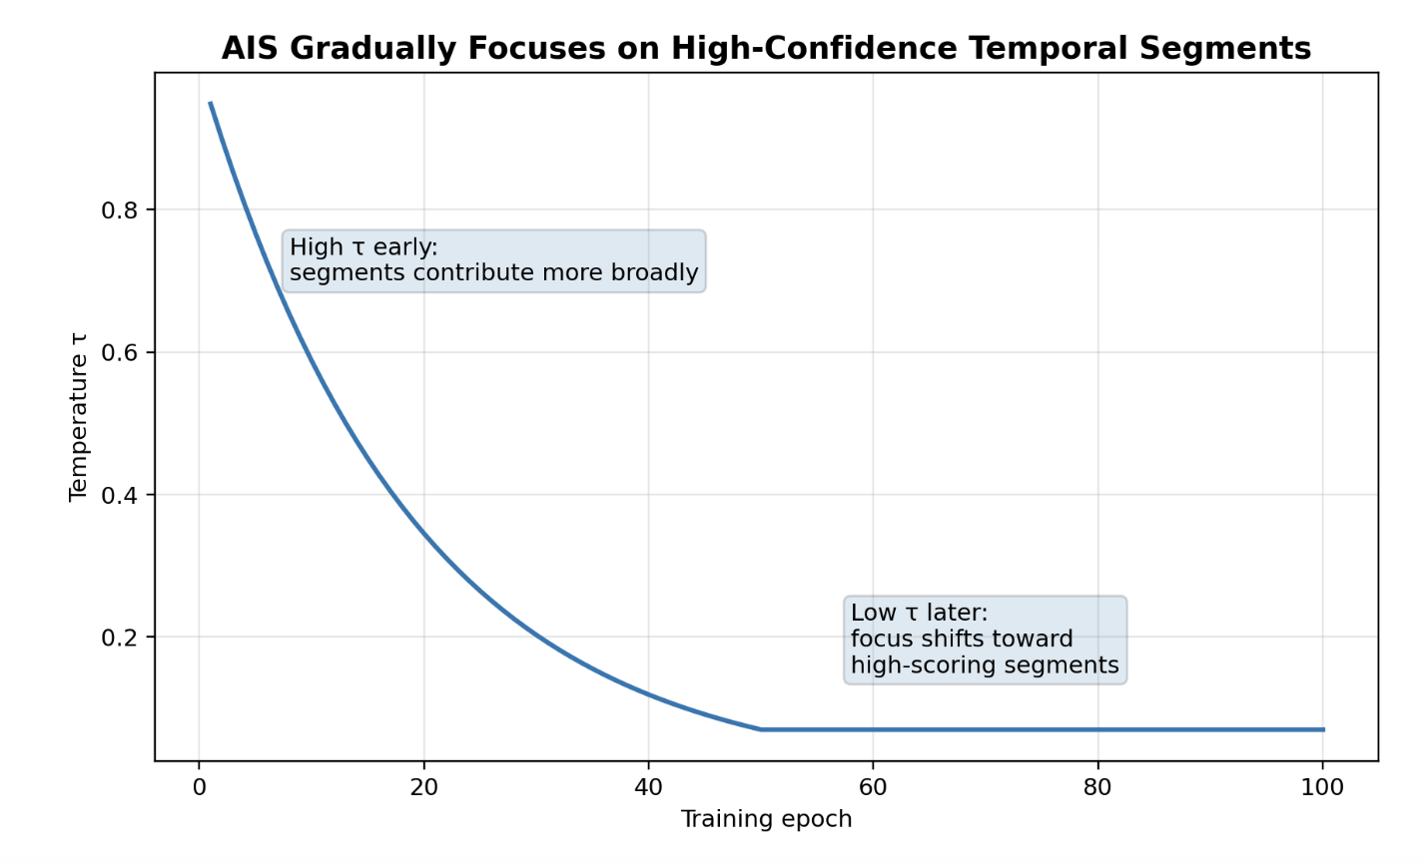

Figure A3 — Top-8 MIL vs AIS Score Comparison


Appendix B — Additional Extension Experiments

Beyond the primary semantic-guided WS-VAD track, several additional exploratory and extension experiments were conducted to investigate temporal modelling, feature extraction strategies, and localisation refinement. These included:
- Florence-2-based dense captioning experiments
- anomaly-focused BLIP prompting
- multi-scale temporal attention
- dynamic normal prototype memory banks
- temporal pyramid dilated convolutions (PDC)
- higher temporal resolutions (T=64 and T=128)
- snippet contrastive learning (SCL)
- score smoothing and post-processing
- ensemble evaluation strategies
These experiments extended the foundational framework and further explored factors affecting temporal localisation precision and weakly supervised optimisation behaviour.

