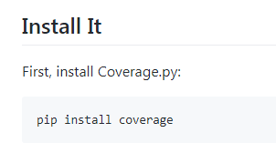

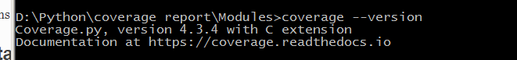

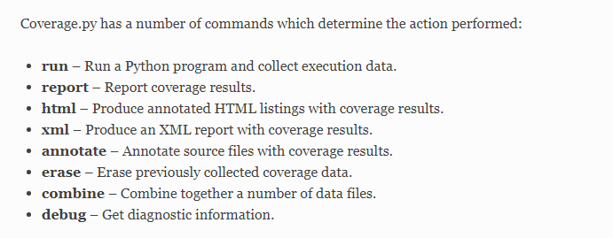

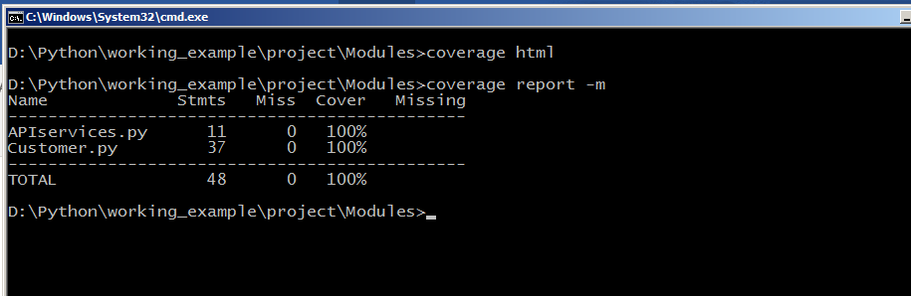

coverage report -m

coverage run Customer.py

coverage report -m

coverage html

#--- Workflow and view id is not covered

#--- Validation is not handled on servicer side (primary key not handled)

#--- creating multiple user with same id and data validation is not handled