Performance Ratio Analysis and Visualization for Solar PV Plant
Take Home Assessment — Project Report
Naresh V | IIT Roorkee | 26 July 2026

1. Introduction
Performance Ratio (PR) is the metric solar plant operators use to judge how efficiently a plant is converting available sunlight into delivered energy, independent of how sunny or cloudy any particular day happened to be. It is expressed as a percentage of actual energy output against the theoretical maximum the plant could have produced given the irradiation it received that day.
PR matters because raw energy output alone is a poor health indicator — a plant can generate less energy purely because a day was overcast, and that says nothing about equipment condition. PR normalises for weather, so a sustained drop in PR is a genuine signal of soiling, panel degradation, inverter faults, or other underlying issues that would otherwise be masked by day-to-day weather variation.
The objective of this assessment was to take raw daily PR and GHI (Global Horizontal Irradiance) readings, scattered across dozens of monthly CSV files, and turn them into a single merged dataset plus a Performance Ratio Evolution chart that combines a colour-coded scatter plot, a smoothed trend line, a dynamically-degrading budget target, and supporting statistics. A bonus requirement extended this into a command-line tool that could regenerate the same chart for any custom date range.
The expected output was a merged CSV file, a high-resolution PNG chart reproducing the required visual features, and — for the bonus — a working --start_date / --end_date interface.

2. Problem Statement
The raw data arrived as two separate folder trees, one for PR and one for GHI, each split into monthly sub-folders holding several daily CSV files apiece (for example, data/PR/2020-03/2020-03-27.csv). The assessment required:
- Recursively reading every PR CSV file across all month folders.
- Recursively reading every GHI CSV file across all month folders.
- Merging PR and GHI into one dataset, keyed on Date.
- Building a specific Performance Ratio Evolution chart — not a generic plot, but one combining GHI-coded scatter points, a 30-day moving average, a dynamic budget line, financial-year point counts, and a statistics box.
- Implementing a bonus feature: accepting --start_date and --end_date from the command line to regenerate the chart for any custom window.

3. Project Workflow
The project follows a linear pipeline, developed first in Jupyter notebooks and later restructured into a modular Python project:
Understanding Dataset
↓
Reading PR files recursively (Path.rglob)
↓
Reading GHI files recursively (Path.rglob)
↓
Creating PR dataframe (pd.concat)
↓
Creating GHI dataframe (pd.concat)
↓
Merging on "Date" (pd.merge, how="inner")
↓
Data preprocessing (datetime conversion, sort)
↓
Feature Engineering (colour, 30-day MA, budget, FY index)
↓
Visualization (scatter + MA + budget + stats + legend)
↓
Bonus implementation (argparse date filtering)
↓
Final Output (merged_data.csv + performance_ratio.png)

4. Dataset Description
Both PR and GHI data are organised as monthly sub-folders (33 months each, from 2019-07 to 2022-03), with each daily reading stored in its own small CSV file rather than one file per month. In total, 394 raw CSV files were provided (197 PR, 197 GHI).
Column | Found In | Description
Date | Both PR and GHI files | Calendar date of the reading (read as text, converted to datetime).
PR | PR files | Daily Performance Ratio (%).
GHI | GHI files | Daily Global Horizontal Irradiance.
After merging, the dataset holds 982 rows spanning 1 July 2019 to 24 March 2022, with no duplicate dates or missing values in either source.

5. Data Preprocessing
All preprocessing lives inside a single function, preprocess_data(pr_folder, ghi_folder), so the logic stays easy to test and reuse:
- Recursive file reading — Path(folder).rglob("*.csv") locates every file regardless of which month folder it sits in, so new months of data don't require any code changes.
- Combining files — pd.concat(..., ignore_index=True) stacks every daily PR file into one PR dataframe, and the same for GHI, avoiding repeated indices that would otherwise break later sorting.
- Merge — pd.merge(pr_df, ghi_df, on="Date", how="inner") joins the two on Date. An inner join was used deliberately, so a date missing from either side is correctly excluded rather than guessed at.
- Datetime conversion — pd.to_datetime(...) turns Date from plain text into an actual datetime, which every later step (sorting, rolling averages, financial-year lookup) depends on.
- Sorting — sort_values("Date") followed by reset_index(drop=True) guarantees chronological order, which matters directly for the 30-day rolling average.
- Feature engineering — a get_color(ghi) function assigns each row a GHI colour band, and calculate_budget(date) computes that row's Target Budget PR (see Section 6).
- Saving the merged CSV — main.py writes the merged dataframe to output/merged_data.csv immediately after preprocessing, independent of any date filtering applied afterwards.

6. Visualization Development
The chart was built incrementally, one feature at a time, checking the result visually after each stage:
- Stage 1 — Basic Scatter Plot: a plain plt.scatter(Date, PR) confirmed the merged data plotted sensibly along the timeline before adding any complexity.
- Stage 2 — Colour Coding using GHI: each point was coloured by its GHI band (navy / sky blue / orange / brown), turning a flat scatter into a two-dimensional read — PR on the y-axis, sunlight conditions in the colour.
- Stage 3 — 30-Day Moving Average: daily PR is noisy, since a single hazy day swings it without meaning much. A 30-day rolling mean, drawn in red, smooths that noise into a readable trend.
- Stage 4 — Dynamic Budget Line: a dark green line shows the Target Budget PR, calculated per financial year rather than hard-coded, so it steps down automatically every July.
- Stage 5 — Financial Year Points Above Budget: the number of days each financial year where PR beat that year's budget is counted and annotated directly next to each budget segment.
- Stage 6 — Statistics Box: a bottom-right text box summarises average PR over the trailing 7, 30, 60, 90, and 365 days, plus the lifetime average of whatever range is plotted.
- Stage 7 — Legend: a custom Line2D-based legend was used instead of Matplotlib's default, since the chart mixes scatter markers with line series that don't combine cleanly in an auto-generated legend.
- Stage 8 — Final Graph: the last pass added a two-line title with the exact date range shown, a light dashed grid, rotated month/year tick labels, and a 300 DPI export suitable for direct use in a report.

7. Bonus Feature
The core preprocessing and visualization logic was developed and validated first, inside two Jupyter notebooks (01-Preprocessing_pvDoctor.ipynb and 02-Visualization.ipynb). To satisfy the bonus requirement, that working logic was restructured into a modular Python project rather than left as notebook cells.
- preprocess.py — a single function, preprocess_data(pr_folder, ghi_folder), holding only the file-reading and merge logic.
- visualization.py — a single function, plot_performance_ratio(data, output_path), holding only the charting logic and its helper functions (get_color, budget_year, calculate_budget).
- main.py — parses command-line arguments, calls preprocess_data(), filters by date if requested, and calls plot_performance_ratio() on what remains.
- requirements.txt and README.md — document dependencies and usage for anyone cloning the repository.
argparse exposes two optional arguments:
python main.py
python main.py --start_date 2020-01-01 --end_date 2020-12-31
When no dates are supplied, the tool runs against the full dataset. When dates are supplied, the dataframe is filtered before the moving average, budget line, financial-year counts, and statistics box are calculated, so every derived figure reflects exactly the requested window. A validation check rejects a start date later than the end date with a clear error instead of silently producing a broken chart.
AI assistance (Claude) was used as a development assistant to help refactor the already-working notebook logic into this modular structure and to implement the argparse-based command-line support. The preprocessing approach, the chart's features, and the budget/financial-year logic were designed and validated in the notebooks beforehand — AI's role was restructuring and wiring up the bonus interface, not designing the analysis itself.

8. Challenges Faced
- Recursive reading: confirming the month-wise folder depth before writing file-discovery logic, and making sure rglob picked up every file without hard-coding folder names.
- Date matching: converting Date to a real datetime type early, since sorting, the rolling window, and the financial-year lookup all depend on it.
- Financial Year calculation: getting the July-to-June boundary right in budget_year(date), particularly the year-offset arithmetic for dates before versus after July.
- Dynamic Budget: implementing the 0.8% reduction as a compounding formula rather than a flat yearly subtraction, so it scales correctly to any number of future years.
- Visualization design: coordinating scatter points, two line series, per-year annotations, a stats box, and a custom legend on one set of axes without anything overlapping.
- Project modularisation: splitting logic from many notebook cells into three clean files without changing what it computed, and confirming the plotting function still worked on an already-filtered subset of data.

9. Learning Outcomes
- Practical pandas skills: reading, concatenating, and merging many small files into one analysis-ready dataframe.
- Building layered, presentation-quality charts in Matplotlib, including custom legends and axes-coordinate annotations.
- Recursive file handling with pathlib as a maintainable alternative to hard-coded file lists.
- Core preprocessing habits: datetime conversion, chronological sorting, and duplicate/missing-value checks before analysis.
- Time-series analysis fundamentals, particularly the difference between a noisy daily signal and its smoothed trend.
- Python project organisation — splitting notebook logic into importable, single-responsibility modules, and exposing them through argparse.
- Structuring a GitHub project (README, requirements.txt, .gitignore) so it is easy for someone else to clone and run.

10. Technologies Used
Technology | Purpose
Python | Core programming language.
Pandas | Reading, merging, and transforming the PR/GHI data.
NumPy | Underlying numerical support for pandas and Matplotlib.
Matplotlib | Building the Performance Ratio Evolution chart.
Pathlib | Recursive CSV discovery across the month-wise folders.
Argparse | Command-line interface for the bonus date-range feature.
Jupyter Notebook | Initial exploratory development of the preprocessing and visualization logic.
VS Code | Editing and organising the final modular project.
Git / GitHub | Version control and repository hosting.

11. Results
- Merged dataset: 982 rows, columns Date / PR / GHI, spanning 1 July 2019 to 24 March 2022, with no duplicate dates or missing values.
- Generated graph: a single Performance Ratio Evolution chart combining all required overlays, exported at 300 DPI.
- Financial Year analysis: 179/366 days above budget in Year 1, 170/349 in Year 2, and 130/267 in the partial Year 3 — roughly 49% of days beating budget in each year.
- Budget analysis: Target Budget PR of 73.90% (Year 1), 73.31% (Year 2), and 72.72% (Year 3), computed entirely from the compounding formula with no year-specific values hard-coded.
- Statistics: average PR of 73.8% (last 7 days), 71.9% (last 30 days), 73.0% (last 60 days), 73.1% (last 90 days), 72.8% (last 365 days), and 72.7% lifetime.
- Bonus functionality: confirmed working for both the full dataset and custom ranges (e.g. --start_date 2020-01-01 --end_date 2020-12-31), with all statistics recalculating correctly for the filtered window.
The chart below is the full-range output (output/performance_ratio.png):
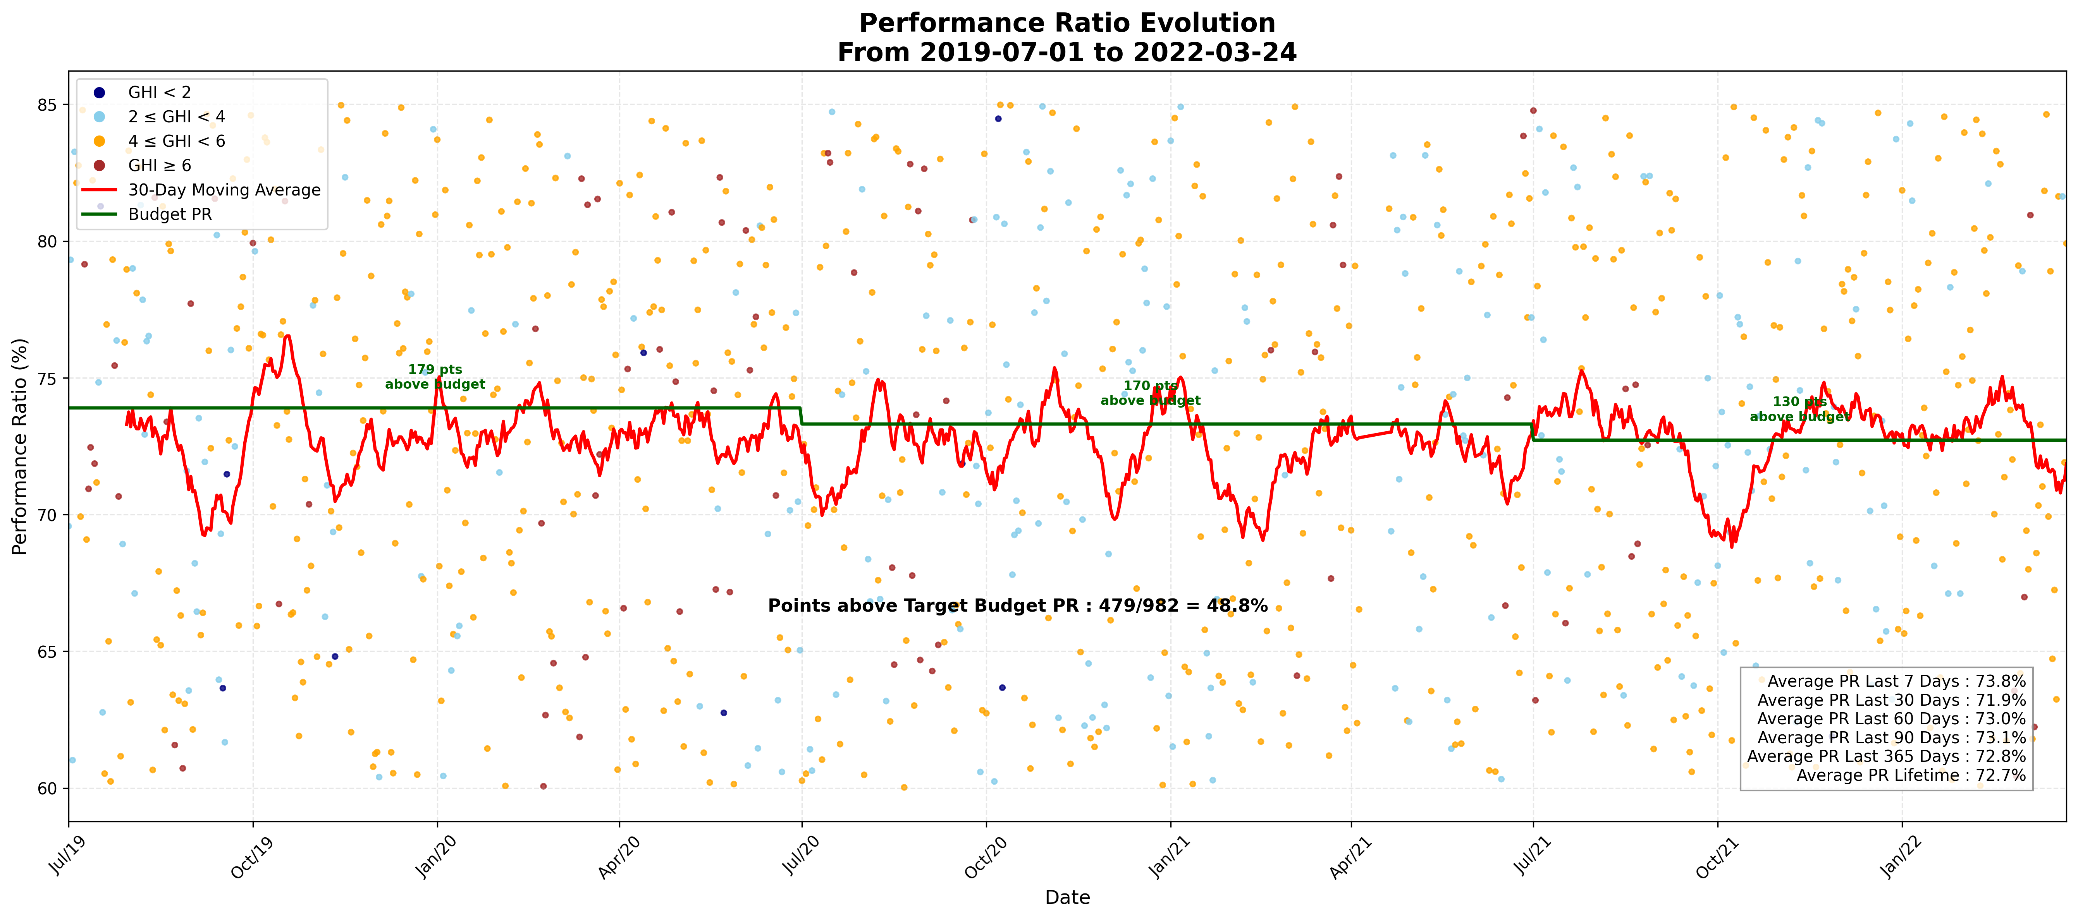

12. Conclusion
This project delivers what the assessment asked for: a clean merged dataset built from scattered monthly CSV files, and a single chart that layers GHI-coded scatter points, a smoothed trend line, a dynamically-degrading budget target, financial-year point counts, and a running statistics summary into one readable figure.
Every objective was met — recursive, non-hard-coded file reading; a chart reproducing all required overlays; a budget line driven by a genuine formula; and a bonus command-line interface that lets the same tool inspect any custom date range without code changes. Possible future improvements include adding automated tests for the preprocessing and budget functions, packaging the project for pip installation, and extending the CLI to export the statistics summary as its own CSV alongside the chart.

