RV_D3SK3_L3_Lab On Error Conditions Within Computation Pipeline

This note explains RV_D3SK3_L3_Lab_On_Error_Conditions_Within_Computation_Pipeline.v, a solution to the "Lab: Pipeline" problem. Error conditions are detected at different stages of a computation pipeline, and the design combines them into a single final error signal using OR-gate aggregation.

Ask:
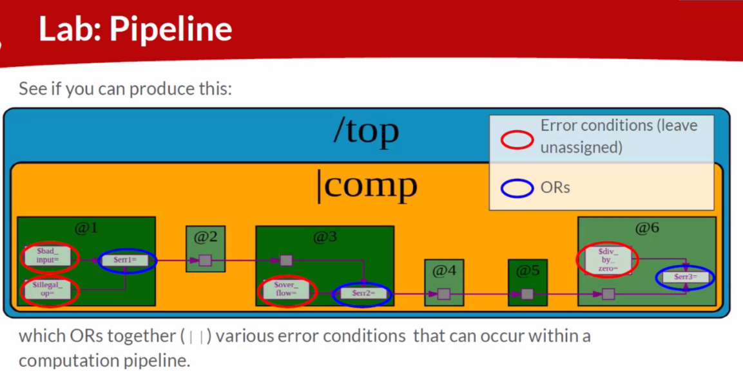

Code:
MakerChip URL: https://www.makerchip.com/v186/ide/~0o2fLcpK/p-0ylcNP
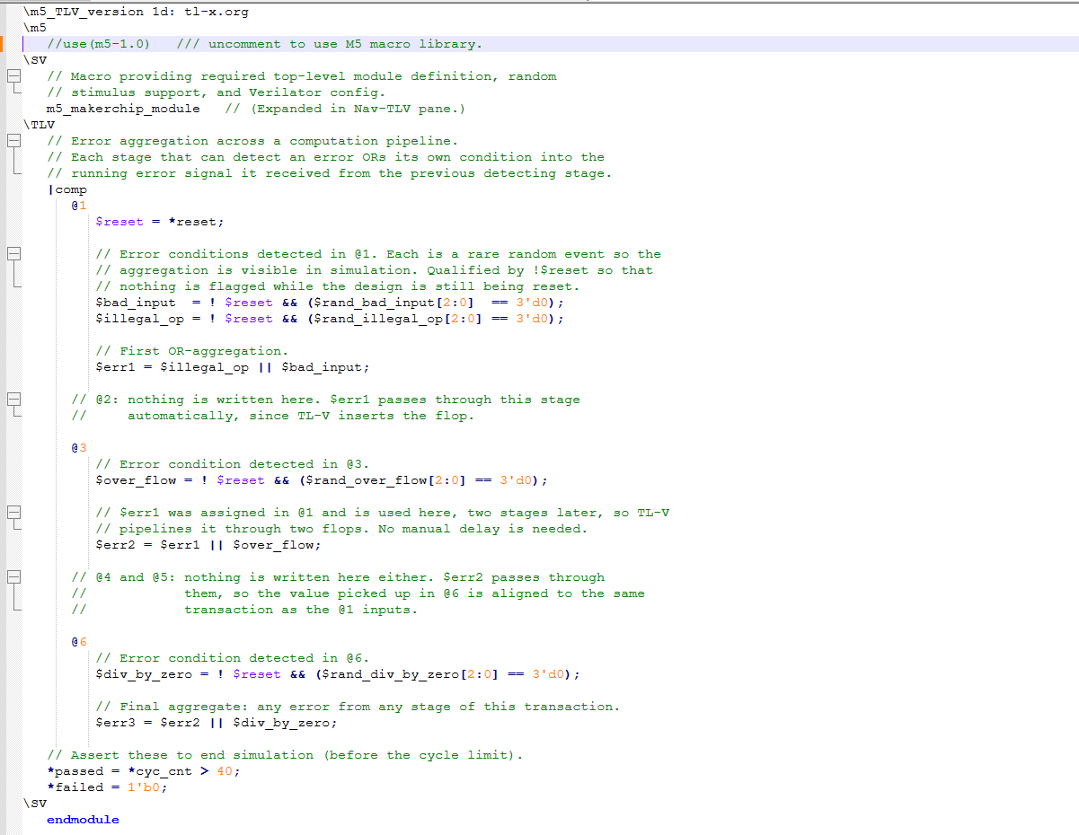

Makerchip execution – Diagram

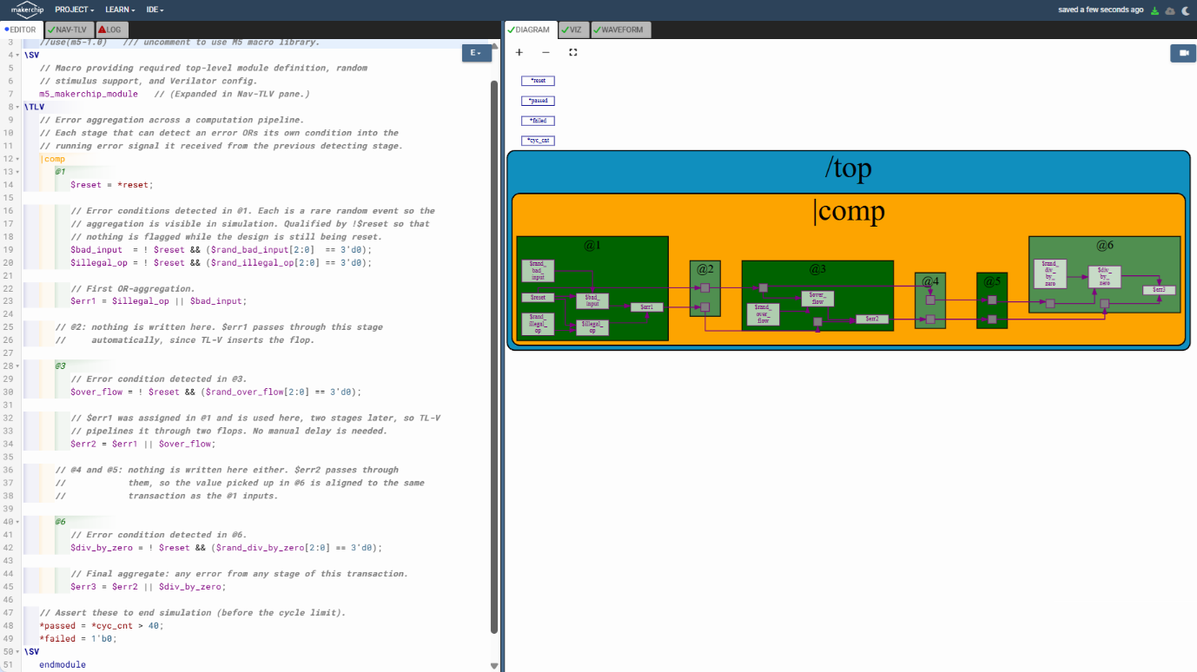

Makerchip execution – Waveform

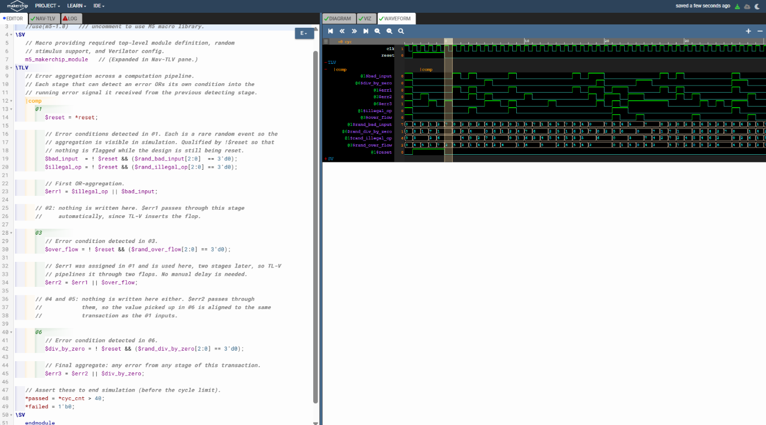

Implementation Elaboration

1. Problem statement
The lab diagram shows a pipeline |comp with six stages. Errors are detected at three of them, and each detecting stage ORs its own conditions with the error signal carried forward from earlier stages.
Stage | Error conditions detected | Aggregate produced
@1 | $bad_input, $illegal_op | $err1 = $illegal_op || $bad_input
@2 | none | $err1 passes through
@3 | $over_flow | $err2 = $err1 || $over_flow
@4, @5 | none | $err2 passes through
@6 | $div_by_zero | $err3 = $err2 || $div_by_zero

$err3 is the final signal: it is 1 if any error was detected at any stage for that transaction.

2. The code
\TLV
// Error aggregation across a computation pipeline.
// Each stage that can detect an error ORs its own condition into the
// running error signal it received from the previous detecting stage.
|comp
@1
$reset = *reset;

// Error conditions detected in @1. Each is a rare random event so the
// aggregation is visible in simulation. Qualified by !$reset so that
// nothing is flagged while the design is still being reset.
$bad_input = ! $reset && ($rand_bad_input[2:0] == 3'd0);
$illegal_op = ! $reset && ($rand_illegal_op[2:0] == 3'd0);

// First OR-aggregation.
$err1 = $illegal_op || $bad_input;

// @2: nothing is written here. $err1 passes through this stage
// automatically, since TL-V inserts the flop.

@3
// Error condition detected in @3.
$over_flow = ! $reset && ($rand_over_flow[2:0] == 3'd0);

// $err1 was assigned in @1 and is used here, two stages later, so TL-V
// pipelines it through two flops. No manual delay is needed.
$err2 = $err1 || $over_flow;

// @4 and @5: nothing is written here either. $err2 passes through
// them, so the value picked up in @6 is aligned to the same
// transaction as the @1 inputs.

@6
// Error condition detected in @6.
$div_by_zero = ! $reset && ($rand_div_by_zero[2:0] == 3'd0);

// Final aggregate: any error from any stage of this transaction.
$err3 = $err2 || $div_by_zero;

// Assert these to end simulation (before the cycle limit).
*passed = *cyc_cnt > 40;
*failed = 1'b0;
\SV
endmodule

3. How it works
Pipeline and stages. |comp is the pipeline and @1, @3, @6 are the stages that contain logic. The diagram's outer /top and the module wrapper come from the m5_makerchip_module macro.
OR aggregation. Each aggregate is one OR gate: $err1 combines the two @1 conditions, $err2 adds the @3 condition, and $err3 adds the @6 condition. Once any stage raises an error, every later aggregate is 1.
Automatic pipelining. The diagram's small grey squares are flip-flops, and none of them is written in the code. TL-V inserts them wherever a signal is used in a later stage than the one that assigned it.
Signal | Assigned in | Used in | Flops inserted
$reset | @1 | @3, @6 | 2 and 5
$err1 | @1 | @3 | 2 (stages @2 and @3)
$err2 | @3 | @6 | 3 (stages @4, @5 and @6)

The empty stages @2, @4 and @5 in the diagram are just the places where those flops sit, so no code is needed for them. Because the values are retimed rather than delayed by hand, $err3 is always aligned to the same transaction as the @1 inputs.

4. Error-handling decisions
- Conditions are driven, not left unassigned. The lab says to leave the red-circled conditions unassigned. Unassigned pipesignals raise warnings in Makerchip, so each condition here is driven from random stimulus. The OR structure is unchanged, and each stimulus expression can be replaced by real detection logic.
- Rare events. Each condition is true about 1 cycle in 8 ($rand_x[2:0] == 3'd0). Errors are then common enough to see in the 40-cycle run but still leave clean cycles, so the OR behaviour is visible in the waveform.
- Reset qualification. Every condition is ANDed with !$reset, so no error is flagged while the design is being reset.
- Errors are not sticky. Each transaction carries its own error flag, since the pipeline is per-transaction. A sticky flag would need state in a single stage and is a different design.
- One-bit signals. Every error signal is a single bit, so no width declarations are needed.

5. Expected behaviour
For any transaction, $err3 is 0 only when all four conditions are 0. Example scenarios:
$bad_input | $illegal_op | $over_flow | $div_by_zero | $err3
0 | 0 | 0 | 0 | 0
1 | 0 | 0 | 0 | 1
0 | 1 | 0 | 0 | 1
0 | 0 | 1 | 0 | 1
0 | 0 | 0 | 1 | 1
1 | 1 | 1 | 1 | 1

Timing: an error raised in @1 shows up in $err1 immediately, in $err2 two stages later, and in $err3 three stages after that (stage @6). The random stimulus makes exact waveforms unpredictable, so in Makerchip look at one transaction at a time and check that $err3 at @6 equals the OR of the four conditions from the appropriate stages.

