RV_D4SK3_L6_Lab for implementing pipeline for sum of 1 to 9 with Register File output
This note explains RV_D4SK3_L6_Lab_with_register_file_output_to_sum_1_to_9.v, a small RISC-V (RV32I) CPU for the MYTH workshop that runs a program adding 1 + 2 + ... + 9 and leaves the answer, 45, in register r10.

Ask:
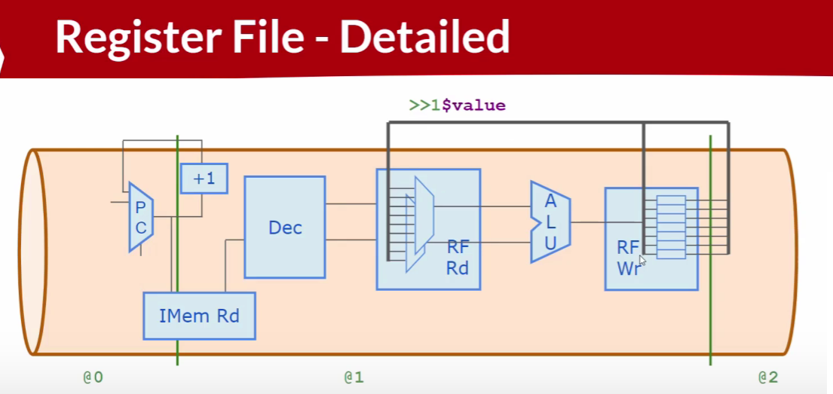

Code
Makerchip URL : https://www.makerchip.com/v186/ide/~0o2fLcpK/p-0rZcAW
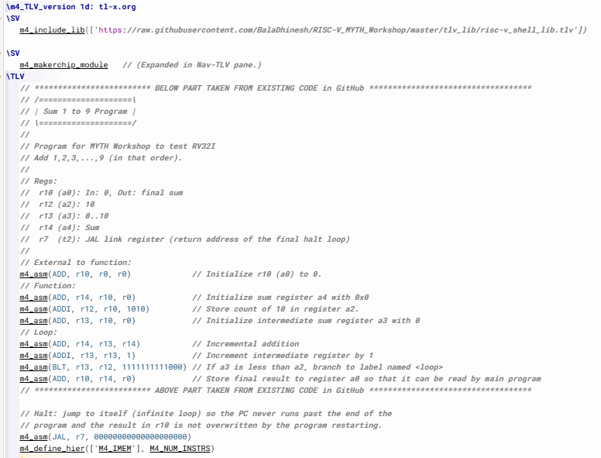
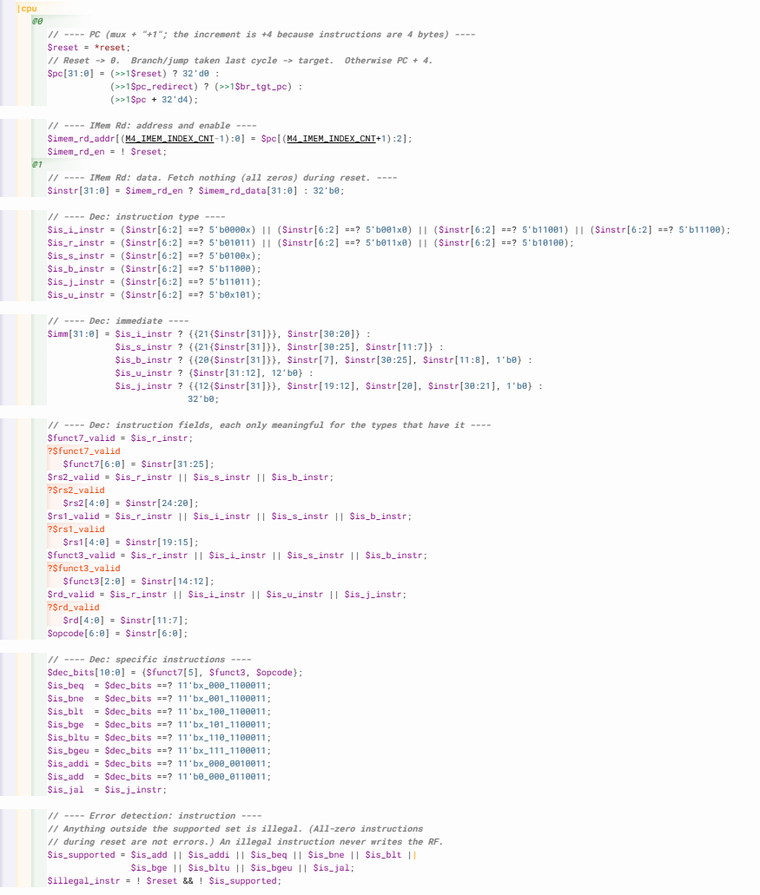
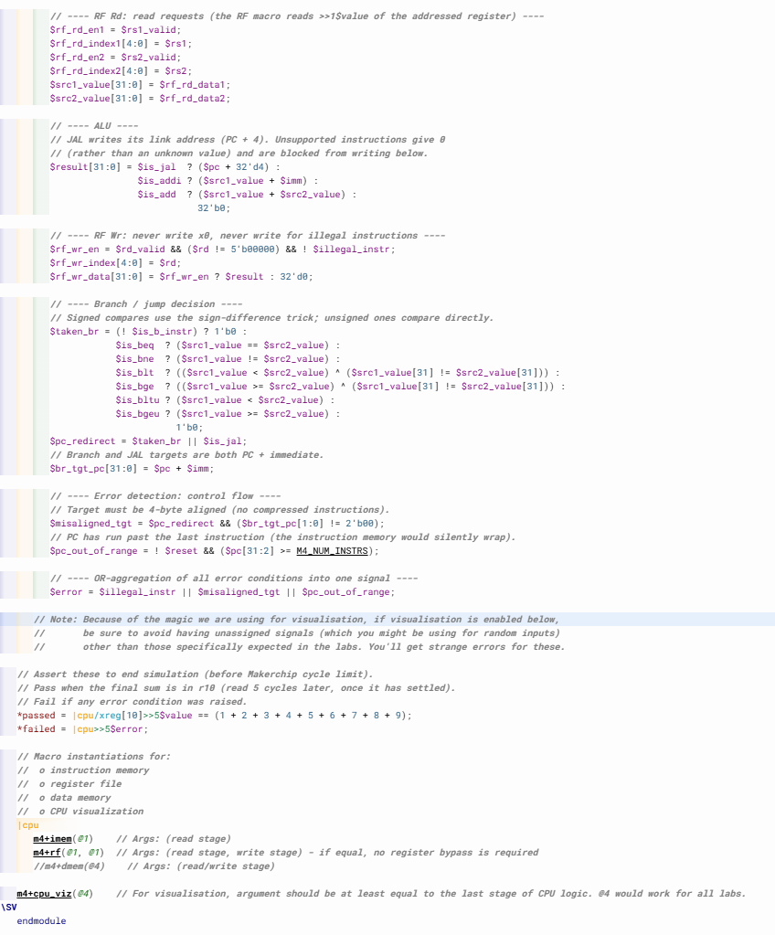

Makerchip execution – Diagram

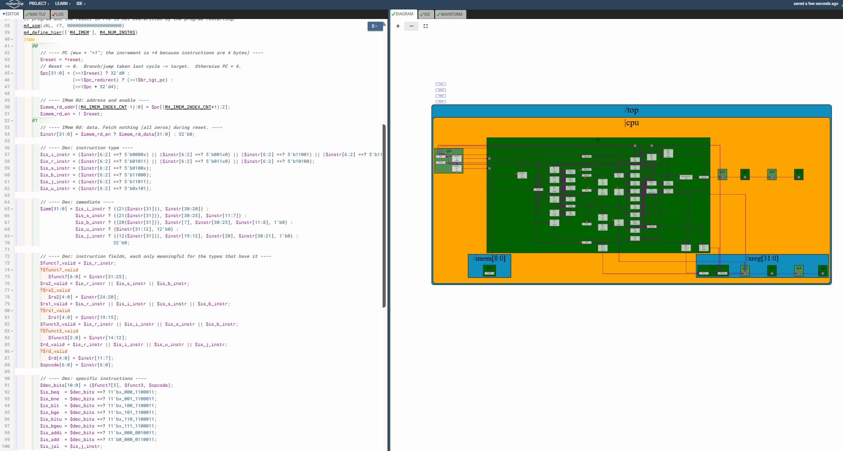

Makerchip execution – Visualization

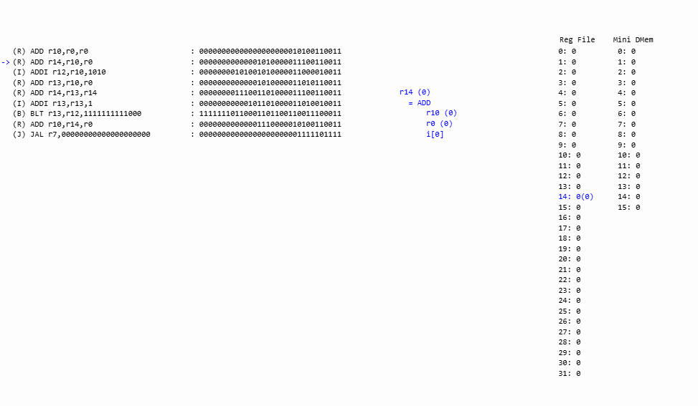

Makerchip execution – Waveform

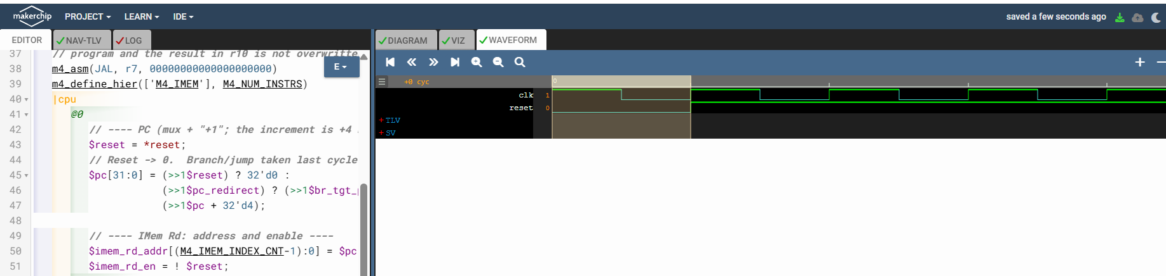

Implementation Elaboration

1. From the diagram to the code
Each block in the diagram has a direct counterpart in the code. Everything left of the second stage line runs in @0 and @1, and the register file feeds its own storage back through >>1$value.
Diagram block | Stage | Code
PC (mux) | @0 | $pc picks 0 on reset, the branch/jump target if one was taken, otherwise PC + 4
+1 | @0 | >>1$pc + 32'd4 (the increment is 4 because instructions are 4 bytes)
IMem Rd | @0 / @1 | $imem_rd_addr and $imem_rd_en in @0; $imem_rd_data and $instr in @1 (m4+imem macro)
Dec | @1 | $is_*_instr, $imm, $rs1, $rs2, $rd, $funct3, $funct7 and the specific $is_add, $is_addi, $is_blt ... flags
RF Rd | @1 | $rf_rd_en*, $rf_rd_index*, giving $src1_value and $src2_value (m4+rf macro)
ALU | @1 | $result: ADD, ADDI and the JAL link address
RF Wr | @1 | $rf_wr_en, $rf_wr_index, $rf_wr_data (m4+rf macro)
>>1$value loop | @1 | Inside m4+rf: each /xreg[i] keeps its value and the read mux reads the previous cycle's value

2. The program
The program is the same as the reference, plus a final halt instruction. The loop adds r13 into the running sum r14, increments r13, and repeats while r13 < 10. Because r13 starts at 0, the ten iterations add 0, 1, ..., 9.
# | Instruction | Purpose
0 | ADD r10, r0, r0 | Clear the result register
1 | ADD r14, r10, r0 | Sum = 0
2 | ADDI r12, r10, 10 | Loop limit = 10
3 | ADD r13, r10, r0 | Counter = 0
4 | ADD r14, r13, r14 | Loop: sum += counter
5 | ADDI r13, r13, 1 | counter += 1
6 | BLT r13, r12, -8 | If counter < limit, go back to #4
7 | ADD r10, r14, r0 | Copy the sum into r10
8 | JAL r7, 0 | Halt: jump to itself forever

Iteration | r13 at start | r14 after | r13 after (branch)
1 | 0 | 0 | 1 (taken)
2 | 1 | 1 | 2 (taken)
3 | 2 | 3 | 3 (taken)
4 | 3 | 6 | 4 (taken)
5 | 4 | 10 | 5 (taken)
6 | 5 | 15 | 6 (taken)
7 | 6 | 21 | 7 (taken)
8 | 7 | 28 | 8 (taken)
9 | 8 | 36 | 9 (taken)
10 | 9 | 45 | 10 (not taken)

In total 4 setup instructions, 30 loop instructions and the final copy make 35 instructions before the halt loop, and r10 holds 45 from then on.

3. How the CPU works
Fetch (@0). The PC is computed from the previous cycle: >>1$reset forces 0, >>1$pc_redirect takes the target, otherwise the PC advances by 4. The instruction memory index is bits [INDEX+1:2] of the PC.
$pc[31:0] = (>>1$reset) ? 32'd0 :
(>>1$pc_redirect) ? (>>1$br_tgt_pc) :
(>>1$pc + 32'd4);

Decode (@1). The opcode bits classify the instruction as I, R, S, B, U or J type, and the type decides which immediate layout and which fields ($rs1, $rs2, $rd, $funct3, $funct7) are valid. Fields are assigned under "when" conditions such as ?$rs1_valid, so they exist only for the types that have them. Specific instructions are recognised from {$funct7[5], $funct3, $opcode} with wildcard (==?) patterns.
Register file. The m4+rf(@1, @1) macro provides 32 registers. Reads and the write are in the same stage, so a value written in one cycle is read back in the next cycle from the >>1$value feedback, and no bypass logic is needed. As I read the workshop library, reset loads register i with the value i, so r10 starts at 10, which is why the program's first instruction clears it. Register 0 is never written.
ALU (@1). ADD adds the two source registers, ADDI adds the source and the immediate, and JAL produces PC + 4 as its link address.
Branches and jumps. $taken_br evaluates BEQ, BNE, BLT, BGE, BLTU and BGEU. The signed compares (BLT/BGE) use (a < b) ^ (a[31] != b[31]), which corrects the unsigned comparison when the signs differ. The target for both branches and JAL is $pc + $imm. Since the decision is made in @1 and consumed at the start of the next cycle's @0, the next fetch already uses the right address, so no wrong-path instruction enters the pipeline and no flush is needed.
Test result. *passed becomes true when r10, read five cycles later, equals 1 + 2 + ... + 9 = 45.

4. Error handling and changes from the reference
Problem in the reference | What the new code does
*passed is assigned twice: once inside the |cpu pipeline and again as *cyc_cnt > 40. Two drivers conflict, and the cycle-count version can pass without the answer being right. | One top-level *passed that is true only when r10 = 45.
With no halt, the PC runs past the last instruction, the instruction memory wraps, and instruction #0 clears r10 again. | A JAL to itself halts the CPU. This needs JAL support: $is_jal, the link value in $result, and $pc_redirect. The final answer stays in r10.
$result is 32'bx for anything that is not ADD or ADDI. | $result is 0 for those cases.
An unsupported instruction is silently executed as a no-op or writes junk. | $illegal_instr flags anything outside ADD, ADDI, the six branches and JAL, and blocks its register write. All-zero instructions during reset are not flagged.
A branch or jump to a misaligned address goes unnoticed. | $misaligned_tgt flags a redirect whose target has non-zero low bits.
Running off the end of the program goes unnoticed. | $pc_out_of_range flags a PC at or beyond the number of instructions.
*failed is always 0. | $error ORs the three error conditions together, in the same way as the error-aggregation lab, and *failed reports it.

Everything else, including the decode, the immediates and the register file macro usage, is kept as in the reference so the visualisation macro still works.

