RV_D4SK3_L7_L8_Lab For Completing Branch Instruction Implementation with Test Bench
This note explains -RV_D4SK3_L7_L8_Lab_For_Completing_Branch_Instruction_Implementation_With_Test_Bench.v. It takes the RISC-V CPU that adds 1 + 2 + ... + 9 and organises it around the lab step "add branch instruction support", using the blocks in the diagram: the PC mux, the "+" that computes the branch target, and the "< >" comparator that decides whether the branch is taken. The program loops with a BLT, so without working branches the sum would stop after one pass.
This updated implementation keeps earlier structure, labels it against the lab steps, and adds branch-specific error handling.

Ask:
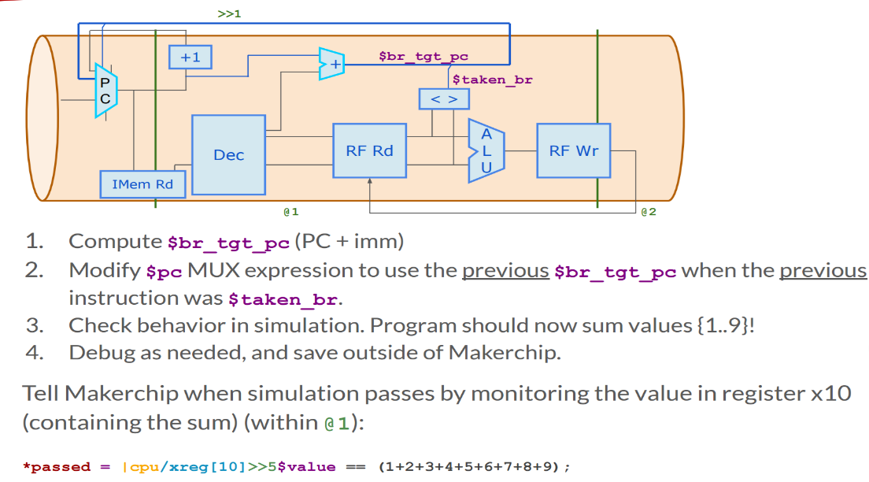

Code:

Chipmaker URL: https://makerchip.com/v186/ide/~031fJcMm/p-0pwczG
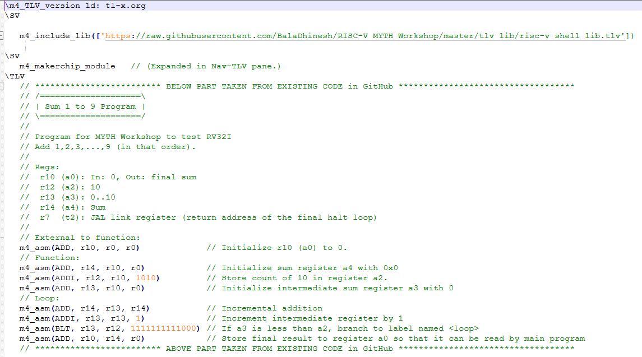
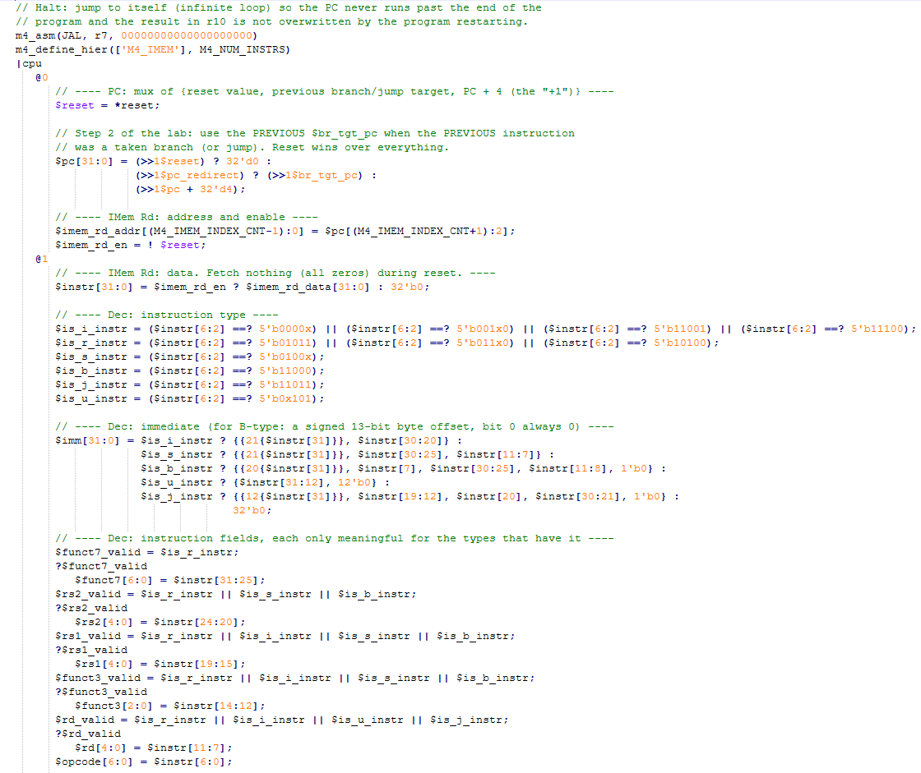
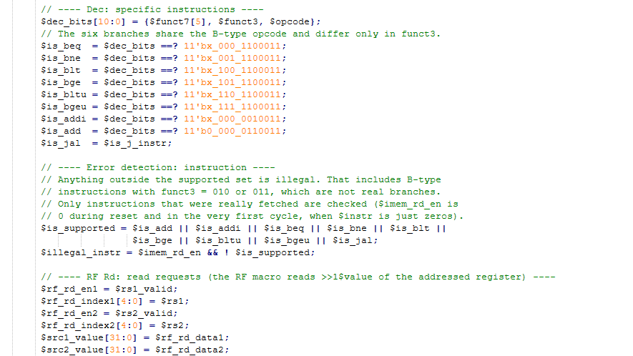

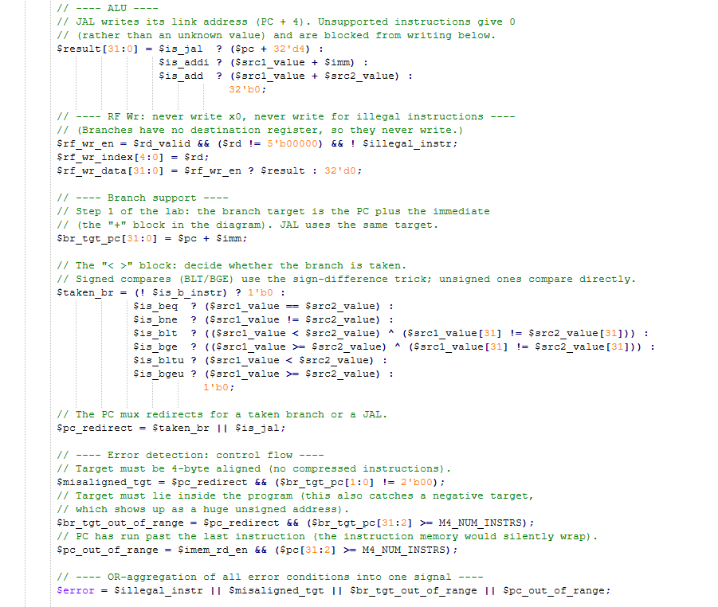

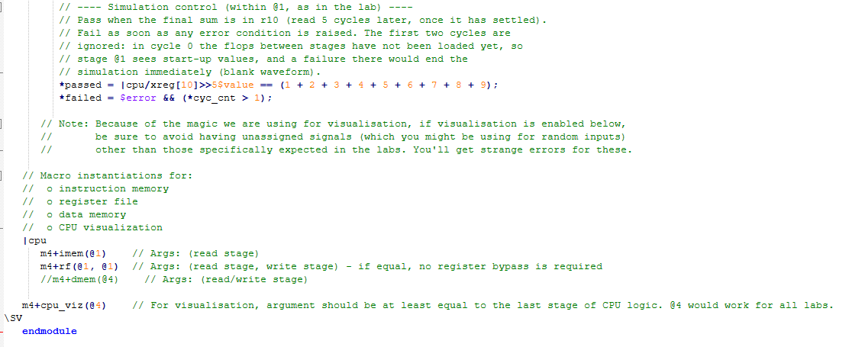

Makerchip execution – Diagram

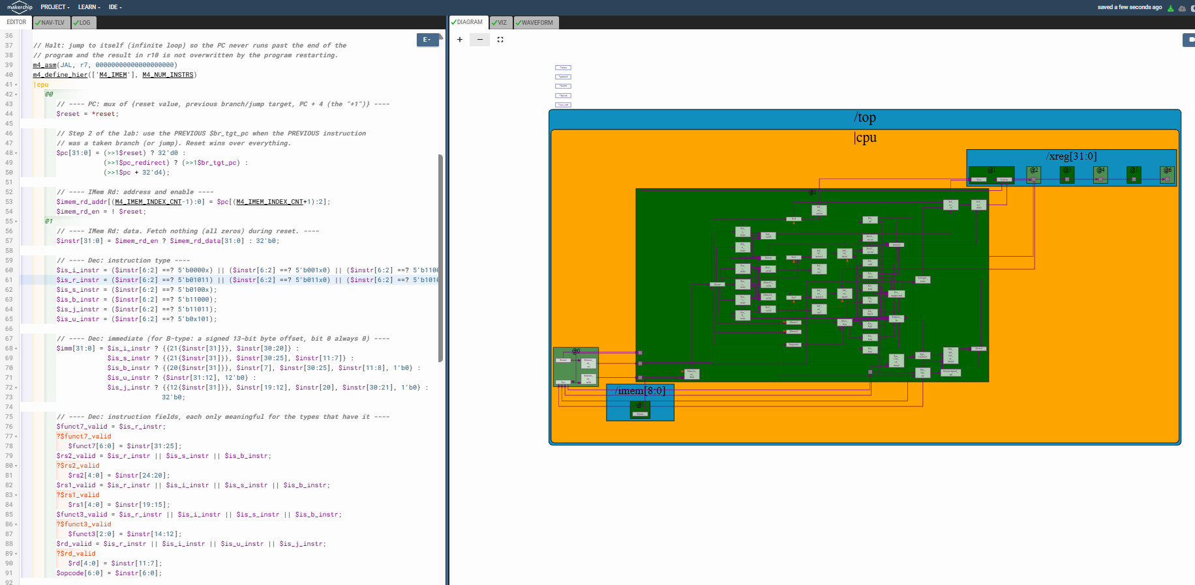

Makerchip execution – VIZ

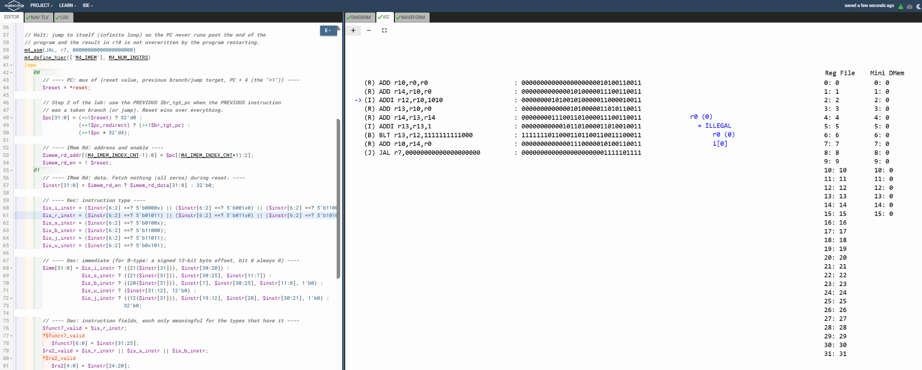

Makerchip execution – Waveform
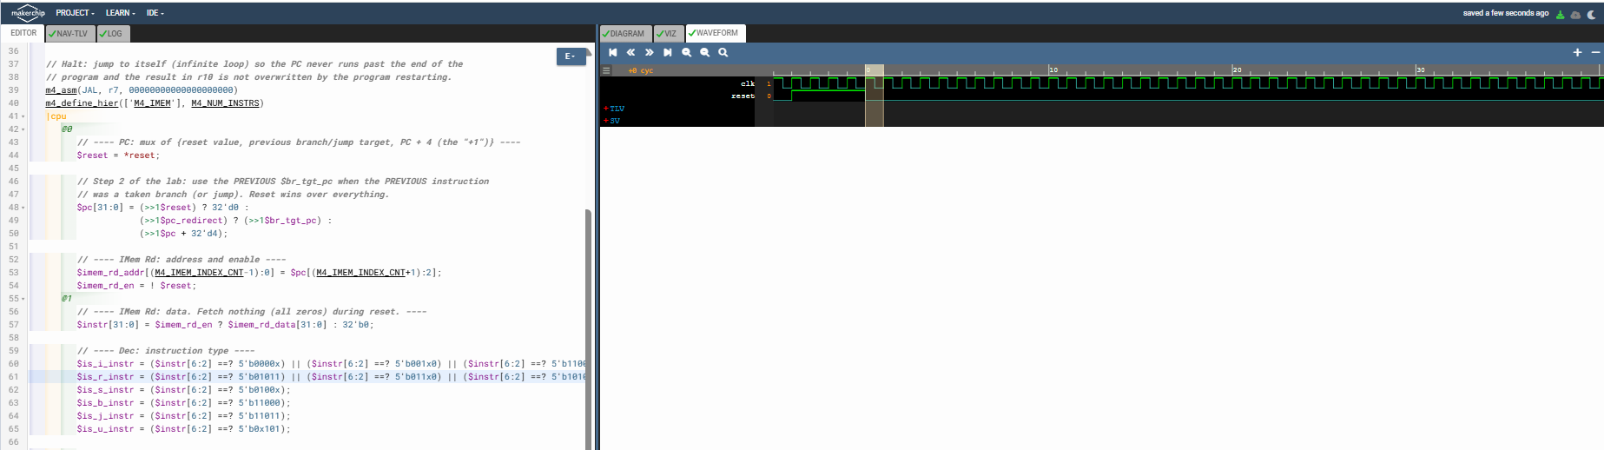

Implementation Elaboration

1. The diagram and the lab steps
The stage lines split the diagram into regions: everything left of the first line is @0, the region between the lines is @1, and the right side is @2. The branch decision is made in @1 and fed back to the PC mux in @0 through the >>1 loop at the top.
Step | Lab instruction | Where it is in the code
1 | Compute $br_tgt_pc (PC + imm) | $br_tgt_pc[31:0] = $pc + $imm; in @1. This is the "+" block.
2 | Use the previous $br_tgt_pc in the $pc mux when the previous instruction was a taken branch | $pc in @0 selects >>1$br_tgt_pc when >>1$pc_redirect is true. $pc_redirect is $taken_br, or a JAL.
3 | Check that the program sums 1..9 | *passed monitors register x10.
4 | Debug | The error signals in section 6 help here.

Diagram block | Stage | Code
PC mux, +1 | @0 | $pc: reset gives 0, a taken branch gives the previous target, otherwise the previous PC + 4
IMem Rd | @0 / @1 | $imem_rd_addr in @0, $instr in @1
Dec | @1 | $is_*_instr, $imm, $rs1, $rs2, $rd, $funct3 and the $is_beq ... $is_bgeu flags
"+" (br target) | @1 | $br_tgt_pc
RF Rd | @1 | $src1_value, $src2_value
"< >" (compare) | @1 | $taken_br
ALU | @1 | $result
RF Wr | @1 | $rf_wr_en, $rf_wr_index, $rf_wr_data

2. The branch instructions
All six RISC-V branches share one opcode (1100011) and differ in funct3. Each compares rs1 with rs2 and, if the condition holds, jumps to PC + imm. The offset is a signed 13-bit byte offset whose bit 0 is always 0, scattered across the instruction as {imm[12], imm[10:5]} in bits 31-25 and {imm[4:1], imm[11]} in bits 11-7.
Branch | funct3 | Taken when
BEQ | 000 | rs1 == rs2
BNE | 001 | rs1 != rs2
BLT | 100 | rs1 < rs2, signed
BGE | 101 | rs1 >= rs2, signed
BLTU | 110 | rs1 < rs2, unsigned
BGEU | 111 | rs1 >= rs2, unsigned

Signed compares. Verilog compares the two 32-bit values as unsigned, so BLT and BGE correct the result when the sign bits differ:
$is_blt ? (($src1_value < $src2_value) ^ ($src1_value[31] != $src2_value[31])) :
$is_bge ? (($src1_value >= $src2_value) ^ ($src1_value[31] != $src2_value[31])) :

For example, -1 (0xFFFFFFFF) and 1: unsigned, -1 < 1 is false, but the signs differ, so the XOR flips it to true, which is right for a signed BLT.

3. Timing: why no flush is needed
The decision $taken_br is computed in @1. The next instruction is in @0 during that same clock cycle, and its PC uses >>1$taken_br and >>1$br_tgt_pc, which are exactly the values just computed. So the very next fetch already goes to the target, no wrong-path instruction ever enters the pipeline, and nothing has to be cancelled. The register file writes and reads in the same stage, so each instruction sees the previous one's result (through the >>1$value loop).

4. The branch in the sum program
The loop ends with BLT r13, r12, -8. It sits at byte address 24. When taken, the target is 24 - 8 = 16, which is the first loop instruction. When not taken, the PC continues to 28.
Execution | r13 (after +1) | r13 < 10? | Next PC
1 | 1 | yes, taken | 16
2 | 2 | yes, taken | 16
3 | 3 | yes, taken | 16
4 | 4 | yes, taken | 16
5 | 5 | yes, taken | 16
6 | 6 | yes, taken | 16
7 | 7 | yes, taken | 16
8 | 8 | yes, taken | 16
9 | 9 | yes, taken | 16
10 | 10 | no, not taken | 28

So the branch is taken nine times and falls through once, the ten passes add 0 through 9, and r10 finishes at 45.

5. Simulation control
The lab says to monitor register x10 "within @1", so both lines sit inside the |cpu @1 block:
*passed = |cpu/xreg[10]>>5$value == (1 + 2 + 3 + 4 + 5 + 6 + 7 + 8 + 9);
*failed = $error && (*cyc_cnt > 1);

The >>5 reads x10 five cycles late so the sum has settled. The reference also had a second driver, "*passed = *cyc_cnt > 40;", at the bottom of the file. Two drivers on one signal conflict, and that one can end the run without the answer being right, so I removed it. (In my previous version I had placed these two lines at the top level, outside the pipeline. They are now in @1, as in your reference and the lab text.)
&& (*cyc_cnt > 1) ignores the first two cycles. In cycle 0 the flops between the stages have not been loaded yet, so stage @1 sees start-up values, for example an all-zero instruction. A failure raised there ends the simulation at once and leaves a blank waveform, which is the likely cause of the blank waveform seen with an earlier version of this code. For the same reason $illegal_instr and $pc_out_of_range only check cycles where an instruction was really fetched ($imem_rd_en).

6. Error handling
Condition | Behaviour
$illegal_instr | Any fetched instruction outside ADD, ADDI, the six branches and JAL. This includes B-type instructions with funct3 = 010 or 011, which are not real branches. Such an instruction never writes the register file and is never taken as a branch.
$misaligned_tgt | A taken branch or jump whose target is not a multiple of 4 (there are no compressed instructions).
$br_tgt_out_of_range | A taken branch or jump whose target is outside the program, including negative targets, which appear as huge unsigned addresses. It is caught on the branch itself, one cycle before a bad fetch.
$pc_out_of_range | The PC has run past the last instruction. Without it the instruction memory would silently wrap around.
$error | The OR of the four conditions above. *failed reports it, ignoring the first two cycles (start-up).

Carried over from the previous step: a JAL to itself halts the CPU at the end (so the program cannot restart and clear r10), $result is 0 rather than an unknown value for unsupported instructions, and instructions fetched during reset are all zeros.

