RV_D3SK3_L4_Lab on 2-Cycle Calculator
This note explains RV_D3SK3_L4_Lab-2_Cycle_Calculator.v, a small calculator that adds, subtracts, multiplies or divides two operands and feeds each valid result back in as the next first operand. It is written for Makerchip and follows the pipeline diagram: two stage lines, a >>2 result recirculation, a >>1 valid toggle, and an inverter and OR gate that zero the output.

Ask:
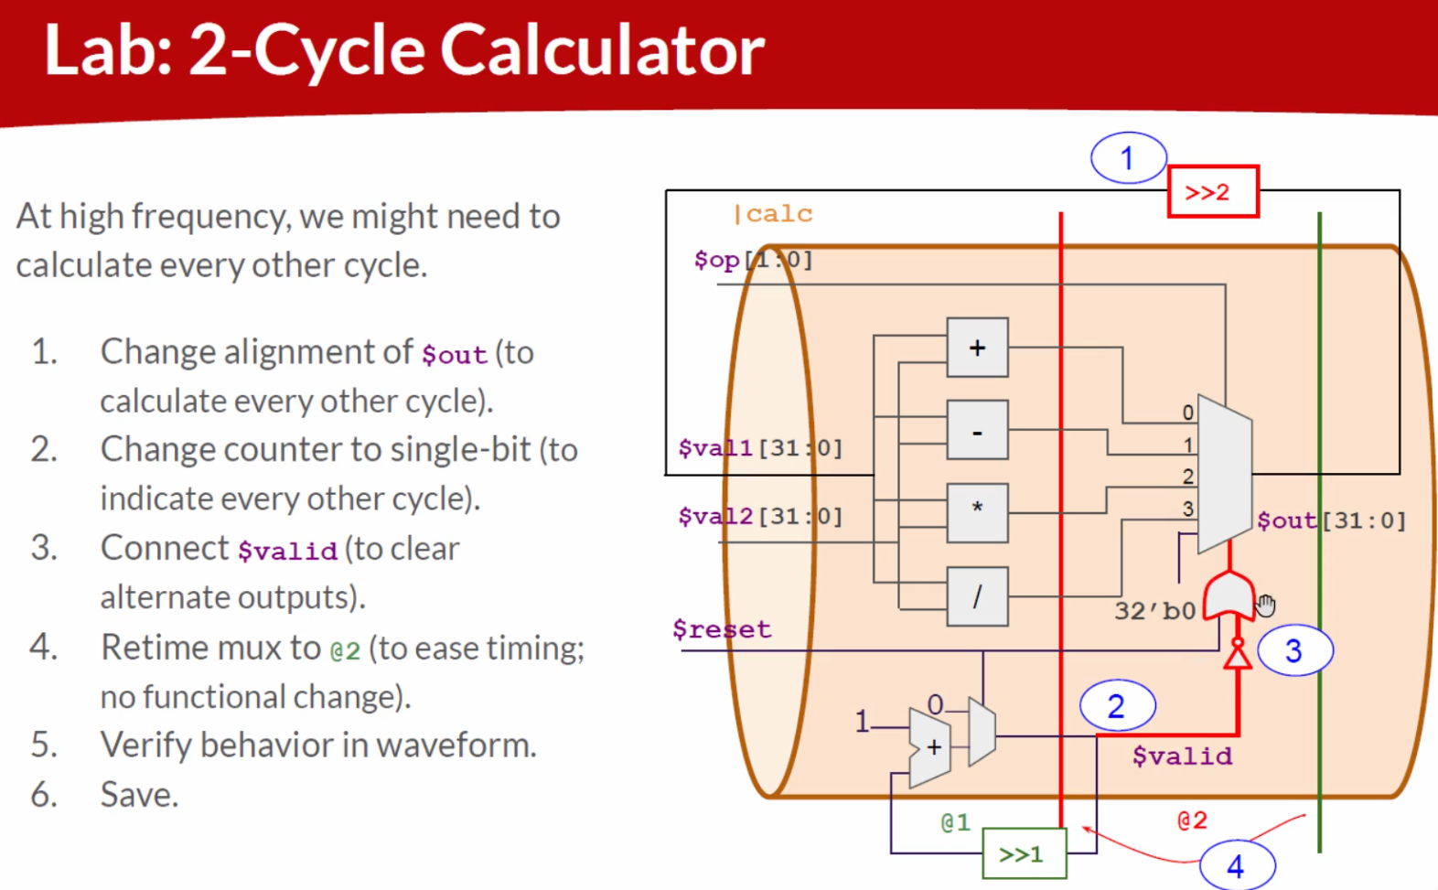

Code:
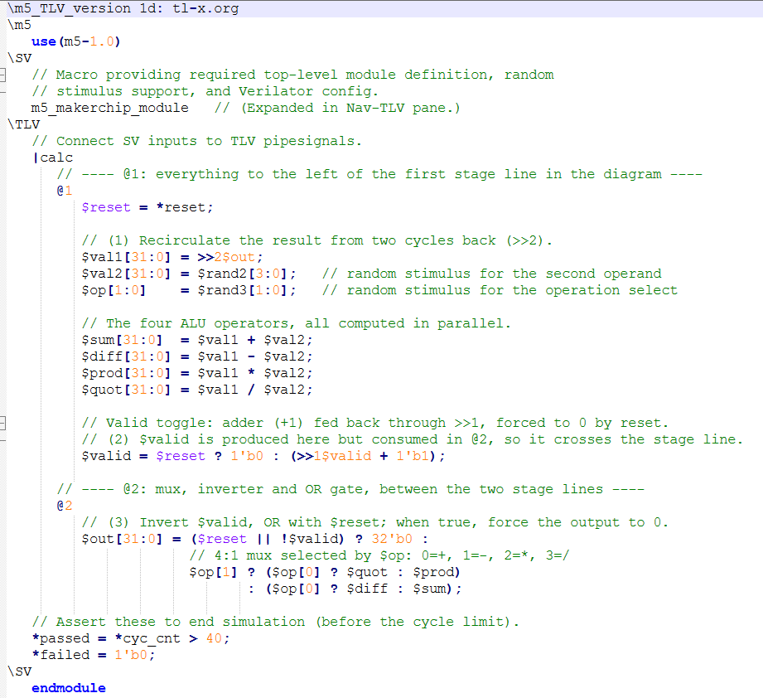

Makerchip execution – Diagram
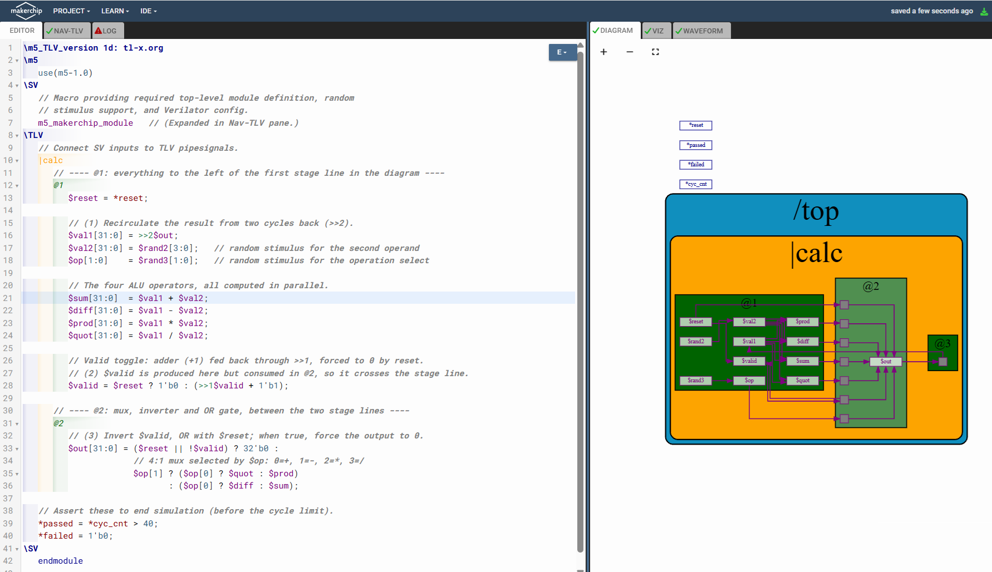

Makerchip execution – Waveform

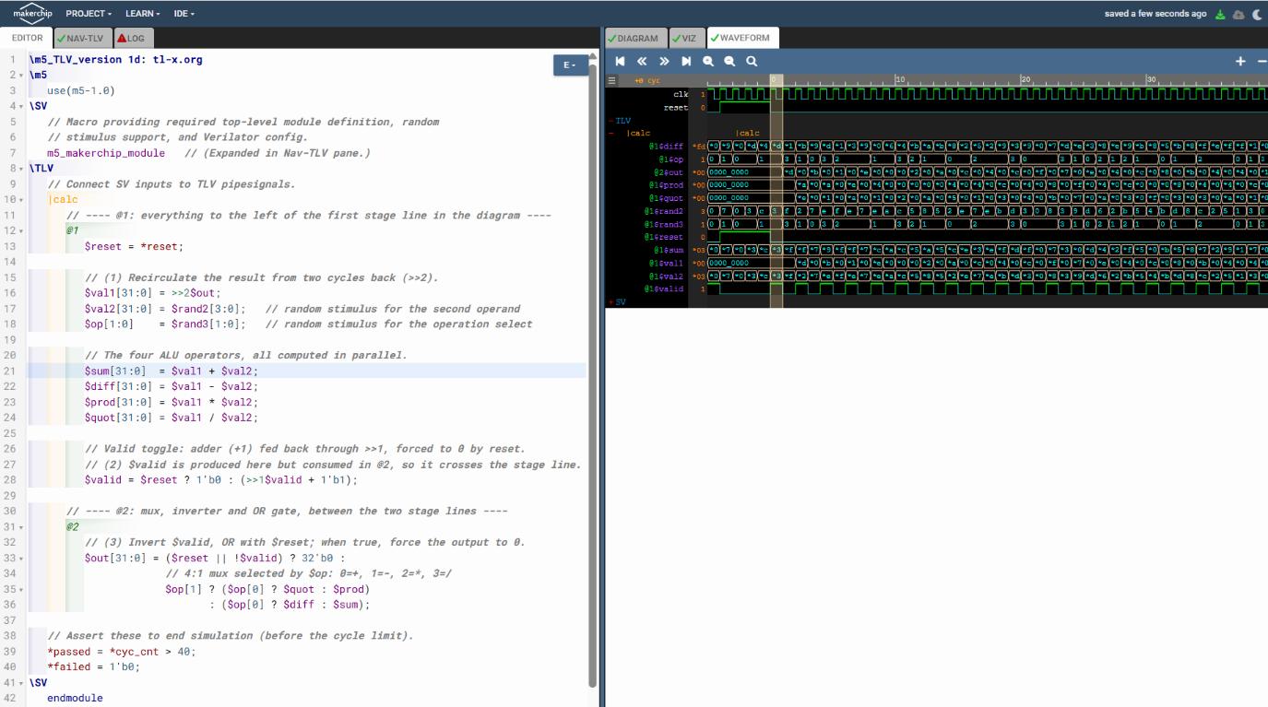

Implementation Elaboration

1. File layout
Region | Purpose
\SV (top) | m5_makerchip_module macro: creates the top-level module, random stimulus (*reset, *cyc_cnt, $rand*) and Verilator settings.
\TLV | The actual design: one pipeline |calc with stages @1 and @2.
\SV (bottom) | endmodule, closing the module opened by the macro.

2. TL-Verilog notation used
- |calc is a pipeline, a named group of related logic.
- @1, @2 are timing stages. TL-V inserts the flip-flops between stages automatically.
- $name is a pipesignal, assigned in exactly one stage.
- *name is a plain SystemVerilog signal at the module boundary.
- >>n$sig is the value of $sig from n cycles earlier.
- Statements are declarative: order does not matter.

3. Stage @1: operands, ALU and valid counter
- $reset = *reset; brings the SV reset into the pipeline.
- $val1 = >>2$out; is the first operand: the result from two cycles ago (the >>2 loop in the diagram).
- $val2 = $rand2[3:0]; is a random 4-bit second operand, zero-extended to 32 bits.
- $op = $rand3[1:0]; is a random 2-bit operation select. The diagram shows $op as an input, and Makerchip needs something to drive it.
- $sum, $diff, $prod, $quot are computed in parallel from $val1 and $val2. Nothing is selected yet.
- $valid = $reset ? 1'b0 : (>>1$valid + 1'b1); is a 1-bit toggle. It is 0 in reset, then alternates 1, 0, 1, 0.

4. Stage @2: select and output
$out[31:0] = ($reset || !$valid) ? 32'b0 :
$op[1] ? ($op[0] ? $quot : $prod)
: ($op[0] ? $diff : $sum);

$op | Result
00 | $sum
01 | $diff
10 | $prod
11 | $quot
!$valid is the inverter and || is the OR gate in the diagram. When either reset is active or the cycle is not valid, the output is forced to zero. $valid and $reset are produced in @1 but used in @2, so they cross the stage line and TL-V pipelines them automatically.

5. Why >>2 and not >>1
Because $valid toggles, a real result appears only every other cycle, and the cycles in between output 0. The previous real result is therefore two cycles back, which is what >>2 reaches.
It also means the feedback loop has exactly one flop in it: $out is finished in @2, one clock after @1, so it is available to @1 one clock later. Using >>1 would create a combinational loop through the ALU.

6. Example trace
Operand and opcode values are illustrative, since the real ones are random. Cycle 0 is the last reset cycle.
Cycle | $valid | $val1 | $val2 | $op | $out
0 | 0 | n/a | n/a | n/a | 0 (reset)
1 | 1 | 0 | 5 | sum | 5
2 | 0 | 0 | 9 | prod | 0 (invalid)
3 | 1 | 5 | 3 | prod | 15
4 | 0 | 0 | 7 | diff | 0 (invalid)
5 | 1 | 15 | 4 | diff | 11
6 | 0 | 0 | 2 | quot | 0 (invalid)
7 | 1 | 11 | 2 | quot | 5

The chain of valid results is 0 + 5 = 5, then 5 x 3 = 15, then 15 - 4 = 11, then 11 / 2 = 5.

7. Simulation control
- *passed = *cyc_cnt > 40; ends the simulation successfully after 40 cycles.
- *failed = 1'b0; means no failure condition is checked. Adding a self-check here would be a natural next step.

8. Known limitations
- Divide by zero: $val2 can be 0. Makerchip's Verilator backend is 2-state, so this gives a meaningless value rather than x. A guard such as ($val2 == 0) ? 32'b0 : ($val1 / $val2) fixes it.
- Operand range: $val2 only spans 0-15, while $val1 is 32 bits wide. This is fine for a demo.
- Wasted work: the ALU computes result on invalid cycles that the mux then discards. Gating the inputs on $valid would save power in real hardware.

