RV_D3SK4_L4_Lab on Calculator with Single-Value Memory
This note explains RV_D3SK4_L4_Lab_on_2-cycle_Calculator_with_Singele_Value_Memory.v, a solution to the "Lab: Calculator with Single-Value Memory" problem. The validity-aware calculator gains two new operations: MEM, which remembers a value, and RECALL, which brings that value back later.

Ask
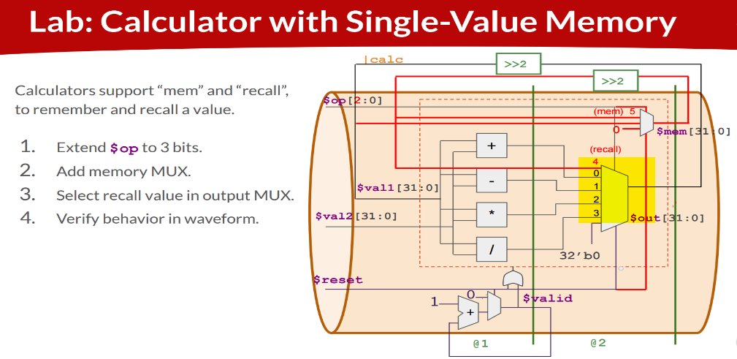

Code:
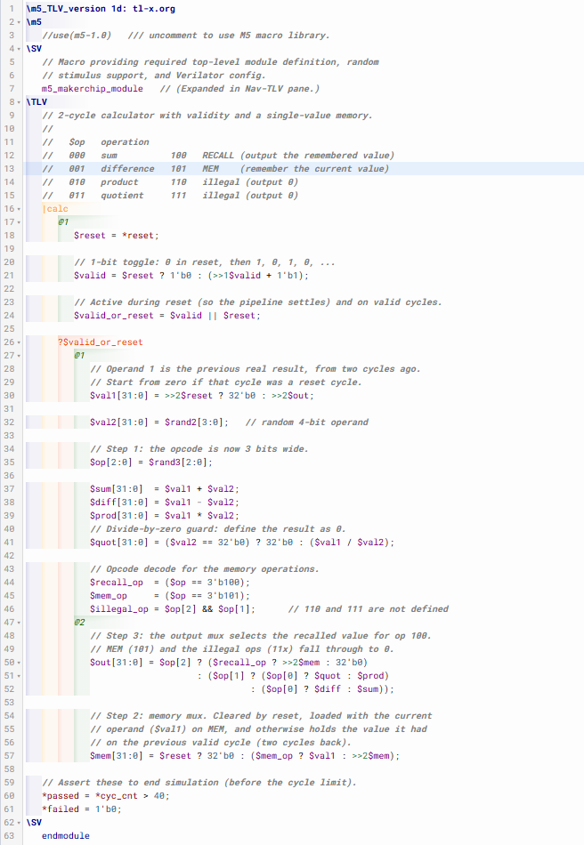

Makerchip execution – Diagram
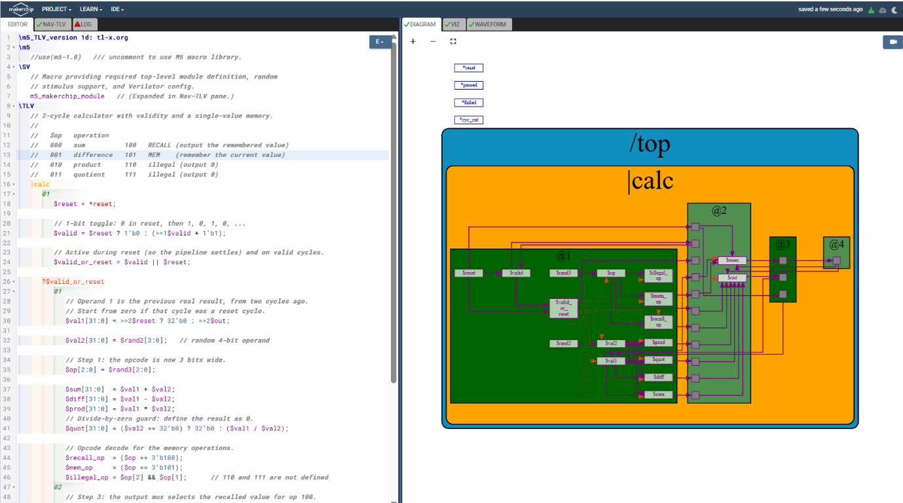

Makerchip execution – Waveform
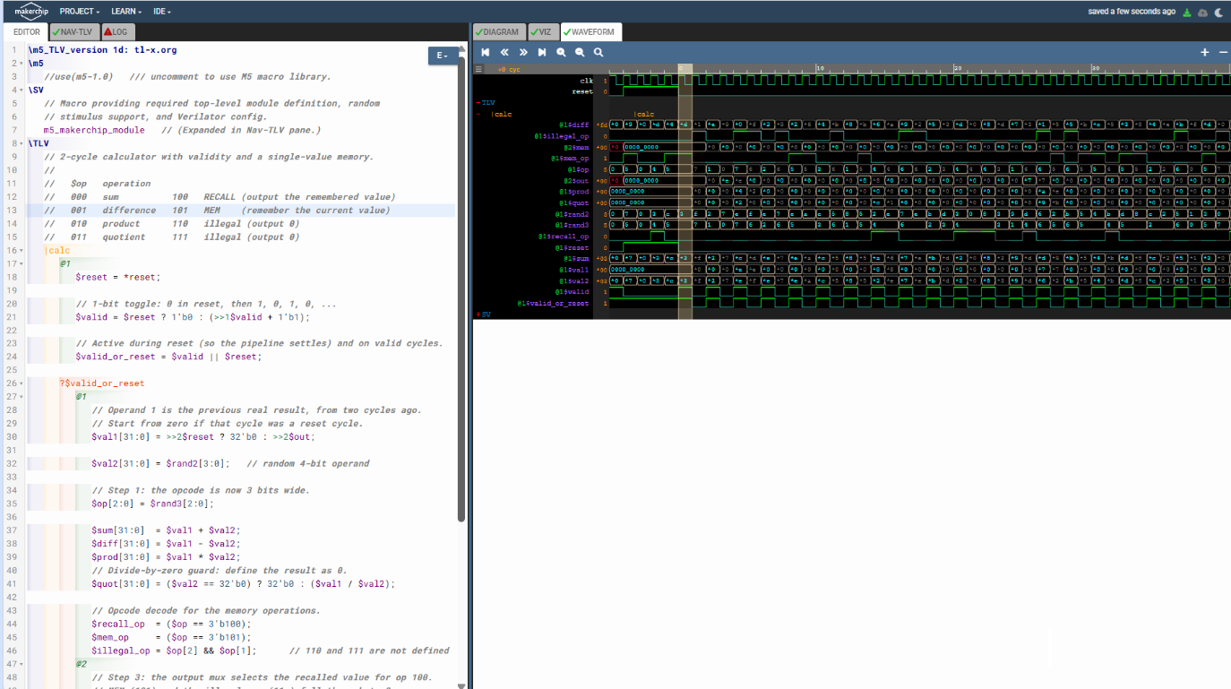

1. Problem statement
The lab asks for four steps:
- Extend $op to 3 bits, so there is room for the new operations.
- Add a memory mux, a single 32-bit storage value, $mem, that is cleared by reset, loaded on MEM and otherwise held.
- Select the recalled value in the output mux, as a fifth input (input 4 in the diagram).
- Verify the behaviour in the waveform.

$op | Operation | $out
000 | sum | $val1 + $val2
001 | difference | $val1 - $val2
010 | product | $val1 * $val2
011 | quotient | $val1 / $val2 (0 if $val2 is 0)
100 | RECALL | the remembered value, >>2$mem
101 | MEM | 0 (and $mem is loaded with $val1)
110, 111 | illegal | 0

2. The code
\TLV
// 2-cycle calculator with validity and a single-value memory.
//
// $op operation
// 000 sum 100 RECALL (output the remembered value)
// 001 difference 101 MEM (remember the current value)
// 010 product 110 illegal (output 0)
// 011 quotient 111 illegal (output 0)
|calc
@1
$reset = *reset;

// 1-bit toggle: 0 in reset, then 1, 0, 1, 0, ...
$valid = $reset ? 1'b0 : (>>1$valid + 1'b1);

// Active during reset (so the pipeline settles) and on valid cycles.
$valid_or_reset = $valid || $reset;

?$valid_or_reset
@1
// Operand 1 is the previous real result, from two cycles ago.
// Start from zero if that cycle was a reset cycle.
$val1[31:0] = >>2$reset ? 32'b0 : >>2$out;

$val2[31:0] = $rand2[3:0]; // random 4-bit operand

// Step 1: the opcode is now 3 bits wide.
$op[2:0] = $rand3[2:0];

$sum[31:0] = $val1 + $val2;
$diff[31:0] = $val1 - $val2;
$prod[31:0] = $val1 * $val2;
// Divide-by-zero guard: define the result as 0.
$quot[31:0] = ($val2 == 32'b0) ? 32'b0 : ($val1 / $val2);

// Opcode decode for the memory operations.
$recall_op = ($op == 3'b100);
$mem_op = ($op == 3'b101);
$illegal_op = $op[2] && $op[1]; // 110 and 111 are not defined
@2
// Step 3: the output mux selects the recalled value for op 100.
// MEM (101) and the illegal ops (11x) fall through to 0.
$out[31:0] = $op[2] ? ($recall_op ? >>2$mem : 32'b0)
: ($op[1] ? ($op[0] ? $quot : $prod)
: ($op[0] ? $diff : $sum));

// Step 2: memory mux. Cleared by reset, loaded with the current
// operand ($val1) on MEM, and otherwise holds the value it had
// on the previous valid cycle (two cycles back).
$mem[31:0] = $reset ? 32'b0 : ($mem_op ? $val1 : >>2$mem);

// Assert these to end simulation (before the cycle limit).
*passed = *cyc_cnt > 40;
*failed = 1'b0;
\SV
endmodule

3. How it works
Validity. As in the previous lab, the datapath sits under ?$valid_or_reset, so it computes only on valid cycles and during reset. On the other cycles it is gated off.
Operand feedback. $val1 is the previous real result, from two cycles ago (>>2$out). It plays the role of the number shown on the calculator display.
Opcode decode. The top opcode bit separates the arithmetic operations (0xx) from the memory operations (1xx). $recall_op and $mem_op decode 100 and 101, and $illegal_op flags 110 and 111.
Output mux (@2). When $op[2] is 0 it is the same 4:1 mux as before. When it is 1 the output is the recalled value for RECALL, and 0 for MEM and the illegal opcodes, which is the 32'b0 input in the diagram.
Memory mux (@2). $mem is 0 in reset, is loaded with $val1 when the opcode is MEM, and otherwise keeps >>2$mem, its own value from the previous valid cycle. That self-feedback through a >>2 is the second red loop in the diagram. Since valid cycles are two apart, the value written by a MEM is what a later RECALL reads.

4. Error-handling decisions and differences from the reference
- MEM stores $val1, not $out. The reference code loads $out on MEM, but $out is 0 for opcode 101, so it would always store 0 and RECALL would never return anything useful. The diagram taps the memory mux from the >>2 loop that feeds $val1, so loaded $val1, the current display value. This is the one deliberate change to the reference behaviour.
- Reset seeding. $val1 = >>2$reset ? 32'b0 : >>2$out starts the accumulation from zero rather than from a meaningless value computed during reset. It assumes reset lasts at least two cycles.
- Divide by zero. $quot returns 0 if $val2 is 0.
- Illegal opcodes. 110 and 111 output 0 and leave $mem unchanged. $illegal_op makes such cycles visible in the waveform, but it does not stop the simulation.
- Driven, 3-bit opcode. The reference leaves $op undriven. Here it comes from $rand3[2:0], so all eight opcodes occur, each about 1 valid cycle in 8.
- Memory cleared by reset. $mem is 0 after reset, so a RECALL before any MEM returns 0 instead of an unknown value.

5. Example trace
Values are illustrative, since the operands and opcodes are random. Only the valid cycles are shown; the odd cycles in between are gated off. Reset lasts cycles 0 and 1.
Cycle | $op | $val1 | $val2 | $out | $mem
2 | 000 (sum) | 0 (seeded) | 5 | 5 | 0
4 | 101 (MEM) | 5 | 3 | 0 | 5
6 | 000 (sum) | 0 | 4 | 4 | 5
8 | 010 (prod) | 4 | 3 | 12 | 5
10 | 100 (RECALL) | 12 | 7 | 5 | 5
12 | 001 (diff) | 5 | 2 | 3 | 5

Cycle 4 stores the 5 that was on the display. That MEM also produces 0, so the next sum in cycle 6 starts from 0. Cycle 10 recalls the stored 5 even though the display had reached 12, and cycle 12 continues from the recalled 5.

6. Verifying in the waveform
- $mem should be 0 through reset, change only on cycles where $op is 101, and stay constant otherwise.
- On a RECALL cycle (100), $out should equal the value $mem held on the previous valid cycle.
- On MEM and illegal cycles, $out should be 0.
- As before, signals inside the when scope should look like don't-care on the gated cycles.

