RV_D3SK4_L4_Lab on 2-Cycle Calculator with Validity
This note explains RV_D3SK4_L4_Lab_on_2-cycle_Calculator_with_Validity.v, a solution to the "Lab: 2-Cycle Calculator with Validity" problem. The calculator no longer forces its output to zero on every other cycle. Instead, the computation is placed under a validity condition, so it is simply not performed on the cycles that do not matter.

Ask
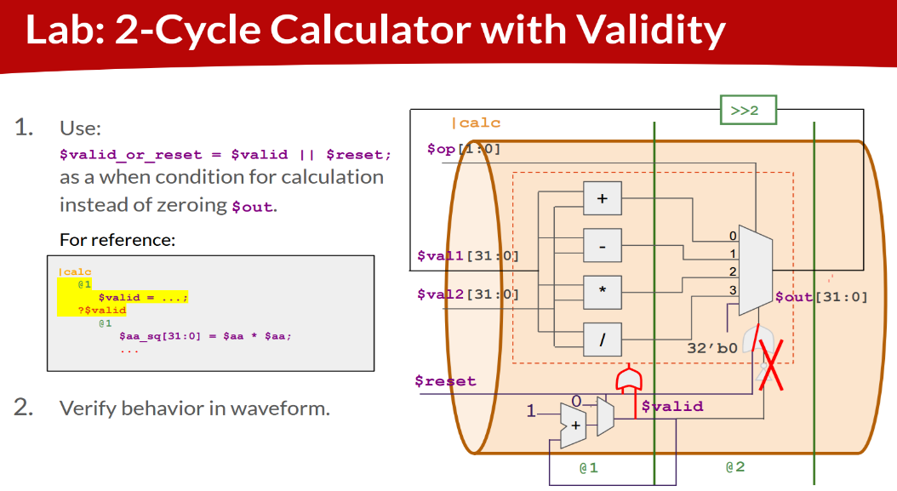

Code:

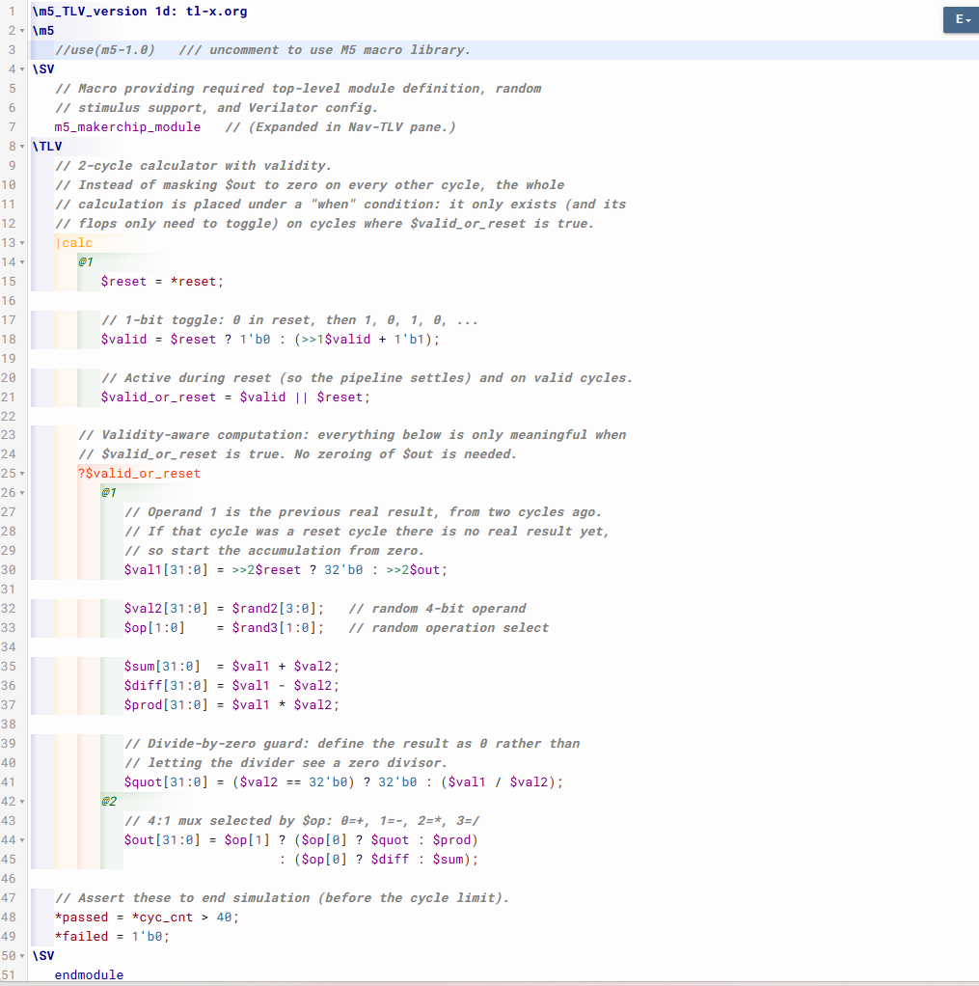

Makerchip execution – Diagram

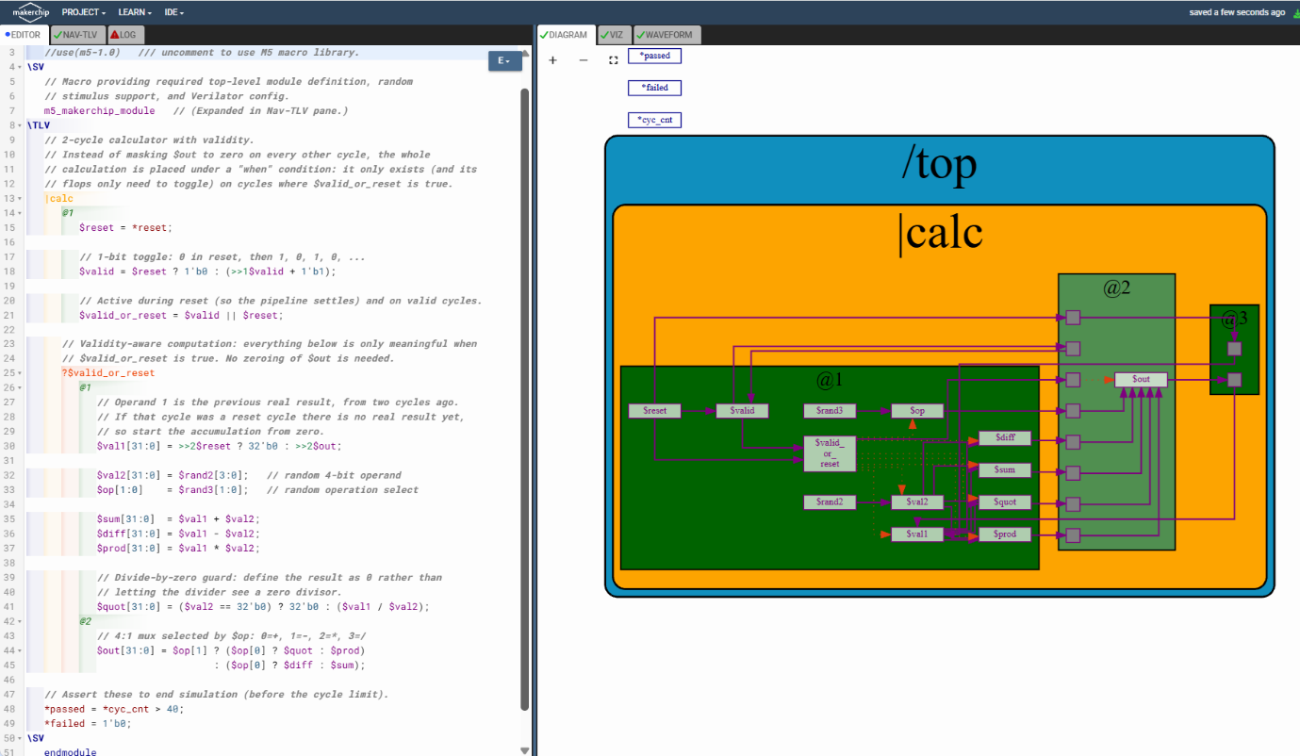

Makerchip execution – Waveform

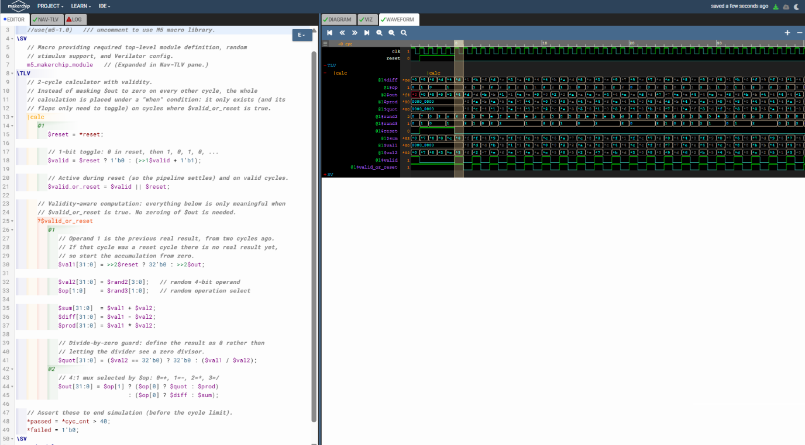

1. Problem statement
The previous version of the calculator masked its output: $out = ($reset || !$valid) ? 32'b0 : <mux>. The lab diagram crosses out that OR gate and the 32'b0 input. The task is to use
$valid_or_reset = $valid || $reset;

as a when condition for the calculation (the dashed red box in the diagram) instead of zeroing $out, and to verify the behaviour in the waveform.
 | Before (manual masking) | After (validity-aware)
Invalid cycles | $out is forced to 0 | $out is a don't-care; the logic is gated off
Extra hardware | OR gate, inverter, 32-bit zero mux | none on the datapath
Meaning of $out | Always defined (0 when unused) | Defined only when $valid_or_reset is true
Where the intent lives | Buried in the $out expression | Explicit ?$valid_or_reset scope

2. The code
\TLV
// 2-cycle calculator with validity.
// Instead of masking $out to zero on every other cycle, the whole
// calculation is placed under a "when" condition: it only exists (and its
// flops only need to toggle) on cycles where $valid_or_reset is true.
|calc
@1
$reset = *reset;

// 1-bit toggle: 0 in reset, then 1, 0, 1, 0, ...
$valid = $reset ? 1'b0 : (>>1$valid + 1'b1);

// Active during reset (so the pipeline settles) and on valid cycles.
$valid_or_reset = $valid || $reset;

// Validity-aware computation: everything below is only meaningful when
// $valid_or_reset is true. No zeroing of $out is needed.
?$valid_or_reset
@1
// Operand 1 is the previous real result, from two cycles ago.
// If that cycle was a reset cycle there is no real result yet,
// so start the accumulation from zero.
$val1[31:0] = >>2$reset ? 32'b0 : >>2$out;

$val2[31:0] = $rand2[3:0]; // random 4-bit operand
$op[1:0] = $rand3[1:0]; // random operation select

$sum[31:0] = $val1 + $val2;
$diff[31:0] = $val1 - $val2;
$prod[31:0] = $val1 * $val2;

// Divide-by-zero guard: define the result as 0 rather than
// letting the divider see a zero divisor.
$quot[31:0] = ($val2 == 32'b0) ? 32'b0 : ($val1 / $val2);
@2
// 4:1 mux selected by $op: 0=+, 1=-, 2=*, 3=/
$out[31:0] = $op[1] ? ($op[0] ? $quot : $prod)
: ($op[0] ? $diff : $sum);

// Assert these to end simulation (before the cycle limit).
*passed = *cyc_cnt > 40;
*failed = 1'b0;
\SV
endmodule

3. How it works
Validity generation (@1). $valid is a 1-bit counter: 0 during reset, then 1, 0, 1, 0. $valid_or_reset is true during reset and on every valid cycle.
The when scope. ?$valid_or_reset opens a "when" scope. Every signal assigned inside it exists only on cycles where the condition is true. Its stages are written inside the scope (@1 and @2), so the pipeline structure is unchanged: operands and the four ALU results in @1, the result mux in @2.
Result selection. $out is now just the 4:1 mux on $op: 00 sum, 01 difference, 10 product, 11 quotient. There is no reset or valid term in it.
Feedback. $val1 takes the previous real result from two cycles back (>>2$out). Since valid cycles alternate, two cycles back is the previous cycle on which $out was actually computed, so a reference to it always lands on a valid value.

4. Error-handling decisions
- Reset seeding. The reference code uses $val1 = >>2$out. Because the calculation now also runs during reset, $out on those cycles is meaningless, and the first valid cycle would pick it up. $val1 = >>2$reset ? 32'b0 : >>2$out starts the accumulation from zero instead. This assumes reset lasts at least two cycles, which the Makerchip reset normally satisfies.
- Divide by zero. $val2 can be 0. $quot = ($val2 == 32'b0) ? 32'b0 : ($val1 / $val2) defines the result as 0 rather than feeding the divider a zero divisor.
- Driven opcode. $op is not assigned in the reference code, which leaves it undriven. Here it comes from random stimulus, $rand3[1:0], placed inside the when scope so it is also gated.
- Reset inside the condition. Including $reset in $valid_or_reset keeps the pipeline active during reset, so the datapath state is well-defined by the time the first real result is needed.
- Explicit widths. $valid uses 1'b0 and 1'b1 so the toggle is a clear 1-bit value.

5. Example trace
Values are illustrative, since the operands and opcodes are random. Reset lasts cycles 0 and 1. "Gated" means $valid_or_reset is false, so the logic is off and the values are don't-care.
Cycle | $reset | $valid | $valid_or_reset | $val1 | $val2 | $op | $out
0 | 1 | 0 | 1 | ignored | ignored | ignored | ignored
1 | 1 | 0 | 1 | ignored | ignored | ignored | ignored
2 | 0 | 1 | 1 | 0 (seeded) | 5 | sum | 5
3 | 0 | 0 | 0 | gated | gated | gated | gated
4 | 0 | 1 | 1 | 5 | 3 | prod | 15
5 | 0 | 0 | 0 | gated | gated | gated | gated
6 | 0 | 1 | 1 | 15 | 4 | diff | 11
7 | 0 | 0 | 0 | gated | gated | gated | gated
8 | 0 | 1 | 1 | 11 | 2 | quot | 5

The chain of real results is 0 + 5 = 5, then 5 x 3 = 15, then 15 - 4 = 11, then 11 / 2 = 5. It is identical to the masked version; only the way the unused cycles are handled has changed.

6. Verifying in the waveform
- $valid should read 1, 0, 1, 0 after reset, and $valid_or_reset should be 1 throughout reset.
- Signals inside the when scope ($val1, $val2, $op, $out and the ALU results) should show real values on valid cycles and appear as don't-care on the gated cycles, rather than showing 0.
- Each valid cycle's $val1 should equal the $out from two cycles earlier (the previous valid cycle), apart from the first one, which is 0.

