RV_D5SK3_L2_Lab to load data from memory to register file
This lab uses the ISA to load data from memory into the register file and asks for three things: clear $valid in the "shadow" of a load, the same way it's already cleared in the shadow of a taken branch; select the PC from 3 instructions ago for the load redirect; and debug/confirm. This lab expects walks through all three, plus the deferred write-back that actually lands the loaded value in $rd once the redirect completes -- without that piece, "load data into the register file" wouldn't actually happen.

Ask
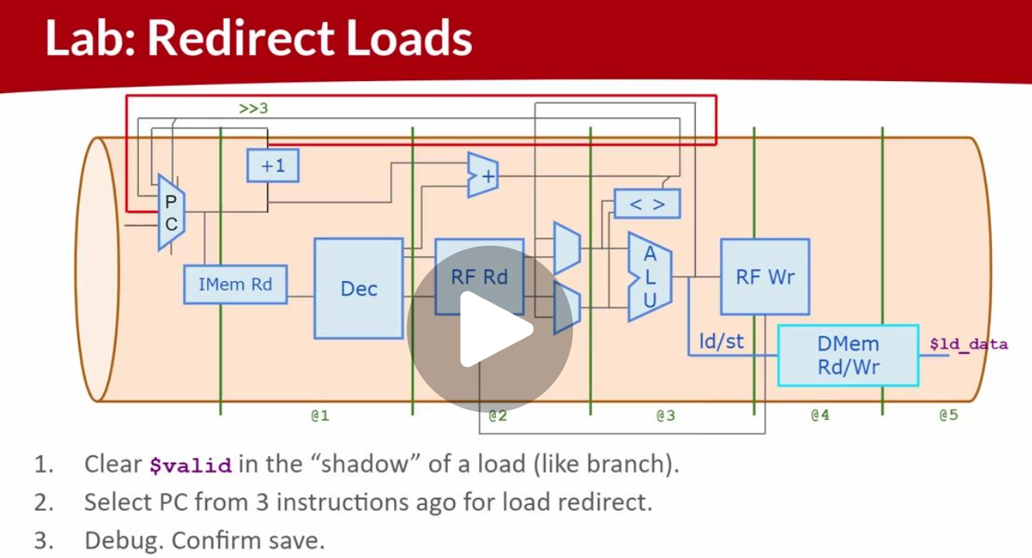

Code

Makerchip URL - https://www.makerchip.com/v186/ide/~0o2fLcpK/p-011c66

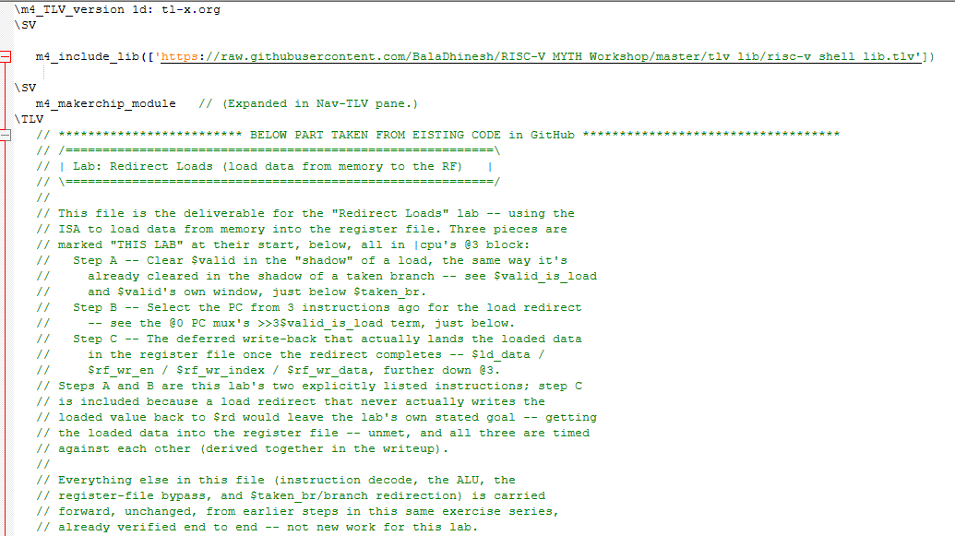
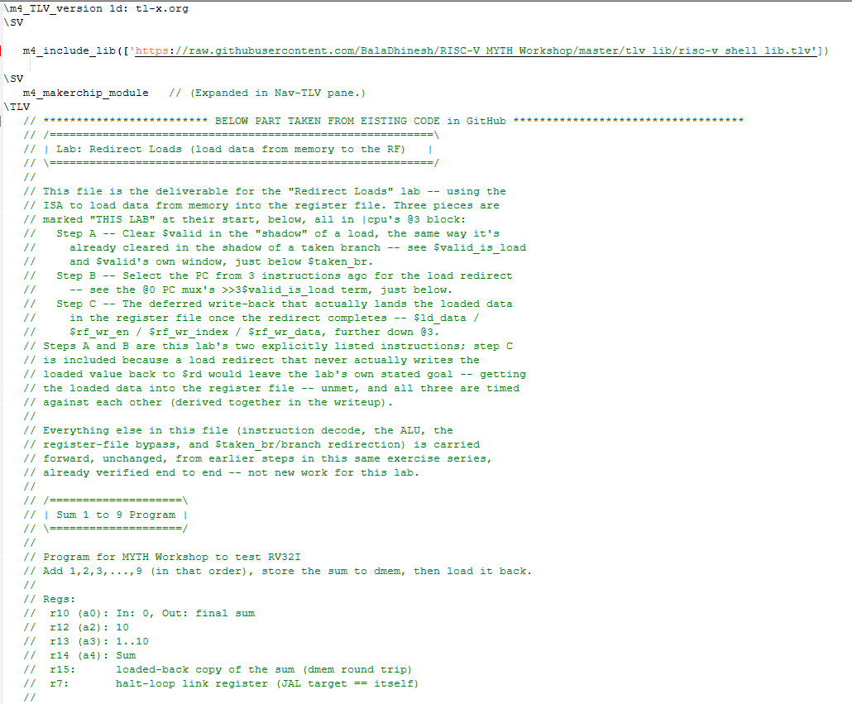

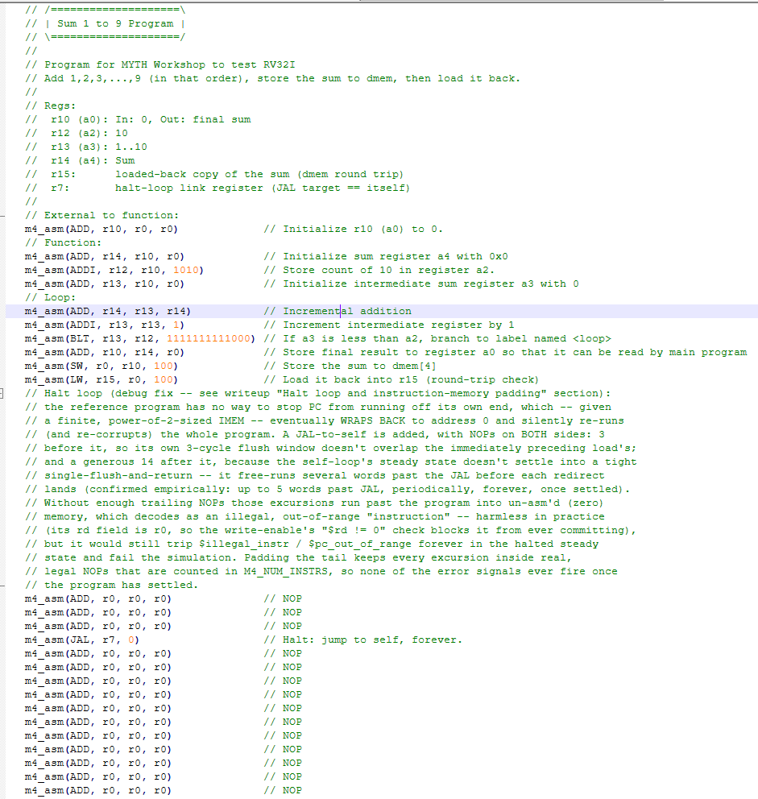

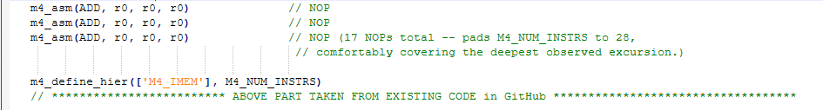

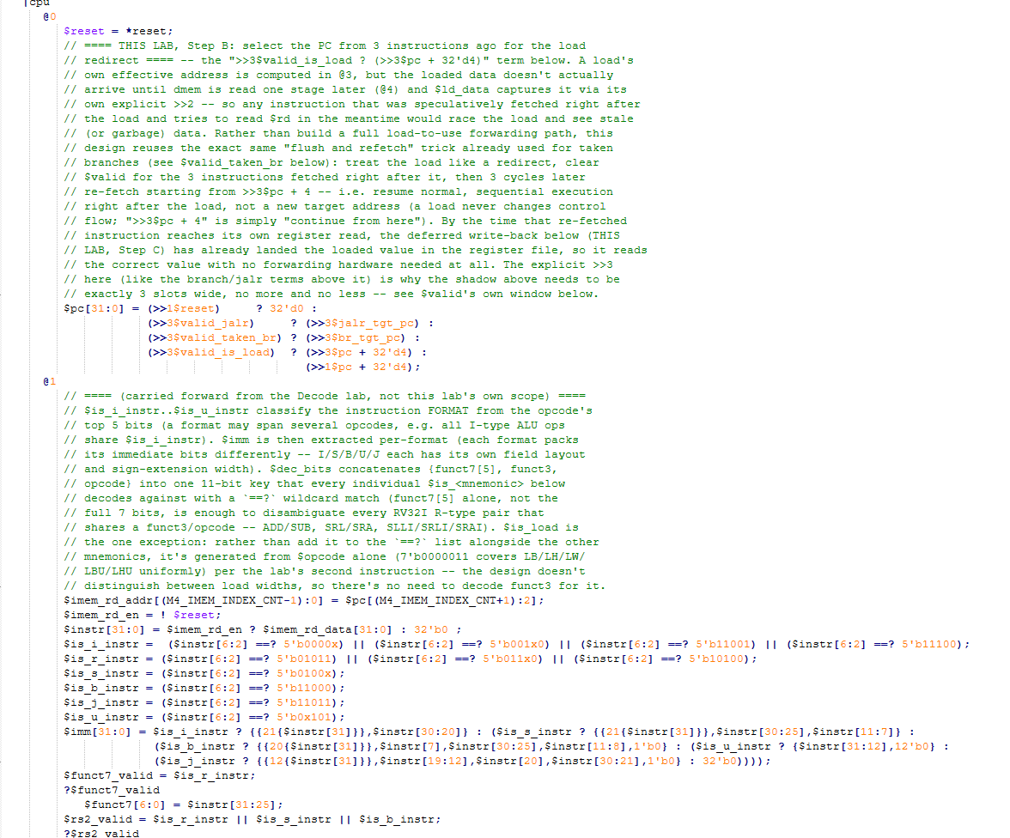
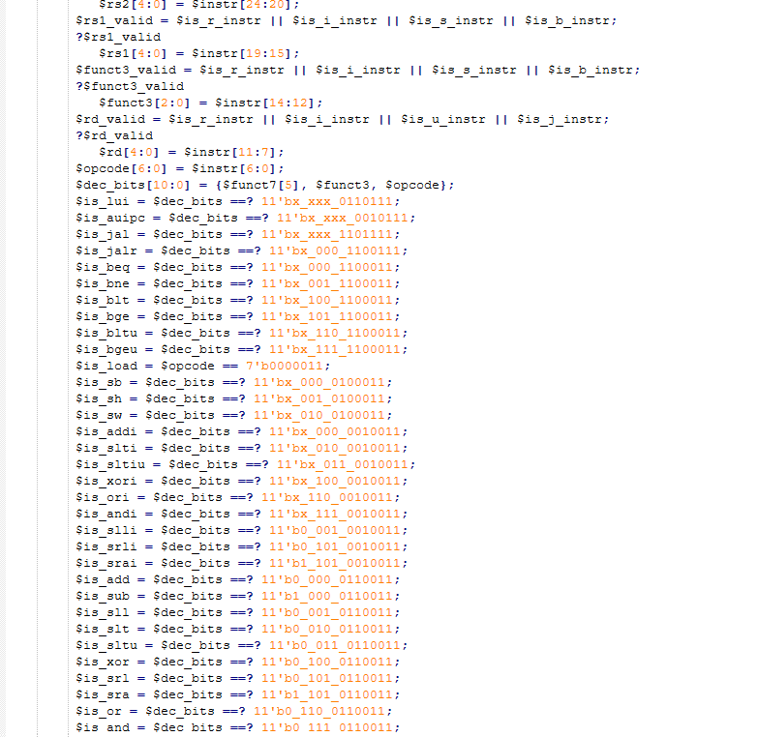
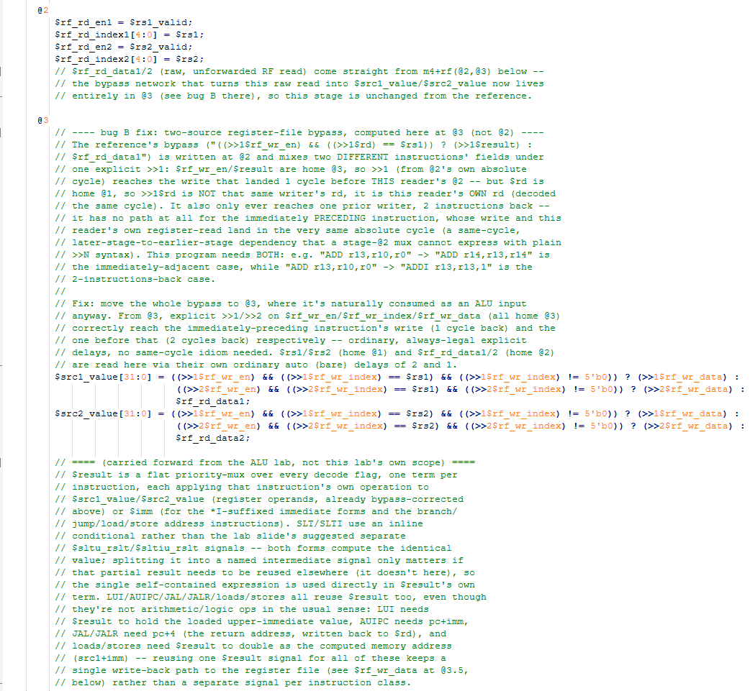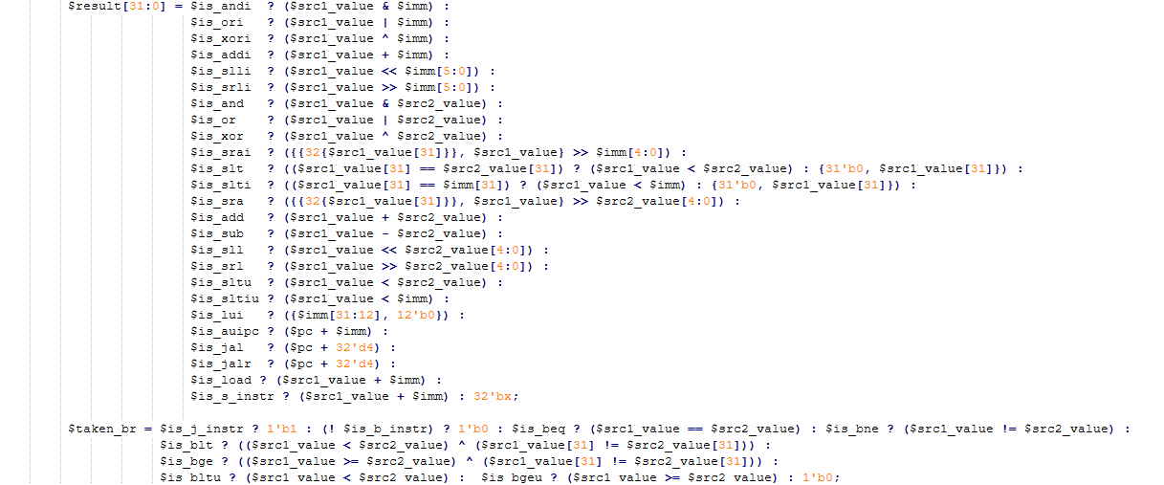

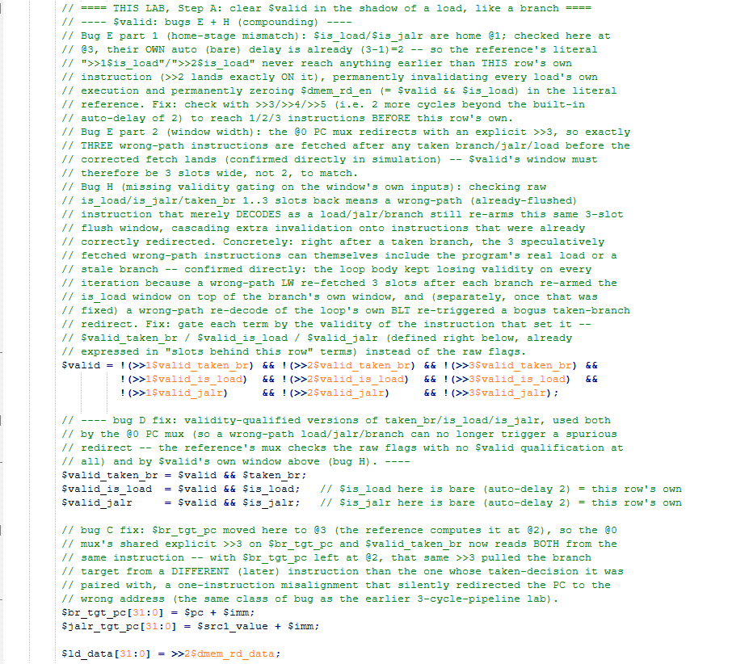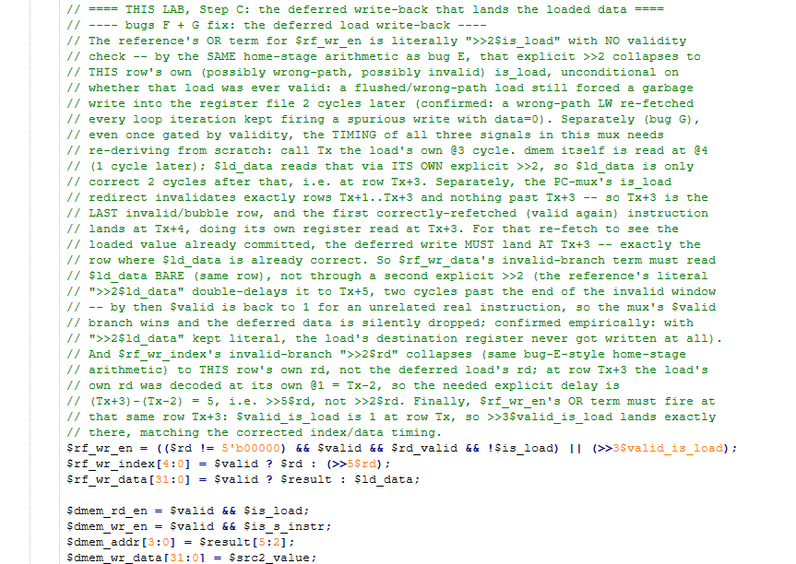
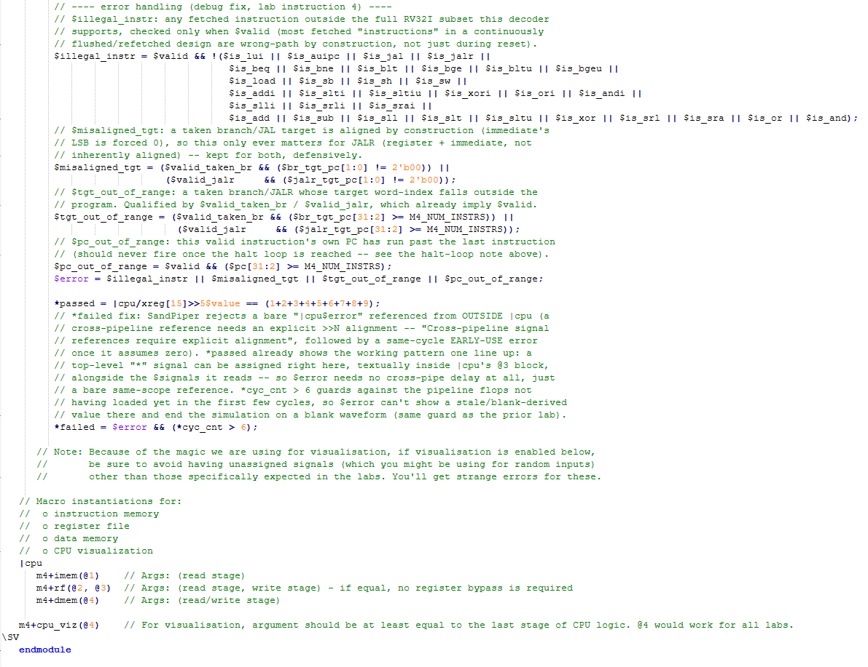

Makerchip execution – Diagram
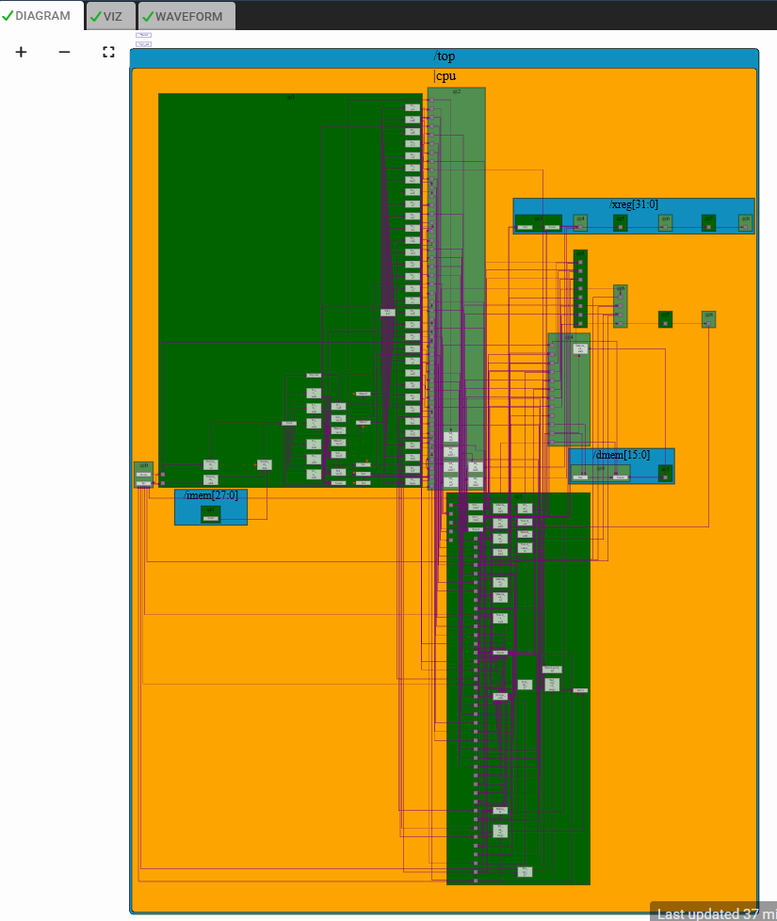

Makerchip execution – Waveform
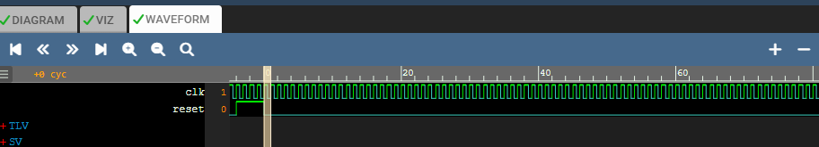

Implementation Elaboration

Why a load needs a redirect at all
A load's own effective address ($result = $src1_value + $imm) is computed at @3, same as every other instruction. But the loaded DATA doesn't arrive that quickly: m4+dmem(@4) reads memory one stage later, at @4, and $ld_data captures that read via its own explicit >>2 -- so the value isn't actually available, in this design's own timing, until 3 cycles after the load's @3. Meanwhile, in a continuously-issuing pipeline with no stalling, the instruction immediately after the load has already been fetched and would try to read $rd well before that -- a classic load-to-use hazard.
There are two standard ways to solve this: build a forwarding path that detects the hazard and stalls or bypasses the dependent instruction, or -- simpler, at the cost of a few bubble cycles -- treat the load like a redirect: flush whatever was speculatively fetched after it and re-fetch once the loaded value has safely landed in the register file. This design takes the second approach, reusing the exact same flush-and-refetch machinery already built for taken branches (a taken branch also flushes 3 speculatively fetched wrong-path instructions and re-fetches from the correct target 3 cycles later). For a load, the "target" is simply the next sequential instruction -- a load never changes control flow -- so the load's redirect always resumes at pc+4, not a computed branch target.

Step A -- clearing $valid in the load's shadow
Exactly as a taken branch invalidates the 3 instructions fetched immediately after it, a load does the same, through the identical mechanism -- an extra term in $valid's own window:
$valid = !(>>1$valid_taken_br) && !(>>2$valid_taken_br) && !(>>3$valid_taken_br) &&
!(>>1$valid_is_load) && !(>>2$valid_is_load) && !(>>3$valid_is_load) &&
!(>>1$valid_jalr) && !(>>2$valid_jalr) && !(>>3$valid_jalr);

$valid_is_load = $valid && $is_load; // gated by this instruction's OWN validity

An instruction is valid only if none of the 3 instructions immediately before it was a validly-taken branch, a valid JALR, or a valid load. $valid_is_load is itself gated by $valid -- a wrong-path (already-flushed) fetch that merely happens to DECODE as a load must never be allowed to re-arm this window; only a load that was itself real should ever clear validity downstream of it. This qualification matters in practice: without it, a speculatively-refetched instruction that decodes as a load (even though it will itself be flushed) can cascade extra, spurious invalidation onto instructions that were already correctly redirected -- confirmed directly in this program's own loop body, where a wrong-path LW re-fetched after every taken branch kept re-arming the load window on top of the branch's own.

Step B -- redirecting the PC from 3 instructions ago
The @0 PC mux gets one more term, parallel to the branch/JALR terms already there:
$pc[31:0] = (>>1$reset) ? 32'd0 :
(>>3$valid_jalr) ? (>>3$jalr_tgt_pc) :
(>>3$valid_taken_br) ? (>>3$br_tgt_pc) :
(>>3$valid_is_load) ? (>>3$pc + 32'd4) : // <-- load redirect
(>>1$pc + 32'd4);

The explicit >>3 matches the width of the shadow cleared in Step A -- both must agree, since the shadow is exactly as wide as the delay before the redirect lands. The redirected term itself, >>3$pc + 32'd4, reads the LOAD instruction's own PC (3 cycles back) and adds 4: this is deliberately just "resume sequential execution right after the load", not a jump to some other target -- a load's only effect on control flow is the 3-cycle bubble needed to let its data land safely, never a change of destination.

Step C -- landing the loaded data in the register file
Clearing validity and redirecting the PC only solves the RACE; the load still needs its data to actually reach $rd. Call Tx the load's own @3 cycle. Three signals need their timing derived together:
Signal | Timing
$ld_data | dmem is read at @4 (1 cycle after Tx); $ld_data reads that via its own explicit >>2, so the loaded value is only correct 2 cycles after that -- i.e. at row Tx+3.
Redirect window | The PC-mux's load redirect invalidates exactly rows Tx+1..Tx+3 and nothing past Tx+3 (Step A/B above) -- so Tx+3 is the LAST invalid row, and the first correctly re-fetched instruction lands at Tx+4, doing its own register read at Tx+3.
Conclusion | For that re-fetch to see the loaded value already committed, the deferred write must land AT Tx+3 -- exactly the row where $ld_data is already correct.

Three signals implement that write, each needing an OR term or a mux branch for the deferred (load) case alongside the normal (every-other-instruction) case:
$rf_wr_en = (($rd != 5'b00000) && $valid && $rd_valid && !$is_load) || (>>3$valid_is_load);
$rf_wr_index = $valid ? $rd : (>>5$rd);
$rf_wr_data = $valid ? $result : $ld_data;

- $rf_wr_en's OR term: $valid_is_load is 1 at row Tx (the load's own row), so >>3$valid_is_load lands exactly at row Tx+3, matching the timing derived above.
- $rf_wr_index's deferred branch needs the LOAD's own $rd, not the current row's -- the load's $rd was decoded at its own @1, i.e. row Tx-2, so reaching it from row Tx+3 needs an explicit delay of (Tx+3)-(Tx-2) = 5: >>5$rd.
- $rf_wr_data's deferred branch reads $ld_data BARE (same row, no further delay) -- row Tx+3 is exactly where $ld_data is already correct, per the table above, so no additional >>N is needed or correct here.

Debugging notes (this lab's third instruction)
Implemented literally against the reference's own timing choices, three mistakes compound here, all traceable to the same root cause -- a signal's home stage isn't @2 the way a naive reading of an explicit ">>2" might suggest, once that signal is referenced from @3 instead:
- The reference's $rf_wr_en OR term is a literal >>2$is_load with no validity check at all. $is_load is home @1; referenced from @3, its own auto (bare) delay is already 2, so an explicit >>2 on top collapses onto THIS row's own (possibly wrong-path) is_load rather than reaching back to a real prior load -- a flushed load could force a garbage write into the register file.
- The reference's deferred data term is >>2$ld_data, double-delaying to row Tx+5 -- two rows past the end of the invalid window (Tx+3). By Tx+5, $valid is back to 1 for an unrelated real instruction, so the mux's $valid branch wins instead and the deferred data is silently dropped: the load's destination register never gets written at all.
- The reference's index term, >>2$rd, collapses the same way as $is_load above -- to THIS row's own rd rather than the load's.
All three are fixed by the re-derivation in Step C above (validity-gated $valid_is_load, and delays re-derived from Tx rather than reused from the reference's literal >>2), and confirmed empirically against a cycle-accurate Python model before being adopted into the delivered .tlv.

Error handling
The same four validity-qualified error signals from earlier labs apply here unchanged; the one most relevant to loads is $tgt_out_of_range / $pc_out_of_range, since a load redirect that landed on the wrong row would show up immediately as the re-fetched PC running past the program or an illegal decode.
Condition | Meaning
$illegal_instr | Any valid, fetched instruction outside the full RV32I subset this decoder supports.
$misaligned_tgt | A taken branch/JALR target with a non-zero low bit (defensive; not applicable to load redirects, whose target is always pc+4).
$tgt_out_of_range | A taken branch/JALR target outside the (padded) program.
$pc_out_of_range | A valid instruction's own PC has run past the last instruction -- would catch a load redirect landing on the wrong row.
$error / *failed | OR of the four above, with the same *cyc_cnt > 6 start-up guard and in-|cpu placement (for the SandPiper cross-pipeline scoping fix) established in the earlier lab.

