RV_D5SK3_L3_Lab to instantiate data memory to the CPU
This lab asks for two things: uncomment //m4+dmem(@4) to instantiate the data memory itself, and connect its interface signals -- address, write data, read/write enables, and the returned read data -- using address bits [5:2] of the computed load/store address, gated on validity. Both pieces were already necessary groundwork for the prior "Redirect Loads" lab (its SW/LW round trip cannot function without a working data memory underneath it), so the wiring already exists in the delivered .tlv, verified end to end; this writeup is where dmem's own generated interface, the address-bit mapping, and the reasoning behind each connecting signal are explained in the depth this lab specifically asks for.

Ask
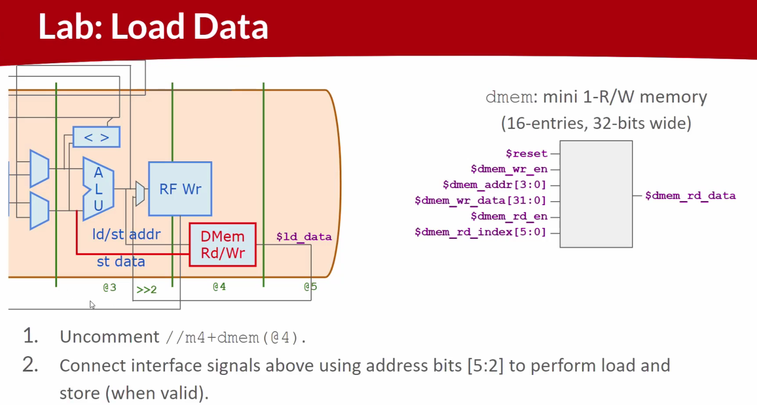

Code
Makerchip URL - https://www.makerchip.com/v186/ide/~0o2fLcpK/p-04mczl
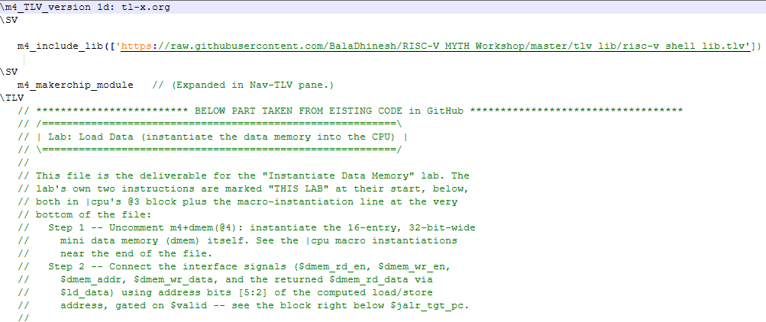

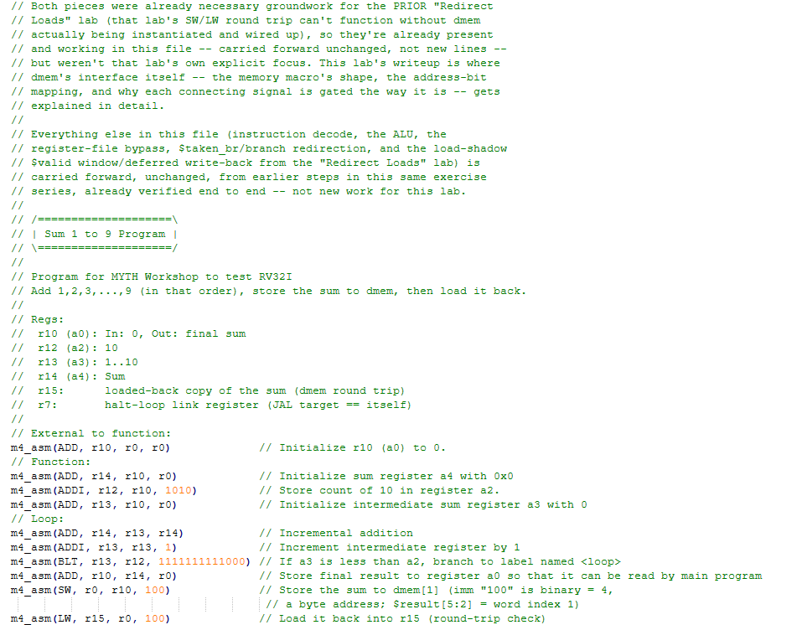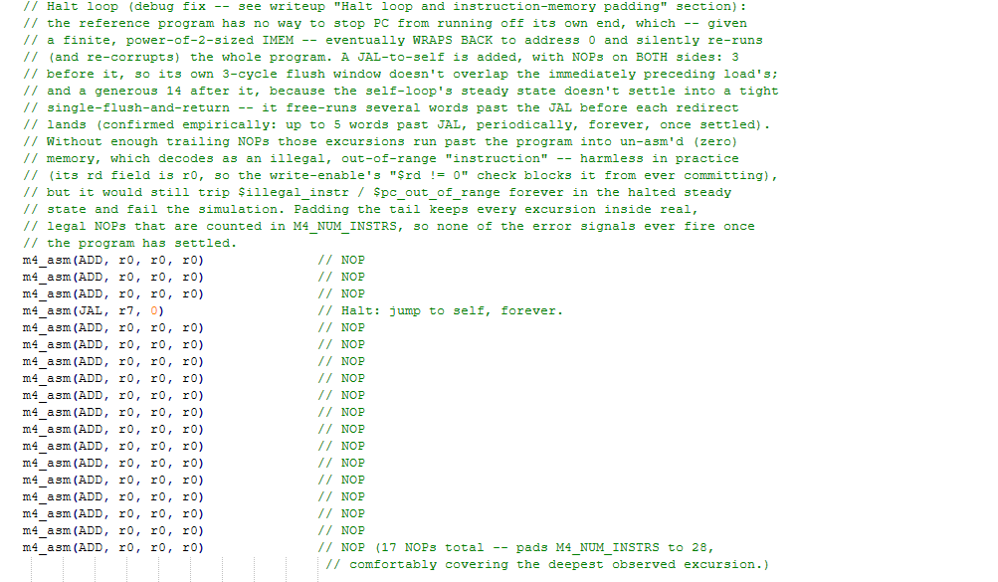

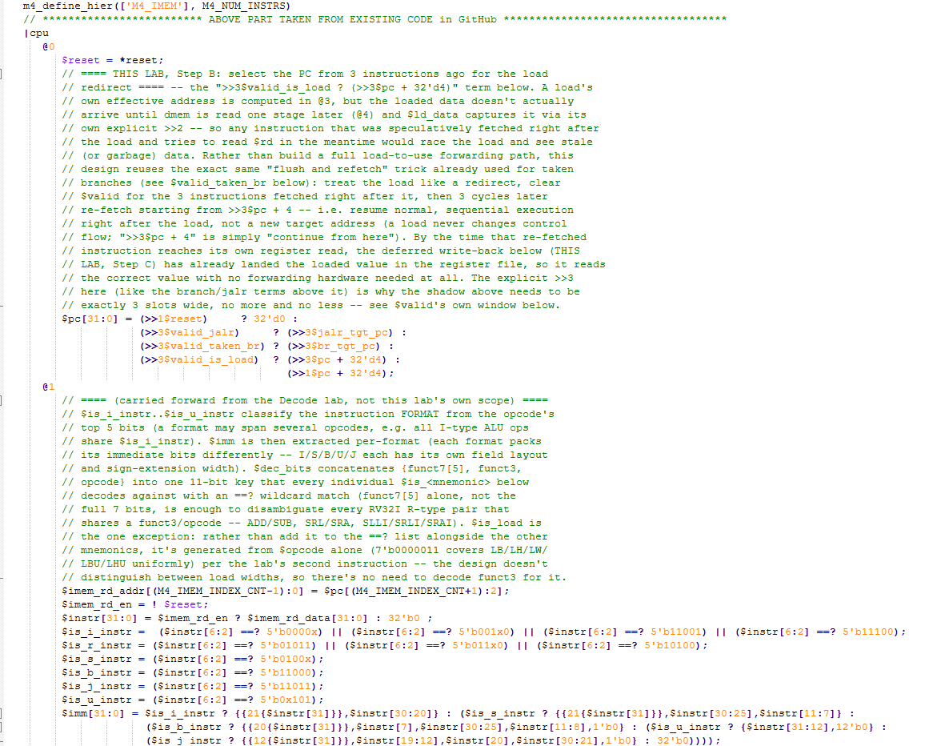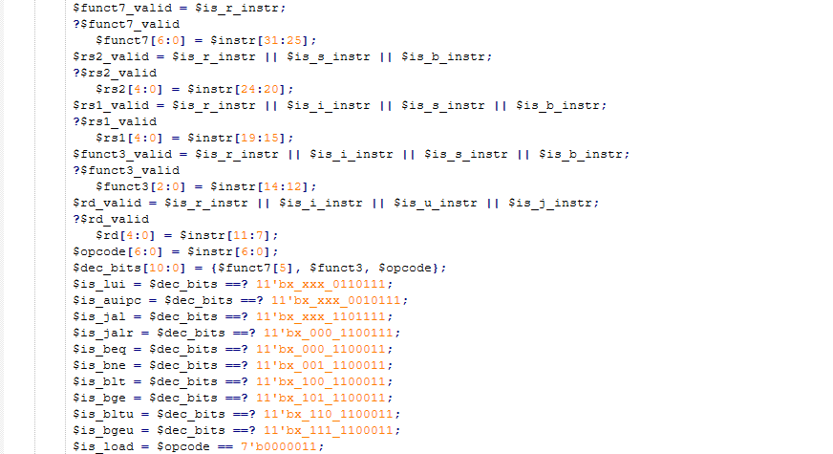
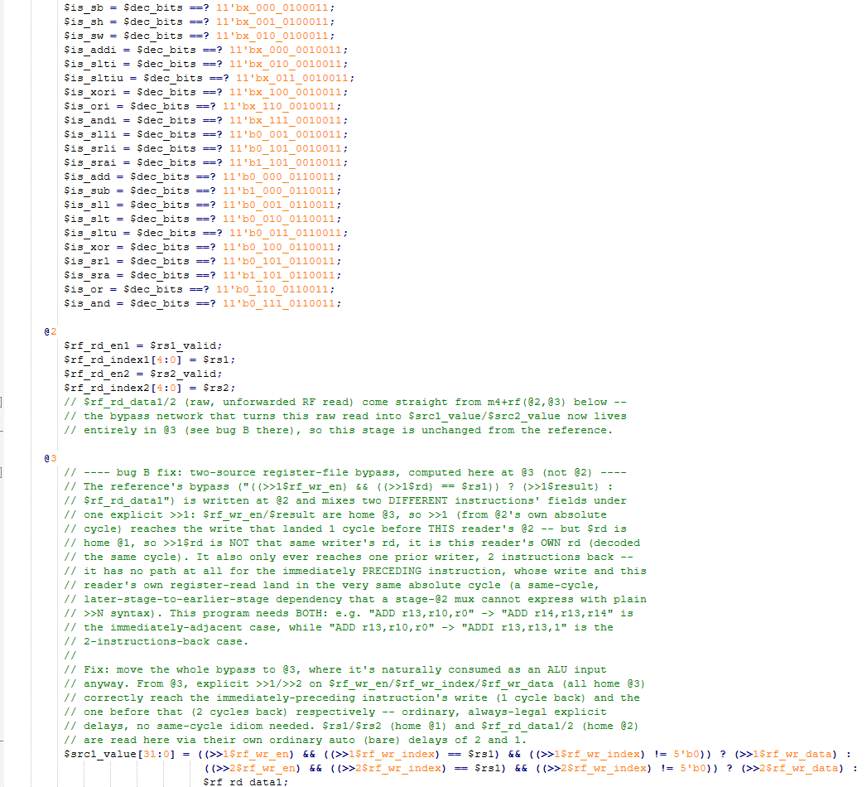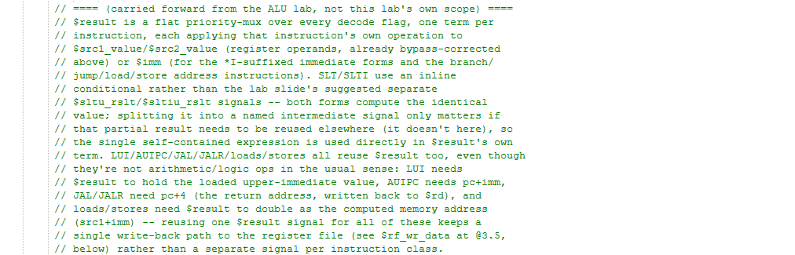
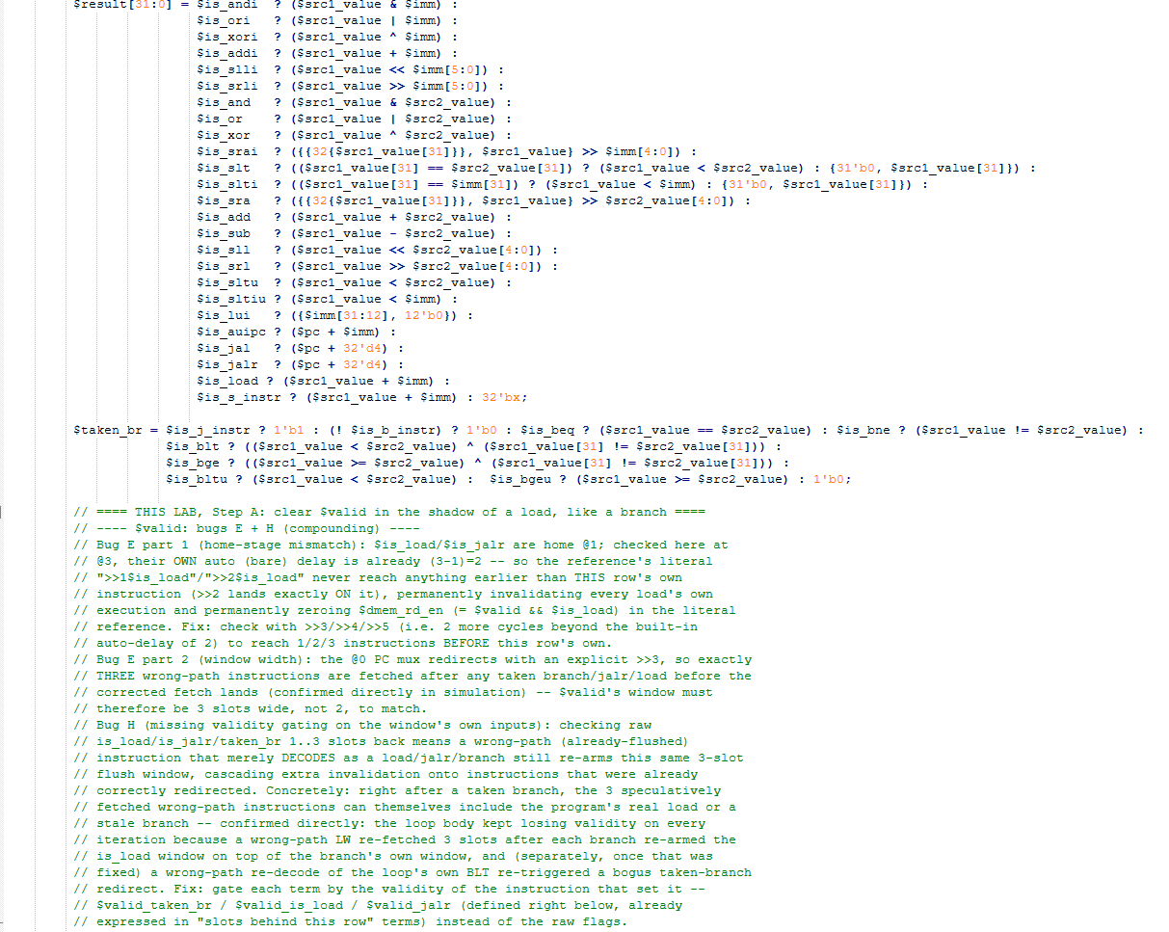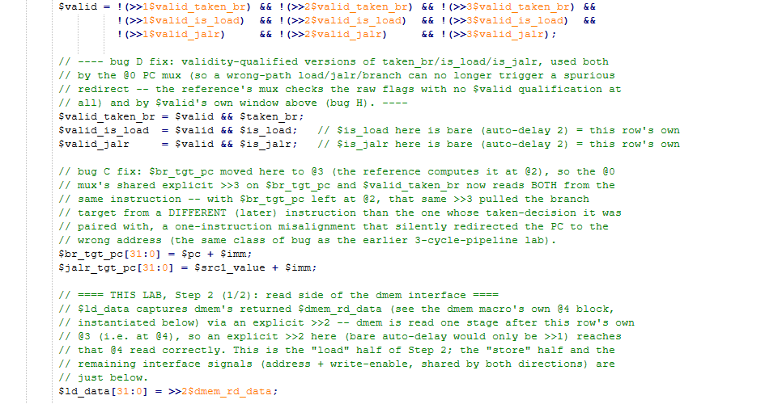
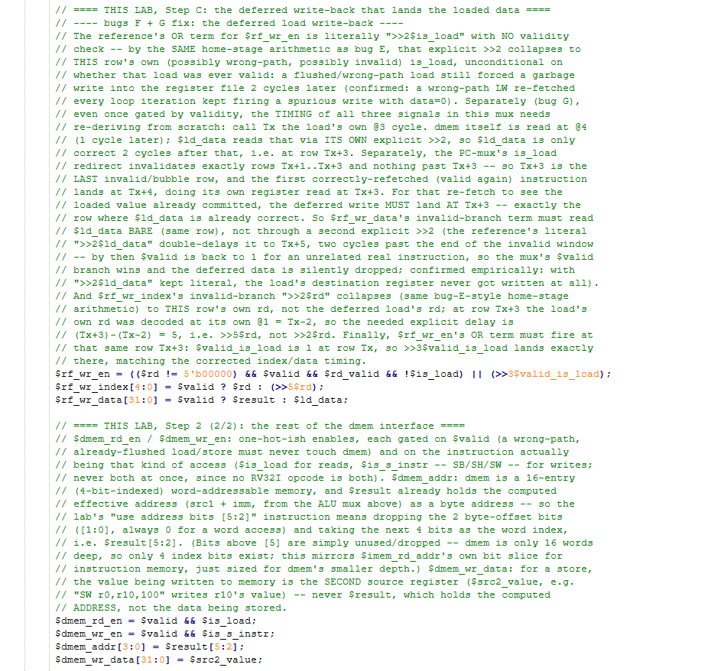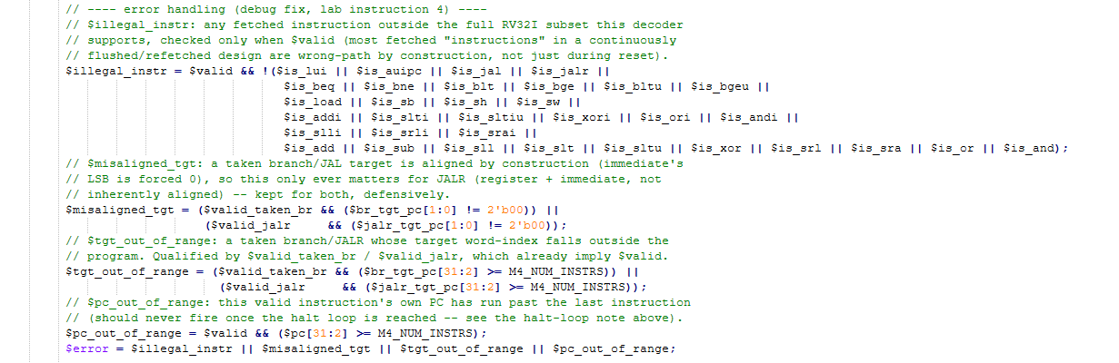
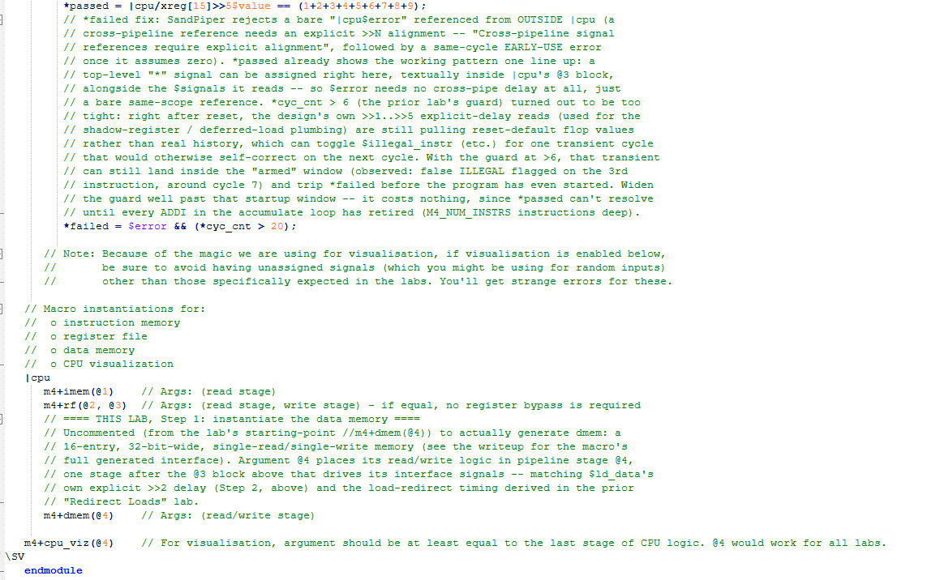

Makerchip execution – Diagram
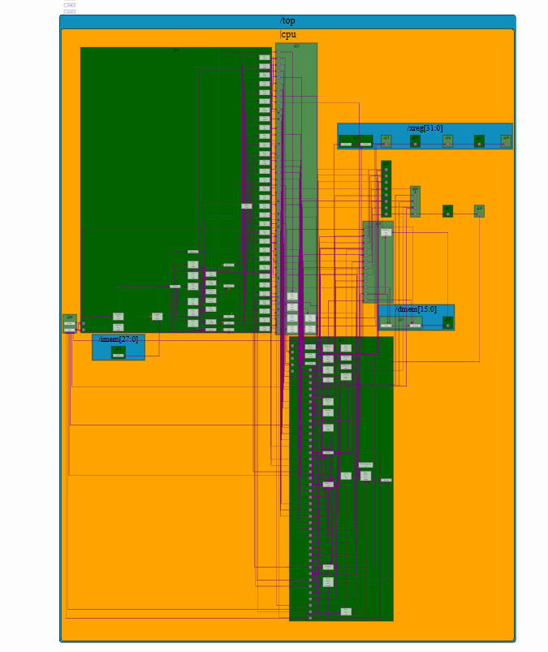

Makerchip execution – Waveform

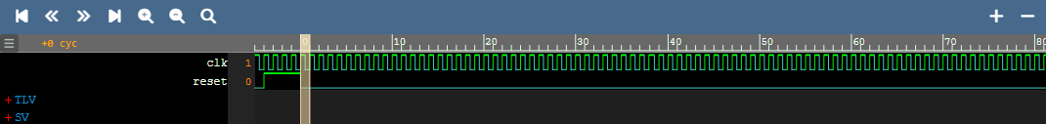

Implementation Elaboration

What m4+dmem(@4) actually generates
The macro expands to a small, self-contained memory block, instantiated inside |cpu at pipeline stage @4:
@4
/dmem[15:0]
$wr = |cpu$dmem_wr_en && (|cpu$dmem_addr == #dmem);
$value[31:0] = |cpu$reset ? #dmem :
$wr ? |cpu$dmem_wr_data :
$RETAIN;
?$dmem_rd_en
$dmem_rd_data[31:0] = /dmem[$dmem_addr]>>1$value;

The /dmem[15:0] construct declares 16 parallel memory entries (indexed 0..15, hence a 4-bit address), each holding one 32-bit $value. Every entry compares the shared $dmem_addr against its own index (#dmem, the entry's built-in index variable) to decide whether THIS entry is the one being written this cycle ($wr); only the matching entry updates, every other entry holds ($RETAIN) its previous value. On reset, every entry initializes to its own index value (#dmem) -- a convenient, deterministic pattern for the waveform/VIZ views, not something the program depends on. The read side is gated by ?$dmem_rd_en (only computed when actually needed) and reads the addressed entry's value through an explicit >>1 -- one extra cycle of registered-read latency inside the memory macro itself, on top of stage @4 already being one stage later than the @3 block that drives the interface. This is exactly the extra cycle this design's own timing derivation (see the "Redirect Loads" lab's writeup) already accounted for when deriving $ld_data's correct explicit delay.

Step 1 -- instantiating dmem
The macro call itself, uncommented from the lab's starting point, alongside the other two memory-family macros:
|cpu
m4+imem(@1) // Args: (read stage)
m4+rf(@2, @3) // Args: (read stage, write stage)
m4+dmem(@4) // Args: (read/write stage) <-- THIS LAB, Step 1

The single argument, @4, tells the macro which pipeline stage to place its read/write logic in. It has to be at or after the stage that computes the interface signals feeding it (@3, where $dmem_addr, $dmem_wr_data, and the two enables are all driven) -- @4 is the natural choice, exactly one stage later, matching the same read-after-@3 pattern already used for the register file (m4+rf(@2, @3)) and instruction memory (m4+imem(@1), read one stage after @0's PC is issued).

Step 2 -- connecting the interface signals
Four signals drive dmem and one comes back from it, all computed at @3, right alongside the ALU and the deferred load write-back logic from the prior lab:
$dmem_rd_en = $valid && $is_load;
$dmem_wr_en = $valid && $is_s_instr;
$dmem_addr[3:0] = $result[5:2];
$dmem_wr_data[31:0] = $src2_value;

$ld_data[31:0] = >>2$dmem_rd_data; // the return path

Signal | Reasoning
$dmem_rd_en / $dmem_wr_en | Each gated on $valid (a wrong-path, already-flushed instruction must never touch memory) and on the specific instruction kind: $is_load for a read, $is_s_instr (SB/SH/SW) for a write. No RV32I opcode is both, so the two enables are naturally mutually exclusive.
$dmem_addr[3:0] | $result already holds the computed effective address (src1_value + imm) as a byte address. dmem is a 16-entry, word-addressable memory (4-bit index), so the lab's "use address bits [5:2]" instruction means dropping the low 2 bits ([1:0], always 0 for a word access) and taking the next 4 bits as the word index -- $result[5:2]. Bits above [5] are simply unused: dmem is only 16 words deep, so only 4 index bits exist at all. This mirrors $imem_rd_addr's own bit-slice for instruction memory, sized down for dmem's smaller depth.
$dmem_wr_data | For a store, the value actually written to memory is the SECOND source register, $src2_value (e.g. "SW r0,r10,100" stores r10's value) -- never $result, which holds the computed ADDRESS, not the data being stored.
$ld_data (return path) | Captures dmem's $dmem_rd_data via an explicit >>2 from @3. dmem's own read (@4, plus its internal >>1 registered-read delay shown above) isn't visible back at @3 until 2 cycles later -- an ordinary bare delay from @3 would only be >>1, so the extra cycle has to be explicit. This is the same $ld_data already relied on by the deferred load write-back built in the "Redirect Loads" lab.

Why address bits [5:2], not [3:0] directly
It would be possible to size $result down to a 4-bit word index directly, but using $result[5:2] against the FULL byte address keeps the address computation itself ($src1_value + $imm) uniform across loads, stores, branches, and JALR -- none of which need to know, at ALU time, that they happen to be feeding a small 16-entry memory. The bit-slice that adapts a byte address into "which word, in a memory of this particular size" is pushed out to the one place that actually cares (the interface connection here), rather than baked into the ALU's own arithmetic. The same pattern is used for $imem_rd_addr at @1, just with a different slice width sized to instruction memory's own (larger, M4_NUM_INSTRS-entry) depth.

Error handling
The same four validity-qualified error signals carried forward from earlier labs apply unchanged here; none of them are specific to dmem's own interface, since dmem itself has no addressable-range check of its own to violate in this design (its 4-bit index simply wraps/truncates $result[5:2] -- a real out-of-range access is instead caught upstream, at the instruction-address level, by $pc_out_of_range / $tgt_out_of_range).
Condition | Meaning
$illegal_instr | Any valid, fetched instruction outside the full RV32I subset this decoder supports.
$misaligned_tgt | A taken branch/JALR target with a non-zero low bit (not applicable to loads/stores, which are covered by the address slice above, not this check).
$tgt_out_of_range | A taken branch/JALR target outside the (padded) program.
$pc_out_of_range | A valid instruction's own PC has run past the last instruction.
$error / *failed | OR of the four above, with the same start-up guard and in-|cpu placement (the SandPiper cross-pipeline scoping fix) established in earlier labs.

