RV_D5SK3_L4_Lab To Add Stores And Loads To The Test Program

Ask
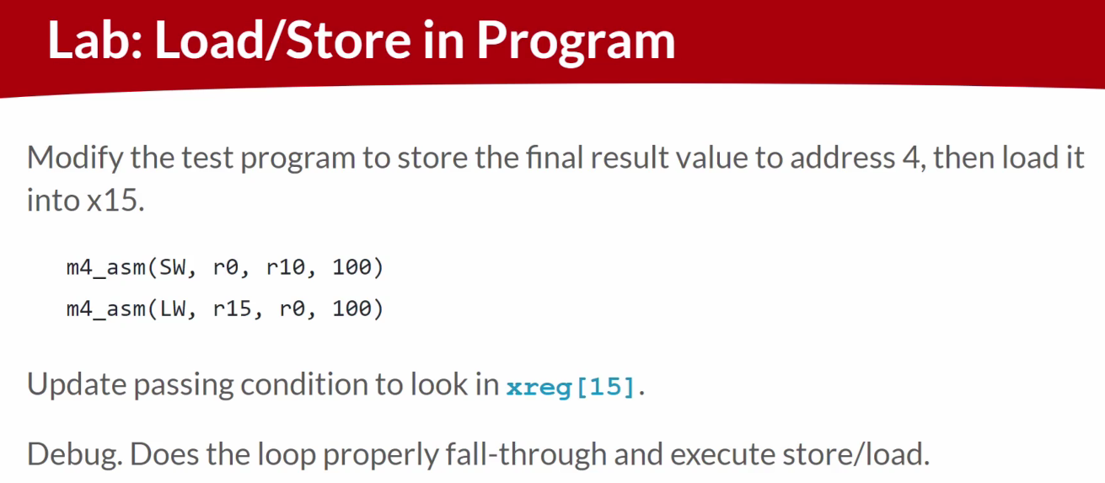

Code
Makerchip URL - https://www.makerchip.com/v186/ide/~0o2fLcpK/p-06ocP1
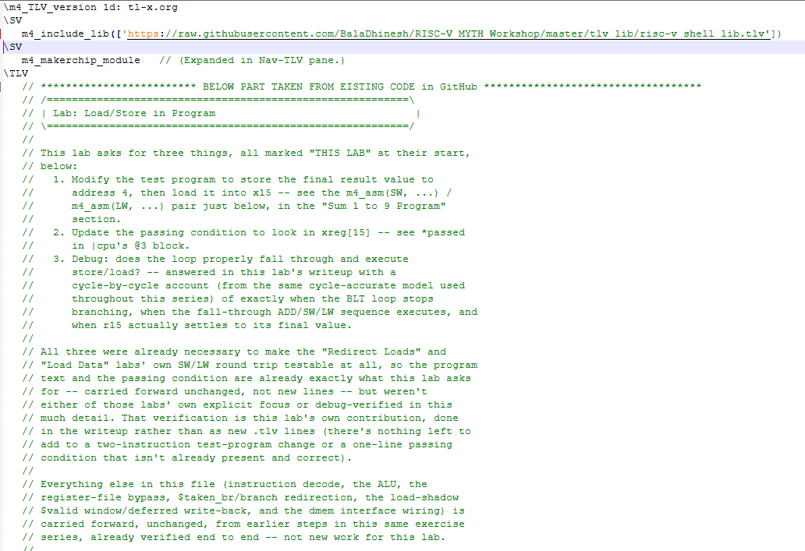
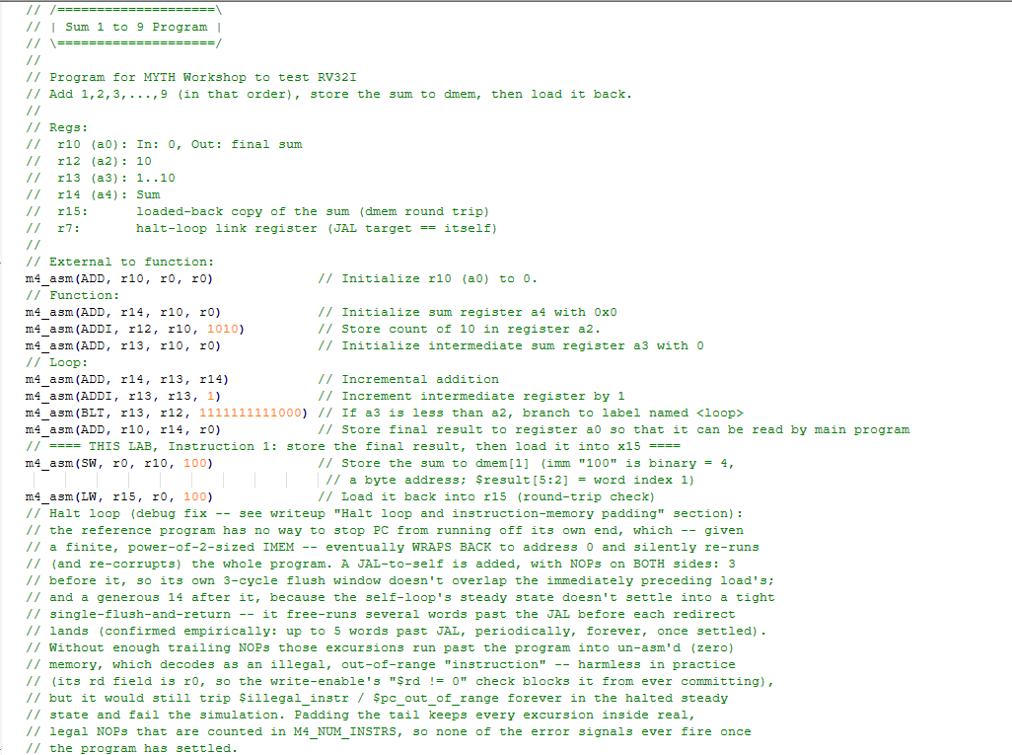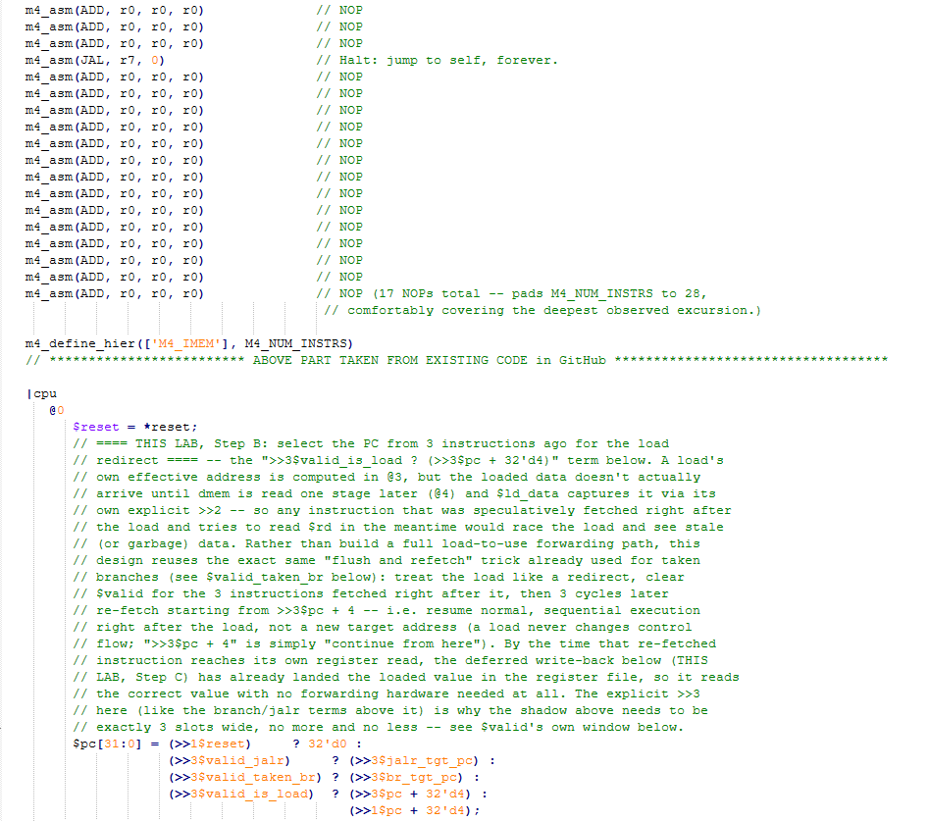
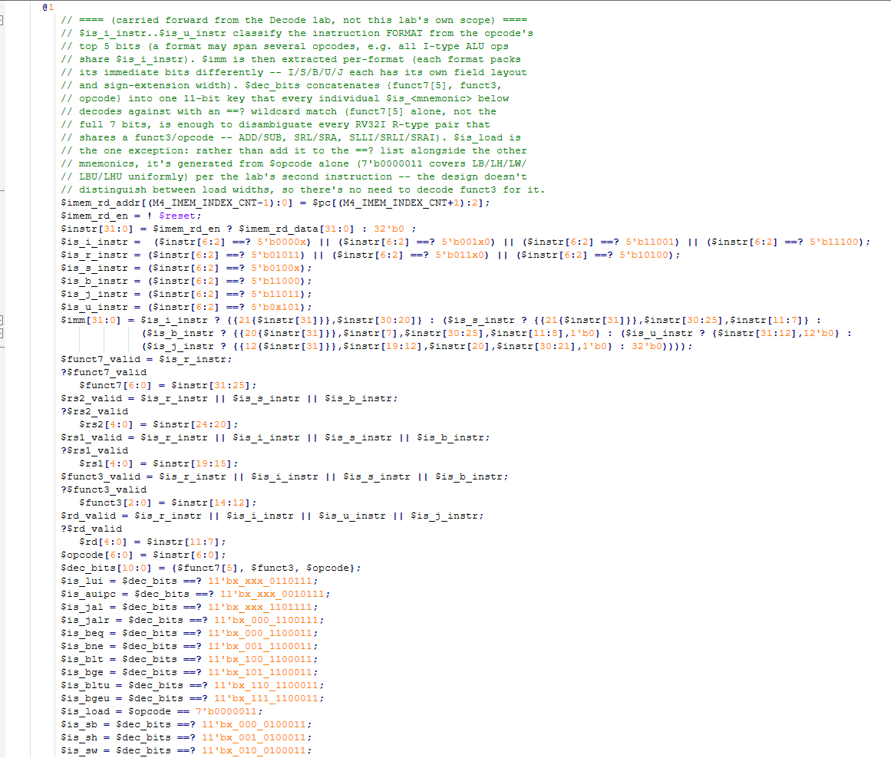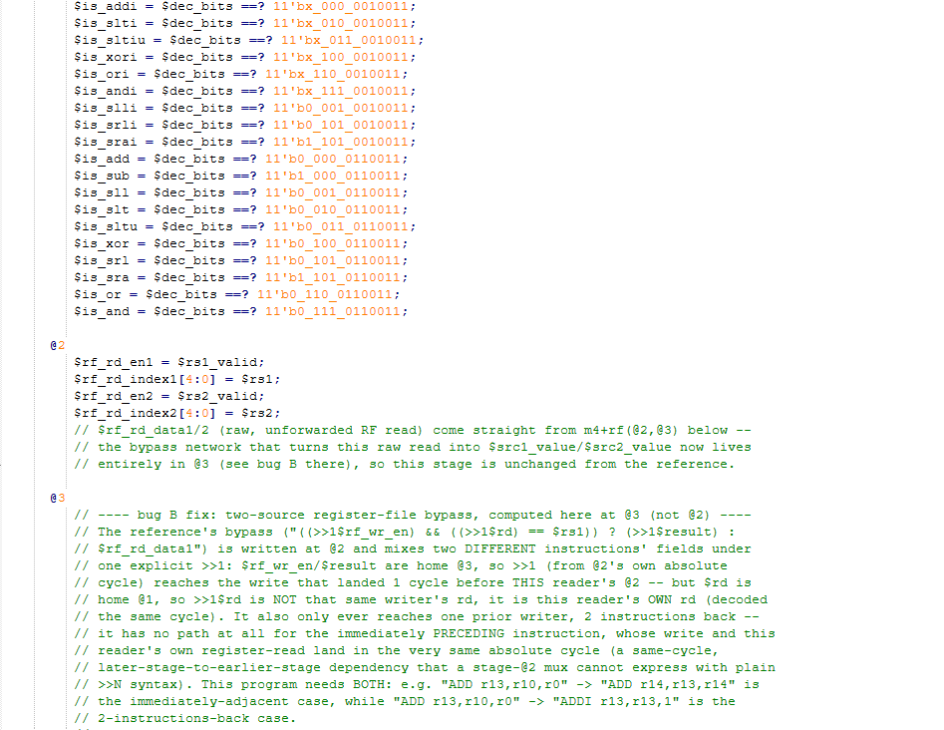
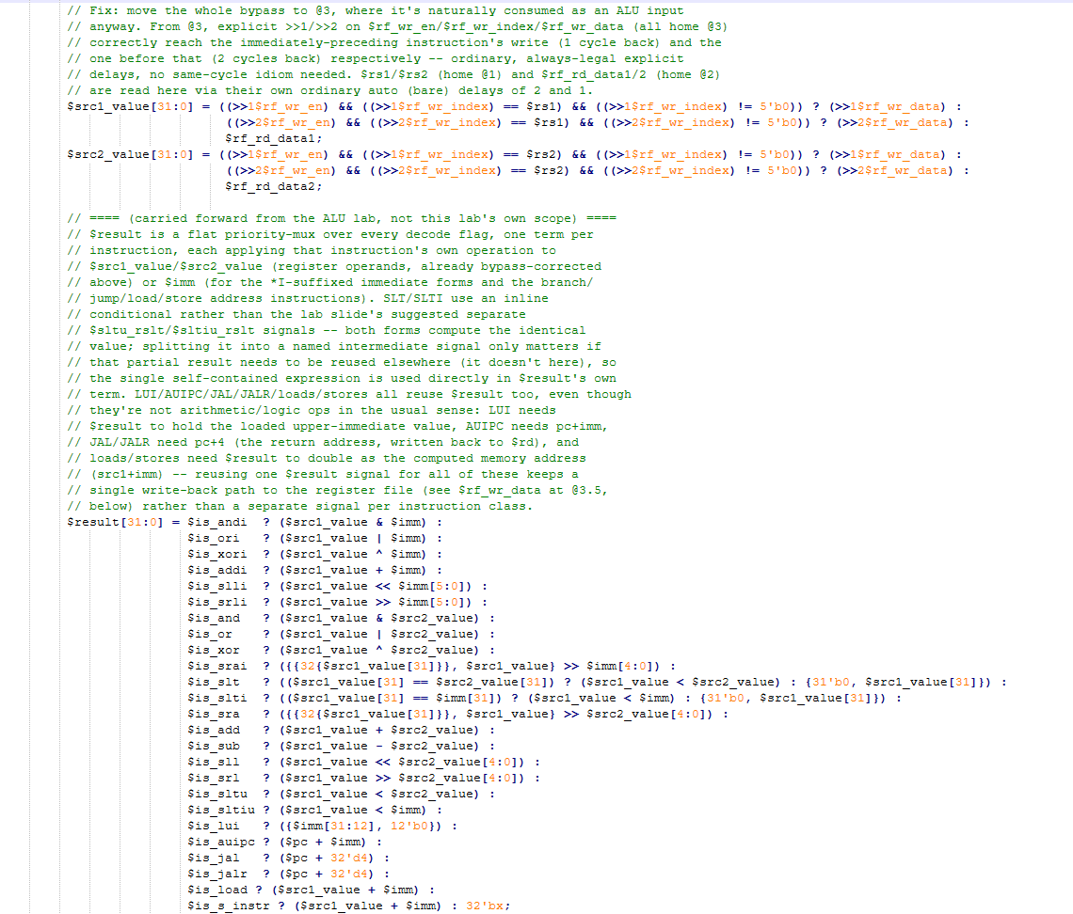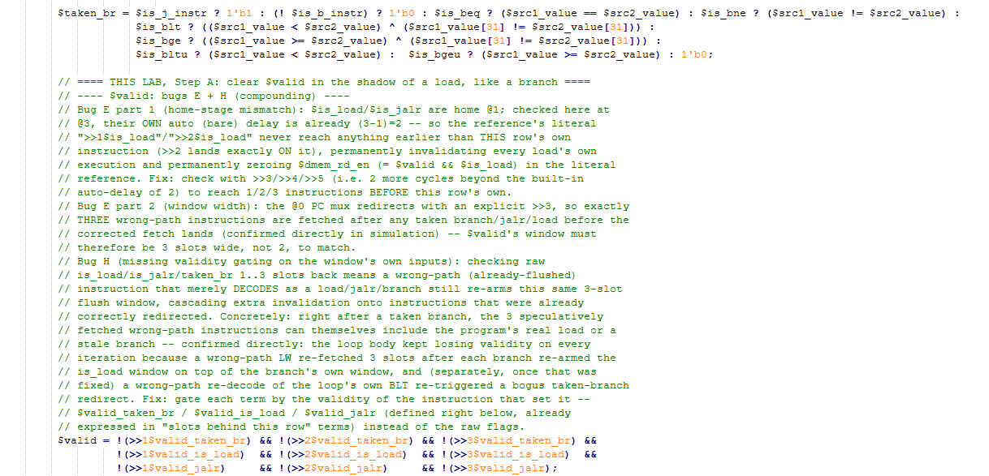
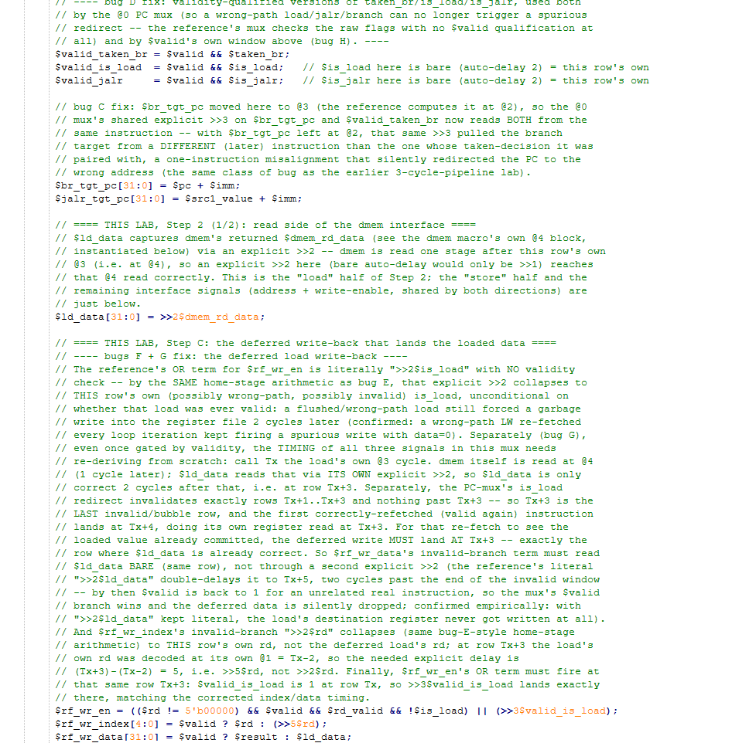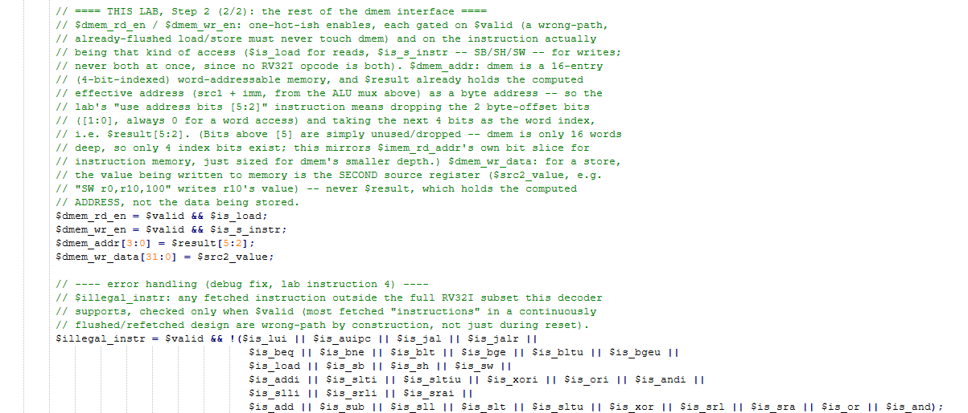
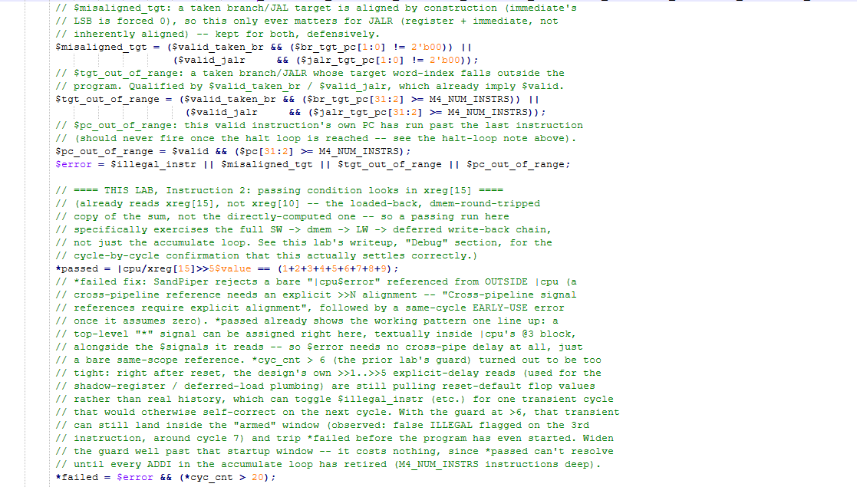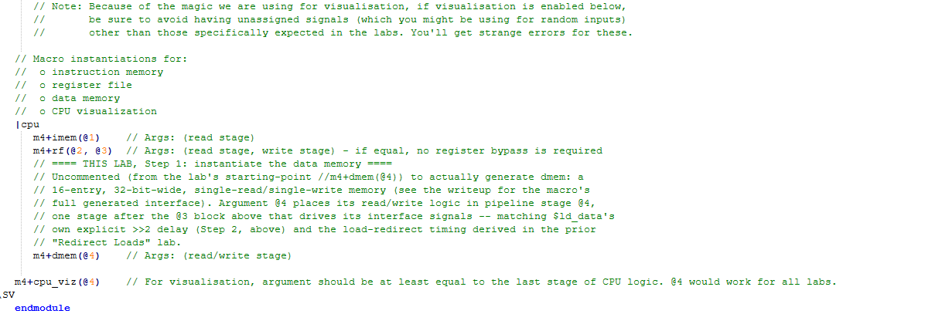

Makerchip execution – Diagram
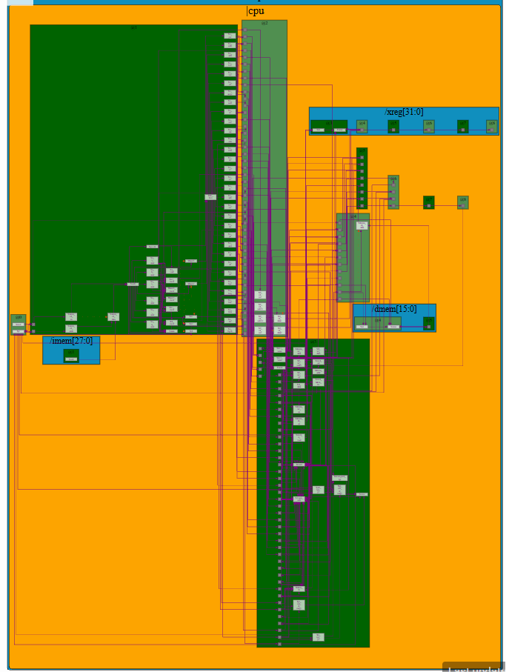

Makerchip execution – Waveform

Implementation Elaboration
This lab asks for three things: modify the test program to store the final result to address 4 and load it back into x15, update the passing condition to look in xreg[15], and debug whether the loop properly falls through and executes the store/load. The first two were already necessary groundwork for the two prior labs' own SW/LW round trip, so the program text and passing condition delivered alongside this document are already exactly what this lab asks for -- confirmed by a line-for-line diff against the last delivered file. What this lab specifically contributes, and what the rest of this writeup is about, is the third item: an explicit, cycle-by-cycle debug pass confirming the loop actually falls through cleanly and the store/load actually executes correctly, rather than merely asserting it.

Instruction 1 -- the test program
The relevant two lines, in program order (10th and 11th instructions):
m4_asm(ADD, r10, r14, r0) // Store final result to r10 (fall-through target)
m4_asm(SW, r0, r10, 100) // Store the sum to dmem[1] <-- address 4 (see below)
m4_asm(LW, r15, r0, 100) // Load it back into r15 <-- THIS LAB

Both instructions use r0 (always 0) as the base register, so the effective address is simply the immediate. That immediate is written as the raw bit-pattern 100 -- consistent with every other immediate in this program (ADDI's 1010, BLT's full branch offset), all given as literal bits rather than decimal -- which is binary for decimal 4, exactly the byte address this lab asks for. Word-indexed against dmem's 4-bit address ($result[5:2]), address 4 lands at dmem word index 1.

Instruction 2 -- the passing condition
*passed = |cpu/xreg[15]>>5$value == (1+2+3+4+5+6+7+8+9);

This already reads xreg[15], not xreg[10] -- a deliberate choice carried through this whole exercise series, not something this lab needs to change. Checking r15 specifically (the value LOADED BACK from dmem) rather than r10 (the value computed directly by the accumulate loop) means a passing run certifies the full store/load path -- SW's address and data, dmem's write, dmem's read, and the deferred load write-back -- not just the arithmetic. A design with a broken dmem interface but a correct ALU would still fail this condition, which is exactly the point of routing the check through r15 instead of r10.

Instruction 3 -- debug: does the loop fall through and execute store/load?
Answered directly against the same cycle-accurate Python model used to verify timing throughout this series (modeling every home-stage delay and bypass path exactly as written in the .tlv). Its trace of the register file confirms three things in sequence:
Event | Cycle | What it confirms
Loop iterates | 10 → 18 → 26 → ... → 82 (8-cycle period, 9 iterations) | r13 increments by 1 at each of these cycles, landing on 1, 2, 3, ..., 10 in turn -- the BLT loop body (ADD/ADDI/BLT) executing and taking the branch back exactly 9 times, matching r12 = 10 (binary "1010").
Loop falls through | 82 | r13 reaches 10; BLT (13 < 12? no, r13 is no longer less than r12) is not taken on this iteration, so the next fetch continues sequentially into the fall-through instruction (ADD r10,r14,r0) instead of branching back -- no extra bubble beyond the ordinary pipeline latency, no stuck loop.
Store executes | 84 | r10 becomes 45 (1+2+...+9), confirming the fall-through ADD landed and committed 2 cycles after the loop exit -- the SW immediately following it (reading r10 as $src2_value) then has the correct, final sum available to write to dmem.
Load executes | 89 | r15 becomes 45 -- the SW -> dmem write -> LW -> dmem read -> deferred write-back chain (Steps A/B/C from the "Redirect Loads" lab, dmem interface from the "Load Data" lab) completes correctly, 5 cycles after r10 settles, matching the store/load timing derived in those two labs.

r15 holds steady at 45 for the remainder of the run (confirmed out to 1000 cycles across four different reset lengths in earlier verification passes), so this is a genuine settle, not a transient. The answer to this lab's debug question is therefore yes on both counts: the loop falls through cleanly at cycle 82 with no extra bubble or stall beyond the pipeline's ordinary latency, and the store/load pair that follows executes and settles correctly, landing the final answer in x15 by cycle 89.

Error handling
Unchanged from earlier labs -- this lab adds no new error condition, since neither the test-program change nor the passing-condition change touches any of the four signals below:
Condition | Meaning
$illegal_instr | Any valid, fetched instruction outside the full RV32I subset this decoder supports.
$misaligned_tgt | A taken branch/JALR target with a non-zero low bit.
$tgt_out_of_range | A taken branch/JALR target outside the (padded) program.
$pc_out_of_range | A valid instruction's own PC has run past the last instruction.
$error / *failed | OR of the four above, with the same start-up guard and in-|cpu placement established in earlier labs.

