RV_D5SK3_L5_Lab To Add Control Logic For Jump Instructions
This lab asks for four things: define $is_jump (JAL or JALR) and, like $taken_br, create invalid cycles from it; compute $jalr_tgt_pc (SRC1 + IMM); select the correct $pc for JAL (via >>3$br_tgt_pc) and JALR (via $jalr_tgt_pc); and save. JALR's redirect path and $jalr_tgt_pc itself were already fully built in the "Redirect Loads" lab's own bug-D fix (JALR needed a dedicated, validity-gated path from day one, independent of that lab's own load-redirect focus), so items 2 and 3 are carried forward unchanged. Item 1 -- $is_jump as an explicit, named signal -- is this lab's own new addition. This writeup covers all eight topics from the lab scope: JAL implementation, JALR implementation, unconditional control flow, jump target computation, PC redirection, jump shadow cycles, control hazard handling, and JALR target address generation.

Ask
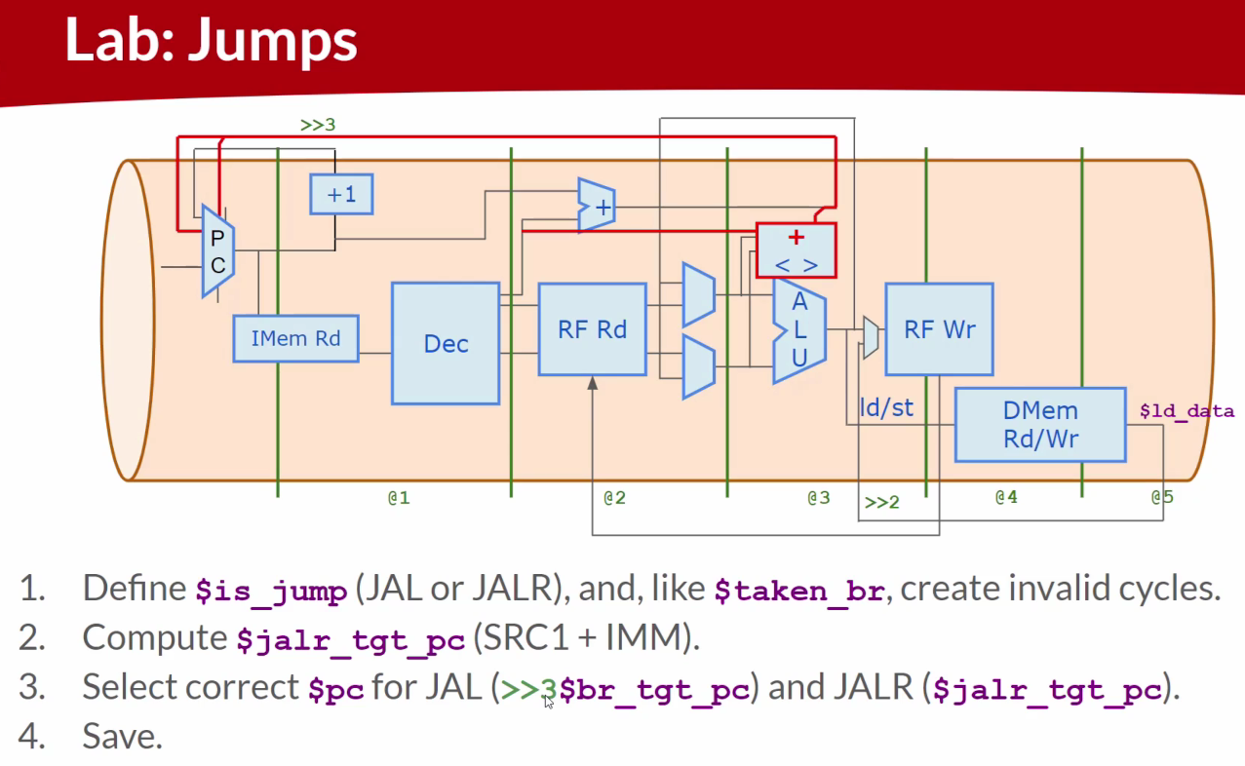

Code
Makerchip URL - https://www.makerchip.com/v186/ide/~0o2fLcpK/p-078czy
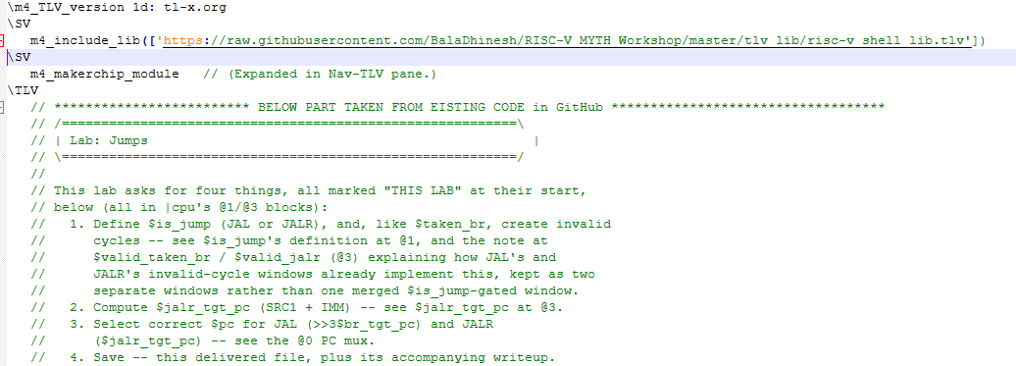
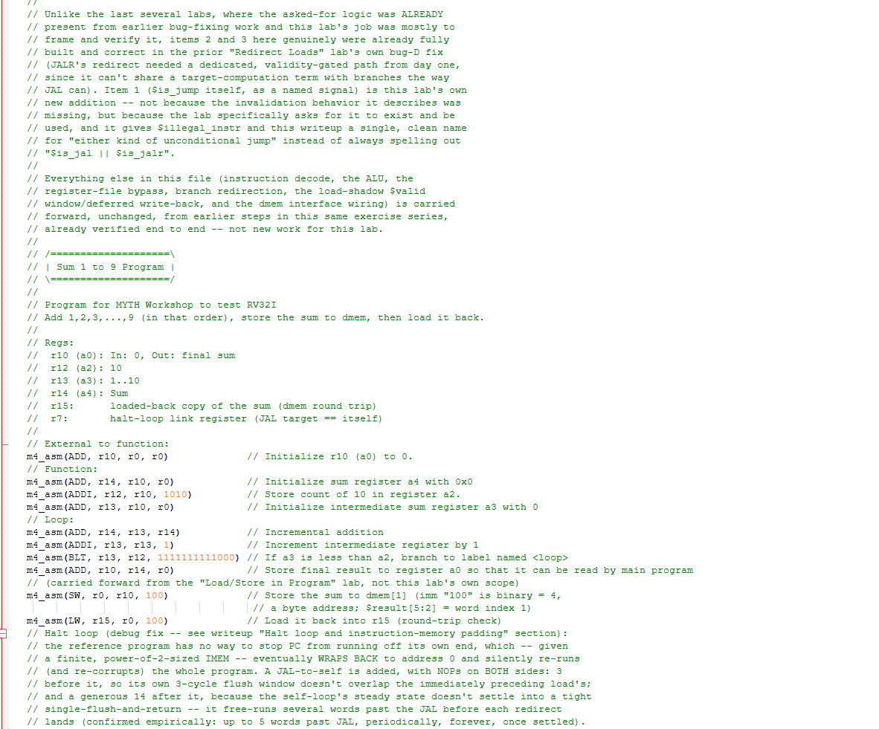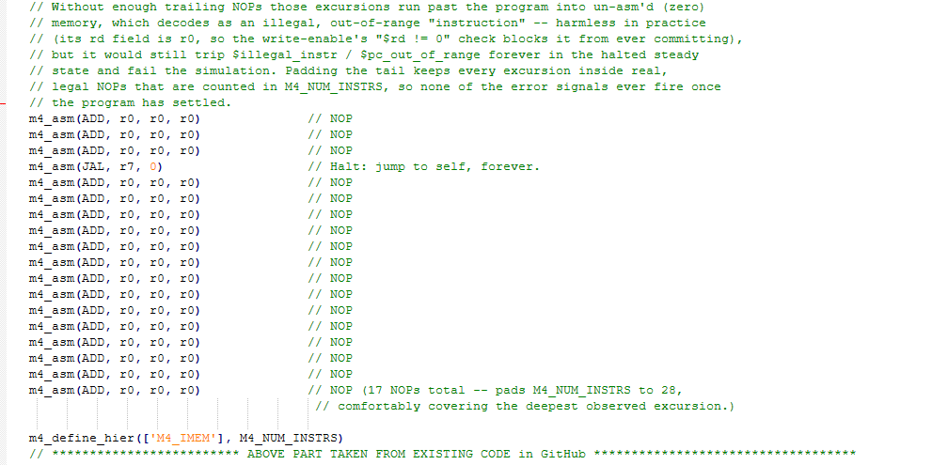
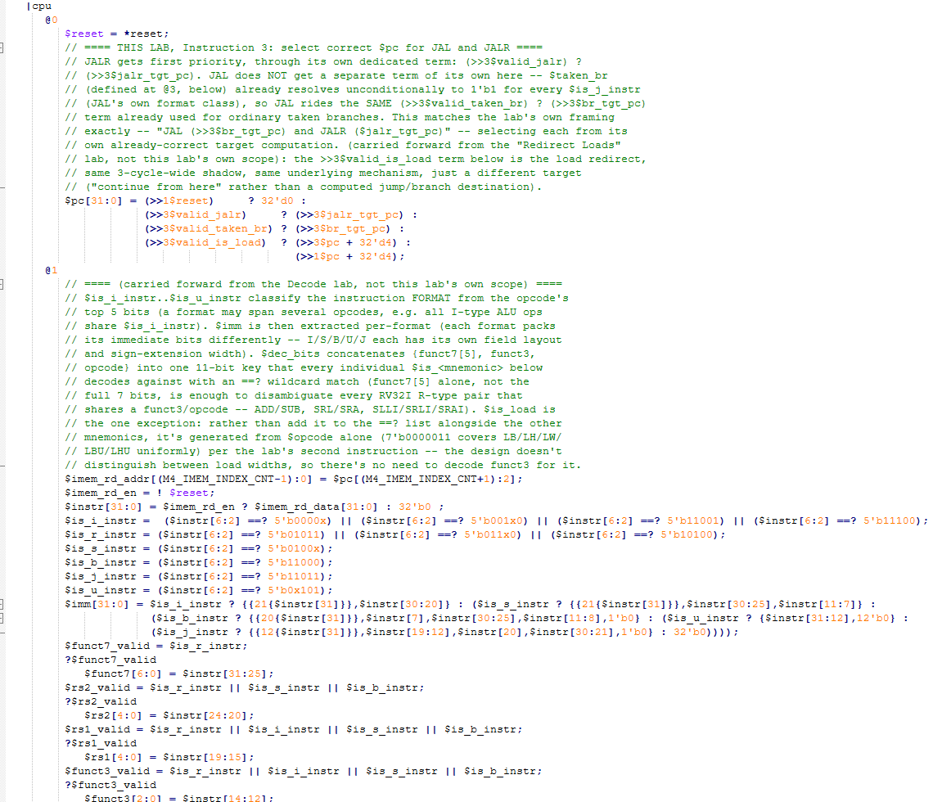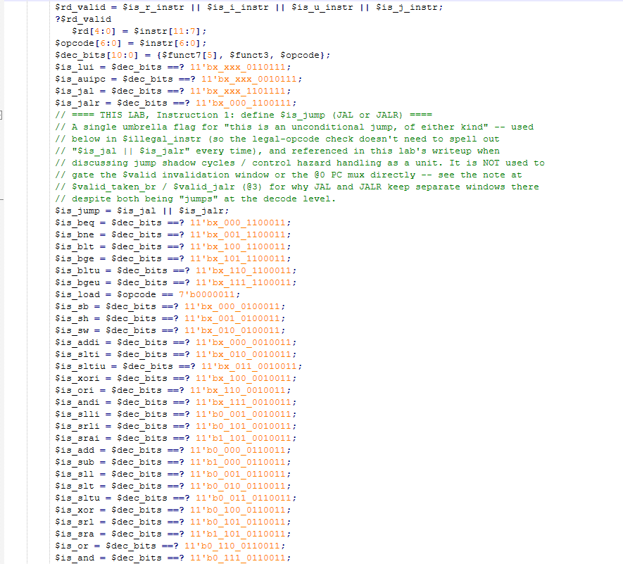
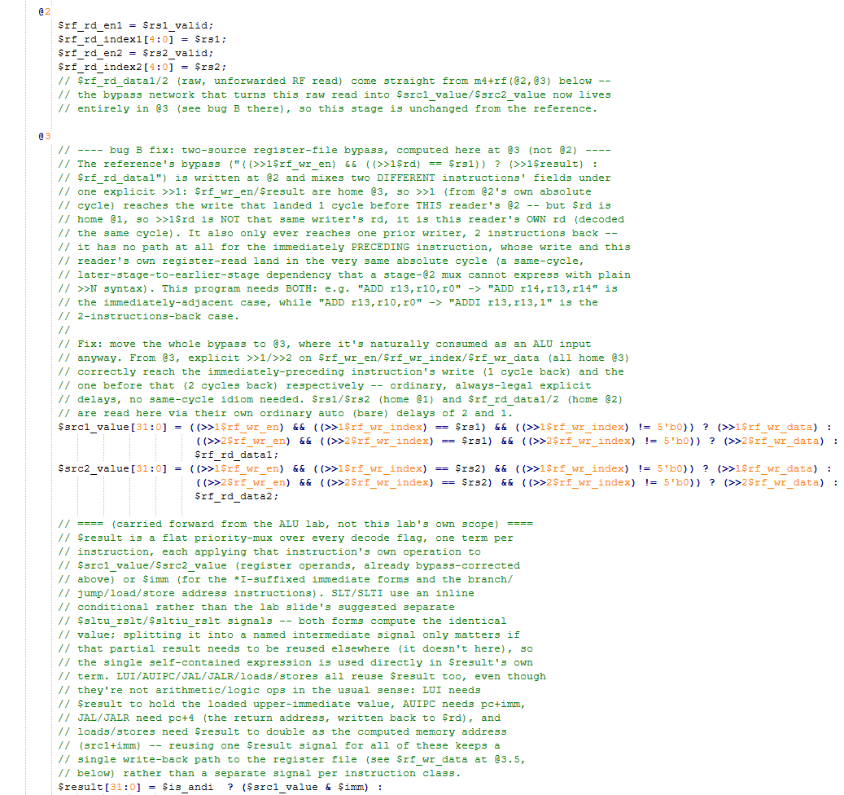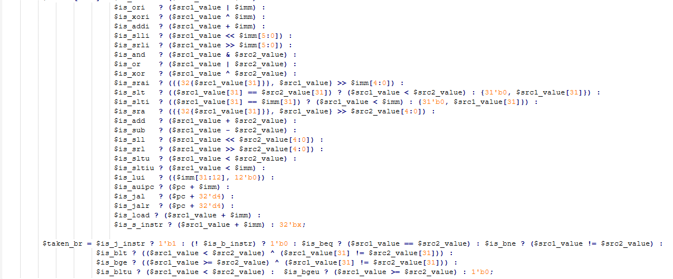
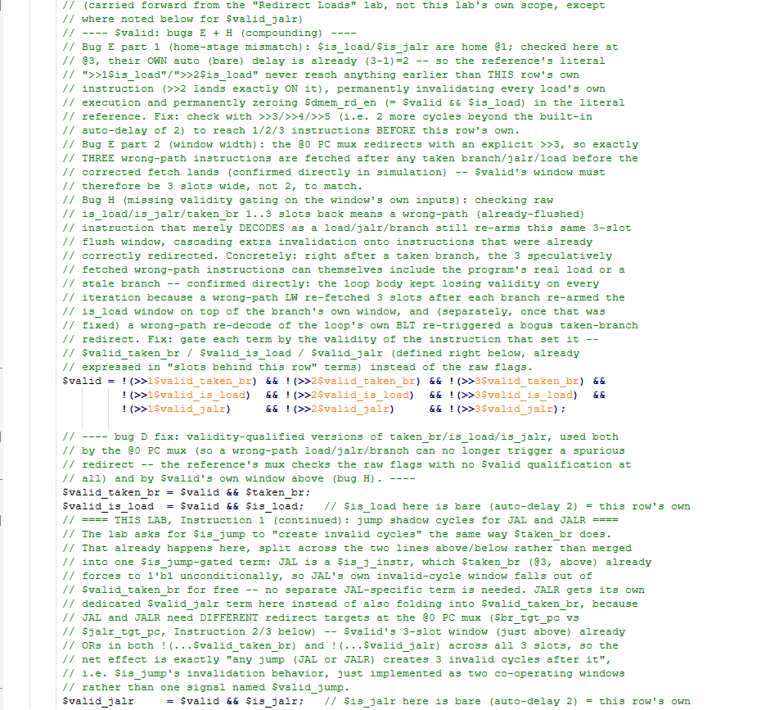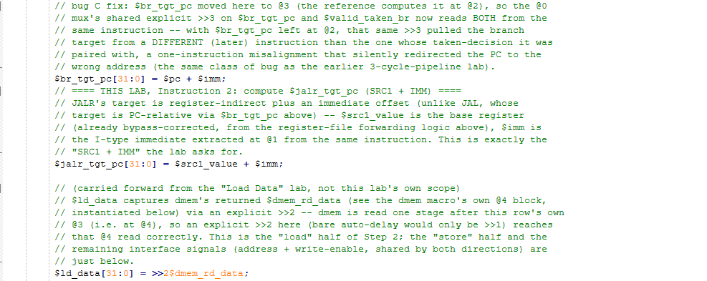
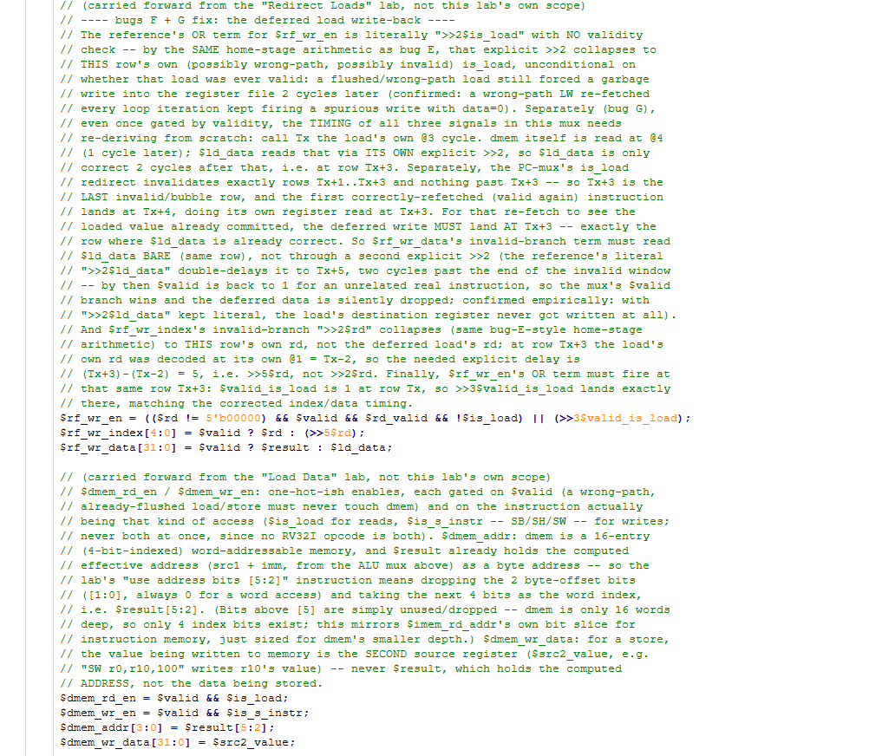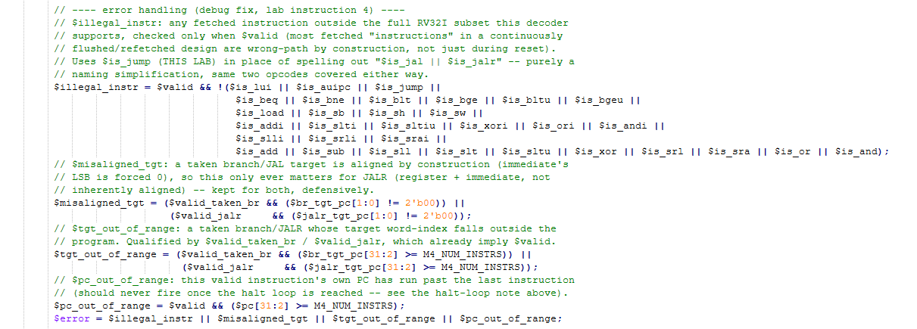
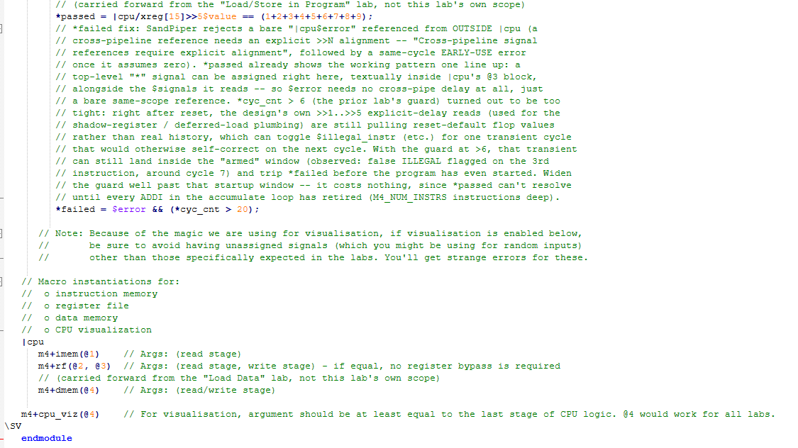

Makerchip execution – Diagram
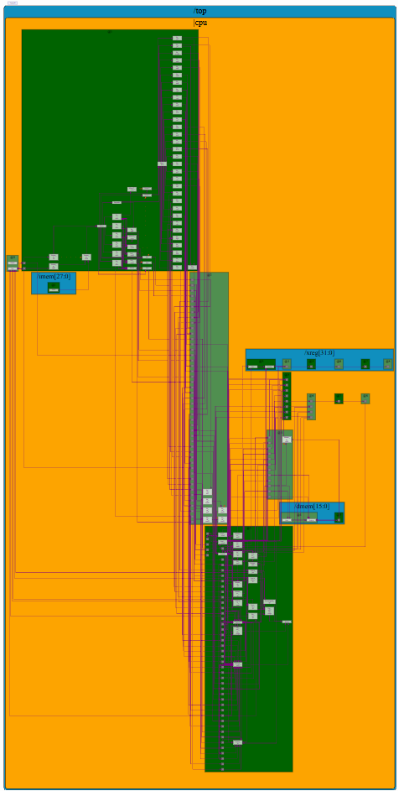

Makerchip execution – Waveform

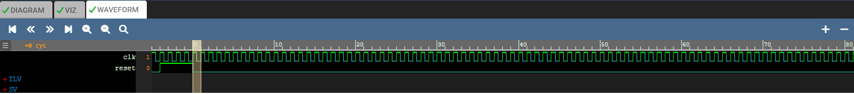

Implementation Elaboration

JAL implementation
JAL is decoded as a J-type instruction ($is_j_instr, opcode 1101111), with its own 20-bit signed, word-aligned immediate extracted at @1 ($imm's J-type branch). Two things happen at @3: $result = $pc + 32'd4 (the return address, written back to $rd -- this is what makes JAL usable as a call instruction, not just a jump), and $taken_br's very first term, $is_j_instr ? 1'b1 : ..., unconditionally asserts for every JAL. That second point is the key design choice: JAL is implemented as a special case of "always-taken branch" rather than as its own separate mechanism, so it automatically inherits every piece of machinery already built for branches -- the 3-cycle invalid-cycle window, the $br_tgt_pc target computation, the @0 PC mux term -- with no new code of its own beyond the decode flag and the return-address write-back.

JALR implementation
JALR is decoded as an I-type instruction with its own opcode/funct3 combination ($is_jalr), sharing $result = $pc + 32'd4 with JAL for the same return-address reason. Unlike JAL, JALR is NOT folded into $taken_br -- it gets an entirely separate, dedicated signal chain: $valid_jalr (its own invalid-cycle window contribution), $jalr_tgt_pc (its own target computation), and its own term in the @0 PC mux, given FIRST priority over the branch/JAL term. The reason for this separation, rather than also merging JALR into the branch machinery, is entirely about the target address -- see "Jump target computation" below.

Unconditional control flow
Both JAL and JALR redirect control flow on EVERY execution, with no condition to evaluate -- unlike BEQ/BNE/BLT/etc., which redirect only when their comparison is true. This shows up directly in $taken_br's structure: its first term, $is_j_instr ? 1'b1 : ..., short-circuits to an unconditional 1 for JAL before any of the conditional branch comparisons even get evaluated. JALR's unconditional nature doesn't need a similar "always 1" term at all, since it isn't routed through $taken_br in the first place -- $valid_jalr = $valid && $is_jalr is unconditional on anything except the instruction actually being a valid JALR.

Jump target computation
Instruction | Target formula and reasoning
JAL (→ $br_tgt_pc) | $pc + $imm -- PC-relative. The J-type immediate is a signed, word-aligned offset from the JAL instruction's own address, so the target is computable directly from decode-time information (PC and immediate), with no register read needed at all.
JALR (→ $jalr_tgt_pc) | $src1_value + $imm -- register-indirect. The base address comes from a GENERAL-PURPOSE REGISTER ($src1_value, already bypass-corrected by the register-file forwarding logic), not from the PC. This is what makes JALR usable for computed jumps and returns (e.g. "jalr x0, x1, 0" as a function return, using whatever address a prior JAL happened to save in x1) -- the destination isn't known until the register value is known, which can depend on prior computation in a way a JAL target never does.

This difference in HOW the target is computed -- decode-time constant offset vs. a register value that may itself need forwarding -- is the actual reason JAL and JALR are kept as two separate signal chains (see "JALR implementation" above) rather than merged into one: they can share the invalid-cycle bookkeeping (both need exactly a 3-cycle shadow), but they cannot share a single target-computation term, since one needs a register read and the other does not.

PC redirection
The @0 PC mux, in priority order:
$pc[31:0] = (>>1$reset) ? 32'd0 :
(>>3$valid_jalr) ? (>>3$jalr_tgt_pc) : // JALR -- highest priority
(>>3$valid_taken_br) ? (>>3$br_tgt_pc) : // JAL and ordinary taken branches
(>>3$valid_is_load) ? (>>3$pc + 32'd4) : // load redirect (carried forward)
(>>1$pc + 32'd4); // sequential (the default)

JALR is checked first because, in principle, more than one of these conditions could be simultaneously true for different in-flight instructions occupying the pipeline at once (though not for the SAME instruction -- an instruction is exactly one of these types), and a fixed priority order is needed to pick one term deterministically; JALR is placed first here simply following the reference design's own ordering, carried forward unchanged. All four active redirect terms (JALR/branch-or-JAL/load) share the same explicit >>3 alignment, landing exactly 3 cycles after the causing instruction's own @3 -- matching the shared 3-slot invalid-cycle window described next.

Jump shadow cycles
This is the lab's Instruction 1: "$is_jump ... like $taken_br, create invalid cycles." The decode-level signal $is_jump = $is_jal || $is_jalr is defined (THIS LAB) specifically for this purpose and for the $illegal_instr check, but the invalid-cycle WINDOW itself is not built by gating a new term on $is_jump directly -- it already exists, split across the two signals that were built for exactly this in the "Redirect Loads" lab:
$valid = !(>>1$valid_taken_br) && !(>>2$valid_taken_br) && !(>>3$valid_taken_br) &&
!(>>1$valid_is_load) && !(>>2$valid_is_load) && !(>>3$valid_is_load) &&
!(>>1$valid_jalr) && !(>>2$valid_jalr) && !(>>3$valid_jalr);

JAL's contribution comes through $valid_taken_br (since $taken_br is unconditionally 1 for JAL, as established above); JALR's comes through its own $valid_jalr. Between the two, every one of the 3 slots immediately following ANY jump (JAL or JALR) is cleared -- exactly the behavior "$is_jump creates invalid cycles" describes, just implemented as two co-operating windows sharing one 3-slot structure, rather than a single new window keyed directly off $is_jump. The two are kept separate rather than merged for the same reason given under "Jump target computation": JAL and JALR need different redirect targets downstream, so their validity signals stay distinct all the way through to the @0 mux, even though the WIDTH of the shadow they create (3 cycles) is identical.

Control hazard handling
Jumps are control hazards: by the time a jump's own outcome (here, always "redirect") is known, at its @3, the pipeline has already speculatively fetched the 3 instructions immediately following it. This design resolves that hazard with the same flush-and-refetch strategy used uniformly for branches and loads throughout this series, rather than a separate jump-specific mechanism: clear $valid for exactly the 3 wrong-path instructions already in flight (the shadow above), then redirect the PC 3 cycles later to the real target. Because JAL and JALR both produce a validity signal that feeds the SAME $valid window, and both produce a target that feeds the SAME (shared-structure) @0 mux, no new hazard-handling logic was needed for this lab beyond the $is_jump decode flag itself -- the hazard-handling machinery is inherently jump-agnostic by construction, having already been generalized to cover "any control-flow-changing event" (branch, JAL, JALR, or load) in the earlier labs.

JALR target address generation
Worth calling out on its own, since it is the one piece of jump-specific arithmetic in this design: $jalr_tgt_pc[31:0] = $src1_value + $imm;
- $src1_value is NOT the raw register-file read -- it is the bypass-corrected value from the @3 forwarding mux (same one every ALU operation uses), so a JALR immediately following an instruction that just wrote its base register (e.g. a prior JAL landing its return address in x1, followed immediately by "jalr x0,x1,0") still gets the correct, up-to-date value.
- $imm is JALR's I-type immediate (a signed 12-bit offset, sign-extended at @1 the same way every other I-type immediate is), added to the base register exactly like an ADDI or a load/store address computation -- JALR's addressing mode is structurally identical to a load's, just interpreted as a jump target instead of a memory address.
- Unlike JAL's target (word-aligned by construction, since the J-type immediate's own low bit is always 0), a register-plus-immediate sum can land on an odd address -- which is exactly why $misaligned_tgt (below) checks JALR's target and not JAL's.

Error handling
The same four validity-qualified error signals apply, with JAL and JALR both already covered -- JAL through the $valid_taken_br terms it shares with ordinary branches, JALR through its own $valid_jalr terms:
Condition | Meaning for jumps specifically
$illegal_instr | Uses $is_jump (THIS LAB) in place of spelling out $is_jal || $is_jalr -- covers any fetched instruction outside the supported RV32I subset.
$misaligned_tgt | Checks $jalr_tgt_pc for JALR only -- JAL's target is aligned by construction (immediate LSB forced 0), so this term can never fire for JAL; kept in the check's OR expression defensively regardless.
$tgt_out_of_range | A taken branch/JAL/JALR target outside the (padded) program -- $valid_taken_br also implies JAL here, so this one check already covers all three unconditionally-or-conditionally-taken redirect kinds.
$pc_out_of_range | A valid instruction's own PC has run past the last instruction -- relevant to the halt-loop JAL specifically (see Verification, below): without the halt loop's tail padding, this would eventually fire once PC wrapped.
$error / *failed | OR of the four above, unchanged start-up guard and in-|cpu placement from earlier labs.

