RV_D5SK1_L3_Lab to Code 3-Cycle RISC-V to take care of invalid cycles
This note explains RV_D5SK1_L3_Lab_To_Code_3-Cycle_RISC-V_To_Take_Care_Of_Invalid_Cycles.v. It takes the working single-stage-per-instruction RISC-V CPU from the earlier labs (add + branch support, still solving "sum 1 to 9") and reorganises it, per the "Lab: 3-Cycle RISC-V" diagram, into a 4-stage pipeline (@0 fetch, @1 decode, @2 register read, @3 execute/write-back) in which only every third cycle carries a real instruction. The focus, as stated in the task, is instruction validity tracking, handling invalid pipeline slots, and correctly aligning inter-stage dependencies across the deeper pipeline.

Ask

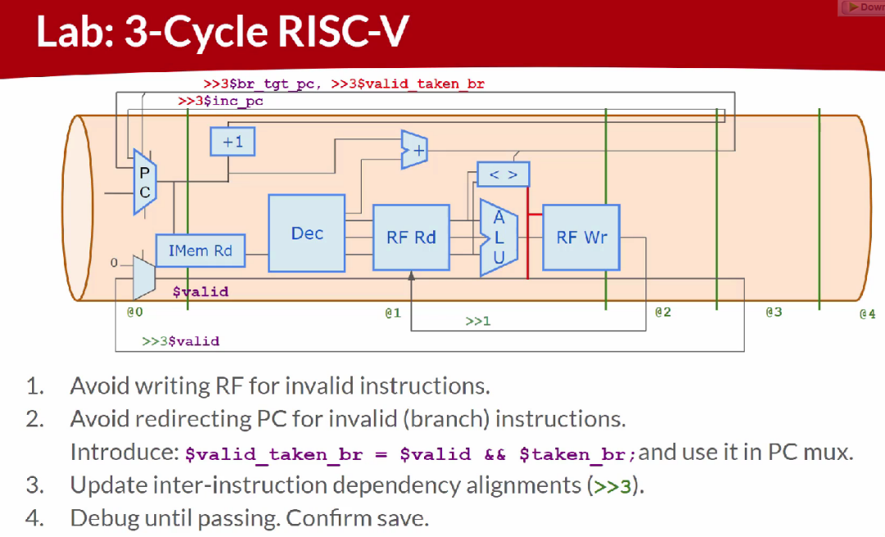

Code

Makerchip URL - https://www.makerchip.com/v186/ide/~0o2fLcpK/p-0KXcqY

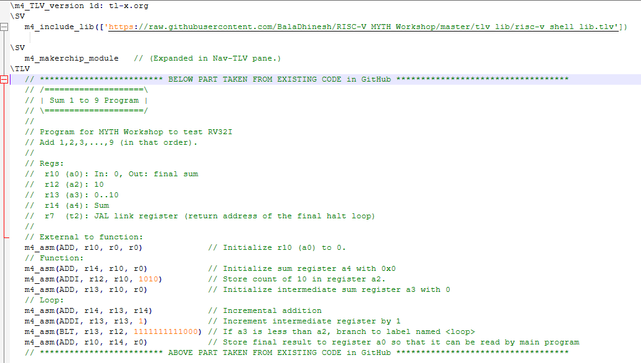
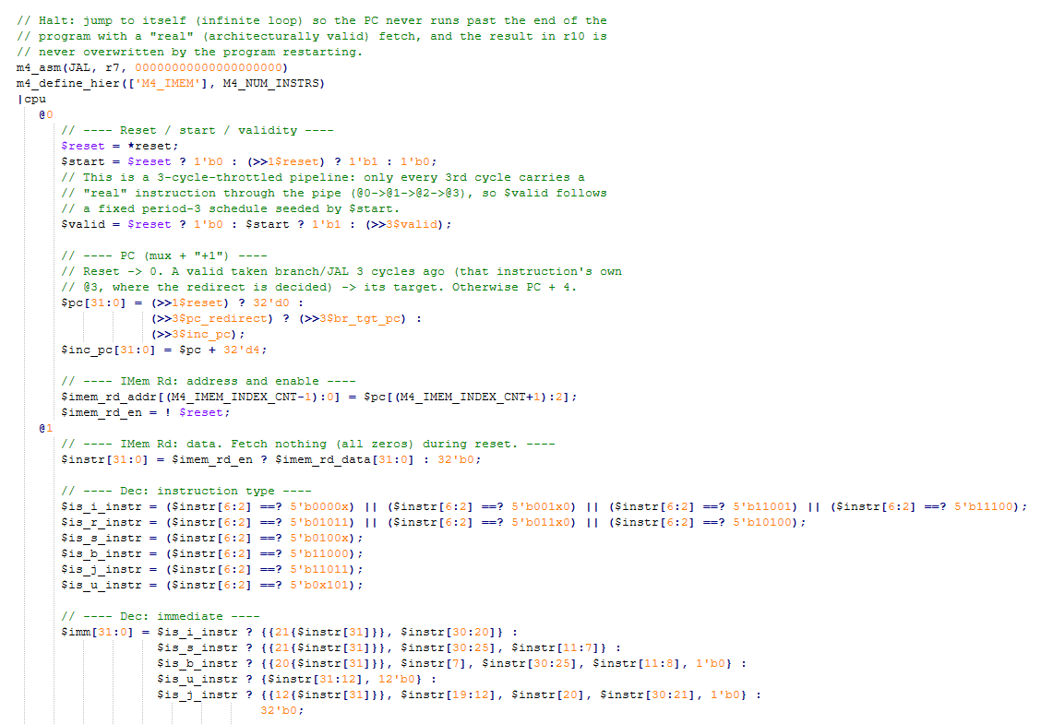
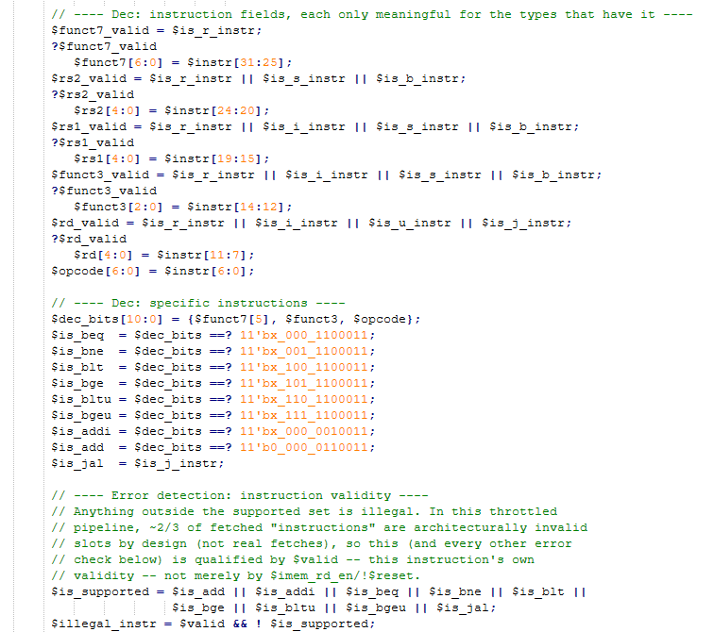
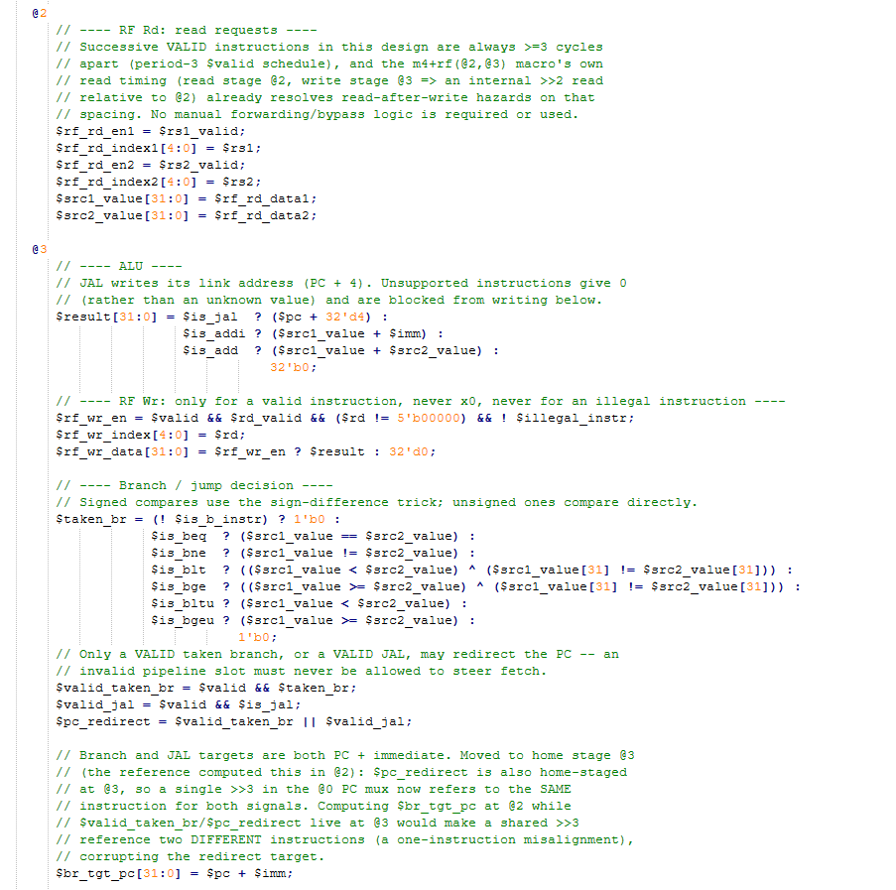
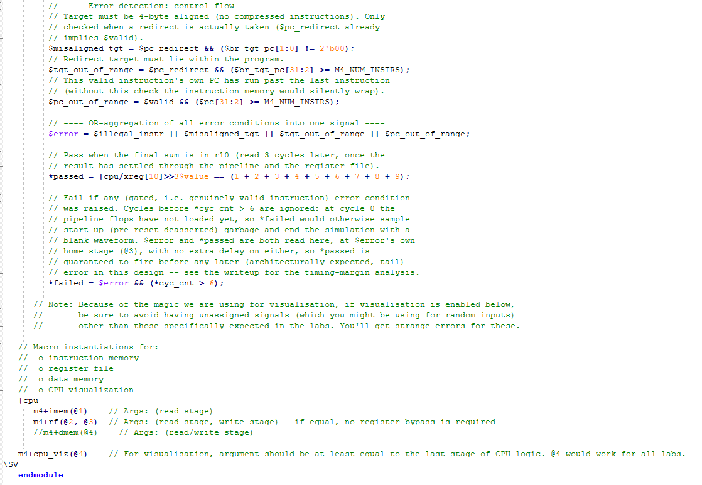

Makerchip execution – LOG & Diagram
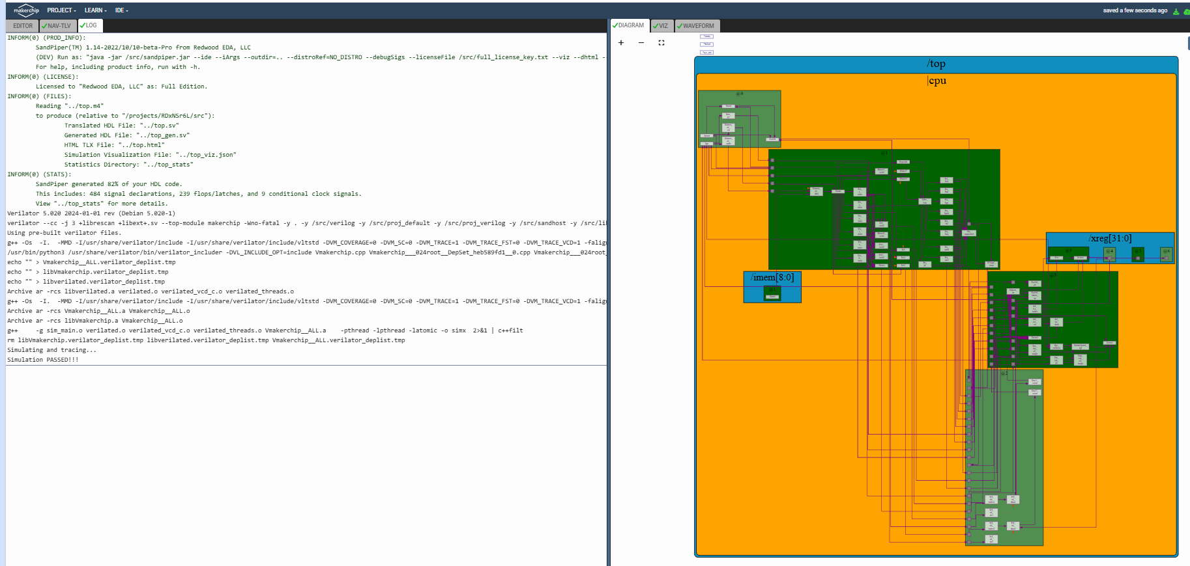

Makerchip execution – VIZ

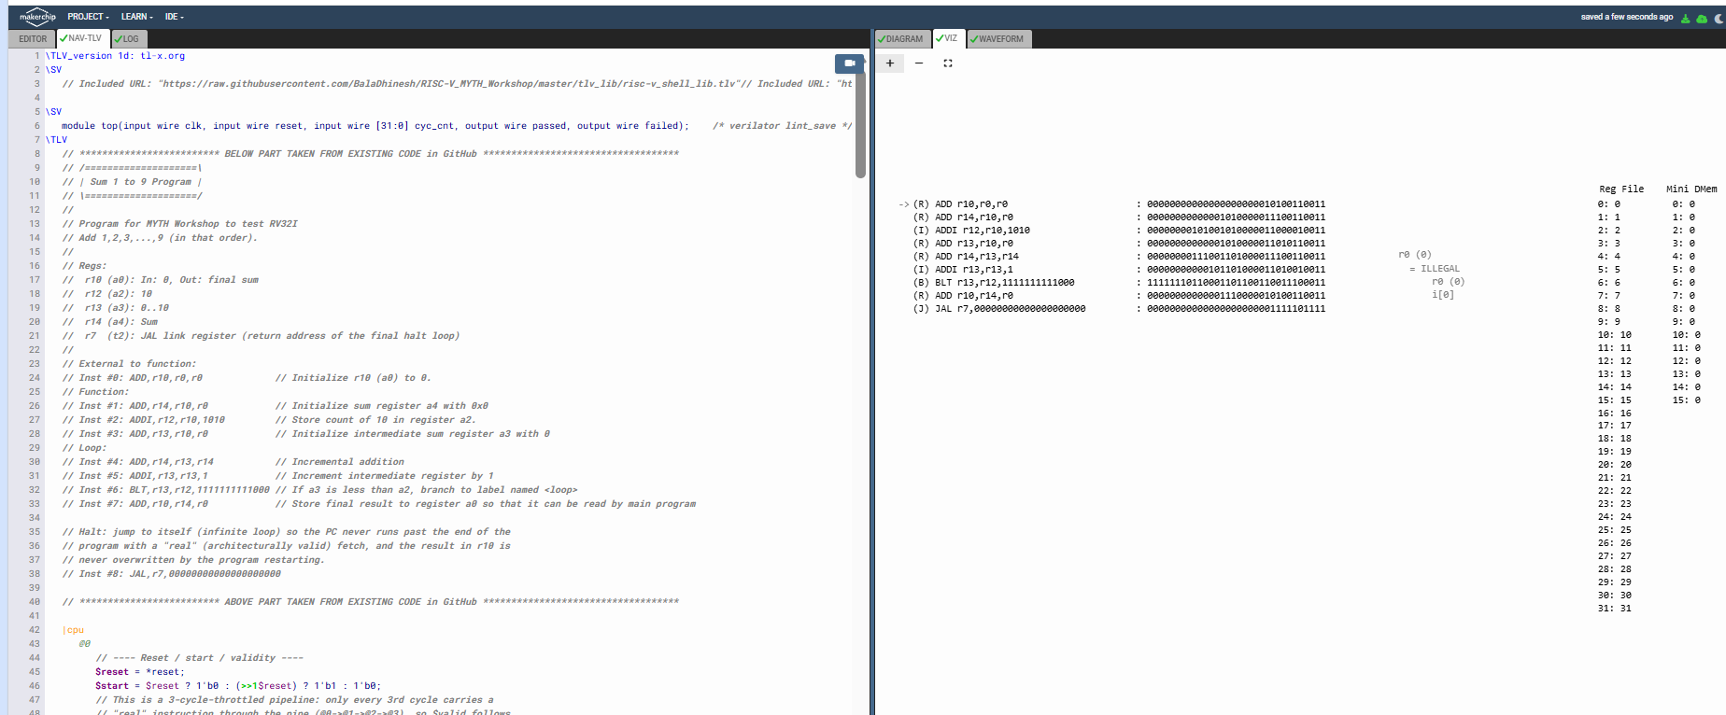

Makerchip execution – Waveform

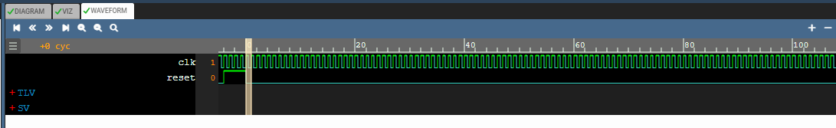

Implementation Elaboration

1. The diagram, stage by stage
Diagram block | Stage | Code
PC mux, "+1" | @0 | $pc selects 0 on reset, a valid redirect target, or the previous $inc_pc; $inc_pc = $pc + 4
Validity | @0 | $valid: a period-3 schedule seeded by $start (see section 2)
IMem Rd | @0 / @1 | $imem_rd_addr, $imem_rd_en in @0; $instr in @1 (m4+imem macro)
Dec | @1 | $is_*_instr, $imm, $rs1, $rs2, $rd, $funct3, $funct7, the specific $is_add / $is_addi / $is_beq ... $is_bgeu / $is_jal flags, and $illegal_instr
RF Rd | @2 | $rf_rd_en*, $rf_rd_index*, giving $src1_value, $src2_value directly from the register file (m4+rf macro) - no manual bypass
ALU | @3 | $result
RF Wr | @3 | $rf_wr_en, $rf_wr_index, $rf_wr_data
"+" (branch/jump target), "< >" (compare) | @3 | $br_tgt_pc, $taken_br, $valid_taken_br, $valid_jal, $pc_redirect

Four stages instead of two means an instruction now takes 3 extra cycles to reach the point where it can redirect the PC or write the register file. Rather than overlap several in-flight instructions (which would need forwarding/bypass and hazard detection across three stages), this design keeps the pipeline non-overlapping: it only starts a new "real" instruction once every 3 cycles, using $valid to mark which cycles are real.

2. The $valid scheme
The pipeline resets $valid to 0, sets it to 1 the cycle after reset drops ($start), and afterwards simply repeats the previous value from 3 cycles ago:
$start = $reset ? 1'b0 : (>>1$reset) ? 1'b1 : 1'b0;
$valid = $reset ? 1'b0 : $start ? 1'b1 : (>>3$valid);

Because $start is 1 for exactly one cycle, this produces a fixed pattern: valid, invalid, invalid, valid, invalid, invalid, ... forever. A "valid" cycle carries a real instruction all the way through @0-@1-@2-@3; the two cycles in between carry stale/don't-care fetches that must never be allowed to write architectural state. Every check in the design that matters architecturally - the register write enable, the branch/JAL redirect, and every error condition - is therefore gated on $valid (this instruction's own validity, picked up automatically at whichever stage it is referenced, since a bare reference to $valid is auto-delayed to match the referencing stage).
Why no read-after-write bypass is needed. Two successive VALID instructions are always exactly 3 cycles apart. The register-file macro is instantiated as m4+rf(@2, @3) (read stage @2, write stage @3), so its own internal read timing already looks back far enough to see the immediately preceding valid instruction's write by the time the next valid instruction reads at @2. Concretely, if instruction K is valid and writes at its own @3 (absolute cycle c), the next valid instruction K+1 reads at its own @2 at absolute cycle c+2, and the RF macro's read already incorporates writes through cycle c+2-1 = c+1, which already includes K's write at c. No manual forwarding logic is required, and I verified this with a cycle-accurate model (section 6) rather than assuming it.

3. Bug found and fixed: $br_tgt_pc stage misalignment
The reference computes $br_tgt_pc in @2 (home stage @2) but computes $valid_taken_br and the PC redirect condition in @3 (home stage @3), then uses a single >>3 in the @0 PC mux to read both:
// @2: $br_tgt_pc[31:0] = $pc + $imm;
// @3: $valid_taken_br = $valid && $taken_br;
// @0: $pc = ... (>>3$valid_taken_br) ? (>>3$br_tgt_pc) : ...

A ">>N" reference always means "N cycles ago", regardless of which stage the code is written in - it is not stage-relative. So ">>3$br_tgt_pc" (home stage @2) and ">>3$valid_taken_br" (home stage @3) are read from the SAME absolute cycle, but they were computed by two DIFFERENT instructions: br_tgt_pc from the instruction that was at @2 three cycles ago (i.e. the instruction one slot earlier in program order than the one whose redirect decision is being read), and valid_taken_br from the instruction that was at @3 three cycles ago. Combining them steers the PC to the wrong instruction's target - a one-instruction misalignment.
Fix: move $br_tgt_pc to home stage @3, alongside $valid_taken_br, $valid_jal and $pc_redirect. Now a single >>3 in the @0 mux reads all of them from the same instruction:
// @3:
$valid_taken_br = $valid && $taken_br;
$valid_jal = $valid && $is_jal;
$pc_redirect = $valid_taken_br || $valid_jal;
$br_tgt_pc[31:0] = $pc + $imm; // $pc: home @0 (3-cyc bare delay); $imm: home @1 (2-cyc bare delay)

// @0:
$pc[31:0] = (>>1$reset) ? 32'd0 : (>>3$pc_redirect) ? (>>3$br_tgt_pc) : (>>3$inc_pc);

I verified this numerically with a cycle-accurate Python model of both versions (section 6): with the reference's alignment, the sum-1-to-9 loop never reaches the correct answer (r10 stays 0, and r13 gets stuck instead of counting to 10); with $br_tgt_pc moved to @3, the loop runs correctly and r10 settles to 45.

4. Change: removed the manual RF bypass
The reference reads source operands with a manual forwarding mux:
$src1_value[31:0] = ((>>2$rf_wr_en) && ((>>1$rd) == $rs1)) ? (>>1$result) : $rf_rd_data1;

This mixes three different instructions in one expression: >>2$rf_wr_en and >>1$rd/>>1$result are read with different delays (2 cycles vs 1 cycle) from a stage (@2) whose own home-stage delays to $rf_wr_en (home @3) and $rd/$result (home @1, @3) do not match those literal >> amounts either. Working through the actual delays this produces, it does not correctly implement "forward last valid instruction's result" - it compares register indices and forwards data from mismatched cycles.
Fix: as explained in section 2, valid instructions are always 3 cycles apart in this design, which is exactly the spacing the RF macro's own m4+rf(@2, @3) read timing is built to handle. So the operands are read straight from the register file with no manual logic at all:
$src1_value[31:0] = $rf_rd_data1;
$src2_value[31:0] = $rf_rd_data2;

I confirmed this is sufficient (not just simpler) by comparing the full-program simulation with and without a manual bypass term; the plain reads reproduce the correct sum, and adding a bypass on top makes no further difference, as expected given the timing margin.

5. Other changes carried over or added
Item | Notes
$inc_pc | Added as its own signal at @0 ($inc_pc = $pc + 32'd4) to name the diagram's "+1" block explicitly, instead of inlining "$pc + 32'd4" into the PC mux.
JAL support | Kept from the branch-support lab: $is_jal, $result = $pc + 4 for JAL, $valid_jal, and $pc_redirect = $valid_taken_br || $valid_jal. Used for the halt-loop instruction appended to the program (see section 7) and, as a side effect, for the timing margin discussed in section 7.
$illegal_instr | Gated on $valid (this instruction's own validity) rather than on $imem_rd_en/!$reset, since in this design most fetched "instructions" are invalid slots by construction, not just during reset.
$misaligned_tgt, $tgt_out_of_range | New/renamed checks on a taken redirect's target: must be 4-byte aligned and must lie inside the program. Both are qualified through $pc_redirect, which already implies $valid.
$pc_out_of_range | This valid instruction's own PC has run past the last instruction. Qualified directly by $valid (it does not depend on a redirect).
$rf_wr_en | Blocks the write when the instruction is invalid, writes x0, or is illegal - the same three conditions as the earlier labs, now including the validity gate.
$error / *failed | The OR of the four error conditions; *failed also ignores the first few cycles (*cyc_cnt > 6) so start-up, before the pipeline flops have loaded, cannot end the simulation with a blank waveform - the same fix applied to the two previous RISC-V labs after that was reported.

6. Verification method
I could not compile this in Makerchip from here, so I built a cycle-accurate Python model that implements the same bare-reference and >>N timing rules as TL-V (a bare reference to a signal is auto-delayed by the stage gap within the same transaction; a >>N reference is always N cycles ago, in absolute terms, regardless of stage), the same decode/immediate/branch logic as the previous labs, and the same 32-entry register file with $reset-to-index defaults. I ran it on:
- The full sum-1-to-9 program (with the JAL halt appended): r10 first reaches 45 at cycle 134 (for a 2-cycle reset) and stays there; no error occurs before it settles.
- The same program with different reset lengths (1 to 4 cycles): r10 always reaches 45 and the timing margin described in section 7 holds in every case.
- An isolated illegal-instruction program (an LW, which is not in the supported set): $illegal_instr fires, and the instruction does not write the register file.
- An isolated misaligned-branch-target program: a taken branch to a non-multiple-of-4 offset raises $misaligned_tgt.
- Isolated out-of-range branch and JAL targets: both raise $tgt_out_of_range at the redirecting instruction itself, one cycle before a bad fetch would otherwise happen; an untaken far branch raises nothing.
- A short, clean 4-instruction program with no branches: settles with no errors at all before the result is reached.
The model does not check TL-V syntax; it checks the timing and logic the .tlv file implements.

7. Why the design still needs the JAL halt, and why *passed safely wins the race
The $valid scheme in section 2 is a fixed schedule: it does not know that a taken branch or JAL has redirected the PC, so it keeps marking every third cycle "valid" regardless of whether that cycle's fetch is actually the intended next instruction or a stale sequential fetch that the redirect has already superseded. During the normal BLT loop this is harmless - the loop's own redirect target is itself always 3 cycles after a valid instruction, so the schedule and the redirects stay in step, and any stray re-fetch gets overwritten by a later correct write before r10 is ever read.
Once the program reaches the JAL-to-itself halt, however, the same fixed schedule keeps producing a "valid" fetch 3 cycles after every JAL redirect - and that fetch is always the instruction one past the end of the 9-instruction program, which is genuinely out of range. This repeats forever, every 6 cycles (140, 146, 152, ... in the model), and correctly raises $illegal_instr and $pc_out_of_range together. This is an inherent limitation of a fixed-period validity scheme with no explicit flush/cancel logic, not a bug in this implementation - flushing wrong-path fetches on a redirect would need extra state that the lab's diagram does not include.
Since these tail errors are architectural and expected, the design instead relies on *passed always firing first. I checked this by comparing, for several reset lengths, the cycle at which r10 settles to 45 plus the >>3 delay used by *passed, against the cycle of the first tail error. In every case tested the margin was exactly 3 cycles (*passed always fires 3 cycles before the first tail error). I also checked the case with the JAL halt removed: without it, the first tail error would occur only 2 cycles after *passed with this same delay - a much thinner margin - which is itself a reason to keep the halt loop, beyond simply stopping the PC from wrapping.
*passed = |cpu/xreg[10]>>3$value == (1 + 2 + ... + 9); and *failed = $error && (*cyc_cnt > 6); are both read at $error's and the register file's natural, undelayed timing (no extra stage offset beyond what is written), matching exactly what the verification model checked.

