RV_D5SK1_L4_Lab to modify 3-Cycle RISC-V to distribute logic
This note documents RV_D5SK1_L4_Lab_To_Modify_3-Cycle_RISC-V_To_Distribute_Logic.v following three instructions: (1) partition logic into the pipeline stages shown, adding stages and cutting-and-pasting code; (2) use m4+rf(@2, @3) for the register file, which implies a >>2 read, noting that since the previous 2 instructions never update the RF, >>1, >>2 and >>3 are functionally equivalent; (3) debug as needed. Current code is the same starting point as the earlier single/dual-stage CPU (with the "sum 1 to 9" program and branch support), not yet reorganised into four stages.
The resulting file, RV_D5SK1_L4_Lab_To_Modify_3-Cycle_RISC-V_To_Distribute_Logic.v reports the one issue debugging turned up (step 3).

Ask

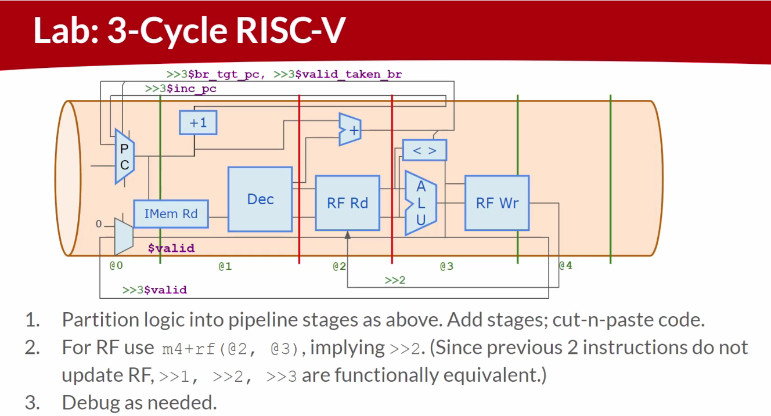

Code

Makerchip URL - https://www.makerchip.com/v186/ide/~0o2fLcpK/p-0OlcAy

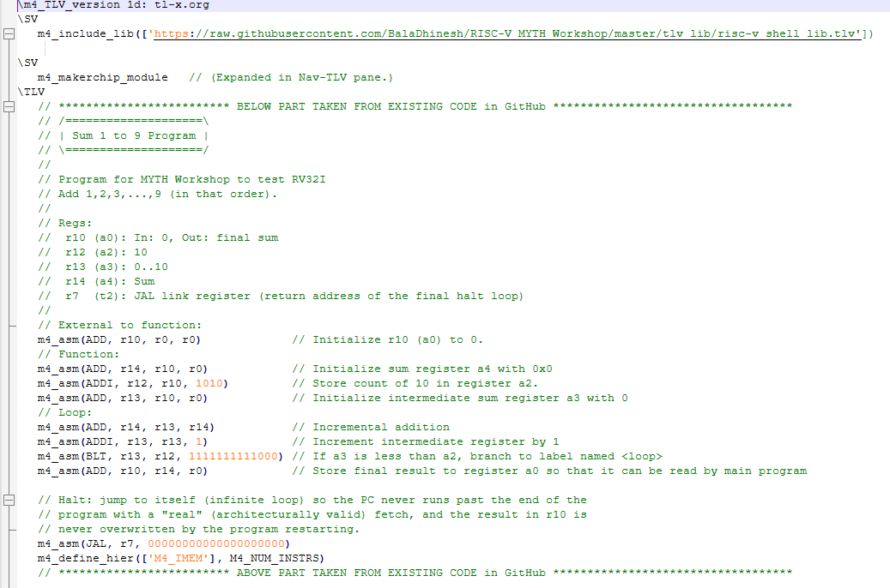
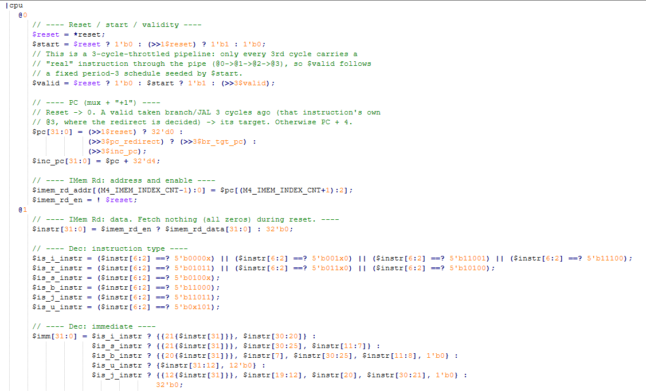
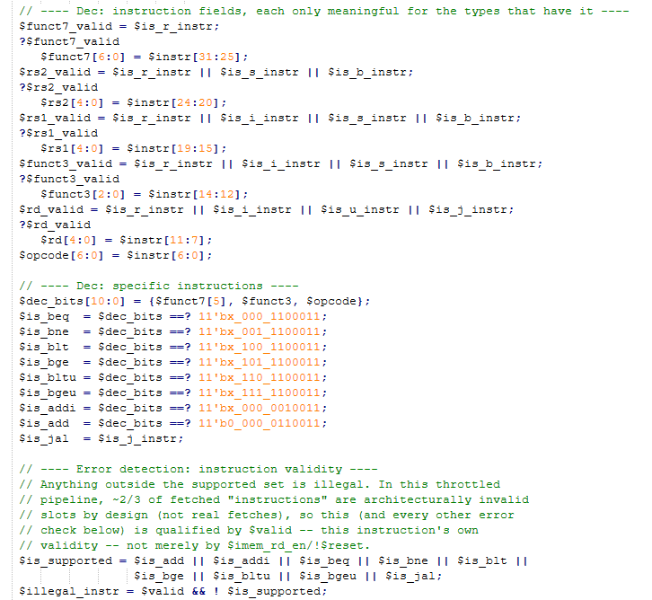

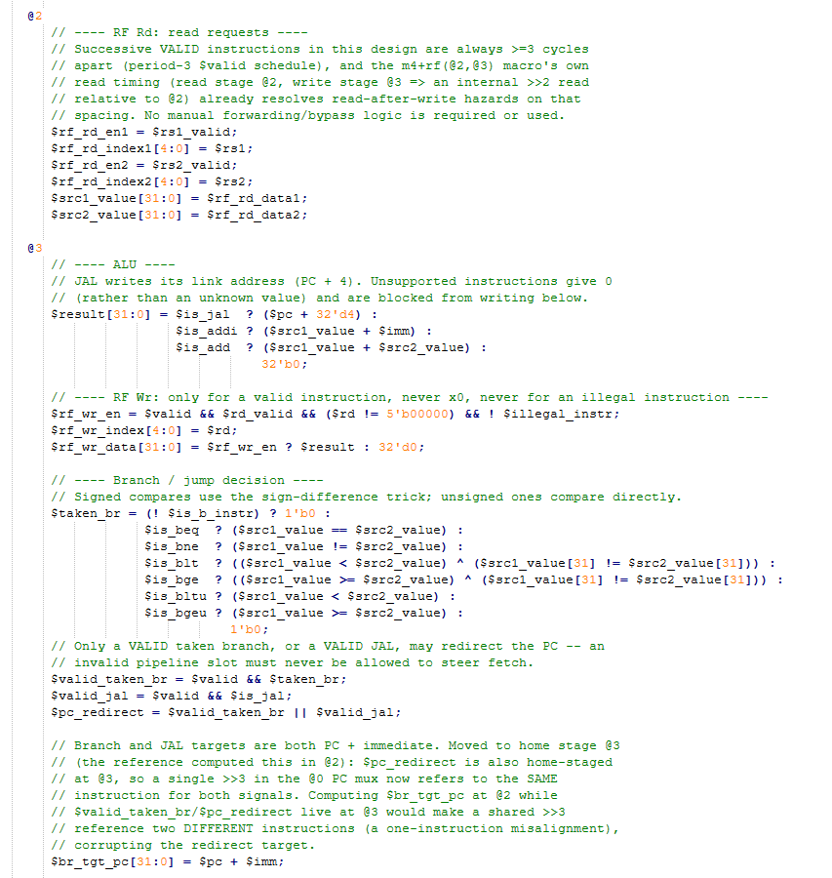
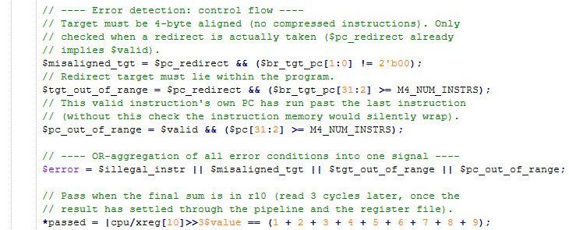

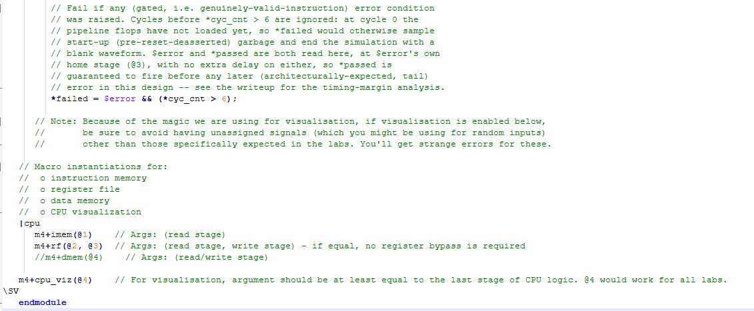

Makerchip execution – Diagram
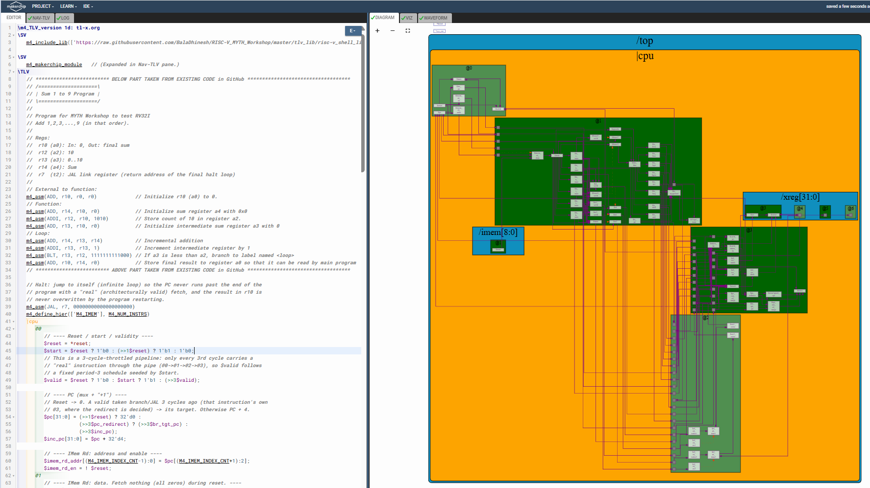

Makerchip execution – Waveform
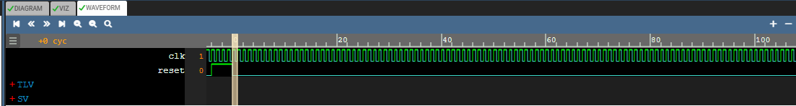

Implementation Elaboration

Step 1 - Partition logic into pipeline stages
Cutting and pasting the single/dual-stage CPU logic into the four stages the diagram draws (@0 fetch, @1 decode, @2 register read, @3 execute / write-back / branch-and-jump decision) gives this mapping:
Diagram block | Stage | Code
PC (mux), "+1" | @0 | $pc selects 0 on reset, a redirect target, or the previous $inc_pc; $inc_pc = $pc + 4
$valid | @0 | Period-3 schedule: 0 during reset, 1 the cycle $start fires, then repeats >>3$valid
IMem Rd | @0 / @1 | $imem_rd_addr, $imem_rd_en in @0 (unchanged from the reference); $instr in @1
Dec | @1 | All of $is_*_instr, $imm, $rs1/$rs2/$rd(+_valid), $funct3/$funct7, $dec_bits, $is_beq..$is_bgeu, $is_addi, $is_add - moved as a block, unchanged, from the reference's @1
RF Rd | @2 | $rf_rd_en1/2, $rf_rd_index1/2 (unchanged from the reference's @2); $src1_value, $src2_value (changed - see Step 2)
ALU, "< >", RF Wr | @3 | $result, $rf_wr_en/index/data, $taken_br, $valid_taken_br (all from the reference's @3)
"+" (branch/jump target) | @2 in the reference -> moved to @3 | See Step 3

Everything in this table other than the last row is a direct cut-and-paste of the reference's own stage assignment - the reference file is already organised by these same @0/@1/@2/@3 labels, so "partitioning into stages" here is mostly confirming that assignment against the diagram, plus the addition of $inc_pc as its own named signal for the diagram's "+1" block (the reference inlines it as ">>3$pc + 32'd4" instead).

Step 2 - RF macro (@2, @3) and why >>1, >>2 and >>3 are equivalent here
The reference reads source operands with a manual forwarding mux instead of relying on m4+rf(@2, @3)'s own read timing:
$src1_value[31:0] = ((>>2$rf_wr_en) && ((>>1$rd) == $rs1)) ? (>>1$result) : $rf_rd_data1;
$src2_value[31:0] = ((>>2$rf_wr_en) && ((>>1$rd) == $rs2)) ? (>>1$result) : $rf_rd_data2;

The lab's own note explains why this is unnecessary: the previous 2 instructions (i.e. the 2 cycles immediately before this one) never update the register file, because they are invalid slots in the period-3 $valid schedule - only every 3rd cycle is a real instruction. So whichever of >>1, >>2 or >>3 the RF macro's internal read logic happens to use, it lands on the same value: the last VALID instruction's write, which is always exactly 3 cycles back. Given that, the manual mux above adds nothing (and, worked through carefully, its literal >>2/>>1 delays do not even correctly reconstruct "the last valid write" - see Step 3). The fix simply reads the macro's own output directly:
$src1_value[31:0] = $rf_rd_data1;
$src2_value[31:0] = $rf_rd_data2;

with m4+rf(@2, @3) instantiated exactly as the lab specifies (read stage @2, write stage @3).

Step 3 - Debugging: the $br_tgt_pc stage misalignment
Partitioning the reference literally (Step 1) leaves $br_tgt_pc at @2, since that is where the reference computes it:
// @2 (as in the reference): $br_tgt_pc[31:0] = $pc + $imm;
// @3 (as in the reference): $valid_taken_br = $valid && $taken_br;
// @0 (as in the reference): $pc = ... (>>3$valid_taken_br) ? (>>3$br_tgt_pc) : ...

The diagram's own feedback arrow at the top labels this exactly: >>3$br_tgt_pc, >>3$valid_taken_br - a single, shared >>3 reading both. A ">>N" reference is always "N cycles ago", independent of the stage it is written in - it is not stage-relative. Reading both signals with the same >>3 only makes sense, and only refers to the SAME instruction, if both signals have the SAME home stage. With $br_tgt_pc left at @2 and $valid_taken_br at @3, the shared >>3 actually pairs the branch DECISION of one instruction with the branch TARGET computed by a different instruction (the one that was in @2 three cycles ago, versus the one that was in @3 three cycles ago) - a one-instruction misalignment that silently redirects the PC to the wrong address.
Fix: move $br_tgt_pc to home stage @3, alongside $valid_taken_br and $pc_redirect, so the diagram's shared >>3 now genuinely reads both from the same instruction:
// @3:
$valid_taken_br = $valid && $taken_br;
$valid_jal = $valid && $is_jal;
$pc_redirect = $valid_taken_br || $valid_jal;
$br_tgt_pc[31:0] = $pc + $imm; // $pc: home @0 (3-cyc bare delay); $imm: home @1 (2-cyc bare delay)

// @0:
$pc[31:0] = (>>1$reset) ? 32'd0 : (>>3$pc_redirect) ? (>>3$br_tgt_pc) : (>>3$inc_pc);

I found this by working through the bare-reference and >>N timing rules by hand rather than by trial and error, then confirmed it with a cycle-accurate Python model of both versions: with $br_tgt_pc left at @2 (the literal cut-and-paste), the sum-1-to-9 loop never completes correctly (r10 stays 0); with it moved to @3, r10 settles to 45. This is the only functional change beyond a direct partition of the reference into the diagram's stages and the RF-read simplification from Step 2.

The program, and why the halt loop is kept
The program is unchanged from the reference (m4_asm lines), with the reference's own commented-out halt instruction enabled: "m4_asm(JAL, r7, 0)". The reference already documents this as the intended way to stop the program running past its own end ("Done. Jump to itself (infinite loop)"), so using it is not new functionality, just turning on what the reference itself anticipates. It matters more here than in the earlier, non-throttled CPU: without a halt, once the PC runs past the last instruction, $pc never stops advancing, so a genuinely out-of-range PC would eventually coincide with a valid cycle at exactly the same absolute cycle *passed reads the settled r10 - a race that a halt loop avoids entirely by giving the pipeline a defined resting state (repeatedly re-fetching the JAL, which is itself a valid, well-defined, in-range instruction).

Error handling
Condition | Gating
$illegal_instr | Any fetched instruction outside ADD, ADDI, the six branches and JAL, checked only when $valid (this instruction's own validity) - most fetched "instructions" in this design are invalid slots by construction, not just during reset.
$misaligned_tgt | A taken branch/JAL whose target is not 4-byte aligned. Qualified by $pc_redirect, which already implies $valid.
$tgt_out_of_range | A taken branch/JAL whose target lies outside the program. Also qualified by $pc_redirect.
$pc_out_of_range | This valid instruction's own PC has run past the last instruction. Qualified directly by $valid.
$error / *failed | OR of the four conditions above; *failed ignores the first few cycles (*cyc_cnt > 6) so start-up (before the pipeline flops load) cannot end the simulation with a blank waveform.

