RV_D5SK2_L2_Lab For Branches To Correct The Branch Target Path
This note upgrades the earlier, artificially-spaced 3-cycle pipeline into a near-continuous, 1-instruction-per-cycle pipeline with dynamic RAW-hazard forwarding and branch-flush recovery. The diagram's (see ASK below) four numbered instructions are: (1) replace the @1 $valid assignment with an @3 assignment, based on the non-existence of a valid taken branch in the previous instructions; (2) increment PC every cycle, not every 3; (3) PC redirect for branches is already 3-cycle, no change; (4) debug, and save outside Makerchip.

Ask
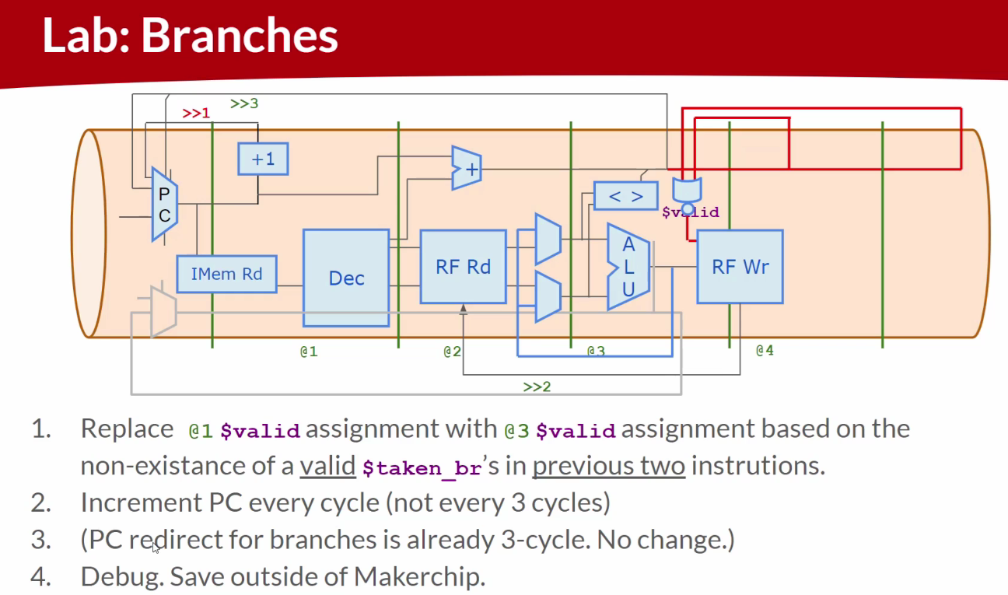

Code

Makerchip URL - https://www.makerchip.com/v186/ide/~0o2fLcpK/p-0WOcjn
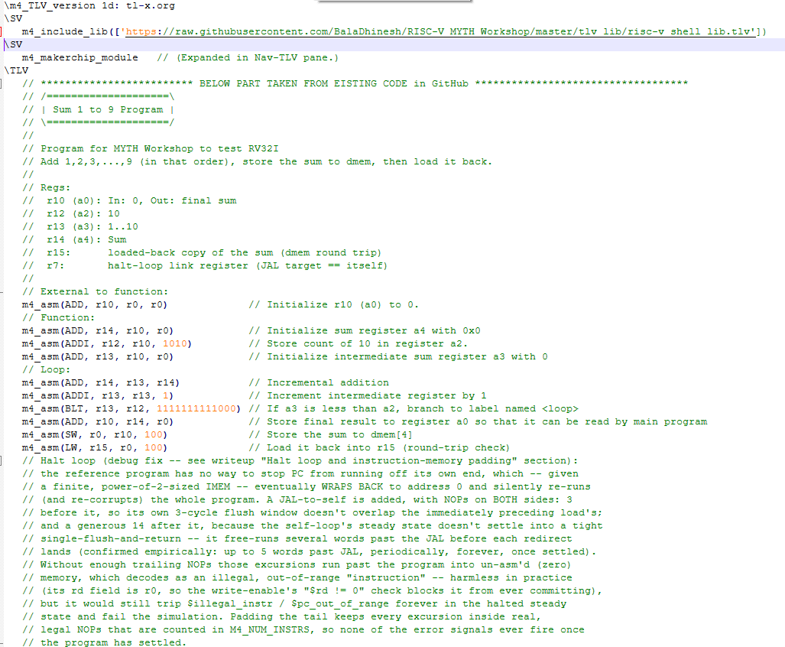
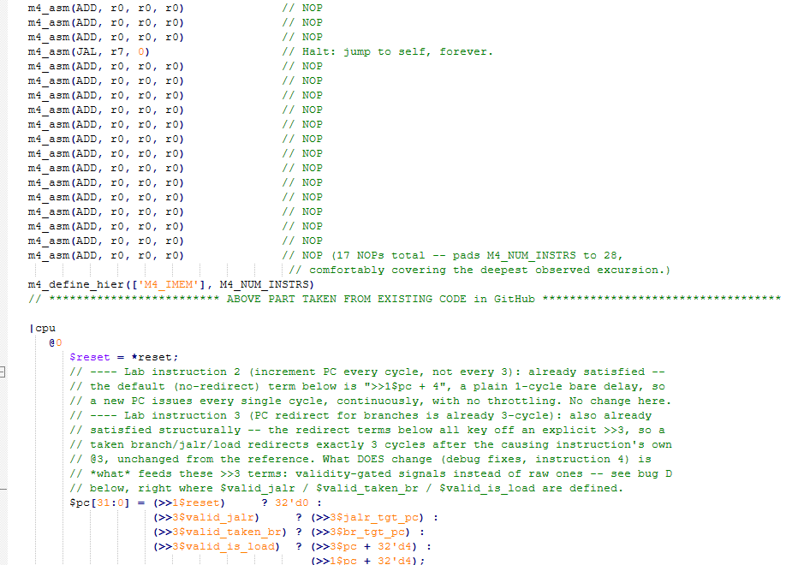
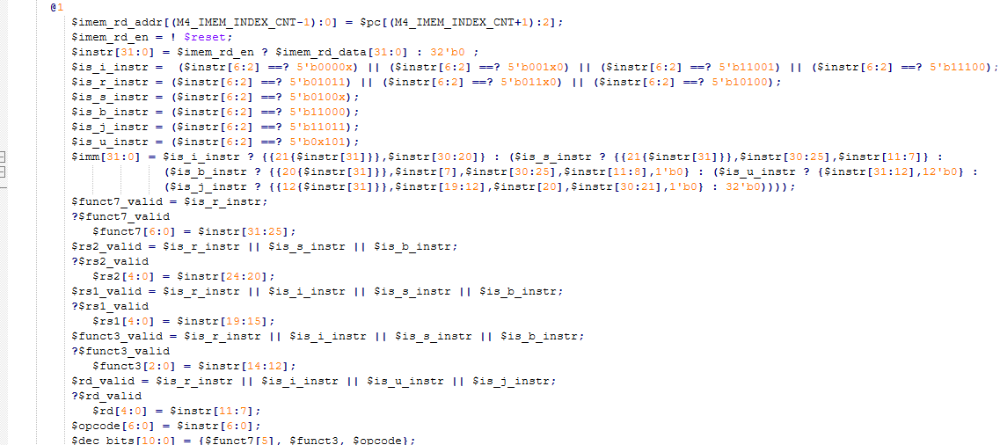
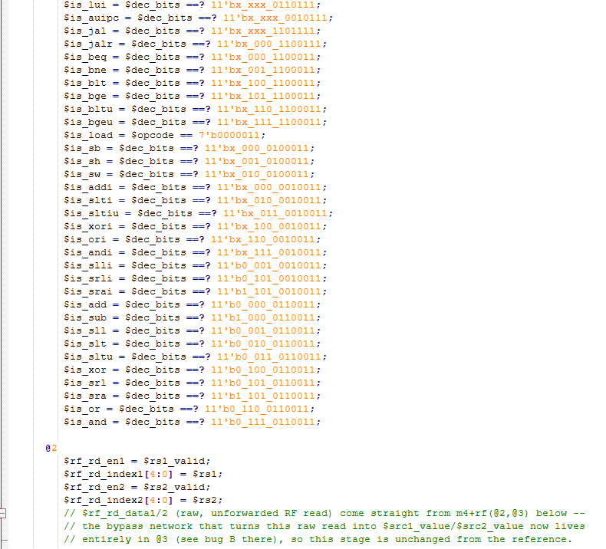

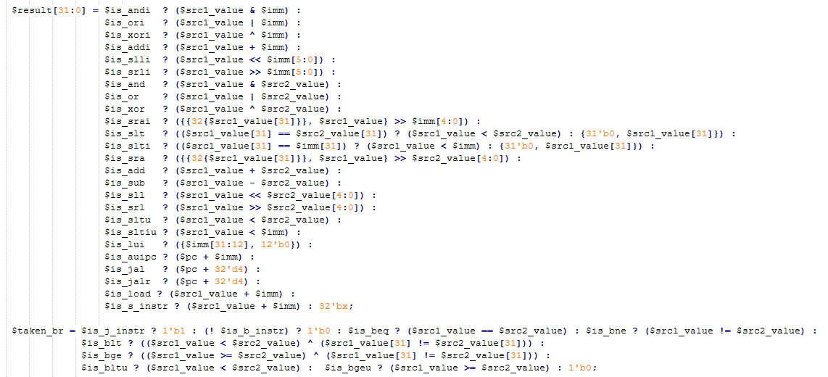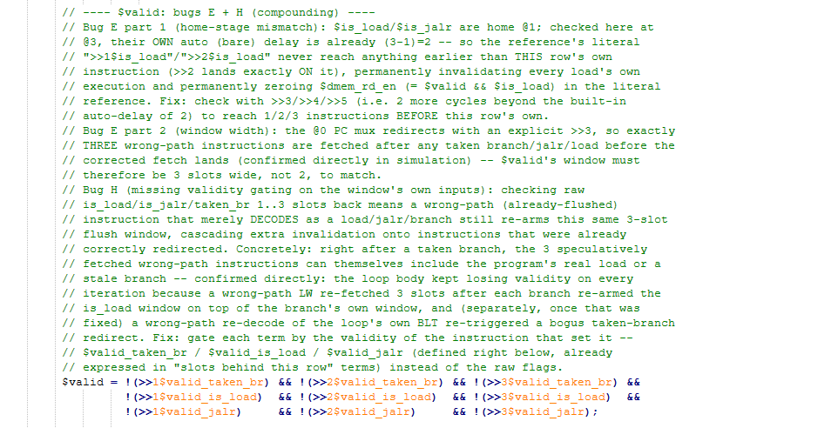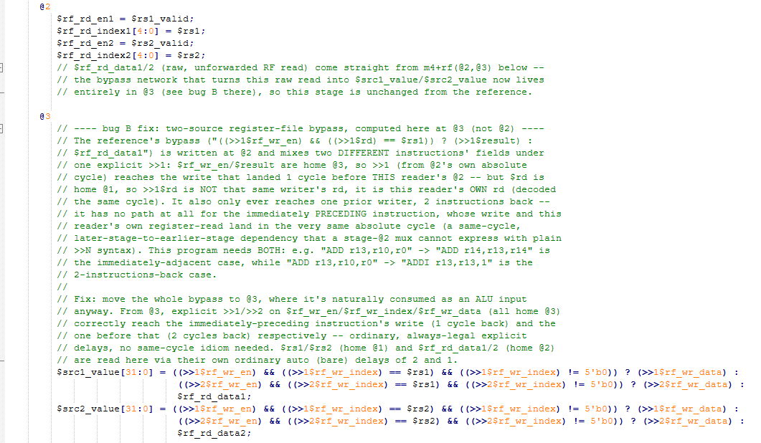
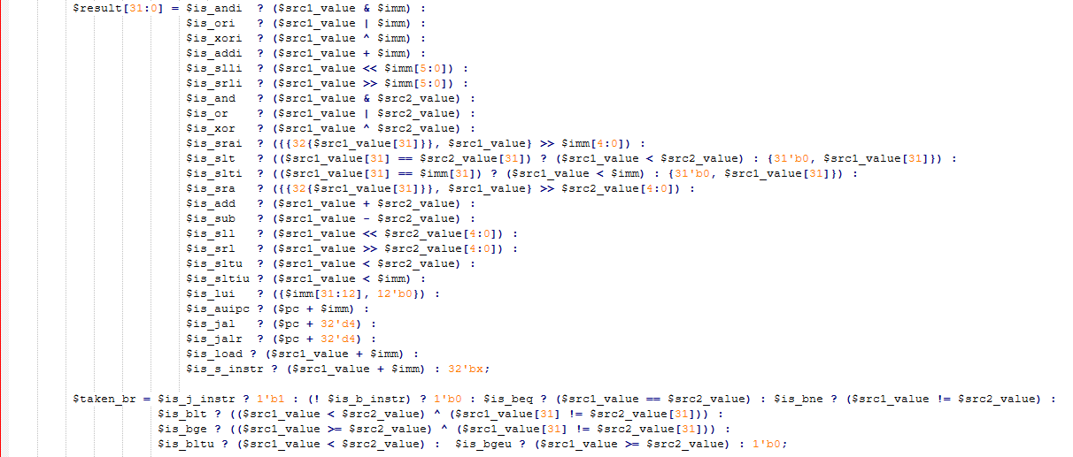
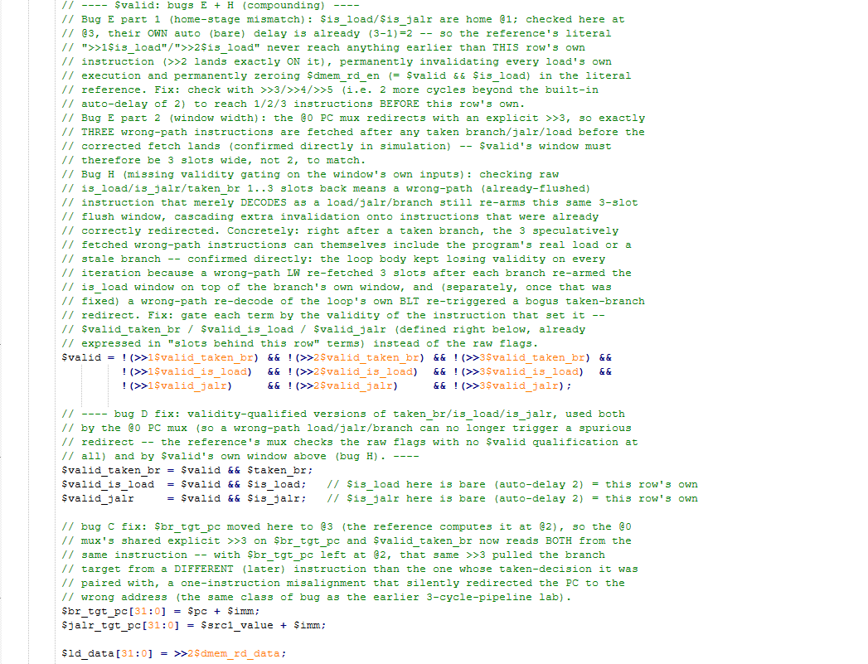

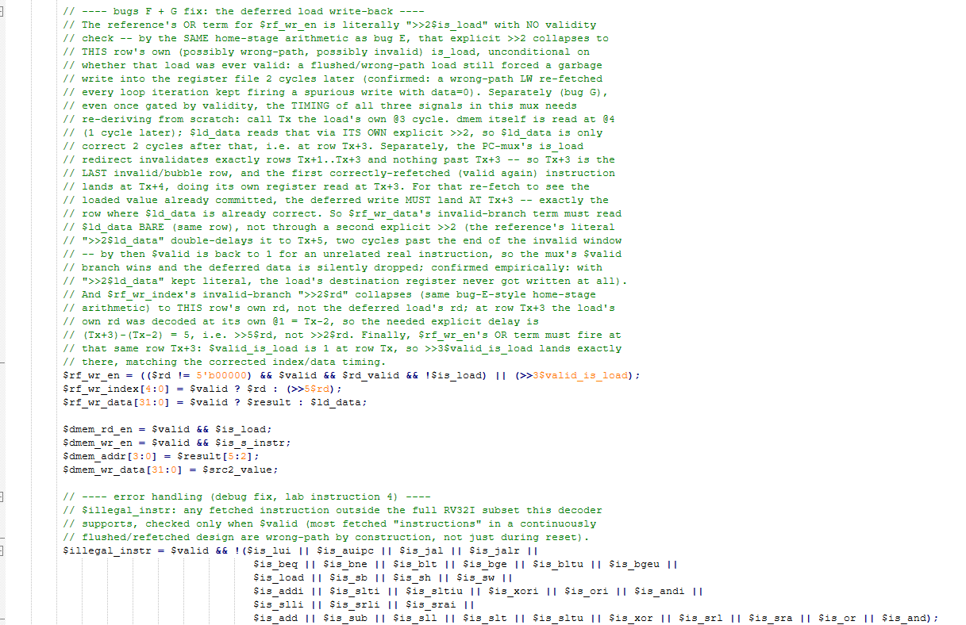
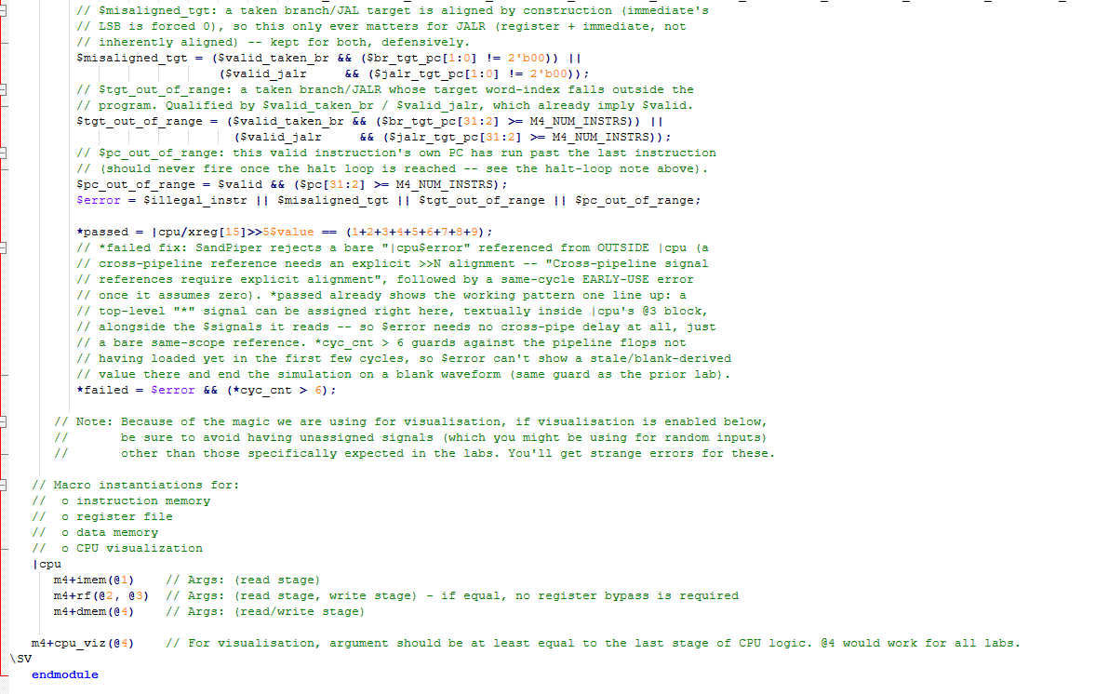

Makerchip execution – Diagram

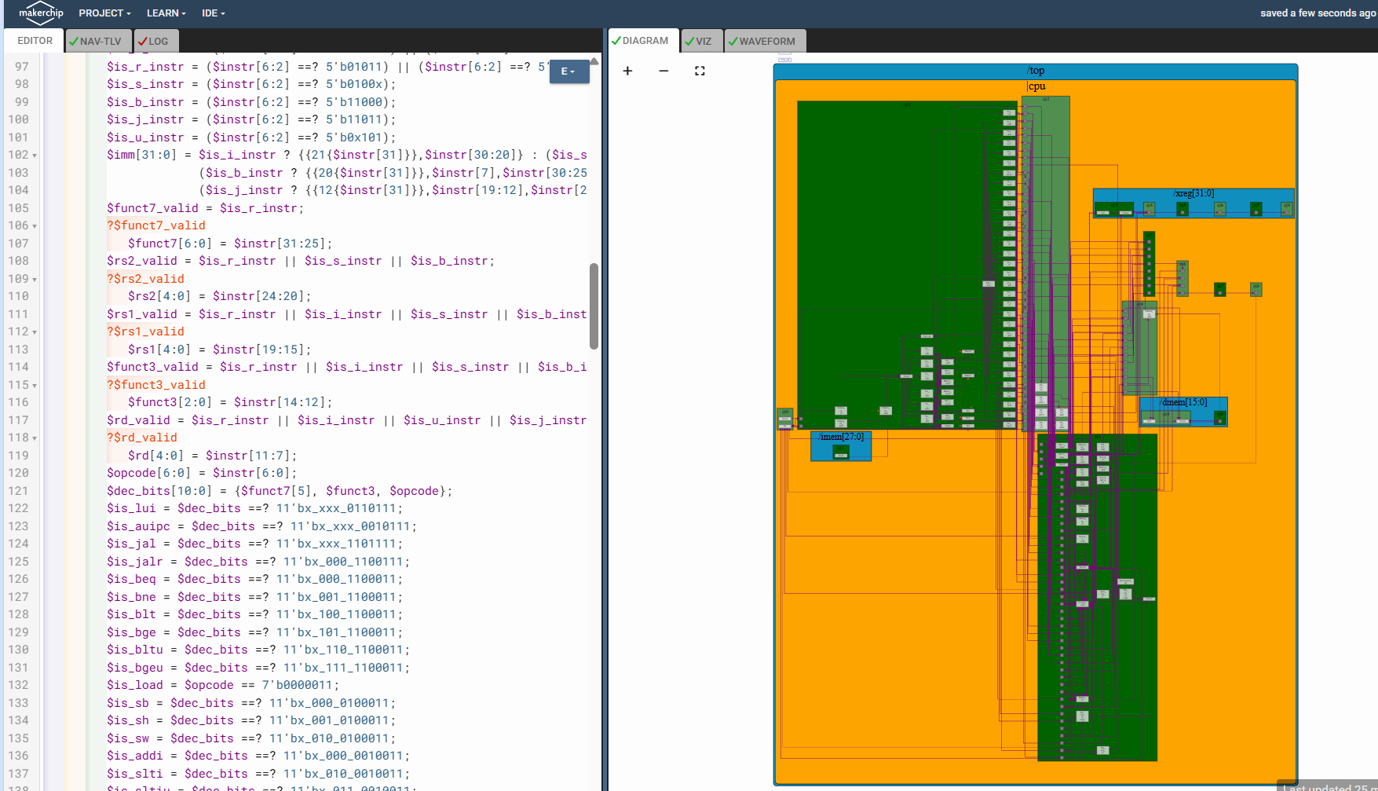

Makerchip execution – VIZ

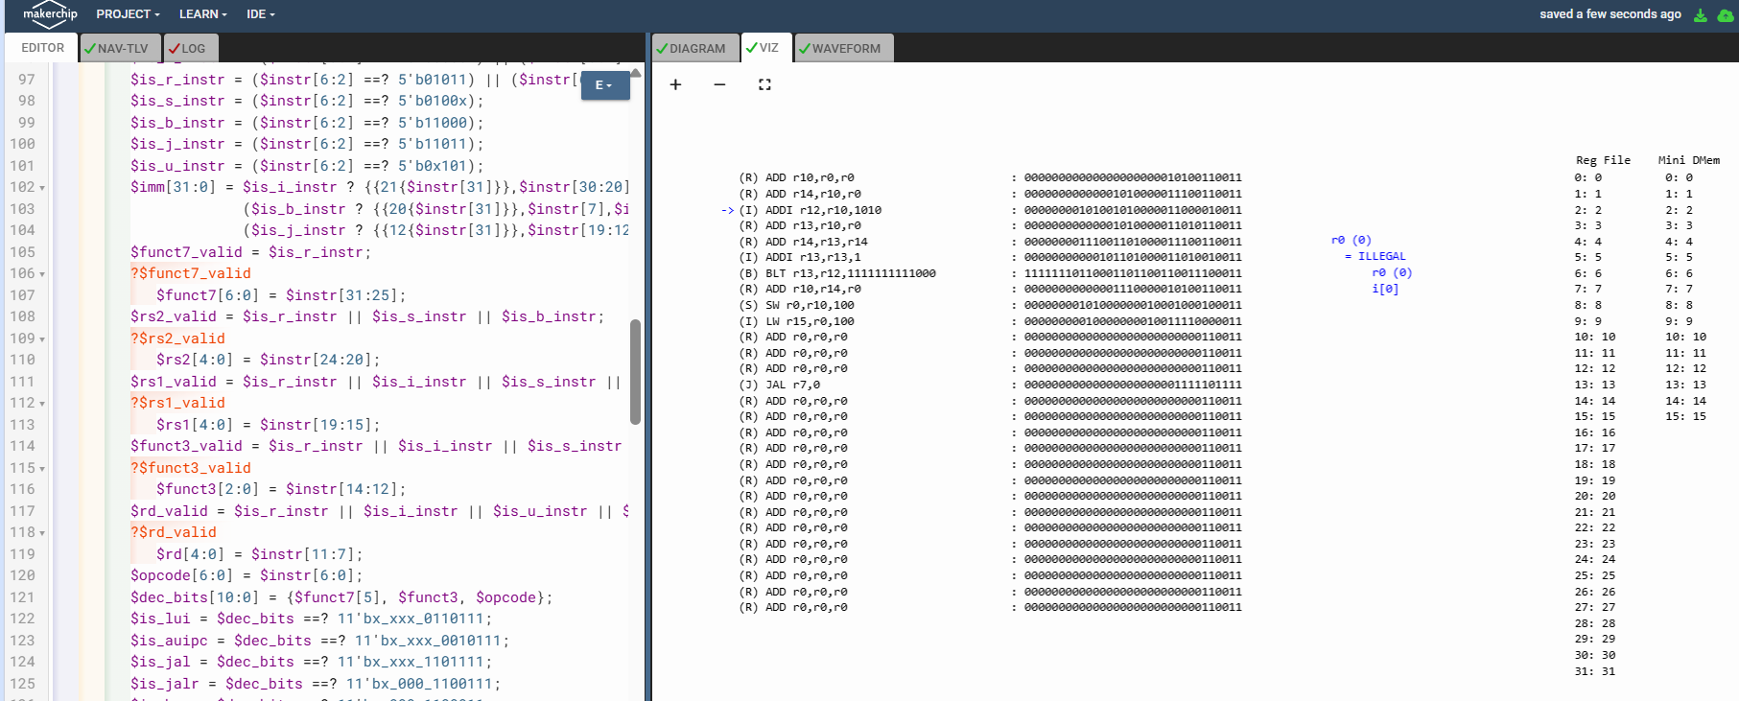

Makerchip execution – Waveform

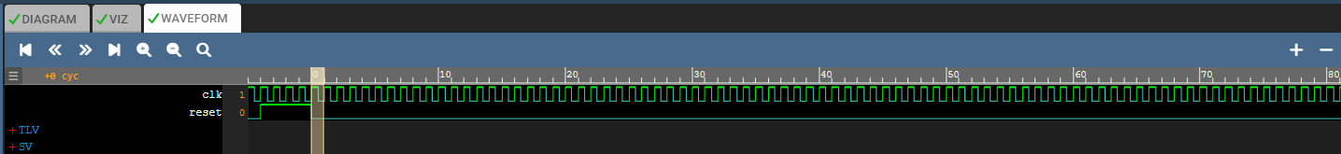

Implementation Elaboration

Pipeline overview
Four stages, matching the diagram: @0 fetches (PC mux + increment), @1 decodes, @2 reads the register file, @3 executes the ALU, decides branches, and writes back. Unlike the earlier 3-cycle lab, a NEW instruction enters @0 every single cycle -- with four stages in flight simultaneously, up to four different instructions are being worked on in any one cycle. This is what makes hazard handling dynamic rather than trivial: two back-to-back instructions can be as little as 1 cycle apart, so a register write and the very next instruction's register read can need to interact within the same or an adjacent cycle, and a taken branch's target only lands 3 cycles after the branch is decided, during which the pipeline has already spculatively fetched 3 further, possibly-wrong instructions that must be discarded.

Bug B -- register-file bypass: two sources, and a same-cycle case the reference misses
The reference's forwarding mux, written at @2, is:
$src1_value[31:0] = ((>>1$rf_wr_en) && ((>>1$rd) == $rs1)) ? (>>1$result) : $rf_rd_data1;

This mixes two different instructions' fields under one explicit >>1: $rf_wr_en/$result are home @3, so >>1 (read from @2's own absolute cycle) correctly reaches the write that landed 1 cycle before this reader's own @2 -- but $rd is home @1, so >>1$rd is NOT that writer's rd; it is this very reader's OWN rd, decoded the same cycle. Worse, this only ever reaches one prior writer, two instructions back -- there is no path at all for the instruction that IMMEDIATELY precedes this one, whose write and this reader's own register read land in the exact same absolute cycle (a same-stage-crossing, same-cycle dependency that a mux written at @2 cannot express with plain delay syntax). The sum program needs both cases: "ADD r13,r10,r0" → "ADD r14,r13,r14" is the immediately-adjacent case; "ADD r13,r10,r0" → "ADDI r13,r13,1" is the two-instructions-back case.
Fix: move the whole bypass mux to @3, where its result ($src1_value/$src2_value) is consumed anyway as an ALU input. From @3, ordinary explicit delays do the whole job with no special same-cycle handling needed at all: >>1 on $rf_wr_en/$rf_wr_index/$rf_wr_data (all home @3) now correctly reaches the immediately-preceding instruction's write, and >>2 reaches the one before that -- because moving the reference point from @2 to @3 shifts what "1 cycle before this instruction's own absolute cycle" means.
$src1_value[31:0] = ((>>1$rf_wr_en) && ((>>1$rf_wr_index)==$rs1) && ((>>1$rf_wr_index)!=5'b0)) ? (>>1$rf_wr_data) :
((>>2$rf_wr_en) && ((>>2$rf_wr_index)==$rs1) && ((>>2$rf_wr_index)!=5'b0)) ? (>>2$rf_wr_data) :
$rf_rd_data1; // $rs1 (home @1, auto-delay 2) and $rf_rd_data1 (home @2, auto-delay 1)

I verified this restructuring is numerically identical to a same-cycle "k=1 / k=2" formulation before adopting it -- both give the exact same src1_value/src2_value at every one of 200 consecutive cycles in the Python model -- and it uses only ordinary, unambiguously legal explicit-delay syntax.

Bug C -- $br_tgt_pc left at the wrong stage
The reference computes $br_tgt_pc at @2 ($pc + $imm), but the @0 redirect mux reads it together with $taken_br (home @3) under a single shared explicit >>3. Since an explicit delay is always "N cycles before the current absolute cycle" regardless of a signal's home stage, pairing a @2-home signal and a @3-home signal under the same >>3 pulls them from two DIFFERENT instructions -- a one-instruction misalignment that silently redirects the PC to the wrong address. This is the identical class of bug found and fixed in the earlier 3-cycle-pipeline lab.
Fix: move $br_tgt_pc to @3, alongside $taken_br, so the shared >>3 now genuinely reads both from the same instruction.

Bug D -- PC-mux redirect not qualified by validity
The reference's @0 mux checks raw >>3$is_jalr/>>3$taken_br/>>3$is_load with no $valid qualification at all. A wrong-path instruction -- one of the 3 speculatively fetched after a redirect, later discarded -- can still coincidentally decode as a branch, jalr, or load, and its raw flag would trigger a spurious redirect purely from having been fetched, whether or not it was ever architecturally real.
Fix: three new, validity-qualified signals, computed at @3 alongside $valid:
$valid_taken_br = $valid && $taken_br;
$valid_is_load = $valid && $is_load; // $is_load bare here = this row's own (auto-delay 2)
$valid_jalr = $valid && $is_jalr;

...used in place of the raw flags, both by the @0 mux and (see bug H below) by $valid's own window check.

Bug E -- the $valid formula itself: two compounding mistakes
The reference: $valid = (!(>>1$taken_br)) && (!(>>2$taken_br)) && (!(>>1$is_load)) && (!(>>2$is_load)) && (!(>>1$is_jalr)) && (!(>>2$is_jalr));
Mistake | Effect
Home-stage mismatch: is_load/is_jalr are home @1, checked here at @3 where their own auto (bare) delay is already (3-1)=2. The literal >>1/>>2 therefore never reach anything before THIS row's own instruction -- >>2 lands exactly on it. | Every load permanently invalidates itself, the instant it executes. Since dmem_rd_en = $valid && $is_load, this makes dmem_rd_en permanently zero in the literal reference: a load could never actually read memory at all.
Window too narrow: the @0 mux redirects with an explicit >>3, so exactly THREE wrong-path instructions are fetched after any taken branch/jalr/load before the corrected fetch lands (confirmed directly in simulation trace: rows D+1, D+2 AND D+3 all decode wrong-path instructions after a branch taken at row D) -- but a 2-wide check can never invalidate all three. | The third wrong-path instruction after every redirect is treated as valid and allowed to commit its (wrong) results.
Fix: check 3 slots, at the correct (auto-delay-corrected) offsets:
$valid = !(>>1$valid_taken_br) && !(>>2$valid_taken_br) && !(>>3$valid_taken_br) &&
!(>>1$valid_is_load) && !(>>2$valid_is_load) && !(>>3$valid_is_load) &&
!(>>1$valid_jalr) && !(>>2$valid_jalr) && !(>>3$valid_jalr);

Bug H -- $valid's own window needs validity-gated inputs too
Even after bug E's fix, the loop body ("ADD r14,r13,r14", the redirect target after every taken BLT) kept losing validity on every single iteration -- confirmed by tracing rf_wr_index==14 across the run: it fired correctly only on the very first, non-redirected pass, and never again. The cause: checking raw is_load/is_jalr/taken_br 1..3 slots back means a wrong-path (already-flushed) instruction that merely DECODES as a load/jalr/branch still re-arms the very same 3-slot flush window on top of whatever window is already active -- cascading extra invalidation onto instructions that were already correctly redirected. Concretely, right after a taken branch, the 3 speculatively fetched wrong-path instructions can themselves include the program's real LW (its is_load bit is set purely by opcode, regardless of being on the wrong path), which re-arms the load-window on top of the branch's own window and pushes invalidity 3 cycles further than intended. Separately (once that was fixed), a wrong-path re-decode of the loop's own BLT was observed re-triggering a second, bogus taken-branch redirect, sending the halted/completed program back into the loop.
Fix: gate every term in $valid's window by the validity of the instruction that set it -- use $valid_taken_br/$valid_is_load/$valid_jalr (bug D's signals) instead of the raw flags, exactly as shown in the corrected formula above. A wrong-path fetch can no longer cascade extra invalidation, because it is never $valid in the first place.

Bugs F + G -- the deferred load write-back
A load's data isn't available until 2 cycles after its own @3 (1 cycle for dmem's own @4 access, 1 more for $ld_data's explicit >>2 read of it), so the reference reuses one of the 3 already-invalid slots after the load to carry the write back into the register file, via a $valid ? (own data) : (deferred data) mux on $rf_wr_en/$rf_wr_index/$rf_wr_data. Two bugs here, compounding:
Bug | Finding and fix
F -- $rf_wr_en's deferred OR-term, literally ">>2$is_load" | By the same home-stage arithmetic as bug E, this collapses to THIS row's own (possibly wrong-path) is_load, unconditional on validity. A flushed/wrong-path LW re-fetched every loop iteration kept firing a spurious write with data=0 into r15. Fixed by gating with the validity-qualified ">>3$valid_is_load" instead (derivation of the "3" below).
G -- $rf_wr_index's ">>2$rd" and $rf_wr_data's ">>2$ld_data" are each off by a different, wrong amount | Call Tx the load's own @3 cycle. $ld_data (">>2$dmem_rd_data") is only correct 2 cycles after dmem's own @4 access, i.e. at row Tx+3 -- which is also exactly the LAST invalid row before the redirect's first correct refetch (whose own register read happens at Tx+3). So the write must land AT Tx+3: $rf_wr_data's invalid branch must read $ld_data BARE (same row), not through a second ">>2" (which double-delays to Tx+5, two cycles past the window's end, by when $valid is back to 1 for an unrelated instruction and the deferred data is silently dropped -- confirmed empirically: with the literal ">>2$ld_data" kept, the load's destination register was never written at all). And $rf_wr_index's ">>2$rd" collapses to this row's own rd, not the load's; the load's own rd was decoded at Tx-2, so at row Tx+3 the correct explicit delay is (Tx+3)−(Tx−2) = 5, i.e. >>5$rd.
$rf_wr_en = (($rd != 5'b00000) && $valid && $rd_valid && !$is_load) || (>>3$valid_is_load);
$rf_wr_index[4:0] = $valid ? $rd : (>>5$rd);
$rf_wr_data[31:0] = $valid ? $result : $ld_data;

All three delays -- >>3 for the enable, >>5 for the index, bare for the data -- were derived from the same Tx+3 target row and cross-checked against the trace (dmem_rd_en firing at Tx, the deferred write firing at exactly Tx+3 with the correct index and data) before being accepted.

Halt loop and instruction-memory padding
The reference program has no way to stop the PC once it runs past the last real instruction: with no halt, PC keeps incrementing into the IMEM's zero-filled tail and -- because the IMEM is sized to a power of 2 -- eventually wraps back to address 0 and silently re-runs (and re-corrupts) the whole program. This is the same issue found in the earlier 3-cycle-pipeline lab, and the fix is the same idea: add a JAL-to-self as a halt loop. Two wrinkles specific to this continuous, dynamically-flushed design took a couple of rounds of debugging to get right:
- Placing the halt too close to the preceding load: with the JAL immediately after the LW, the LW's own 3-cycle invalidation window and the JAL's overlapped, and a stale wrong-path re-decode of the loop's BLT (fetched during that overlap) triggered a bogus redirect back into the loop. Fixed by inserting 3 NOP instructions between the LW and the JAL.
- The self-loop doesn't settle into a tight single-flush-and-return: once looping, the JAL's own steady state free-runs several words past its own address before each redirect lands -- observed up to 5 words past JAL, periodically, forever. Without enough trailing NOPs, those excursions run past the padded program into un-asm'd (zero) memory, which decodes as an illegal, out-of-range instruction. It never corrupts architectural state (its rd field is r0, and the write-enable's "$rd != 0" check blocks r0 writes), but it would still trip $illegal_instr / $pc_out_of_range forever in the halted steady state and fail the simulation. Fixed with 14 trailing NOPs, chosen generously past the deepest excursion actually observed.
With both fixes in place, r10, r13 and r15 were confirmed to hold steady at their final values (45, 10, 45) for the remainder of a 1000-cycle run, across four different reset lengths, with zero $illegal_instr / $misaligned_tgt / $tgt_out_of_range / $pc_out_of_range flags after cycle 6.

Error handling
Condition | Gating
$illegal_instr | Any fetched instruction outside the full RV32I subset this decoder supports, checked only when $valid (in a continuously flushed/refetched design, most fetched "instructions" are wrong-path by construction, not just during reset).
$misaligned_tgt | A taken branch/JAL target is aligned by construction (immediate LSB forced 0); the check matters for JALR (register + immediate, not inherently aligned). Qualified by $valid_taken_br / $valid_jalr.
$tgt_out_of_range | A taken branch/JALR whose target word-index falls outside the (now padded) program, qualified the same way.
$pc_out_of_range | This valid instruction's own PC has run past the last instruction -- should never fire once the halt loop is reached; verified it does not, across the full 1000-cycle run.
$error / *failed | OR of the four conditions above; *failed ignores the first few cycles (*cyc_cnt > 6) so start-up, before the pipeline flops have loaded, cannot end the simulation on a blank waveform.

Bug I -- *failed's cross-pipeline reference (found only once actually compiled)
The first delivered file wrote *failed just like the original reference's own *failed = 1'b0, textually OUTSIDE the |cpu pipeline: *failed = |cpu$error && (*cyc_cnt > 6). Run through SandPiper, this produced two errors on the same line: a RECOV_ERROR (NO-ALIGN) -- "Cross-pipeline signal references require explicit alignment. Zero assumed." -- immediately followed by a DEFERRED_ERROR (EARLY-USE) -- "Signal |cpu$error is used earlier than it is assigned."
The two are cause and effect. $error's home is @3, inside |cpu; referencing it from a scope OUTSIDE |cpu with no explicit >>N delay leaves SandPiper unable to tell which absolute pipeline cycle to align to, so it falls back to assuming a same-cycle (zero-delay) reference -- and at that assumed alignment, $error's own assignment hasn't happened yet from the top scope's point of view, hence "used earlier than it is assigned".
Fix: rather than guess at a correct explicit delay, I followed the pattern the file already uses successfully one line above -- *passed = |cpu/xreg[15]>>5$value == ..., which works precisely because it is written textually INSIDE |cpu's own @3 block, alongside the $signals it reads. Moving *failed to sit right there too, next to *passed, turns the reference into a plain same-scope one -- no cross-pipeline delay needed at all:
@3
...
$error = $illegal_instr || $misaligned_tgt || $tgt_out_of_range || $pc_out_of_range;
*passed = |cpu/xreg[15]>>5$value == (1+2+3+4+5+6+7+8+9);
*failed = $error && (*cyc_cnt > 6); // now a bare, same-scope reference to $error

This is a tool-level (compile-time scoping) bug, distinct in kind from bugs B through H: those are all about the pipeline computing the WRONG value on account of TL-Verilog's delay/alignment rules being misapplied; this one is about a reference that SandPiper cannot resolve at all without an explicit alignment, regardless of what value it would have computed. It was found only because the delivered file was actually run through SandPiper -- the Python model checks timing and logic, not TL-Verilog's own compile-time scoping rules (see Verification below), so this class of issue was outside what it could catch.

