RV_D5SK2_L4_Lab To Code Complete ALU
This lab completes two pieces of the RV32I pipeline: instruction decode -- generating an $is_<mnemonic> flag for every remaining instruction except loads, plus $is_load from the opcode alone -- and the ALU -- assigning $result for every one of those decoded instructions. This writeup walks through both, then covers the error-handling signals added on top. The code covered in this document is on top of the previously developed CPU already built and verified earlier in this course (branch resolution, register-file bypass, hazard-aware $valid, deferred load write-back, and halt-loop program padding all carried forward unchanged) -- decode and the ALU were already complete and correct there, so this writeup documents what those two sections do and why, without repeating the pipeline-timing derivation covered in the earlier writeup.

Ask

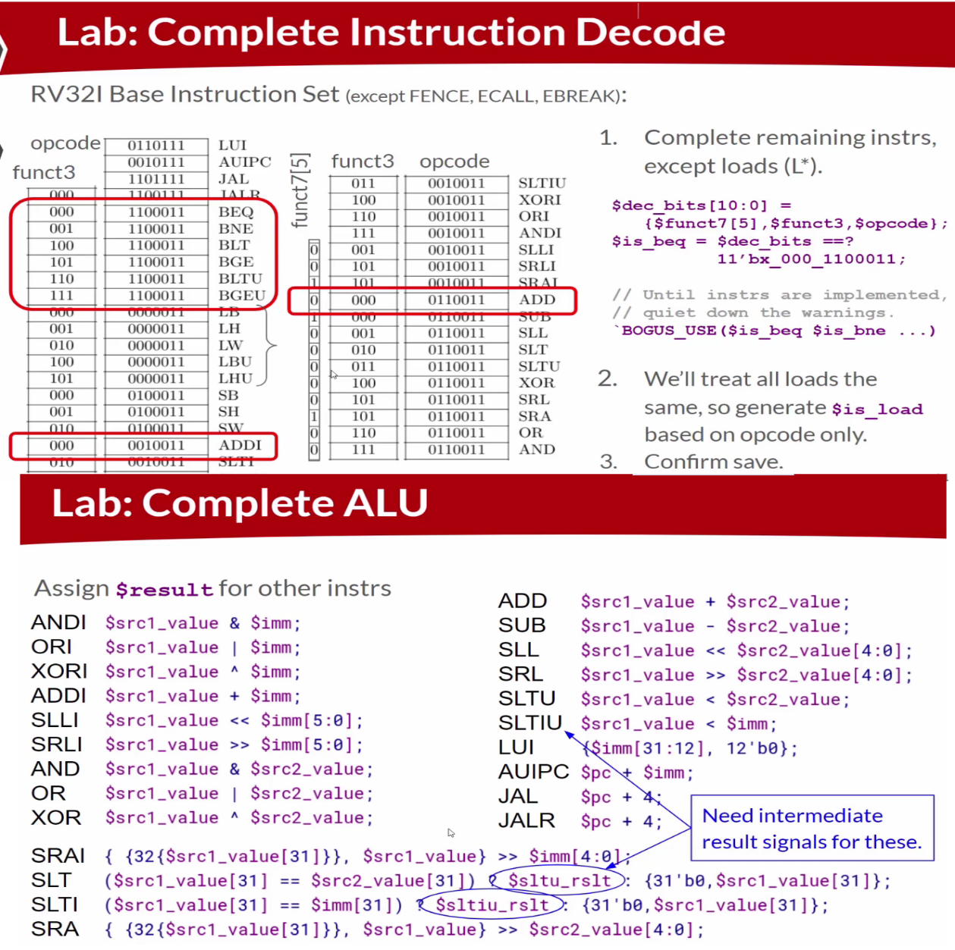

Code

Makerchip URL - https://www.makerchip.com/v186/ide/~0o2fLcpK/p-0Xxc4y

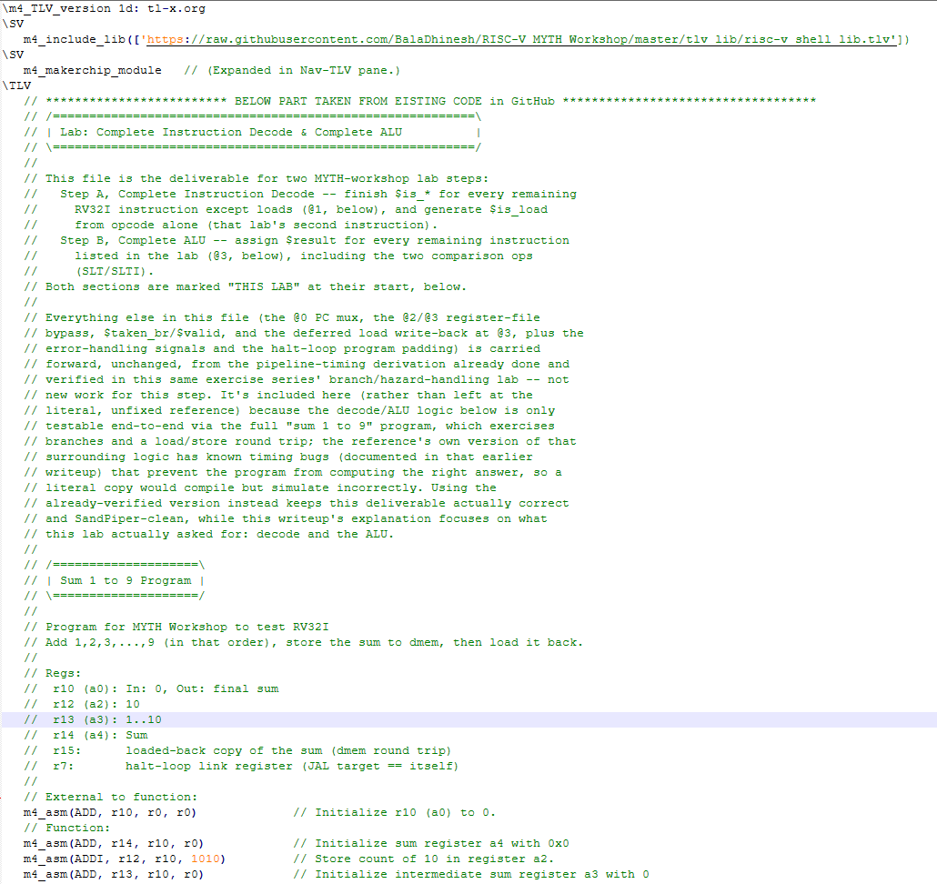
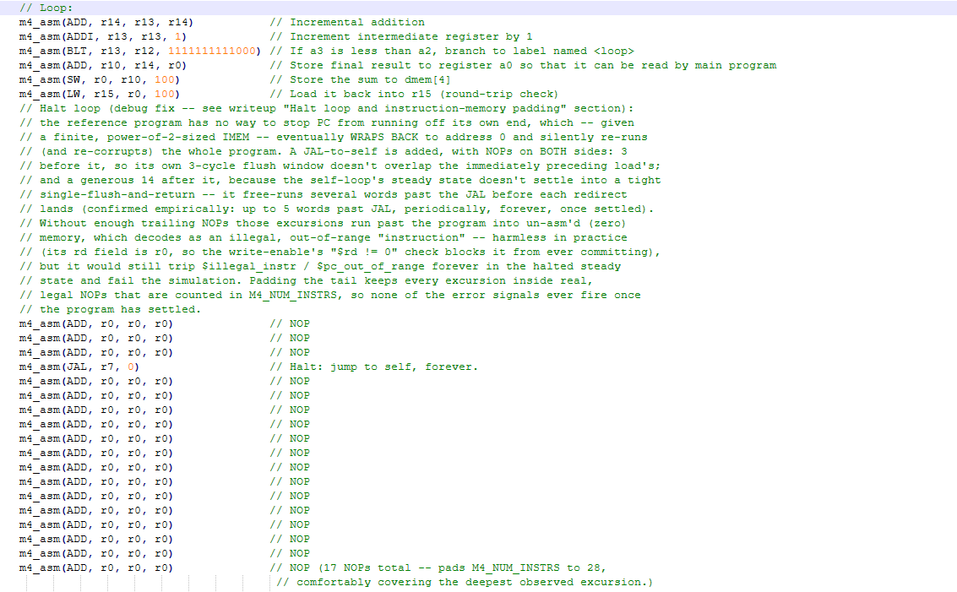
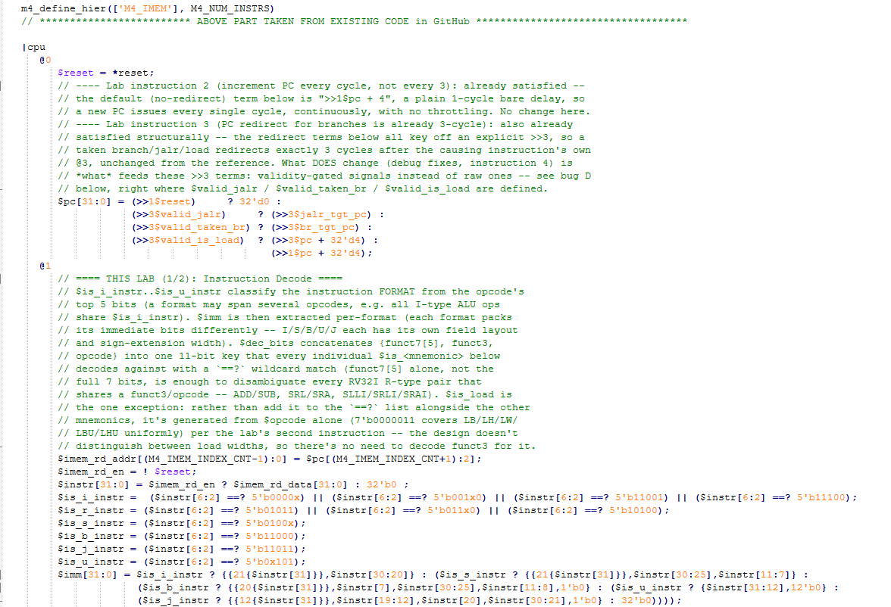
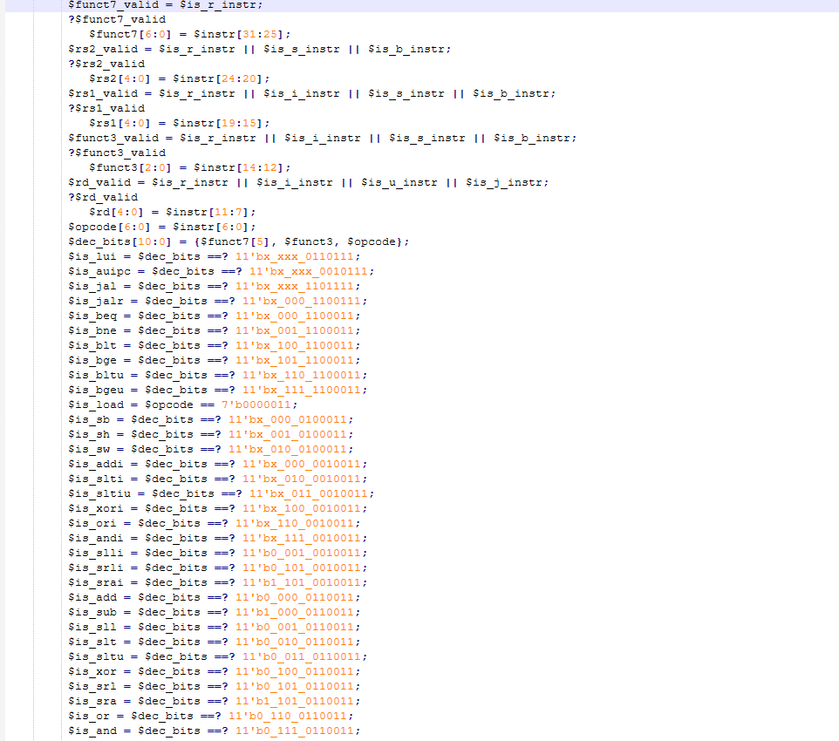
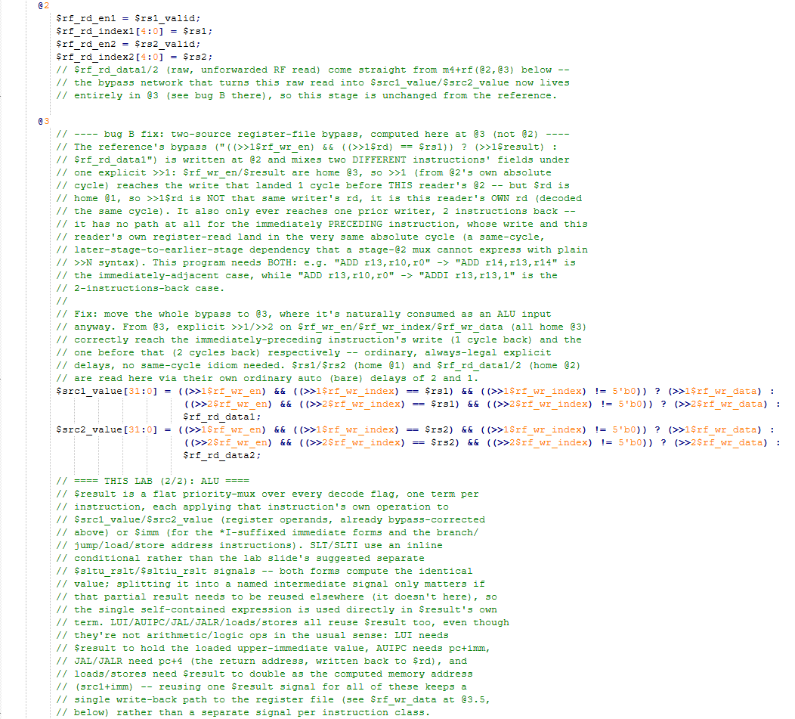
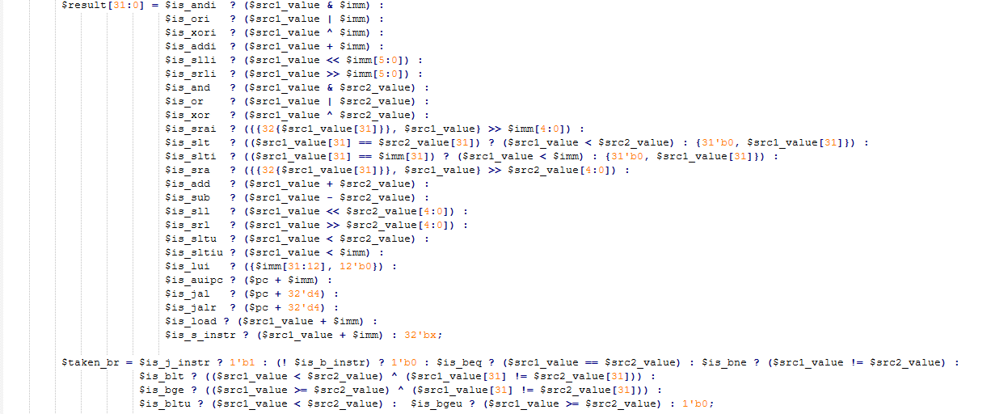
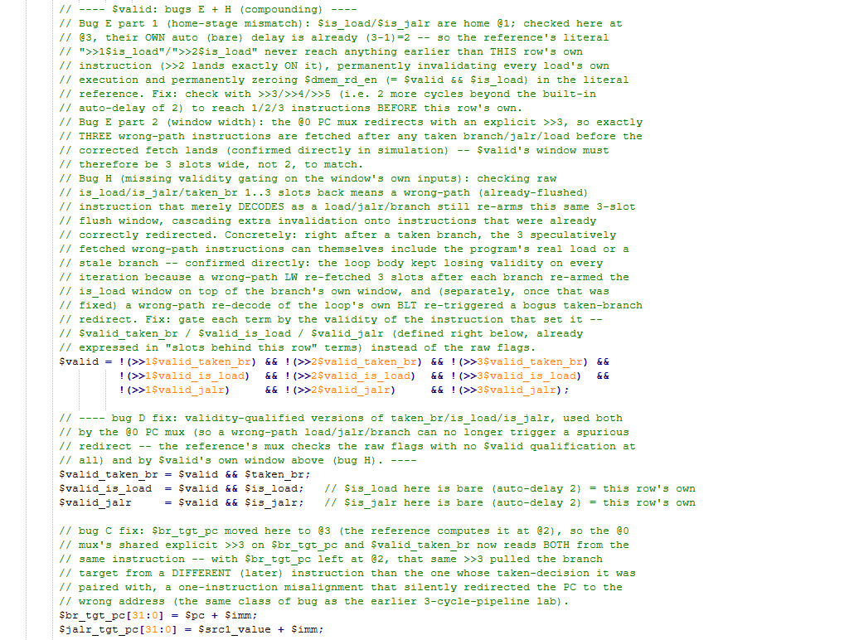
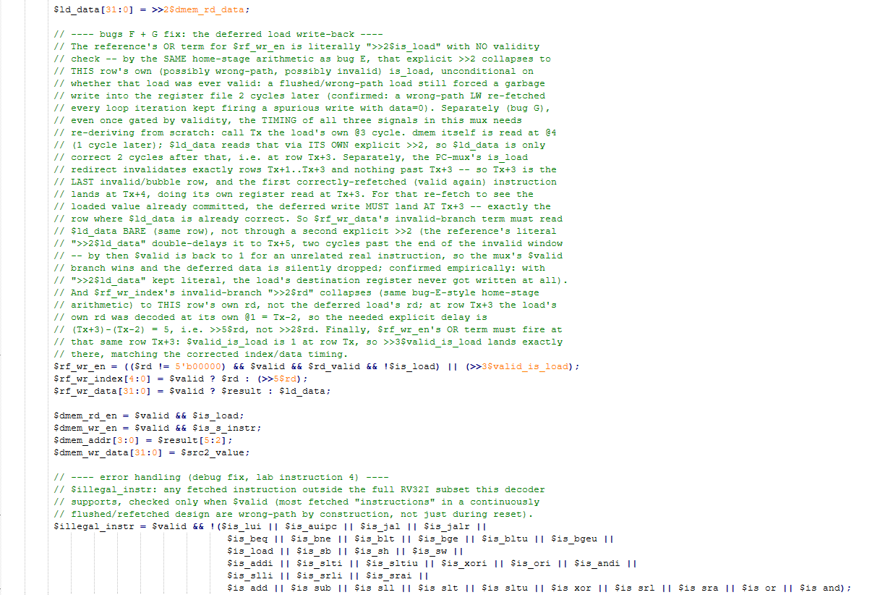
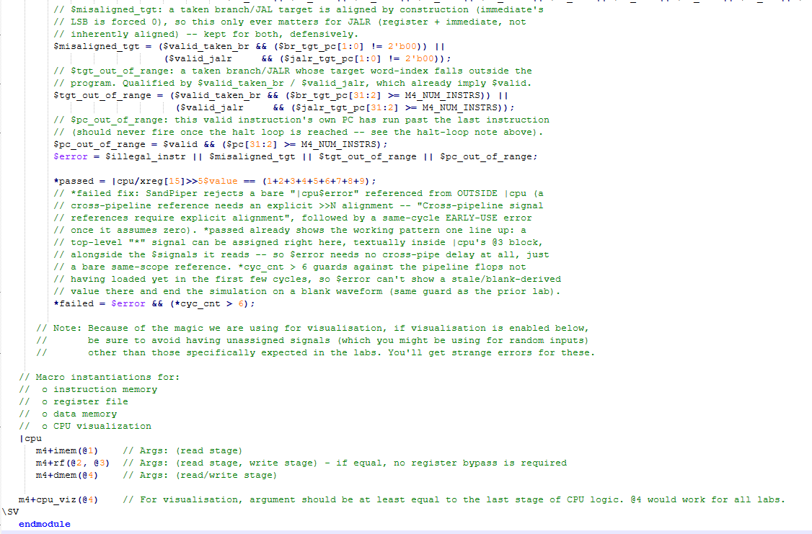

Makerchip execution – Diagram
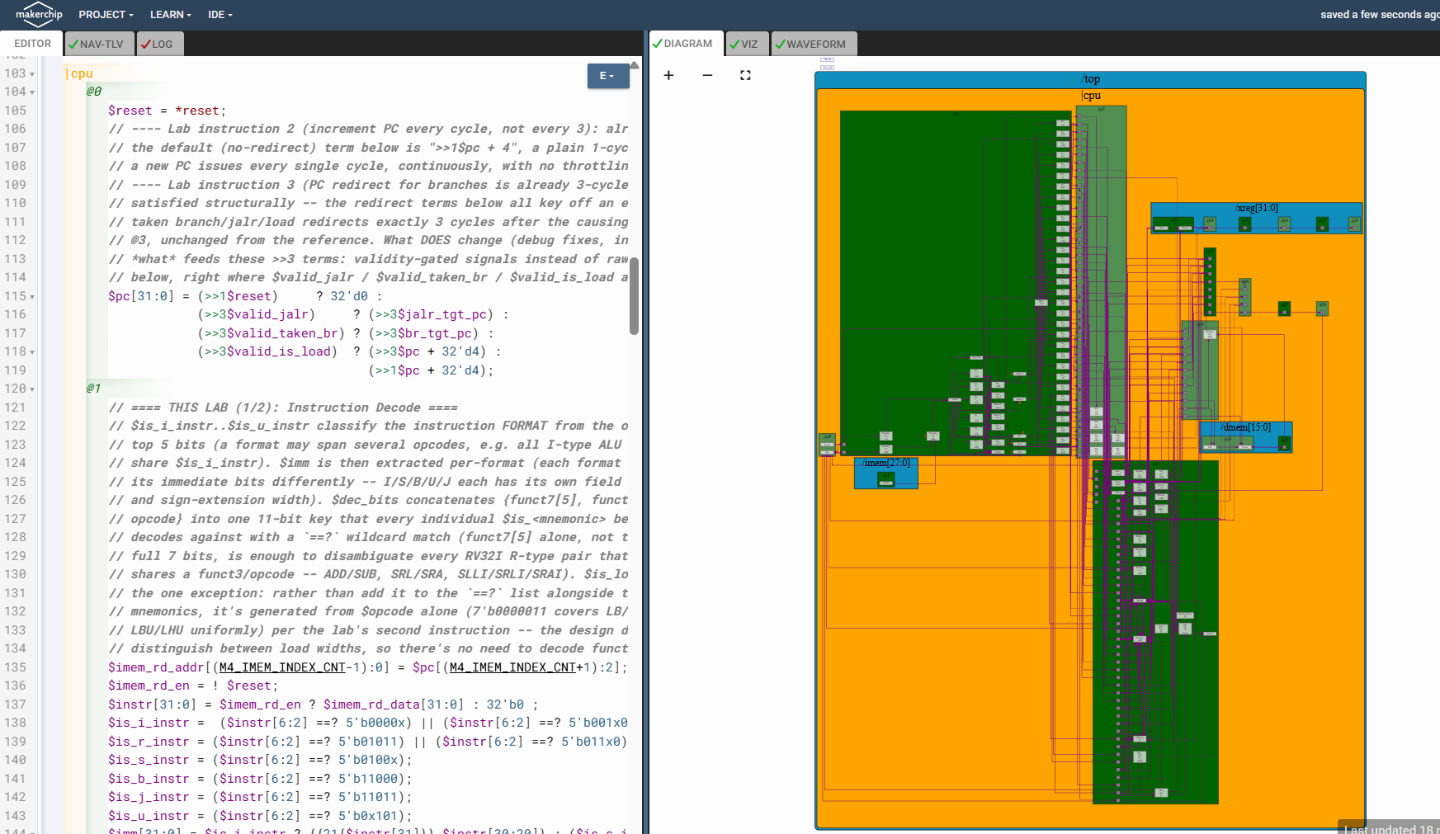

Makerchip execution – VIZ
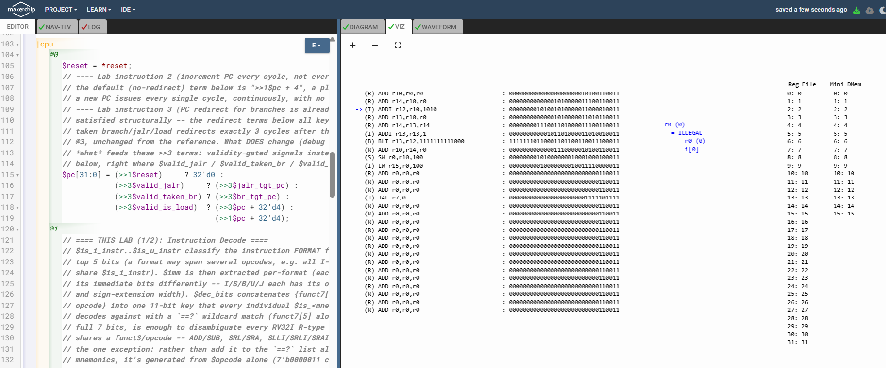

Makerchip execution – Waveform
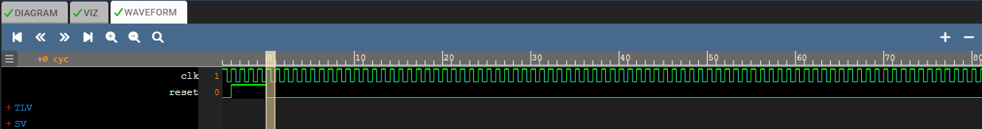

Implementation Elaboration

Instruction formats and the decode pipeline
RV32I packs every instruction into one of six formats -- R, I, S, B, U, J -- that differ only in how the 32 bits after the 7-bit opcode are carved up into register fields, a 7-bit funct7, a 3-bit funct3, and an immediate. Decode (stage @1) works in three passes: first classify the instruction's FORMAT from the opcode's top 5 bits; second, extract that format's immediate and its register-index fields (only the fields a given format actually has, guarded by a ?$rs1_valid / ?$rs2_valid / ?$rd_valid / ?$funct3_valid / ?$funct7_valid condition, since e.g. a U-type instruction has no funct3 or funct7 field to speak of); third, decode the specific MNEMONIC from a combined {funct7[5], funct3, opcode} key.
Signal | What it does
$is_i_instr / $is_r_instr / $is_s_instr / $is_b_instr / $is_j_instr / $is_u_instr | One-hot format classification, decoded from $instr[6:2] (the opcode with its fixed bottom two bits dropped) against each format's set of opcodes.
$imm[31:0] | Format-specific immediate extraction and sign-extension: I-type sign-extends bits [31:20]; S-type reassembles [30:25],[11:7]; B-type reassembles the branch offset with an implicit LSB of 0; U-type places bits [31:12] in the top and zero-fills the bottom 12; J-type reassembles the jump offset, also with an implicit LSB of 0. Each is sign-extended from $instr[31] except U-type, which has no sign bit to extend (its immediate always occupies the full upper 20 bits).
$funct7 / $rs2 / $rs1 / $funct3 / $rd | Extracted only under their own ?$..._valid condition, so a format that doesn't carry that field (e.g. U-type has no $rs1) never assigns it.
$dec_bits[10:0] | {$funct7[5], $funct3, $opcode} -- one 11-bit key every $is_<mnemonic> below matches against with `==?` (wildcard). Only funct7 BIT 5 is needed, not the full 7 bits: it is the single bit that disambiguates every RV32I R-type pair sharing an opcode/funct3 (ADD/SUB, SRL/SRA, SLLI/SRLI/SRAI) -- the other 6 funct7 bits are always 0 for the instructions this decoder supports, so checking bit 5 alone already fully identifies the mnemonic.

This lab's task: every remaining $is_<mnemonic> signal -- LUI, AUIPC, JAL, JALR, all six branches (BEQ/BNE/BLT/BGE/BLTU/BGEU), the three stores (SB/SH/SW), all nine *I-immediate/logic ops (ADDI/SLTI/SLTIU/XORI/ORI/ANDI/SLLI/SRLI/SRAI), and all ten R-type ALU ops (ADD/SUB/SLL/SLT/SLTU/XOR/SRL/SRA/OR/AND) -- each a single `==?` match against $dec_bits with the appropriate x/1/0 pattern in the funct7[5]/funct3/opcode positions.
$is_addi = $dec_bits ==? 11'bx_000_0010011; // funct3=000, opcode=0010011, funct7 irrelevant (x)
$is_slli = $dec_bits ==? 11'b0_001_0010011; // funct7[5]=0 disambiguates from SRLI/SRAI
$is_srai = $dec_bits ==? 11'b1_101_0010011; // funct7[5]=1 disambiguates from SRLI
$is_add = $dec_bits ==? 11'b0_000_0110011; // funct7[5]=0 disambiguates from SUB
$is_sub = $dec_bits ==? 11'b1_000_0110011; // funct7[5]=1

Loads, this lab's second instruction: rather than add a bit pattern per load width, $is_load is generated from $opcode alone -- $is_load = $opcode == 7'b0000011; -- since opcode 0000011 covers LB/LH/LW/LBU/LHU uniformly and this design doesn't distinguish between load widths downstream (every load reads a full 32-bit word from dmem; narrower loads aren't separately implemented). This also sidesteps needing $is_load to depend on $funct3_valid the way the other decoded flags do.

ALU
The ALU (stage @3) is a single flat priority-mux, one term per instruction, assigning $result[31:0]. Each term applies that instruction's own operation to its operands -- register values ($src1_value/$src2_value, already register-file-bypass-corrected -- see the earlier writeup) for R-type ops, or $imm for the *I-suffixed immediate forms and for the branch/jump/load/store address calculations.
Group | Terms
Immediate logic/arith (*I) | ANDI/ORI/XORI/ADDI: bitwise/add against $imm. SLLI/SRLI: shift by $imm[5:0] (a 6-bit shift amount, even though RV32 only needs 5 bits, matching the immediate's own field width).
Register-register logic/arith | AND/OR/XOR/ADD/SUB: bitwise/add/subtract $src1_value against $src2_value. SLL/SRL: shift by $src2_value[4:0] (5 bits is enough here -- a register operand, unlike SLLI's immediate, only ever needs the bottom 5 bits read for a 32-bit shift amount).
Arithmetic shift right (SRAI/SRA) | {{32{$src1_value[31]}}, $src1_value} sign-extends $src1_value to 64 bits by replicating its own sign bit 32 times above it, then shifts right by $imm[4:0] or $src2_value[4:0] -- an arithmetic right shift preserves the sign, unlike SRL/SRLI's logical (zero-fill) shift.
Comparisons (SLT/SLTI/SLTU/SLTIU) | Signed forms (SLT/SLTI) special-case operands with differing sign bits, since a plain unsigned "<" on the raw bit patterns gives the wrong answer whenever the operands' signs differ; unsigned forms (SLTU/SLTIU) compare directly.
LUI / AUIPC | LUI: {$imm[31:12], 12'b0} -- $imm already holds the loaded value left-shifted into position by the U-type immediate extraction, so this just zero-fills the bottom 12 bits. AUIPC: $pc + $imm.
JAL / JALR | $pc + 32'd4 -- the return address (PC of the instruction AFTER the jump), written back to $rd. The jump target itself is computed separately, as $jalr_tgt_pc for JALR ($src1_value + $imm) and $br_tgt_pc for JAL/branches ($pc + $imm); $result only ever holds the link-register value here, never the target.
Loads / stores | $src1_value + $imm in both cases -- the computed memory address, reused via $dmem_addr[3:0] = $result[5:2] below.

On the SLT/SLTI intermediate-signal note: the lab slide suggests routing these through separate $sltu_rslt/$sltiu_rslt signals. This file instead inlines the same conditional directly as one term of $result's own mux:
$is_slt ? (($src1_value[31] == $src2_value[31]) ? ($src1_value < $src2_value) : {31'b0, $src1_value[31]}) :
$is_slti ? (($src1_value[31] == $imm[31]) ? ($src1_value < $imm) : {31'b0, $src1_value[31]}) :
Both forms compute the identical value; a named intermediate signal only earns its keep when that partial result needs to be reused somewhere else in the design (it isn't, here -- SLT/SLTI's comparison result feeds nowhere but $result itself), so the single self-contained expression is used in place of the extra signal.

Error handling
Four error conditions are checked, each qualified by $valid so a wrong-path (speculatively fetched, later-flushed) instruction can never spuriously trip one -- in a continuously-flushed, dynamically-redirected pipeline, most fetched "instructions" at any given moment are wrong-path by construction, not just during reset, so gating by validity here matters far more than it would in a simple non-pipelined design.
Condition | Meaning
$illegal_instr | Any valid, fetched instruction outside the full RV32I subset this decoder supports -- i.e. none of the $is_* flags above matched.
$misaligned_tgt | A taken branch/JAL target is aligned by construction (its immediate's LSB is forced to 0 by the B/J-type extraction), so this only ever matters for JALR (register + immediate, not inherently aligned) -- checked for both, defensively.
$tgt_out_of_range | A taken branch/JALR whose target word-index falls outside the (padded) program.
$pc_out_of_range | A valid instruction's own PC has run past the last instruction.
$error / *failed | OR of the four conditions above. *failed additionally ignores the first few cycles (*cyc_cnt > 6) so pipeline start-up, before the flops have loaded, can't end the simulation on a blank/stale-derived waveform -- and, per the SandPiper compile fix from the earlier lab, *failed is assigned textually inside |cpu's own @3 block (right next to $error and *passed), not from outside the pipe, since a cross-pipeline reference to $error with no explicit >>N alignment is rejected by the compiler (RECOV_ERROR NO-ALIGN, followed by a DEFERRED_ERROR EARLY-USE once it falls back to assuming zero delay).

What this lab reuses from earlier work
Decode and the ALU are only testable end-to-end through the full "sum 1 to 9" program, which exercises a loop (BLT), a store, and a load round-trip -- none of that runs correctly without the surrounding pipeline infrastructure also being right: the PC redirect mux, the two-source register-file bypass, $taken_br/$valid's hazard window, and the deferred load write-back timing. The literal reference code has known bugs in every one of those (documented in this series' branch-handling lab writeup) that silently corrupt the sum whenever they're exercised, without necessarily tripping any error flag. Rather than re-derive or re-explain those fixes here, this file simply carries them forward unchanged -- confirmed by a direct line-for-line diff against the already-verified pipeline file, which shows every functional (non-comment) line identical between the two.
- ALU: confirm $result matches the expected value for each instruction -- easiest to check on the ADD/ADDI chain building the running sum (r14), and on the final SW/LW round trip (r15 should equal r10 once the load completes).
- r10 and r15 should both settle to 45 well before *passed goes high (at cycle 89, per the model, for a 2-cycle reset), and stay there -- watch for the JAL halt loop taking over cleanly once the program completes.

