LabView Tutorial
By Lee Wienkes
This work has been support by Dr. John Colton

Table of Contents:

- Introduction
- Starter Tutorials
  - Without Instruments
    - The Basics: The Screens, Types of Variables, etc
    - Case and Sequence Structures
    - Loops
    - SubVI’s
    - Arrays & Clusters
    - Global Variables: Interrupt Buttons and Constants
    - Graphing, Property Nodes, Text Rings/Enums and Formulas
    - Decorations – Making it Look Nice (Interlude)
    - Event Handling: Efficient User Input and Variants
    - Time and Dialogue
    - Debugging and Error Handling
    - File Operations
    - Misc. Topics
  - With Instruments
    - Communicating with Instruments: Back to Basics (GPIB, RS 232)
    - Handling Error from Instruments
    - Serial Polling
- The Equipment
  - The Spectrometer
  - The Pulse Generator
  - The Photon Counter
  - The LCD Retarder
  - The Magnet
    - Power Supply
    - Temperature Control
    - Level Meters
    - Putting it all together
  - Scans: Example with the Spectrometer
- Helpful Coding Suggestions
- References and Further Reading
- Appendix
  - Numerical String Formatting

0.0 Introduction Back to Top

Welcome to LabView! This is probably your first look at things, so we will try to start from the beginning. I am assuming you have had some kind of computer program experience; that is you at least understand the basic concepts of variable, loops, etc and just need to learn the syntax and format of the LabView program. This is (or will be soon) an entire series of tutorials covering a variety of subjects in LabView – the usual format will be a brief outline of what is contained, an exercise(s) to be done at the end of the tutorial (solution is included in this folder as well) and then all the pertinent information. As concepts do build on each other, these tutorials should be done in approximately the order intended, though that is not to say that you couldn’t figure it stuff out if you skipped one, but if you don’t know a word or concept, chances are you missed it in one of the previous tutorials. The tutorials begin with a basic exploration of LabView and its abilities and functions (both with and without instruments attached) and then proceeds to programming issues specific to the equipment we have in the laboratory.

1.1.1 The Basics Back to Top

LabView is graphical programming language in contrast to text based languages like Java or C++. You program by placing icons on a screen and then linking them up with wires, with various operators that represent functions. In the end, it looks like a cross between a flow chart and a schematic diagram.
To start off with, in LabView you have two screens – the Front Panel and the Block Diagram – both of them together compose the VI (Virtual Instrument), which is your program. The front panel is your graphical interface; that is what you will see when the program is actually running. This is where you will put your buttons, text boxes, numerical indicators and so on. Right-clicking on the background of the front panel will bring a palette, which has all the different types of objects that you can use. They are grouped by variable type (e.g. Boolean, numerical, etc). Each item you place on the front panel (with only minor exceptions) will have a counter part on the block diagram called the terminal. Once they have been placed, both items may be moved separately; that is if you move an object on the front panel, it’s counterpart on the block diagram does not move, but if you delete one, the other will also disappear. The block diagram is essentially the code of the program, though it is a graphical kind of code. You must link up the various terminals with wires to transfer data between them. In addition to the terminals there are numerous functions that LabView provides – such as add, subtract, Boolean operations, etc. Later on, we will learn how to make our own functions, which will be called subVI’s.
There are two main types of front panel objects – controls and indicators. As one might suspect, indicator can only be used to display something during run time – the user cannot alter these values while the program is running, only the code (block diagram) can. Controls let you alter a value from the front panel during run time, but can also be changed by the code by using local variables.
There is another important way to divide the objects in LabView; by data type. The common ones are numeric (which can be further defined as integers, floating, etc), strings, Boolean, arrays (which can be string arrays, Boolean arrays, numeric arrays, etc), clusters and finally the code (which is also represented visually).
As mentioned before, the code is very similar to a flow chart. There are the representations of your data (i.e. your variables), “nodes”, which carry out operations or call functions, and wires that transmit your variables to the nodes or data between nodes. All of the abstract operations from text-based coding now become physical realities; wires you can follow, nodes you can see, etc. As an example, let us examine Figure 1.1. We can see all the different parts of LabVIEW, as we can see both the block diagram and the front panel. The wires, variables and function nodes are pointed out. Additionally, the front panel object is linked to the object on the block diagram to indicate the dual nature of the objects. Notice that there is no front panel representation for the function node; this exists only in the code.
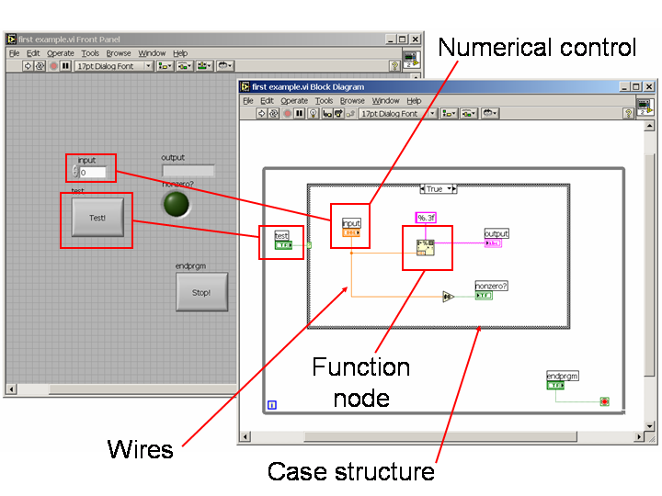
Figure 1.1: Some of the many things you will find in LabVIEW; wires for connecting data, controls and indicators for user interaction and function nodes to perform operations.

Introduction of Variables in LabVIEW
Variables are an important part of LabVIEW. There are three kinds of variables: your “terminal” (which is really your object), local and global. The first two types will be discussed here and global variables will be saved for a later chapter. The first two types of variables are the same in almost every way; the only difference is that the terminal reflects the input/output nature of the front panel object. That is, if the front panel object is a control, you can only take data from the terminal. Local variables are used when you need to reference a front panel object more than once in your code (a highly likely situation). There are two ways to create a local variable; the first is to right-click on the terminal or front panel object and select “Create:Local Variable” from the list of options. This will automatically create a write-only local variable. The second way is to go to structures palette in the block panel and select local variable. This will allow you to place a blank local variable, which you can then link to any object already in existence by click on the “?” in the center of the local variable. You can link multiple local variables to the same object.
Once you have a local variable, you can right-click on it to change its read/write status. Note, this does not affect the control/indicator status of the front panel object; it only affects the particular local variable selected. This is how you can change the value of a control during the program without user input. You can have essentially an infinitely number of local variables for a particular object and they are all linked, so that when the value for one instance of a variable changes, all of them change. (Note on usage of term variable versus object)
Below is a list of variable types. Each variable type corresponds to a certain color that makes it easy to distinguish variable types. Black is reserved for “undefined” – usually your program will not run if you have any black variables floating around. All wires, variables and constants are color coded. Notice that, with the exception of Boolean buttons, all variables types behave the same on the block diagram, even if they have different visual representations on the front panel. (mention cutting/copying issue)

List of Variable Types:
- Numerical (blue = integer, orange = fractional - floating point, scientific, etc)
A number that can be in many formats: integer, floating, single/double precision, complex, time stamps, etc. LabVIEW is usually good about being able to convert between the different formats if it needed. For example, you can add a time stamp and an integer; it simply takes the integer to be seconds and adds accordingly. There are also many numerical operations and functions that can be found on the numerical palette on the block panel (but not on the front panel palette because function nodes have no front panel representation). NOTE: You can make any integer a floating by adding a decimal and zero. LabVIEW will get rid of your decimal point but the number will change from blue to orange.
- String (pink)
Strings consist of characters, which have numerical Ascii values. There are a wide variety of built in functions for strings, such as concatenate, search, replace, etc. Additionally, you can convert many types of variables into strings, which is sometimes done to display coherent messages (e.g. “The wavelength was measured to be 801 nm”, where 801 was probably a number at some point). These conversions are all found in the string palette on the block diagram.
- Boolean (green)
A true/false variable. This variable type is used in logic operations (AND, OR, XOR, etc), if/then statements, cases, comparisons, etc. The main complication of this variable type comes with mechanical action property that is found by right clicking on the front panel object. Booleans with non-latching mechanical action settings cannot be used as local variables as their value is not steady. You can convert an array of Boolean statements into an integer (and vice versa). This is often useful in reading the status of instruments.
- Array (thick/double line – matches variable type color)
An array is an indexed list of elements. You can have an array of almost any data type; an array of Booleans, numbers, strings, etc. The only stipulation is that they are all of the same data type – this goes even for different types of integers! For example, if you have an array of integers and put 6.3 into it and then look that value up later, you will find that it has become 6. Furthermore, arrays can have more than one index (i.e. a 2D or 3D array). Commonly used built in functions are: search, sort, index (picks an element of the array) and insert.
- Cluster (brown)
A cluster is similar to an array in that it is a collection of elements. However, clusters have no index and can contain multiple data types. Thus you can have a cluster that contains a string, a number and a Boolean. You can create arrays of clusters.
- Path (blue-green)
Related closely to string. Can convert to a single string or an array of strings.
- Ring/Enum (blue, because it is really an integer index)
This variable type allows you to choose from a list of options. The main difference between these two variables is that in an enum you can reference a string (the label of that option) while in a ring you must reference its index number.
- Graphs (brown or pink)
Graphs are not really a different data type, they are really a different way of displaying a specific data type. A graph is an array of clusters, where the cluster contains the coordinates for a point on that graph (two points if it is a 2D graph). Furthermore, these arrays can be clustered again, then put into another array to form a muli-plot graph. This is outlined below:
Cluster of Points → Array → Single Plot Graph
Cluster of Points → Array → Cluster of Arrays → Array → Multi-plot graph

Constants
Besides variables, there are constants as well in LabVIEW. These follow all the variable types, but are simply fixed values that you can use. For instance, if you wanted to divide a number by two, you can wire the input number to the “divide” function node, along with the constant two, and the output will be x/2. Thus, you don’t need a variable for every number in your program; just the ones that might change!

Comments
Comments are a very important aspect of any programming language; it lets others (or you if it is has been a while) know what is going in a program. Simple phrases like “Button Checking Loop” can tell a user what a piece of code does without them having to trace the whole thing. It can also be helpful for marking bugs that you have found and do not know how to fix or simply do not have time to fix right now. To place a comment in the block diagram, simply double click on the white background and start typing. This will place a text box that has no effect on the program itself.

Default Values
Default values are the values that a variable/object have when LabVIEW first starts up. The built-in default values are: numeric = 0, string = “” and Boolean = false. However, by right-clicking on an object, you can change its default value by selecting set current value to default (under the data operations menu). Please note that the variables only revert to their default values after you exit out of LabVIEW completely! If you just stop and start your program, the variables will maintain their last value from the previous running of your program. Thus, it is often important to create an initialization step in your program that resets all the variables where the initial value matters.

Labels, Captions, Boolean Texts and Good Variable Naming
Right-clicking on an object will bring up a menu with the option Properties. By selecting this and then going to the Appearance tab on the new screen gives you two options: label and caption. While the two words may have similar meanings, in LabVIEW they are very different things. A label is the name of your variable; it is what LabVIEW will use to refer to that variable. A caption is just a text box attached to the variable; it has no bearing on anything else. Generally, you want to make your variable names, the label, as short and concise as possible. For example, if you had a numeric that was a random integer, rndint or RndInt might be a good variable name, depending on your feelings towards capitalization in variable names. However, this would not be good as the descriptive text attached to the numeric on the front panel. By changing the variables caption to Random Integer, hiding your labeling and displaying only your caption, you can have the best of both worlds; a short and concise variable name and a descriptive text attached to it.

Object Order and Grouping on the Front Panel
As with any graphical user interface (GUI), there is an order to the objects on the front panel that helps the computer decide what to do should two objects occupy the same visual space on the front panel. LabVIEW is no different. At the end of the tool bar there is a box that looks like two arrows going in a circle; this is the order and group button. By clicking on an object/group of objects you can move them forward, so that they will be displayed on top of other objects or move them back so other objects will have preference. Furthermore, by selecting a group of objects, you can group them together, which means they will move as if they were one object on the front panel. All of the functions are merely for ease of layout; they have no effect on the code of the program.

Good Housekeeping: A Quick Note on Clean Code
With a graphical program like LabVIEW, clean code becomes not just an item on a check list that earns you 5 points on an assignment; it is a necessity. Without clean code, in any decent-sized program, you will quickly become lost and fixing bugs/tracing code can be a hopeless task. Here are a few tips to keep your code readable.
- Space considerations: Make your code as compact as possible, but not so compact that you cannot clearly see all the labels and where the wires are connected.
- Straight Wires: Keep as few bends in your wire as possible, while still being able to trace the wires from start to finish.
- Use Small Icons on the Block Diagram: Rather than using the default icons on the block diagram, use the smaller ones, it will conserve space. To switch your icons, go to Tools:Options, select Block Diagram from the menu and uncheck Place Front Panel Terminals as Icons.
- Periodically Clean up Your Code: Keep your code clean, do not wait until the very end to try to clean everything up; it may be too late by then!
- Use Stacking Structures When Possible: By doing this, you will be able to see the most amount of your code without lots of scrolling. You will learn about structures in the next few chapters.
- Use subVIs Often: Once again saves space and allows you to get the “gist” of the code without seeing the cuts of everything. SubVIs will be discussed in section 1.4.

Exercise 1.1: Adding Machine: create a simple calculator. It should add two numbers together and then display the result. Add another output that displays the difference (absolute). One display should be a numerical and one should be a string display. HINT: The number→string function can be found under the string palette. Hints on formatting can found in the appendix. Experiment with the properties of the inputs and outputs. What is the difference between a label and caption? Find out how to adjust the size, style, etc of the font. Explore also the different button mechanisms (i.e. latching vs non-latching) and the other properties that you can change for each type of object on the front panel.

1.1.2 Case and Sequence Structures Back to Top

A case structure is a box with different layers corresponding to the different possible inputs of the variable type being used. The easiest case structure to imagine is for a Boolean expression; you have just true or false, but you can also have numerical cases (0, 1, 2…) or string cases. You can find the case structure in the structures palette in the block diagram. You place it by clicking on the diagram and then expanding the rectangle to enclose all the code you want to be run for a particular case. Every time the condition is met, you will run the code that is inside of the structure. The condition is defined by the small green question mark on the left hand side of the case structure (you wire the variable being checked to that box). You can cycle through the possible cases by clicking on the arrows at the top of the case structure (the “case toggle” if you will). Right-clicking on the top of the case structure allows one to add cases, delete cases or rearrange the cases. Additionally, you can rename the cases (e.g. you can change true to false). Nested statements are possible by simply placing a case within a case.

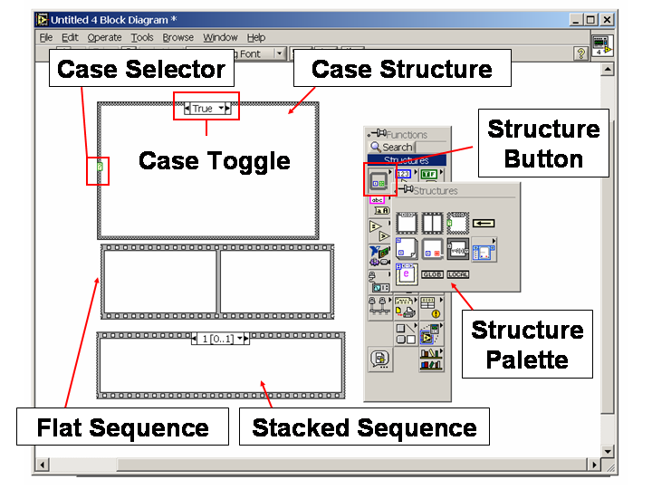
Figure 2.1: Various structures in LabVIEW (left). On the right hand side of the figure is the palette, where you will find all your objects and functions. There is a different palette for the block diagram (shown) and the front panel.

A sequence structure is a structure that allows the user to create an explicit order of execution for instructions. On the block diagram, LabVIEW will of course execute instructions that produce data that is needed for another structure in the correct order, but outside of this, there is no particular order. By placing different code inside different frames (think of making a movie) of the sequence structure, you are telling LabVIEW to follow the order you defined. You can create stacked or flat sequence structures, the only difference being that in a flat sequence structure, you can see all of the frames at once. The stacked version has the advantage of saving space on the block diagram. Right-clicking on the sequence brings up similar options as with the case structure: add a frame, delete a frame, rearrange the frames and others options. Figure 2.1 below depicts a case and a sequence structure, along with the palette used to create them.

Passing Data in/out of Case and Sequence Structures
Passing data into a case or sequence is straight forward. Simply wire your data (i.e. variable) to the wall of your structure. This will create a small rectangular tunnel, whose color matches that of the variable type being used. The tunnel will have an output, which is on the inside of the structure; you can wire this to anything inside the structure. Conversely, you can usually use the data directly to whatever is on the inside of you structure and LabVIEW will create this tunnel automatically. One important thing to notice is that once the data is passed into the case structure via that tunnel, the value does not change, even if the value of variable to which it is attached does. For example, if I wire num1 into a sequence structure to num2 and sometime after the data has been passed to the tunnel, but before it is passed to num2, num1 changes, the value that will be passed num2 will be the older value of num1, because that is what is stored at the tunnel.
Passing data between frames of a flat sequence structure works the same as passing data into a sequence to begin with. However, if you are using a stacked structure, you will need to create a sequence local, which a variable that is local to that particular sequence. This is done by right-clicking on any of the walls of the sequence and choosing the option “Add Sequence Local”. You can wire it to some variable and it will maintain that value for the rest of sequence (i.e. you can set its value once). Each subsequent frame will have an output where the sequence local is and each previous frame will have simply a small grayed out box. Passing data out of sequence works the same as passing data in, except in reverse. That is, wire an output from inside the sequence to an input that is outside of the sequence.
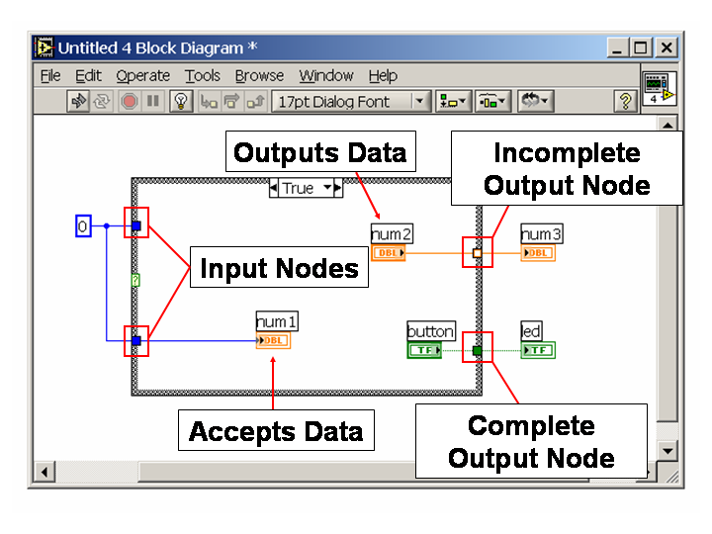
Figure 2.2: Getting data into and out of structures using nodes.

Getting data out of a case structure is a bit more complicated, but you need to define the output for each case. You start out by wiring your case structure the same as if you were bringing in data (except in reverse) and should notice that your small tunnel is now white, with a color outline. This means that not all the cases have a defined value for that output. You must now go through your cases and wire a value to that tunnel for each case. This is illustrated in Figure 2.2.

Exercise 2.1: Calculator: expand the functionality of your simple calculator from before. Add the option to add, subtract, multiply or divide. You should have two displays still, but now they should display the same number based on your selection. Add a light that turns on when the result is positive.

Exercise 2.2: Rube Goldberg Machine: create a program that does a series of tasks in order. It should:
- Turn on a light.
- Add two numbers.
- Check if that sum is non-negative and take the square root if it is.
- Pick out the 4th and 5th character of a string and concatenate it to the end of the string.
- Light a red light to signal it is done.

There should be a second between each stage. HINT: The wait timer is found under the “Time & Dialogue” menu of the block palette. We’ll talk more about this in a later section – all you need to do is wire a numerical constant to the input, which is the desired wait time in milliseconds.

1.1.3 Loops Back to Top

Loops are some of the most important coding tools that one can have, because it takes advantage of the main strength of a computer; its ability to do repetitive tasks quickly and efficiently. A loop consists of two main parts; the body of the loop (i.e. the instructions it will carry out each iteration) and a condition that determines whether the loop will be run again. For some loops (specifically ones using shift registers, which will be discussed shortly) there is the optional initialization portion, where you define an initial value for some variable.
– mention auto-indexing – finishes instructions after stop condition reached – shift register – if just tunnel and no auto-indexing?

Run-Continuous Loops and User Input Buttons

Checking for a Change (i.e. User Input)

Button Checking Loops

Exercise 3.1: Advanced Calculator: expand your previous calculator by adding a factorial button (not the built in function!). Also, add an overall while loop with an exit button to let the calculator run continuously. Add a square root (that handles both real and imaginary roots), a raise to power and a log button. You may use the built in functions (under the Numeric palette). Extra Credit: Write your own square root function. If you have taken any Computational Mathematics course, you should know how to do this (for the curious use keyword: Babylonian Method). You can do away with the positive indicator as well.

Exercise 3.2: Guessing Game: create an integer guessing game, where the computer will randomly pick an integer between 0 and 100 (inclusive). The user should be given a high/low indication. Add a “guess” button, a guess counter (displays the number of the guesses), a give up button and an exit button.

1.1.4 SubVI’s Back to Top

This next section will introduce you to the concept of subVI’s – a glorious way of writing code that will make your code much easier to read and, even better, will save you lots of time! You may not realize it, but have been using subVI’s this whole time – any time you use the logarithmic function or concatenate string function, these are really subVI’s. The only difference is that these are subVI’s written by LabVIEW, whereas we will learn how to write our own custom subVI’s.

In the traditional language of computer programming, subVI’s would be called subroutines, procedures or functions. They serve three main purposes: they allow you to reuse sections of code (imagine if you had to write the code for the concatenate function every time you wanted to use it!), they make your code easier to follow and read and easier to debug. The second purpose is of particular importance in LabVIEW because of the graphical nature of the code; if you were to look at the entirety of your code all the time, it would quickly become gibberish. Using subVI’s allow you to replace a large area of code with a small rectangular box, whose name can give you the gist of what that code does without having to worry about the actual mechanisms involved. They save time, because instead of rewriting lots of code or even cutting and copying code, you can simply place on object on the screen. As for debugging, with subVI’s you can effectively compartmentalize your code, so you can test each subVI separately to find the source of your problem.
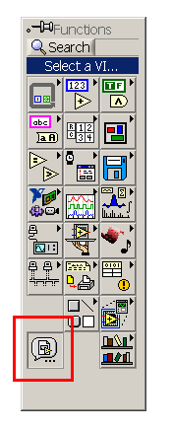
Figure 4.1: Getting subVI’s on the block diagram palette.

Before we can use a subVI, we must learn how to create one. You start by creating a VI as you normally would. For example, you could write a factorial VI, where you would input the number and have the factorial of it as the output. At this point, you could save the VI and simply place it in another VI to make your factorial VI a subVI. This is done by going to your palette in the block diagram and clicking on the button in the bottom left corner called Select a VI. This will open up a file dialogue, where you must find your VI and place it within another VI. However, this does not do us much good here, since we want to be able to pass, or input, values into our subVI and receive an output. Otherwise, we will always calculate the same factorial, or default value, and will never be able to check the value of that factorial. To add inputs and outputs for our VI, we go to the upper right corner of LabVIEW, where our icon currently is. By right-clicking on it, we see the option to Show Connector, which we should choose. A box with several compartments should appear. Each compartment is called a terminal and we can link a variable to it. Simply click on the terminal and then on the object on the front panel. Notice how the terminal took on the color of the variable type. Now if we save the VI and place it in another VI, we see that where the terminal was (in relation to the subVI icon), there is now an input/output terminal, which we can wire to some variable.
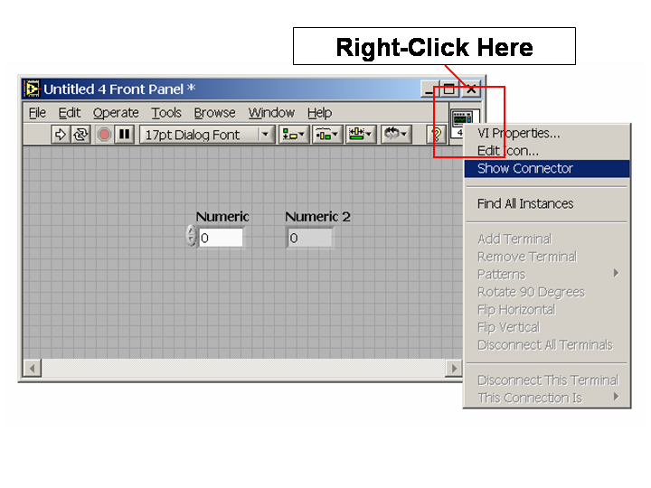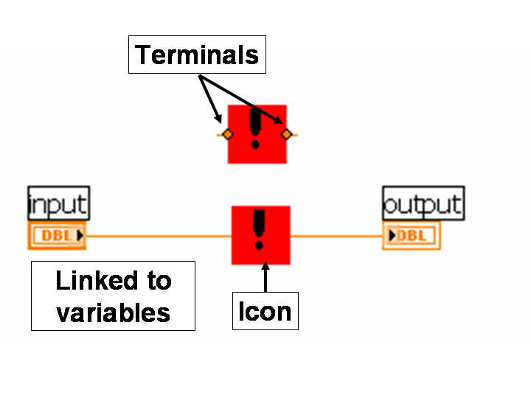
Figure 4.2 – Left - where to click to get the connector menu, right - shows the placement of a subVI on a block diagram.
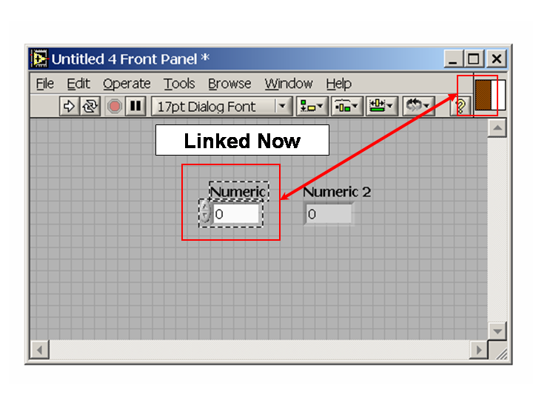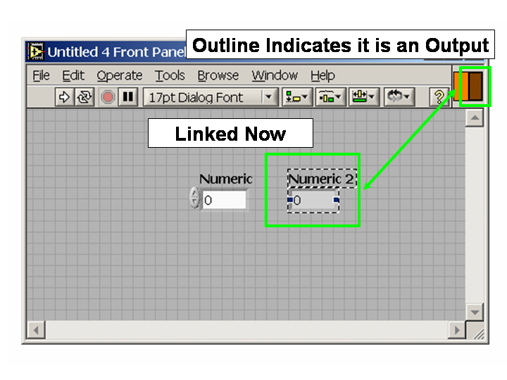
Figure 4.3 – Shows the linked terminals.

Editing the Terminals and Terminal Names
You should have noticed that when you first looked at the connector, there were as many terminals as there were variables. However, the connector does not grow automatically after you first look at it. Therefore, if later on you decide to add an input (perhaps an option for display the number in scientific notation or floating point), you will have to add another terminal. You can just right-click on the connector and select Add Terminal, but this will sometimes rearrange your existing terminals and/or place the new terminal in an odd location. Another way of doing this is to click on Patterns which allows you to choose the layout of your terminals. Furthermore, you can define each terminal as optional, recommended or required (by right-clicking on it). If a terminal is required, LabVIEW will not let a program containing the subVI run unless some value is wired to it. Note that if you do not wire anything to the terminal, the variable associated with that terminal will take on its default value.

Editing the Icon
Now that we are using subVI’s within our program, it would be helpful if we could change the icon so they do not all look the same. By right-clicking on the terminal, we can select Show Icon and then by right-clicking on the icon, we can choose Edit Icon. This brings up a screen reminiscent of Paint, which allows you design a custom icon. Remember that this icon will be small, so do not try to put a lot of words on it – easily recognizable symbols work much better.

Recursion and Order of Operations
Even though it is tempting to try to create a recursive formula using subVI’s, this is forbidden by LabVIEW. If you want recursion, you must make it using feedback loops or shift registers. One should also note that there is a hierarchy to subVI’s within a program; indeed this applies to other nested structures as well, such as loops and case structures. If we imagine the large VI or loop as the top of hierarchy, we can create a pyramid style diagram. Once a subVI is executed within a branch of the hierarchy, everything above it in that branch must wait for it to finish running before they can return to action. For example, if you have a button checking loop, and a button is pressed, causing a subVI to be run, the loop will stop checking the buttons until the subVI is finished running. This can become problematic for things like interrupt buttons, a topic we will examine in a later chapter. It is not always a problem, just something to keep in mind if your program is not behaving as you would like it to.

VI Properties
Scroll bars, abort, run, menu, etc
Pop up vi’s

Special Topic: Random Number Generator

Exercise 4.1: Advanced Calculator with SubVI’s: create subVI’s for your factorial button, custom square root function (if you did that) and an additional subVI that computes the value of the sine function using the series expansion. HINT: You will need to add a piece of code that will adjust the input for the periodic nature of sine (e.g. Sin[5 Pi/2] = Sin[Pi/2]. Put these subVI’s into your calculator program, replacing your code that was there previously. Notice how nice it looks now! Also remember to create neat icons for your subroutines.

Exercise 4.2: Random Integer Generator: create a random integer generator subVI, where you can generate a random integer within a user defined range.

1.1.5 Arrays and Clusters Back to Top

Arrays and loops go hand-in-hand; without loops, it would be almost impossible (at least impractical) to handle arrays. Therefore, this next chapter may seem like a review of loops, but you will also practice many of functions associated with arrays. After a look at arrays, we will examine a similar structure in LabVIEW, the cluster.
An array is an index list of elements. Those elements could be numbers, Booleans or strings, but they must all be of the same type. Arrays can be 1-dimensional lists or they can be multi-dimensional objects. The index of an element gives its position within the array. An element in an n-dimensional array will have n indices. In LabVIEW, all indices start with zero and go to k - 1 for an array of length k. LabVIEW has many built in functions to deal with arrays; some of these we will rewrite ourselves in the exercises to gain experience using arrays and loops. Some of the most common functions are found below:
- Index Array – gets the element at the given position. You input the array and the required indices and it fetches the element.
- Array Size – gets the length of the array in each dimension. If the array has n dimensions and n > 1, the output will be an array of length n.
- Build Array – build an array by adding on elements to the end. You must append an entire row at a time; if you have a 1-dimensional array, this is just a single element. If your array has 2 dimensions, then you must append a 1D array to it (i.e. a row).
- Initialize Array – creates an n x m array filled with one element, which is user defined.
- Sort Array – sorts an array in ascending order (or alphabetical order). To get a sort in the other direction, combine this with Reverse Array.
- Search Array – searches an array for a given element and returns the index. The value -1 is returned if the element does not exist within the array.
- Insert, Replace and Delete from Array – three different functions that are related. Insert inserts an element into an array, pushing down all the elements below it. Replace will delete an element and put another in its place. Delete simply removes the element, sliding all the elements below it up one.
- Transpose Array – Rotates the array, so that length becomes width.

Creating Arrays
To create an array, open up the front panel palette and go to Array & Cluster and select Array. You now have a blank array; it should be black (on the block diagram). To finish creating your array, you have to create an object of the data type that you want your array to be of (recall arrays can only contain one type of data) and place it in the array. You now have an array! There are two ways to change the size of an array; you can click and drag on the individual cells to make all of the cells larger or you can click and drag on overall array to show more elements. Determining which one you are actually clicking can be somewhat difficult so be careful. Note that the number of elements you are displaying is independent of how many elements are actually in the array. Right-clicking on the array allows you hide or show the radix, which allows the user to scroll through all of the elements of the array if they are not all visible, as well as to add dimensions to the array.

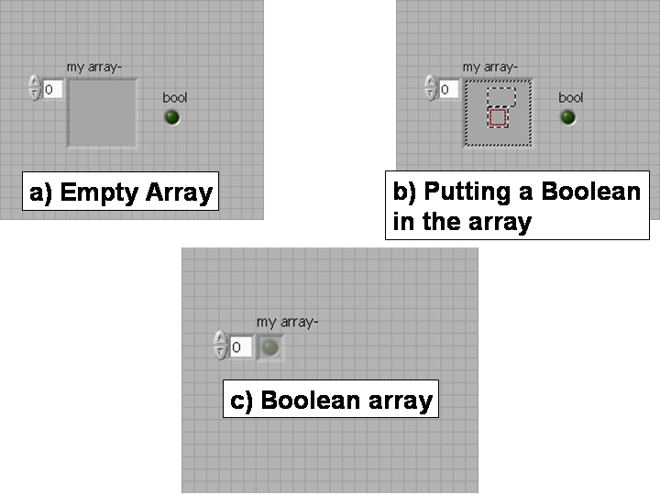
Figure 5.1: Creating an array. Figure 5.1a – 5.1c show the steps involved in the creation of a Boolean array.

Auto-indexing
Auto-indexing is another function that is useful when combining arrays and loops. If you are generating a series of data elements (whether they are random numbers or data points from your machine), instead of building the array yourself, you can have LabVIEW do it for you. Simply wire the output to the wall of the loop; you should see a solid tunnel as usual. If you right-click on it, you can select Enable Indexing, which will automatically index your elements and build an array. In For loops, this is the default action as you wire elements out of your loop.
Finally, I would like to give a quick tip on default settings for arrays. There are two kinds of default settings for an array: a default for the entire array and a default for new cells. To set the default for the entire array, you need to be sure you have the entire array highlighted when you click on Set Current Value to Default. This will causes an array to be come up as the same value very time you start up LabVIEW; for example, you could set an array of numbers called fib to come up as (1, 1, 2, 3, 5, 8, 13). If you are clicking on a single cell of an array when you set the default value, you will set the value that each new element becomes (if left undefined) every time you extend an array. For example, if you set this default value to 0 for a particular array, every time you create a new element without directly defining it, it will be 0.

Cluster
A cluster is very similar to the array, in that it is collection of elements. However, a cluster is an un-indexed collection of elements, which may or may not be of the same type. This means that I have a cluster that contains a string, two numbers and a Boolean; it does not matter. You can have an array of clusters, which is helpful if you want to attach a string or label to some number, rather than relying solely on the index for identification of the number. The elements of a cluster also maintain some of their individuality; they all keep their individual name (i.e. label). To create a cluster, you use the Bundle command, where you input as many different elements as you want and you get back a cluster containing all of those elements. Unbundle works the same, except in reverse; it displays the data type along with the terminal for the element. A more elegant way of examining a cluster is to use Unbundle by Name. As the name suggests, when you use this function, the names of the elements in the array are displayed rather than just their data type. Of course there is a Bundle by Name command, but to use this you have to input the cluster, meaning it already exists.

Creating Clusters
Creating clusters is a fairly straight forward task; you open up the front panel palette and go to Array & Cluster and choose the Cluster option. After placing this on the front panel, you can name it and then begin adding items to it. Simply create any kind of front panel object you want (string, numeric, etc) and place it inside of the cluster. Doing so will add it to the cluster. Once inside the cluster, the object retains its prior name and does not acquire an index number. The only stipulation is that they all have to be controls or they all have to be indicators. If you attempt to place a control inside of an indicator cluster, the control will be automatically switched to an indicator of the same variable type.

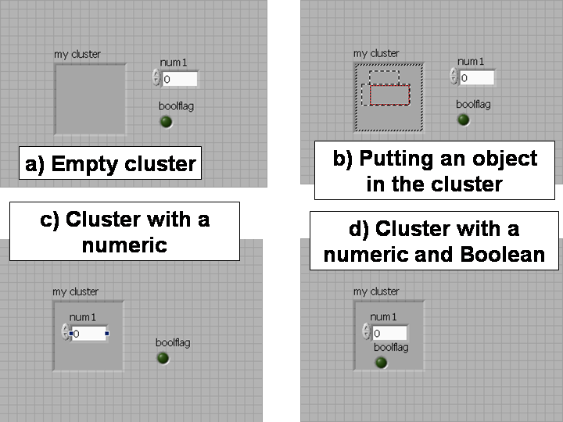
Figure 5.2: Creating a Cluster. Figure 5.2a – 5.2d show the steps to create a cluster.

Because clusters are un-indexed, it is less helpful to use loops with them. However, if you have a cluster that contains elements of the same type, you can use the cluster→array and array→cluster subroutine to convert the cluster into an array to use in a loop and then back again. However, you will lose some properties of your cluster in the mean time, such as the individual names of the elements; you will end up with something like nameofarray[i] for your element names.

Exercise 5.1: Check the Random Integer Generator: check that your random integer is really random by making sure all your values have an equal probability of being selected. HINT: One way to check this is to create an array of zeroes of length n + 1, where your random integer range is 0 to n. Then randomly pick x values, where x is very large (say a million). Every time you select a number y, add 1/x to the array value at index y and write over this value in the array. If you have an equal probability, you should get approximately the same value for each cell.

Exercise 5.2: Search/Sort Program: create a program that will search and sort data without using the built-in LabVIEW functions. You should have four buttons: a generate array button, a sort ascending, sort descending and search button. The generate array button should generate a 1D array with n random number elements, where n is user defined. The two sort buttons should sort the array in the desired direction. Finally, the search button should be able to find a user defined number and be able to return the index or let the user know that there exists no such number within the array. HINT: It is faster to search a sorted array (lookup binary search if you are unsure why), so create two buttons; one for sorted arrays and one for non-sorted arrays. Also write a method to search a 2D array (and a button to generate a 2D array).

Exercise 5.3: Dr. Colton’s Grading Program: create an array of clusters; the cluster should have two strings and a number. Make your array at least 15 elements long. Enter a series of names (one box for first, one for last) for the strings and a test score (0-100) for the number. Write a program that searches the array for the right name and reports the proper score (capitalization and white spaces should not alter the search). Create a button that sorts the array by either last name (alphabetically) or by score. HINT: Comparing strings with > and < gives a true or false based on ASCI character values, which are in alphabetical order (though you will have problems with capitals versus lower case). Also create a buttons that creates a “score report”, which lists all the student’s names and their respective scores, as well as mean and standard deviation. The output for score report should be a single string. HINT: There is a built-in standard deviation node under the Analyze:Mathematics:Probability and Statistics palette.

1.1.6 Global Variables: Interrupt Buttons and Constants Back to Top

Global variables are an important part of LabVIEW; it is one of two ways to have two VI’s interact in real time (the other will be discussed in chapter 9). A global variable is a variable which can be accessed by any VI currently loaded for you LabVIEW session. Global variables are nice in that they do not have to be passed to subVI and thus can be continuously monitored and updated. The downside is that you have to a bit more careful in how you alter global variables, as any changes made to the global variable in a subVI are saved even if you do not want them to be.
In LabVIEW, global variables exist separate from any VI in their own .vi file. Global variables look just like the front panel to any other VI, however, there is no block diagram. Thus, you can store only values in a global variable. By placing different objects in a global variable, one global variable in LabVIEW can store a wide range of values. You can have a global variable that contains a number, a string and a Boolean all at the same time. You simply have to tell LabVIEW what value you want each time you access that global variable. Thus the term global variable is perhaps a bit of a misnomer; the objects within the global variable are the global variables, while the file itself is best called a global file.
To create a global variable, go to the structures palette on your block diagram and select Global Variable. Once you place this on your block diagram, double click on it to bring up the global variable itself. Here you can add numerical indicators or strings indicators just as you would on any other front panel. You must first save your global variable to the hard disk before you can access it elsewhere. If you go back to your original block diagram and click on the global variable, it will bring a short menu of all the variables stored in that global variable. Select the one you want to read/write and you are on your way! You can switch the read/write status of you variable in the same manner as for a local variable. You can add another instance of the same global variable the same way you would add a subVI to your program. Simply go to Select a VI… on your palette and search for your global variable file. Once you have placed this on your block diagram, you can click on it to select which object in your global variable you want to reference.
Global variables hold the same value for any VI currently running in LabVIEW. This allows us to have real time interaction between VI’s. If a subVI is monitoring a global variable and the global variable’s value is changed elsewhere in the program, this change is reflected instantly in the subVI that is monitoring that global variable. Therefore global variables work well for stop conditions on loops, where the stop condition happens elsewhere in your program. It is also important to note that the global variable only stores the value it does not save it! That means, it will store the value for the current LabVIEW session, but once you exit of out of LabVIEW completely and come back in, the global variables goes back to its default value (which of course you can set to be whatever you want).

Interrupt Buttons
One of the most useful applications of global variables of global variables is for interrupt buttons. For example, if you were continuously polling an instrument using a subVI, you might want to able to stop this with a button in case it took to long. We will look at the broader case of a loop with in a subVI that you want to stop. First, create your global variable and add a Boolean to it called interrupt. Put this in whatever loop you want to stop as the stop condition (or one of the stop conditions). The loop will now continuously monitor that global variable and when it comes up as true, the loop will stop. If you go back to your main or driver program, you probably have an overall while loop that checks your front panel for user interaction. If you recall, this loop freezes when it goes into the subVI and does not advance until the subVI is done; thus we cannot put our interrupt button in this loop. However, a second loop next to your overall while loop will still run even if the overall while loop stops to run a subVI. LabVIEW will run loops and sequences in parallel if they are on the same “level” or have the same importance, where importance is defined by how all of your loop/sequence structures are nested within each other. This is how we can keep checking our interrupt button even we are running a subVI in the overall while loop. Simply put a condition in your second loop that flags your global interrupt as true whenever you push your interrupt button. You will have to think about your stop conditions for both loops to make the interrupt button work more than once.

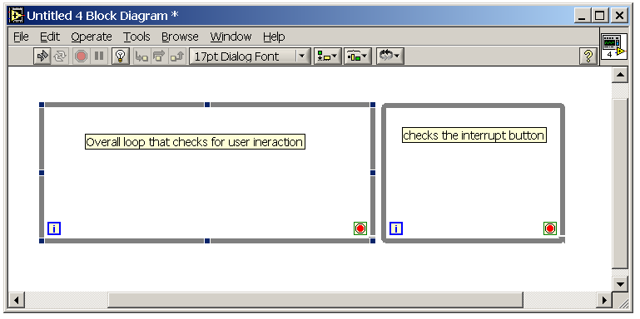
Figure 6.1: Loop structure for creating an interrupt button. The two loops will run in parallel because they have the same importance.

Global Variables as Constants
Another important use of global variables is for constants, such as equipment communication parameters, settings that do not change and other information (for example, if true/false button that you want to use to toggle change the caption on a box, you could store those strings in a global variable). You could, of course, simply use the built-in constants of LabVIEW to do all this, but using global variables has the advantage, that if you ever need to change that constant value, you can change it in one place and that changes all of its occurrences. If you had used constants, you would have track down all of them and change them one by one. As I mentioned before, global variables do not save their value once you leave LabVIEW; they go back to their default value. So the trick is to create your global variable, create your objects and put in all your information. Then right-click on the objects and select Set Current Value to Default. Now that variable will revert to those settings every time LabVIEW starts up and if you are using it as a constant, you never write to it, just read, so it should be that value all the time. A handy way of doing this is to use an array of clusters. You could create a cluster which includes some kind of designation or identification tag (a string or number) and then all the information that goes along with it (such as communication settings or settings for a particular activity). Put this cluster in the array and create a subVI that searches through the identification tags and then extracts the appropriate information. The figure below shows a global variable being used to store communication parameters for a various instruments. This tag identifies the setting as belonging to the spectrometer (see section 2.1 for more information on the spectrometer). There is a toggle that determines if the instrument uses GPIB or RS-232 (serial) communication standards. This one uses GPIB, so the GPIB address is provided. Global variables are good for communication parameters, because many such parameters, such as GPIB addresses, are not fixed, but rather can be altered by changing a setting on the instrument. Thus, if for some reason you need to one of these parameters, you can do so with minimum hassle.

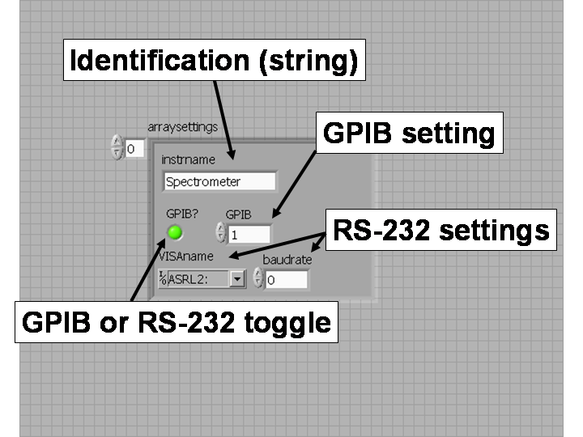
Figure 6.2: A global variable being used to store instrument communication settings.

Exercise 6.1: Create an interrupt button for a counting loop. Make two counting loops; one that does not use a subVI so that you can use a local interrupt and one that uses a subVI so that you must use a global interrupt. The subVI should be a “pop-up” subVI, meaning it displays itself when called and should have no scroll bars. The interrupt should stop the counting, not the overall program (i.e. I can hit the count button and then interrupt it without getting kicked out of the program). HINT: It may make your life easier to change the mechanical action of one or more of your button on the front panel so that you can create local variables for them. You should also add a separate counter that displays where the subVI counter should be and a “busy bar” or “wait bar” that cycles through an array of 10 LEDs, turning each one on (and then back off) in order. This should have the effect of making one light appear to run along the array of 10 lights. A good speed would be to change one light every 100 ms. HINT: Recall loops and sequences will run in parallel if they have the same importance to get all three processes (the subVI, counter and lights) to run at the same time.

Exercise 6.2: Global Variables as Constants: create a program with one button and a set of radio buttons, so that the button does a different, but similar task depending on the radio button. One of the radio buttons should be called “+10” and add 10 to a number. One should be called “-5” and should subtract 5 from a number. The third button should be called “*2” and should multiply the number by two. Finally, the last button should divide by 4 and be called “/4”. You should create a global variable as described above, each which has an identification tag, a toggle to switch between addition and multiplication and the number with which the operation is being carried out. For example, +1 might have a string tag “increment” or simply “+1”, the toggle set to addition and 1 stored in the numeric. You must input the tag and then extract the other information. HINT: a subVI with a searching loop will work nicely for this. Exit out of LabVIEW and come back in to ensure that your settings are preserved. There are, of course, easier ways to do this simple example, but once you begin to write larger and more complicated programs, you will begin to see the value of this approach.
(description is confusing per Andrew)
1.1.7 Graphing, Property Nodes, Text Rings/Enums and Formulas Back to Top

Graphs are an important part of any scientific program, however, they are not truly unique. A graph (in LabVIEW) is just another way of viewing an array of points. Thus a graph is an array of points, where the points are represented by clusters of numbers. You would cluster two points together for a 2D graph and three points together for a 3D graph. The graph object is found in your front panel palette under Graph; the most common one that we will use is called the XY Graph, though you can experiment with the other types if you want.

XY Graph
An XY Graph consists of an array of clusters of two numbers, which appears brown in LabVIEW. To create a multi-plot graph, you need create a separate cluster from each plot and then make an array of all of the clusters; this appears pink. The process of building a graph is depicted in the figure below. It usually works best to build your arrays using loops, like in chapter 5. You can change all of the different properties of your graph, such as the range, color or point style, using property nodes, which are discussed below. This is useful for run-time changes, but for non-run-time changes, you can simply click on the properties that are visible and edit them. For example, you can just click on the axes labels and it will let you type something in to change it. Or you can right-click on the graph to bring up the property menu like before.

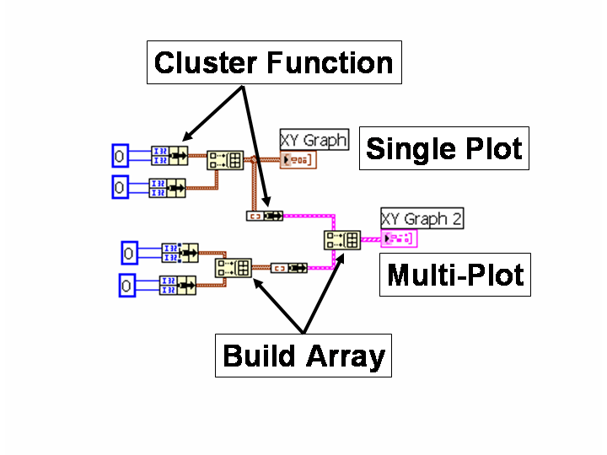
Figure 7.1: For single plot graphs: numbers → cluster → array, for multi-plot: numbers → cluster → array → cluster (single plot) → array.

Property Nodes
A property node is a node that can read or alter the properties of an object in LabVIEW. To create a property node, you can right-click on an object or a terminal (object in the block diagram) and select Create:Property Node. Alternatively, you could open up the palette on the block diagram and select Application Control:Property Node. After creating the property node, you can right-click on it and select Link To…, which opens up a menu containing all of the objects in your current VI. Simply select one to link that property node to that object. Examples of object properties are: value (signaling), caption, height and width, placement on the front panel, min or max values (for the x-scale of a graph for example) and visible. The value signaling property will become very important once we begin event-driven programming. There are many properties you can alter, some of which are object specific, far too many to list. The best way to learn how to use some of the properties work is to create some property nodes for different objects and examine your options. Clicking on the property node allows you to change the property being displayed. You can also drag the bottom of the property node, which expands it, so that you can display more than one property at a time for a given object. Right-click on the property also brings up option to change the read/write status of that property or all properties currently being displayed for that node.
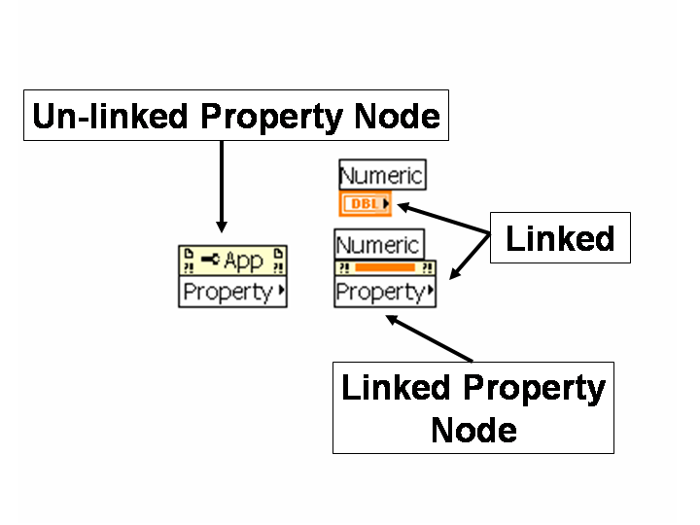
Figure 7.2: Property Nodes

Text Ring and Enums
Text rings and enums (short for enumerated) are very similar objects; they both allow you to create a pull-down menu of options. To create a text ring or enum, on your front panel palette, go to Ring & Enum and select one. By right-clicking on it, you can go to Edit Items, where you can add different options. You will notice each option gets an index number; this is how you can set your object to a certain number (you should also notice on the block panel, that text rings and enums are blue; the same color as integers). If you wanted to manually set your ring to option 2, simply wire a 2 to the text ring. The difference between the two comes in how you read what option has been selected. For both objects, it is best to use a case structure. Wire the output of your text ring or enum to a case structure and it will automatically change the cases to the first two by index number. However, text rings display the case by index number and enum by the title of your option. Each works well for a certain situations. If you right-click on the case structure, you can select Create Case for Every Value, which does exactly what the name suggests so you do not have to do it manually.

Formula Nodes and Expression Nodes
As you have seen, doing math in LabVIEW can be a bit cumbersome. However, complex math can be made much easier using formula nodes and expression nodes. To place an expression node, open up the block diagram palette and go to Numeric; there you will find the expression node. Formula nodes are found under the Structures menu in the block diagram’s palette. An expression node is essentially a simplified version of a formula node. With an expression node, you have only one input, which is always denoted by x, and one output. You do not need to use a y = or anything, just type in your expression and your output is the result of that expression. With a formula node, you can have more than one input and output. You do this by right-clicking on the node’s walls and selecting Add Input or Add Output. By typing in the box that appears, you can give the variable a name (can be a multi-character name). You then wire values to it the same as any other input/output scheme. Finally, in formula nodes you can write multi-line expressions. Each line is separated by a semicolon.

Syntax
Here is a quick note on syntax, which is the same for both formula and expression nodes. To multiply, you must use a *, you cannot simply leave a space between the two variables as in Mathematica. To raise a number to a power, you use ** rather than ^ (e.g. x**y = x^{y}). To use functions, like sine and cosine, you type the function code followed by parentheses, which surround the value you want to input to the function. Some common functions are below; a more extensive list can be found in the LabVIEW help file.
exp(x) (e^{x}), cos(x), sin(x), log(x) (base 10), ln(x) (natural log), abs(x) (absolute value), sqrt(x) (square root), ++ -- (increment, decrement)

Furthermore, you can use logical operators in both the expression nodes and formula nodes. Some logical operators are shown below; once again, refer to the LabVIEW help for more. An output of 1 and 0 will be used to denote true and false respectively.
|| (or), && (and), == (equals), != (inequality), > < (greater than, less than)

Exercise 7.1: Graphing Calculator: add a graphing function to your calculator. You should be able to enter a polynomial function in a text box and have the program graph it. HINT: If you do not want to try to figure out how to extract a polynomial from a text box, you can just create an array, which contains a cluster of two numbers; the coefficient and the x power. Furthermore, it should be able to do a “stat plot” – plot a list of points. It should just graph a line for the function, but show each point for the stat plot, with the option of connecting the points (you may want to add an order by x value button for the list). Make an input for the x and y max and min. Make a switch to make it auto-scale or manual. HINT: The name of the property that does this is XScale.ScaleFit and the values are 2 for auto and 0 for manual.

Exercise 7.2: Numerical Solution to a Differential Equation: create a program that graphs the solution to the three differential equations (DEs) below. You should be able to choose which of the three DEs you are graphing using an enum. You should graph two solutions: the analytical solutions (given) and the numerical solution using Euler’s Method (also described below). (HINT: Even for the analytical solution, you are still just plotting points; that is, just feed in the x’s to the solution function and plot those points. You will have to determine how many points to feed in.) It should plot them simultaneously. Furthermore, create a slide to adjust the plotting speed so that you can watch it plot if you so desire. Also, you should be able to adjust the color of each plot. The color property for the graph takes the input in the following fashion: RRGGBB, where it is a hexadecimal number. The odd thing is, even though that the format to determine the color is hexadecimal, the property node takes decimal numbers. So it will work best to have three numerical inputs, convert these to a hexadecimal string, concatenate them together and then convert that into a decimal number to send to the property node. To select the plot whose color you are altering, use a text ring. You should also set the range on the plot accordingly.
Differential Equations Initial Conditions Analytical Solution
1. 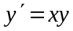 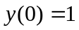 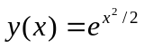
2. 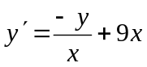 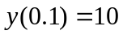 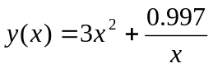
3. 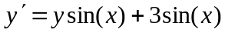 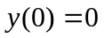 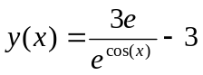

Euler’s Method: To approximate the solution to a differential equation, we use a tangent line to approximate the next y value. Since our differential equation represents the slope of the line, our tangent line looks as such:
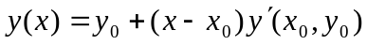 (since y’ may be a function of both x and y)

So the next y value can be predicted based on the old y value and x value. This method is an iterative method, where each step we increment our x value by some step value h. So if we have our k^{th} approximation, we can generate the (k+1)^{st} approximation using the following:
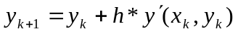

Some pseudo-code for Euler’s Method:
x = x₀, y = y₀, h = (step size), stop = (stop value for x); “initialization”
f(x_,y_) = (your differential equation); “input diff. eq”
Do While (x <= stop) “loop to generate our values”
y = y + h*f(x,y); “generate the new y”
x = x + h; “step our x value”
Print[x,y]; “Prints the new x and y values – could also store them in an array”
End;
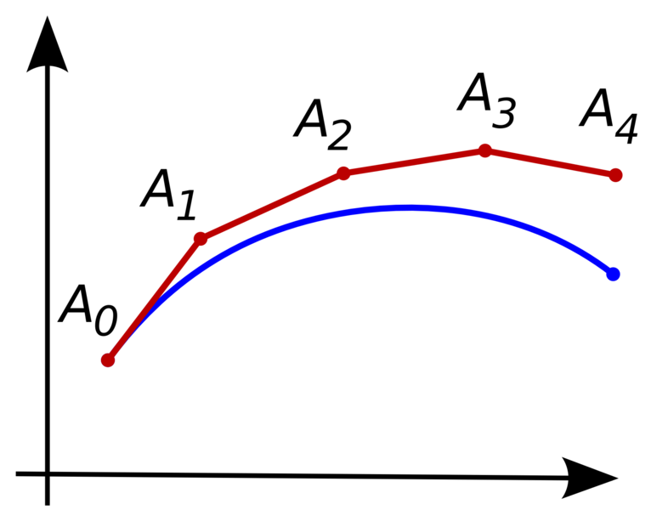
Figure 7.3 Graphical Representation of Euler’s Method, the blue is the analytical solution while the red represents each iteration of the approximation.
1.1.8 Decorations – Making it Look Nice (Interlude) Back to Top

In addition to functional front panel objects, you can add front panel objects that merely enhance the appearance or make the front panel easier to read and decipher. All of the decorations can be found in the front panel palette under Decorations; there are many to choose from in a variety of shapes and sizes. One of my personal favorites is the Recessed Box, which is helpful for grouping objects on the front panel together. Other handy ones are the label, the arrows and the other shapes for grouping items together. Note that when I mention grouping here, it is nothing more than visually grouping your items together; it has no consequence on the how anything behaves. Explore this area of the palette and see what each one looks like on the screen. Refer to chapter 1 if you do not remember how to change the order on the front panel; this will be help as many of the decorations are opaque.

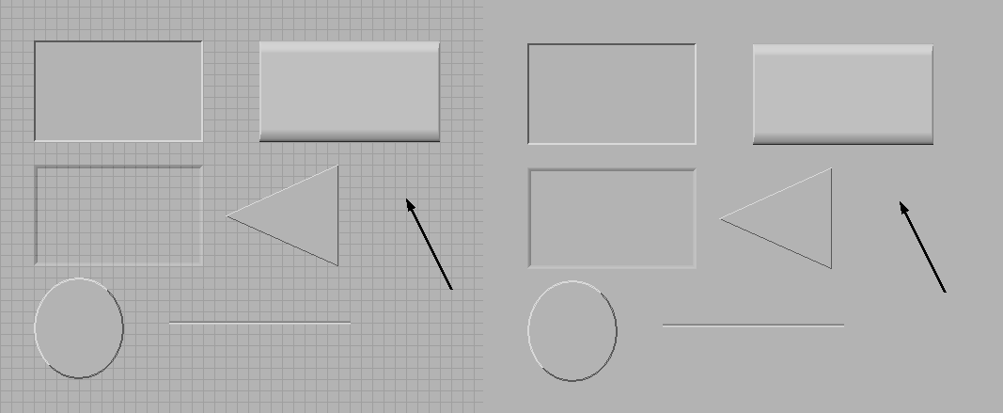
Figure 8.1: Examples of some decorations during development (left) and runtime (right).

Exercise 8.1: Pretty Calculator: Add some decorations to your calculator to make it easier to read. Group all your buttons together in some sort of decoration, as well as your input and outputs. Furthermore, add a snazzy title area to your calculator, which proudly proclaims your calculator program to be the best in the land.

1.1.9 Event Handling: Efficient User Input and Variants Back to Top
what are and why use?
Basic components
Notify vs filter
Static and dynamic, registration
Programmatically generating events
Dynamically loading VI
Controlling front panel objects
Passing references

Exercise 9.1: Analyzing the Efficiency of the Event Handling Structure: write two programs that do a very simple task; they check a button repeatedly and add one to a counter if it is pushed. Write one program using the previous loop techniques and one using event handlers. Also add a loop iteration counter for both programs (for the overall while loop that checks the buttons). Now open up your task manager and loop at the CPU usage. Run both programs and note any interesting observations.

Exercise 9.2: Interrupt Button Revisited: create a program that has two buttons; one to counts and one that stops it. The counter should be activated by a start button and after the second button has been pressed output the time elapsed (a non-updating stop watch if you will). Make the counting routine a subVI. Use event handling to stop the counter without creating a separate event structure to continuously check your interrupt button. HINT: You can pass a reference to a front panel object. Details are on page 5-22 and 5-23 of the LabVIEW manual.

Exercise 9.3: Calculator v2.0: try to rebuild your old calculator using event handling; you should have lots of work done already because you created some subVI’s from chapter 6. The catch this time is to try to make it behave like a real calculator. That is, have one input area where you would input a number, hit add, then another number, hit equals and get an answer in a display. Check it out on your computer calculator to see how it works and see if you can duplicate that.

1.1.10 Time and Dialogue Back to Top

Exercise 10.1: Simple Dialogue Boxes

Exercise 10.2: Stop Watch Program: create a program that has two buttons; one to start a stop watch (accurate to hundredths of a second) and one to stop it. HINT: Think what would work better, wait or wait until next multiple. Add functionality to store laps and make sure to have a clear/reset button. Also format the display to look like a stop watch (i.e. in 00:00:00.00 format).

1.1.11 Debugging Back to Top
Suggestions – no Exercise

1.1.12 File Operation Back to Top

Exercise 12.1: Clock In/Out Machine

1.1.13 Misc. Topics Back to Top

1.2.1 Communicating with Instruments: Back to Basics Back to Top
GPIB
RS232
USB

1.2.2 Handling Error from Instruments Back to Top

1.2.3 Serial Polling Back to Top
2.1 The Spectrometer Back to Top

In this tutorial we will learn to control the spectrometer using LabView. What is nice about this instrument is that it comes with most of the functions we will need already written, so there is no need to rewrite them or use the programming manual that came with it. This contains all the commands that the subVI’s use to actually control the instrument. All the subVI’s that came with the spectrometer can be found in the library iba_user.llb in …\Spectrometer\Libraries. The two that I wrote can be found in the main Spectrometer folder. Places in matrices are defined as (row,col)

There are a few basic functions we are going to want to be able to do:

- Learn to initialize the spectrometer.
- Control the grating, which affects the wavelength that the spectrometer is currently reading. We will want to control not only spinning the grating, but which grating (turret is the place which holds the grating) we are actually using. There are 3 turrets, though only 2 gratings, which means one spot is empty. We will primarily use turret #1. We will want to read and write the spinning but can only write the turret setting.
- Control the slits, which, by altering their widths, adjust how much light is entering the spectrometer and the photomultiplier tube. There are four slits, but we only use two – the axial entrance, which controls how much light enters the spectrometer, and the lateral exit, which controls how much light enters the photomultiplier tube. It is recommended by the manual that we keep the entrance and the exit the same for best results. We will want to read and write this.

Your task at the end of this will be to write a short program that controls the spectrometer and has the following features/does the following tasks:

- Initializes the spectrometer on start up and through a button – both time reading the instrument settings.
- Can set the turret and read the blaze wavelength and groove density
- Can read the wavelength (preferably continuously, at least every half second)
- Can change the wavelength to a user defined one, checking the allowable limits of the spectrometer. You should also be able to watch the wavelength progress on an indicator as it steps forward.
- Can read the slit widths.
- Can set the slit widths, checking the allowable limits before hand.
- Have a button that just closes the slits (that is sets them to zero).
- An error and spectrometer ready (that is already initialized) indicator.
- A mechanism to ensure that one cannot change anything on the spectrometer until it is initialized.

A solution can be found at Spectrometer Tutorial.vi. Please note this is not the only possible solution (or necessarily the best) just the route that I took.

- Initializing the spectrometer
It is important to initialize the spectrometer at the beginning of every program you write (or every part of the program where you might try to access the spectrometer for the first time in that program). It is actually only necessary the first time you use the spectrometer after you turn it on, but since the spectrometer is rarely off, this is seldom. However, it could happen and rather than having to run a separate program before you can use your main program, it is good to put it the main code. It only takes a few milliseconds to complete if the spectrometer is already initialized, so there is no harm in doing it more than necessary.
The actual initialization of the spectrometer is carried out by a subVI that came with spectrometer entitled Start up.vi. This does the dirty work – all you have to define is the number of contact attempts, which I generally set to 2, which seems to work well. This will attempt to contact the spectrometer and three possible things can happen:
  - The spectrometer has already been initialized, which is the most likely case. It will simply return the boot version and the main version, which contain no important information, though I like to have it pop up just to be sure that has made contact and things are running smoothly. The boot version and the main version are stored in positions (0,0) and (1,0) respectively of the array Controller Program Versions. Start up.vi will also output an error, which will be true if an error has occurred.
  - The spectrometer has not been initialized but is able to be initialized. This process takes several seconds, as the spectrometer spends some time spinning the gratings to find the correct one. After it is done, it will return the boot version, main version and error as in the case beforehand.
  - The spectrometer has not been initialized and cannot be for whatever reason (most likely = power unplugged). This time, the program will not return the boot version or the main version, simply “Error = T”. The program Start Up.vi will attempt the contact the spectrometer until it times out, so generally I set the timeout to 1000 ms before I run Start Up.vi.
It is also a good idea once you have made contact with the spectrometer to read all the variables (wavelength, slit width, etc) to see what the spectrometer is set to.
I have put this entire process into a subVI called Initialize Spec.vi, which you can use in test program if you want, or you can try and write one from scratch. You will need to read the next two sections to find out how to control the grating and the slits so you can read them in your initialization program.
- Controlling the grating
The grating is the main part of the spectrometer – it controls what wavelength you are on and what range of wavelengths you have (by changing which grating you are using). The first step in communicating with the grating will be set the turret, so that you have the correct information to know which wavelength you are on.
  - Setting the turret
Unfortunately there is no way to simply read which turret you are using (at least that I have found yet). You must simply set the turret at the beginning of your program, which I do in the initialization subVI (Initialize Spec.vi). Knowing what turret, and therefore grating, you are using is important, because gratings can have a potentially different groove density, which the program thatcontrols the wavelength position uses to determine which wavelength it is on. However, both gratings used now have the same groove density of 1200 groves/mm, but if another grating were added with a different groove density, this would be important.
To set the turret, you use the program Port & Grating.vi, which was supplied by the manufacturer. You input the spectrometer number, desired turret number and the mirror positions and you receive as output the error, blaze wavelength and groove density of the grating.
- The spectrometer number is zero and is only meaningful if you have more than spectrometer you are trying to control with the same program.
- The desired turret number is either 0, 1, or 2, but only two of them actually have gratings (0 and 1 – on the back of the spectrometer that corresponds to grating 1 and 2, respectively. I will always refer to them by either 0 or 1 because that corresponds to the coding). Turret position #1 is what we have used for almost all of our experiments to date, therefore, when I initialize the spectrometer, I tell it to go to turret #1, which it is usually already at.
- There are two mirror positions, entrance and exit and can be set to either T or F, which correspond to “in position” and “out of the way” approximately. The mirror settings are always the same, entrance = F and exit = T. Entrance is set to F because there is no mirror here and exit is set to T because the exit mirror is needed to direct the light into the proper exit slit.
- The error returns as T if something has gone wrong with Port & Grating.vi.
- The groove density is used by the wavelength program to determine which wavelength it is at, however, it retrieves this data automatically from a global variable used by Port & Grating.vi, so there is no need to save the variable yourself. I usually display it, because it often more important to know that than the turret number.
- The blaze wavelength is not as important for the program as the groove density. Basically the blaze wavelength (or blazing wavelength) refers to the wavelength where the particular grating is most efficient.
  - Reading the wavelength
Reading the wavelength is accomplished with a subVI provided by the manufacturer called Spectral Position.vi. You have to just input the spectrometer number and it will output the current wavelength, the spectral unit and the error. To my knowledge, the spectral unit will never change from nm. I believe it is primarily there to make programming with other models easier, which may have ranges crossing the nm limit. Once again, the error will be T if there was a problem.
  - Setting the wavelength
One sets the wavelength using a manufacturer-supplied program called Spectral GOTO.vi, found in the usual library file. To set the wavelength you need only input the spectrometer number and the desired wavelength and it will output error, limit hit and invalid wavelength. So that we don’t have to worry about these indicators (and as a matter of good form), it is probably a good idea to set up a check for the wavelength being passed to Spectral GOTO.vi to ensure it is within the limits, which are 0 nm and 1400 nm for both gratings.
One thing that I usually do is to run the Spectral GOTO.vi and Spectral Position.vi simultaneously (Spectral Position.vi will have to be in a loop – the other won’t), so that the program displays the wavelength as it is moving – not only is it a cool effect but it also lets us know that it is still moving. To achieve this effect, set up two frame structures in the area of the code where you are going to want to move the grating – one to tell it to move the grating and one to track the changes, using a variable to signal from “move to section” to tell the “tracking section” that you are at the required wavelength. A possible solution is in Spectrometer Tutorial.vi.
- Controlling the slits
The slits control much light enters the spectrometer – therefore the width of your slits will be proportional to the number of counts you get. Letting in too much light can damage the photon counter, so it is always good to have safe guards in place, but that will be covered in the photon counter tutorial.
  - Reading the slits
Unfortunately there was no “read slits” subVI when we received the library files from the manufacturer; however I was able to modify the “set slits” subVI, called Slits.vi, to only read the slits and not set them. The read only subVI is called Read Slits.vi and can be found in the main spectrometer folder. The only input is the spectrometer number and you receive as an output the four slits and error. The first and last slit (axial entrance and lateral exit respectively) are the only two that you need to concern yourself with when writing a program.
  - Setting the slits
To set the slits, you can use the built in subVI Slits.vi, where you specify the slit widths in mm and the spectrometer number and you receive as an output the adjusted slit widths and error. Once again, only the first and last slits concern us, the other two can be left blank (the default is zero, which is fine). It should also be noted that the smallest possible step size is 0.002 mm – the computer will automatically round it for you to the closest one (though curiously, 0.001 mm is rounded to 0.000 mm, even though 0.003 mm is correctly rounded to 0.004 mm)

Useful Information:
- Gratings
  - Grating 0
    - Groove Density – 1200 g/mm
    - Blaze Wavelength – 500 nm
  - Grating 1
    - Groove Density – 1200 g/mm
    - Blaze Wavelength – 750 nm
- Slits
  - Ones in use – Axial Entrance and Lateral Exit
  - Min – 0 mm
  - Max – 2.24 mm
  - Step – 0.002 mm
- Spectrometer Files:
  - Manufacturer supplied – C:\LabView Programs\Spectrometer\Libraries\iba_user.llb
    - Start Up.vi
    - Port & Grating.vi
    - Spectral Position.vi
    - Spectral GOTO.vi
    - Slits.vi
  - Other – C:\LabView Programs\Spectrometer
    - Initialize Spec.vi
    - Read Slits.vi
    - Tutorial – Spectrometer Tutorial.vi in folder Spectrometer
2.2 The Pulse Generator Back to Top

The Agilent 81110A Pulse/Pattern Generator, as its name suggests, can do two major things; put out a pulse that repeats itself or put out a certain pattern. The pulse is simple – just up and down, what you control is the frequency, amplitude, duty cycle, etc. The pattern generation is more complicated but ultimately more useful – it is this feature that we will use more often than not.

In this tutorial, you will learn to do the following things:

- Learn some basic commands and also which preexisting subVI’s can be used in place of those commands.
- Learn to use the pulse mode of the pulse generator by adjusting the frequency, amplitude, etc.
- Learn to use the pattern mode to create different shaped patterns (this will also require the basic pulse concepts such as frequency and amplitude learned above).
- Write a small program to use both modes as well as initialize the pulse generator.

Communicating with the Pulse Generator
Communicating with the pulse generator is straight forward – it uses GPIB and works well with LabVIEW. For the most part, you shouldn’t have to worry about talking to the pulse generator directly as there exists a system of subVI’s to do all a number of tasks, though we will still cover the basics of GPIB communication in the first section. The subVI’s are located at C:\LabVIEW\Instruments\Pulse Gen\... to see all these subVI’s. There are subVI’s to do the following tasks:
  - Check to see if the pulse generator is on.
  - Set/Read the voltage levels.
  - Set/Read the period or frequency.
  - Set/Read the pulse width or duty cycle.
  - Set/Read the output status (output 1, not-output 1, output 2, not-output 2).
  - Set/Read the various digital parameters associated with using the pattern mode (pattern mode on/off, NRZ/RZ).
  - Turn on and off the display on the front of the spectrometer.
  - Set the arming source of the pulse generator.

- Basic Commands

The pulse generator uses GPIB to communicate, so use the appropriate GPIB communication subVI’s supplied by LabVIEW. The commands are always preceded by a semicolon and there is a semicolon between each section of the command. After the command is fully specified there is a space and then the value(s). If a unit is needed it follows the value directly (no space) and is also in all caps. Queries are simply the command followed by a question mark (no space). There is often a channel number associated with the command, since there are two channels and this comes directly after the command, before the question mark or space. Also note that if you look in the manual at the commands they usually appear longer – anything in brackets is optional. I will always give the shortest possible command. If a channel number is specified, channel 1 is assumed.

  - Asking for the Pulse Generator’s System Version
A query that returns the current system version – usefully for checking to see if the pulse generator is on/connected.
:SYST:VERS?
  - Default Settings
Resets pulse generator to the default settings. Exception to the usual syntax because this is a general GPIB command that works on any GPIB compatible piece of equipment. Default settings can be found on page 33 of the Agilent Reference Guide.
*RST
  - Frequency-Period
These two settings are linked – that is if you change one, you necessarily change the other and it doesn’t matter which one you specify. Telling the pulse generator a frequency of 1 Hz or a 1 sec period is the same thing.
:FREQ (value)(unit choice – S MS µS NS)
***responses from the pulse generator always use S
:PULS:PER (value)(unit choice – HZ KHZ MHZ GHZ)
***responses always use HZ
  - Duty Cycle-Width
As with the previous set of commands, these two are linked. Duty cycle refers to the percentage of time that the pulse is “on” or at the high voltage level. This is specified using a percentage, from 0 to 100. Width specifies the same thing, except you do it with a time, 50NS for example. Width must be between zero and the period currently in use.
:PULS:DCYC(1|2) (value)%
PULS:WIDT(1|2) (value)(unit choice - S MS µS NS)
  - Voltage Levels
Sets the voltage levels – there are several ways to do this, but the easiest is to specify a high voltage and a low voltage. The other ways to set the voltage can be found in the reference book. Note that these commands are all linked as well.
:VOLT(1|2):HIGH (value)(unit choice – V MV)
:VOLT(1|2):LOW (value)(unit choice – V MV)
***responses always in V
  - Outputs
There are four total outputs – output1, not-output1, output2, and not-output2. Output1 is for channel 1 and output2 is for channel 2. All four can be turned on and off separately.
:OUTP(1|2) (ON|OFF)
:OUTP(1|2) (1|0)
:OUTP(1|2):COMP (ON|OFF)
:OUTP(1|2):COMP (1|0)
***responses will be given in terms of 1 (on) or 0 (off)
  - Pattern Mode On/Off
This command simply sets the machine in either pattern or pulse mode.
:DIG:PATT (ON|OFF)
*responses are given as ON or OFF
  - Loading Pattern Data
This command is used to load the pattern into the pulse generator. The pattern itself is just a string of 1’s and 0’s, which correspond to high and low voltage respectively. This command is slightly more complicated than most of the others.
:DIG:PATT:DATA(1|2) #(length of header)(header, which tells the length of the data)(data)
***there are no spaces after the # - length of the header is just a number (1 – 9). The header consists also of 1 – 9 and can be as long as you specified earlier. . The data must be only 1’s and 0’s. (I think 2’s are possible if you are using the output adding function, but I am not sure about this) The header can only be 9 bits long!! This means the max length of pattern is 999999999.
Example:
:DIG:PATT:DATA1 #1510101
The pattern goes to channel 1 – the header is 1 bit long, the pattern is 5 bits long and the pattern is 10101
  - “Return to Zero” Status
This is a setting for pattern mode. If it is set to return to zero (RZ) then after each bit in the pattern, whether it is a one or zero, the pulse generator goes to zero. Conversely, if you are in not return to zero status (NRZ), then the pulse generator stays at whatever voltage level the bit from the pattern tells it to.
:DIG:SIGN(1|2):FORM (RZ|NRZ)
***responses are given as RZ and NRZ
  - Pattern Updating
When uploading a pattern, the pulse generator can either switch to the new pattern right away (pattern update = auto) or it can keep the old one running and hold the new one in its memory until you manually tell it to switch. So we have three commands – to set it to auto, set it to manual and to tell it to update.
:DIG:PATT:UPD ONCE
  - Triggering and Arming
There are two commands here that are related, but not quite the same. Arm refers to when you are ready to start a new period/pattern. Trigger refers to when you actually start your next period/pattern. By setting the trigger source to the internal osc. (INT) we can sync these two up, so that every time it is armed, it triggers right away. This will be our most common mode of operation. For most of our experiments, we will arm using the external input (EXT1) and hook up the PEM out to the external input. This way our pulse generator will stay synced with the PEM, keeping our laser pulse synced with changes in retardance of the PEM. If you simply want to output a 30 MHz continuous wave, set your arm source to IMM.
:TRIG:SOUR (INT|INT2|EXT2)
:ARM:SOUR (EXT1|INT2|IMM|MAN)
INT = Internal osc.
INT2 = Internal PLL
EXT1 = External Input on the front of the pulse generator.
EXT2 = Clock-In on the back of the pulse generator
IMM = Signifies continuous mode where the next period/pattern starts right after the previous
MAN = Manual key (on the front of the pulse generator).

Additionally there is trigger count (:TRIG:COUN) which can allow you to do tw periods/patterns for each arm. Each new period/pattern is triggered by your trigger source. We will usually keep this at one.

Note: The PLL (INT2) cannot be used as both a triggering and arming source)
  - Turn on/off display
This command simply turns on or off the display – the pulse generator programs faster when the display isn’t on, so when speed counts turn it off!
:DISP ON
:DISP OFF

- Pulse Mode
All pulse mode means is that you are creating a periodic wave, which may be continuous or triggered based on your preferences. In its most basic form, pulse mode simply puts a TTL of a certain frequency. You already have all of the commands you will need to run the pulse generator. Pulse mode is the easiest mode to run it in; all you need to do is specify your freq/period, width/duty cycle and voltage levels. You may have to adjust the triggering and arming sources if you are starting off with the default settings.
(include examples and Exercises)

- Pattern Mode
Pattern mode is a bit more complicated than pulse mode – in pattern mode you are defining a pattern using 1’s and 0’s (high and low voltage respectively). The sending of the pattern is only slight complicated, once you figure out where your header is and such. The most complicated part is probably generator the pattern using an interface that people can easily understand. You can see one way of doing this in a the subVI Build Pattern into String.vi. Basically you input your desired periods of on and off, along with your actual period and it fits a string of 1’s and 0’s to it. It should also be noted that most of the programs will do the opposite of what you want (in terms of 1’s and 0’s) because for the laser is actually on for 0’s and off for 1’s. This seemed a more like a more logical approach to things when the programs were first written because the user only had to think in terms of the traditional 1 and 0, rather than having to switch it all in ones mind.
(include examples and Exercises)

- Exercise

Create a program with the following features/abilities:

- Initialize on start up and through a button (i.e. create a subVI for initialization).
- Can create either patterns or pulses and a toggle between.
- Adjustable amplitude.
- Adjustable frequency or period and can toggle between the two.
- Adjustable duty cycle.
- Pattern as follows:
  - User defined number of sections (areas that alternate between up and down)
  - User can adjust the length of each section separately.
  - Your program must process this information and turn it into a pattern that the pulse generator can use (a string) – make this into a subVI.
- A button to send all the new information to the pulse generator (i.e. it doesn’t update real-time, rather only when you tell it to).
- A text box that displays the current settings of the pulse generator (at least all the items that are supposed to be adjustable) – updated every 0.5 seconds.
- Can select with output you want to use.

- Useful Information

  - Minimum Period: 3.03 ns (330 MHz)
  - Maximum Period: 999.5 s (0.001 Hz)
  - GPIB Address: 10
  - Bus: 0

2.3 The Photon Counter Back to Top

A photon counter is a device that does exactly what its name suggest; it counts photons. It does this by examining current spikes from the photomultiplier tube (PMT). Each time a photon strikes the detection surface of the PMT, an electron is released via the photoelectric effect. This electron then strikes a series of dynodes, which release additional electrons. For example if one dynode releases 5 electrons for each electron it receives and there are 6 dynodes, then one photon generates 5⁶ = 15,625 electrons. Thus one photon generates thousands or even millions of electrons.
The photon counter has nothing to do with this detection process – it merely counts the current spikes to determine how many photons have been detected, but it does have special capabilities. A photon counter must be able to detect these current spikes, set a level (called a discriminator level) to determine how the high the spikes must be and, of course, count fast. Additionally, many photon counters are gated, which means that over different intervals, the photons are counted by different channels. For example, if you are counting over 1 second, you can define the first half second to be counted by channel A and the second half second to be counted by channel B. Of course, this arrangement can be more complicated. All of these are settings that can be adjusted via LabVIEW.

In this tutorial, you will learn to do the following things:
- Learn some basic commands and also which preexisting subVI’s can be used in place of those commands.
- Learn to count photons both with and without gates.
- Write a small program to use both modes as well as initialize the photon counter.

    - Basics

    - Gating

    - Exercise
Create a program that does the following things:
  - Initializes with the basic settings that are almost never changed.
  - Counts photons for a set time period and displays both total counts and normalized counts per second (CPS). This will involve creating a subVI that acquires the data from the photon counter (using a serial poll). It should be able to count for one cycle or continuously.
  - Create a stop counting button. This will probably require use of global variables.
  - Can count in gated or un-gated mode, with one or two channels.
  - Can adjust the gate width and delay.
  - The program should be able to take the count time input as seconds and adjust them in terms of the number of cycles for whatever counter you are using.

    - Commands

Cmd List
0 CM {j} Counting Mode
1 CI i {,j} Counting Inputs
2 NP {m} Number of Periods
3 NN {j} Scan Position
4 NE {j} Scan End Mode
5 DT {x} Dwell Time
6 SD {j} Count Disp Mode
7 TS {j} Trigger Slope
8 TL {v} Trigger Level
9 DS i {,j} Disc Slope
10 DM i {,j} Disc Mode
11 DL i {,v} Disc Level
12 GM i {,j} Gate Mode
13 GD i {,t} Gate Delay
14 GW i {,t} Gate Width
15 CS START Key
16 CH STOP Key
17 CR Reset Counters
18 CL Default State
19 SS {j} Read Status Byte
20 ST m Store
21 RC m Recall
22 QA Read A
23 QB Read B
24 CP i {,m} Counter Presets
2.4 LCD Retarder Back to Top
2.5 Magnet Back to Top
3.0 Helpful Coding Suggestions Back to Top
4.0 References and Further Reading Back to Top

- LabView7 Express: User Manual.
- LabView7 Express: Getting Started.
- LabView7 Express: Development Guidelines.
- LabView for Dummies. < http://www.iit.edu/~labview/Dummies.html>
- Info-LabView. <http://www.info-labview.org/>
- LAVA: LabView FAQ. <http://forums.lavag.org/index.php?showforum=30>
  - LabView forums where you can read posts and ask questions.
- National Instruments: LabView. <http://www.ni.com/labview/>
  - LabView homepage.
- LabView Developers Zone. <http://zone.ni.com/devzone/labviewzone.nsf/ OpenPage?openagent&lvsection=labviewzone>
  - LabView developers site supported by National Instruments.

5.0 Appendix Back to Top
5.1 Numerical String Formatting Back to Top
The format is:
%.(digits past decimal)(display type)
Example: %.3f = floating point with 3 digits of precision (3 digits past the decimal).
10.4533 → 10.453
%.2e = engineering (scientific) format with 2 digits past the decimal.
10.4533 → 1.05E+1
The allowed formats include:
    - f = floating point
    - e = scientific or engineering format
    - p = floating point in SI format
    - g = LabVIEW uses floating point if the value of the exponent in scientific notation is > -4 or less than the precision specified; otherwise it uses engineering format
    - x = hex
    - o = octal
    - b = binary
    - u = unsigned

**Certain members of the scientific community, especially those in computationally heavy areas, will recognize this as FORTRAN formatting.

Note: I would recommend changing your palette options. Go to “Tools:Options…” and find “Controls/Functions Palettes” in the pull down menu. From there, choose “Palette View” to be “Advanced” and “Format” to be “All Icons”.
Some computer languages distinguish between functions, which return a value, and procedures/subroutines, which simply do something, but do not output anything.
For more information on what a spectrometer is, see the manual that came with it or http://en.wikipedia.org/wiki/Spectrometer
For a complete set of the commands used to communicate directly with the pulse generator, see the Agilent 81110A Reference Guide, beginning on pg. 43.
There is a problem with this; thermal energy can lead to the spontaneous emission of electrons, which will be registered as a false photon. The sum of the spikes generated from thermal emissions is known as the dark current and it obviously dependent on temperature. Our PMT is cooled to approximately -40 C, where the dark current is in the single digits of counts per second. Further PMT information: http://en.wikipedia.org/wiki/Photomultiplier.

