Scheduling in LabVIEW: A Crash Course

Introduction
LabVIEW is a dataflow language which demands parallelism. However, most computers have only one processor, and even though modern operating systems can support several tasks at once (“multitasking”), the CPU can process only one instruction at once. To overcome this, the OS and LabVIEW alike use a scheduler to simulate concurrent execution of tasks. However, scheduling introduces a whole host of problems, many of which can be solved using mutexes.

Terminology
Please consult Wikipedia if these terms are unfamilar.
- Task – generic term for a something a computer needs to do.
- Process – one application program on your computer, e.g. Firefox or Internet Explorer.
- Thread – one simultaneous subtask of a process, e.g. Firefox:Contact web server, Firefox:Paint graphics on screen, Firefox:Get user input.
- Multitasking – an operating system that can process several tasks at once.
- Sleep – all threads that are not currently loaded into the CPU are sleeping.
- Scheduler: the operating system's mechanism that chooses which thread will run when and for how long..
- Timeslice – the maximum time a thread may execute before the scheduler puts it to sleep (if others are waiting.) Usually on the order of 50ms.
- Context switch – the act of swapping one thread on the CPU for another.
- Mutex – a key to the toilet. Only one person can have the key – occupy the toilet – at one time. (Sometimes called a semaphore.)
- Critical section – a short task that should never be interrupted.

Naïve examples
I need to wash the dishes and call my buddy on the phone. Each takes three minutes. I can order the tasks like this:
Time | Task
1 | Dishes
2 | Dishes
3 | Dishes
4 | Phone
5 | Phone
6 | Phone
Or I can order them like this (or any other combination, for that matter):
Time | Task
1 | Dishes
2 | Phone
3 | Dishes
4 | Phone
5 | Dishes
6 | Phone
Obviously, the first case is optimal. No one wants to be put on hold for a minute while I switch to do the dishes. But unfortunately, a computer must do several things simultaneously to keep the user from getting impatient. Here's a real example, where a disk drive is working far faster than a user's fingers on the keyboard:
Time (ms) | Task
0 | File copy to disk
1000 | Handle keyboard interrupt, paint character “h” on screen
1010 | Handle keyboard interrupt, paint character “i” on screen
1020 | Finish
Or alternatively:
Time (ms) | Task
0 | File copy to disk
100 | Handle keyboard interrupt, paint character “h” on screen
110 | File copy to disk
510 | Handle keyboard interrupt, paint character “i” on screen
520 | File copy to disk
1020 | Finish
In the first case, the text comes on screen in fits and spurts, and only when it's convenient for the OS. Of course the user would prefer the second case, since it's much smoother. A real world operating system switches between tasks with ease, and does so fast enough that you probably won't notice.
However, this leads to concurrency problems during context switches. While LabVIEW's thread scheduler guarantees a VI its own timeslice if it contains no subVIs. Conversely, if a VI contains even one subVI, there is no guarantee that it will complete before something else begins. Context switching can generate arbitrary and unpredictable behavior that must be accounted for.

LabVIEW example
A user wants to write a scan program that sends the instrument I commands to move over a range of values. She also wants to use a separate program to monitor the current position on a display.
Each command to the instrument driver has three parts:
- Send command
- Read response
- Hang up
There are two atomic commands in this system:
- A: Get wavelength, shown in red
- B: Read wavelength, show in blue.
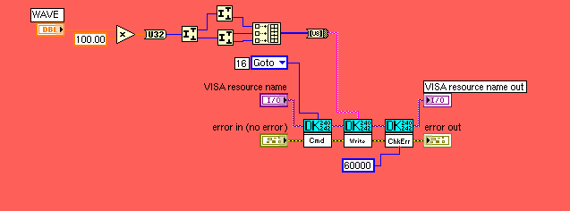
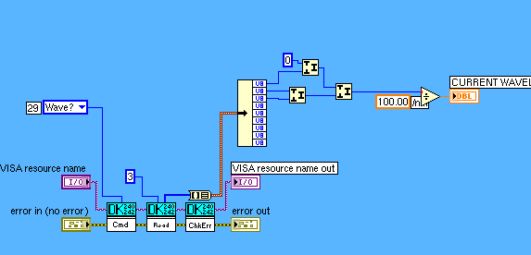
Ideally, the threads would be scheduled like this:
Time | Command | Transcript
1 | A: Goto wavelength | A>I GOTO 256
2 | A: Read response | A<I NOW AT 256
3 | A: Hang up | A>I KTHXBYE  A<I CYAL8R
 | Context switch; now in B
4 | B: Get wavelength | B>I WHUT WAVE?
5 | B: Read response | B<I 256
6 | B: Hang up | B>I KTHXBYE  B<I CYAL8R
However, LabVIEW actually scheduled the threads like this:
Time | Command | Transcript
1 | A: Goto wavelength | A>I GOTO 256
 | Context switch; now in B
2 | B: Get wavelength | B>I WHUT WAVE?  (instrument receives two commands in a row, and is now confused)
 | Context switch; now in A
3 | A: Read response | A<I 256
4 | A: Hang up | A>I KTHXBYE
 | Context switch; now in B
5 | B: Read response | B<I CYAL8R
6 | B: Hang up | B>I KTHXBYE  (no response)
Can you see why concurrent use of the instrument is difficult? A and B have both received the wrong responses, and the instrument is confused and might crash.

Solution
There are two solutions to this problem:
- Flatten the code
We could decapsulate the code into only one subVI. This would guarantee the task runs interrupted. However, this would create a horrible mess of spaghetti code and would be hard to read and maintain, thereby defeating the purpose of encapsulation.
- Implement a mutex
A mutex, or mutual exclusion signal, is a special programming technique to allow threads to be scheduled at will, yet still guarantee tasks run contiguously. In other words, it guarantees that only one person can use the toilet at once.
We will slightly modify the command structure. We need to find a critical section of the code at which to lock and unlock the mutex. This section should not be too big, lest we delay the user and defeat the scheduler, nor too small, since we don't want it to be interrupted. We will designate the critical section to be each atomic instrument command:
- Wait for signal and lock mutex
- send command
- read response
- hang up
- Unlock mutex and signal
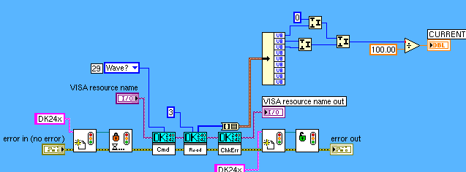
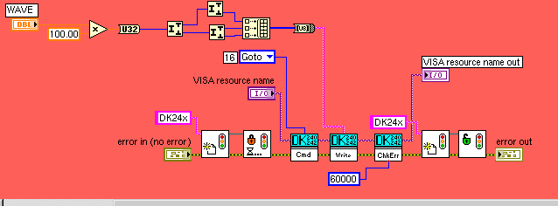
Here is how the two tasks will play out in real-time:
Time | Command | Transcript
1 | A: Wait  A: Lock | (Mutex initially unlocked.)
2 | A: Goto wavelength | A>I GOTO 256
 | Context switch; now in B
3 | B: Wait for signal | (Mutex locked by A. B gives up goes back to sleep.)
 | Context switch; now in A
4 | A: Read response | A<I NOW AT 256
 | Context switch; now in B
5 | B: Wait for signal | (Mutex locked by A. B gives up goes back to sleep.)
 | Context switch; now in A
6 | A: Hang up | A>I KTHXBYE  A<I CYAL8R
7 | A: Unlock mutex & Signal B | (A unlocks mutex. A signals B and terminates.)
 | Context switch; now in B
8 | B: Wait for signal | (A signals B, B continues and locks its mutex.)
9 | B: Get wavelength | B>I WHUT WAVE?
10 | B: Read response | B<I 256
11 | B: Hang up | B>I KTHXBYE  B<I CYAL8R
12 | B: Unlock mutex | (B unlocks mutex and terminates.)
Do you see how the mutex helped? The thread scheduler twice interrupted A with a B timeslice, but the mutex prevented B from using the instrument until A was finished with it.

Conclusion
In modern systems, multitasking can interrupt threads and cause undefined behavior. To guarantee that critical sections execute contiguously, one must implement a mutex. This allows scheduling and multitasking while keeping code running properly.

