Experiment No: 6

Name: Vaishnavi Kumar Sutar

Roll No: 54 Batch: T3

Q.Design Windows form based MDI application for different controls and field validation.

//File1.cs

namespace WinFormsApp5

{ public partial class Form1 : Form

{ public Form1()

{

InitializeComponent();

}

private void Form1_Load(object sender, EventArgs e)

{

}

private void toolStripTextBox1_Click(object sender, EventArgs e)

{

}

private void fileToolStripMenuItem_Click(object sender, EventArgs e) {

Form2 newMDIChild = new Form2(); newMDIChild.MdiParent = this; newMDIChild.Show();

}

private void newToolStripMenuItem_Click(object sender, EventArgs e)

{

Form2 newMDIChild = new Form2(); newMDIChild.MdiParent = this; newMDIChild.Show();

}

private void menuStrip1_ItemClicked(object sender, ToolStripItemClickedEventArgs e)

{

}

}

}

//Form1.cs [Design]

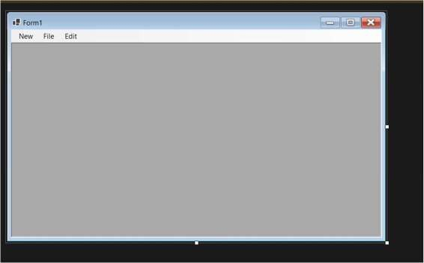

//Form2.cs using

System; using

System.Collections.Generic; using System.ComponentModel; using System.Data; using System.Drawing; using

System.Linq; using System.Text; using

System.Threading.Tasks; using

System.Windows.Forms;

namespace WinFormsApp5 { public partial class Form2 : Form

{ public Form2()

{

InitializeComponent();

}

private void richTextBox1_TextChanged(object sender, EventArgs e)

{

}

}

}

//File2.cs[Design]

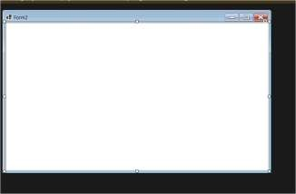

Output:

