**Experiment No 10**

Name: Vaishnavi Kumar Sutar

Roll No.: 54 Batch:T3

**Q. Design Simple Login & Registration page using client side validation controls in ASP.Net.**

m id="form1" runat="server">

<asp:Label ID="Label1" runat="server" Text="Enter Your Name"></asp:Label>

<asp:TextBox ID="TextBox1" runat="server"></asp:TextBox>

<asp:RequiredFieldValidator ID="RequiredFieldValidator1" runat="server"

ControlToValidate="TextBox1" ErrorMessage="Enter Something"></asp:RequiredFieldValidator> <p>

<asp:Label ID="Label2" runat="server" Text="Enter Your Surname"></asp:Label>

<asp:TextBox ID="TextBox2" runat="server"></asp:TextBox>

<asp:RequiredFieldValidator ID="RequiredFieldValidator2" runat="server"

ControlToValidate="TextBox2" ErrorMessage="Enter Something"></asp:RequiredFieldValidator>

</p>

<p>

<asp:Label ID="Label7" runat="server" Text="Enter Your Roll No"></asp:Label>

<asp:TextBox ID="TextBox7" runat="server"></asp:TextBox>

<asp:RequiredFieldValidator ID="RequiredFieldValidator7" runat="server"

ControlToValidate="TextBox7" ErrorMessage="Enter Something"></asp:RequiredFieldValidator>

</p>

<p>

<asp:Label ID="Label4" runat="server" Text="Enter Mobile No"></asp:Label>

<asp:TextBox ID="TextBox4" runat="server"></asp:TextBox>

<asp:RequiredFieldValidator ID="RequiredFieldValidator4" runat="server"

ControlToValidate="TextBox4" ErrorMessage="Enter Something"></asp:RequiredFieldValidator>

<asp:RangeValidator ID="RangeValidator1" runat="server" ErrorMessage="Should be

10 digit" MaximumValue="10" MinimumValue="10"></asp:RangeValidator>

</p>

<p>

<asp:Label ID="Label8" runat="server" Text="Enter Email"></asp:Label>

<asp:TextBox ID="TextBox5" runat="server" Height="16px"

Width="126px"></asp:TextBox>

<asp:RequiredFieldValidator ID="RequiredFieldValidator8" runat="server"

ControlToValidate="TextBox5" ErrorMessage="Enter Something"></asp:RequiredFieldValidator>

<asp:RegularExpressionValidator ID="RegularExpressionValidator1" runat="server"

ControlToValidate="TextBox5" ErrorMessage="Enter Correct Email"

ValidationExpression="\w+([-+.']\w+)*@\w+([-.]\w+)*\.\w+([-

.]\w+)*"></asp:RegularExpressionValidator>

</p>

<p>

<asp:Label ID="Label6" runat="server" Text="Enter Address"></asp:Label>

<asp:TextBox ID="TextBox6" runat="server"></asp:TextBox>

<asp:RequiredFieldValidator ID="RequiredFieldValidator6" runat="server"

ControlToValidate="TextBox6" ErrorMessage="Enter Something"></asp:RequiredFieldValidator>

</p>

<p>

<asp:Button ID="Button1" runat="server" Text="Submit" />

</p>

</form>

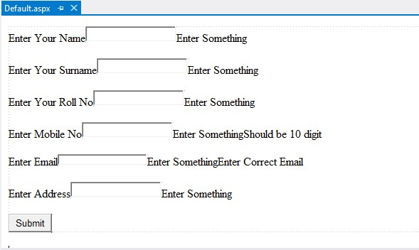

Output:

